**AWS Certified Developer - Associate Level**

**Overview of Certification and Required Services**

**Lecture: Course/Exam Prerequisites And How To Prepare For**

In this lecture, we will discuss the assumptions that Amazon Web Services makes when administering the exam. We'll talk about required knowledge needed before taking the certification. We will then discuss how to best prepare for the exam.

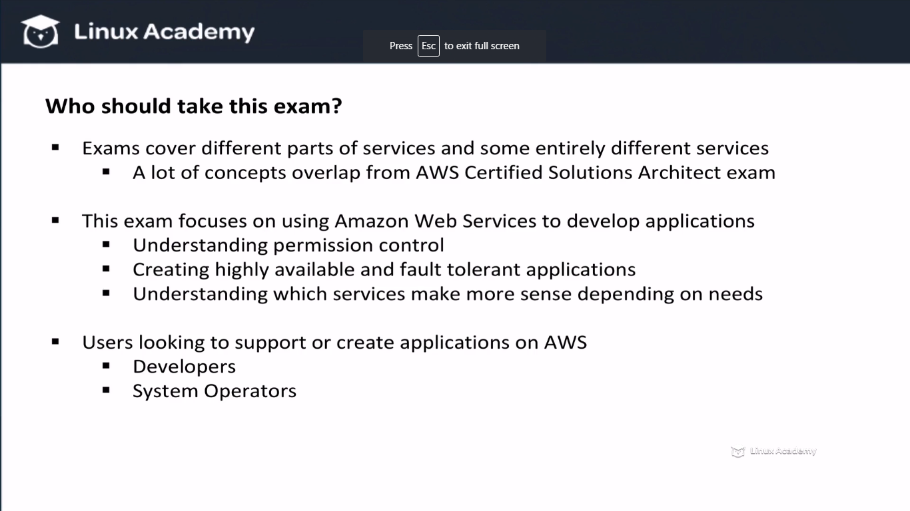

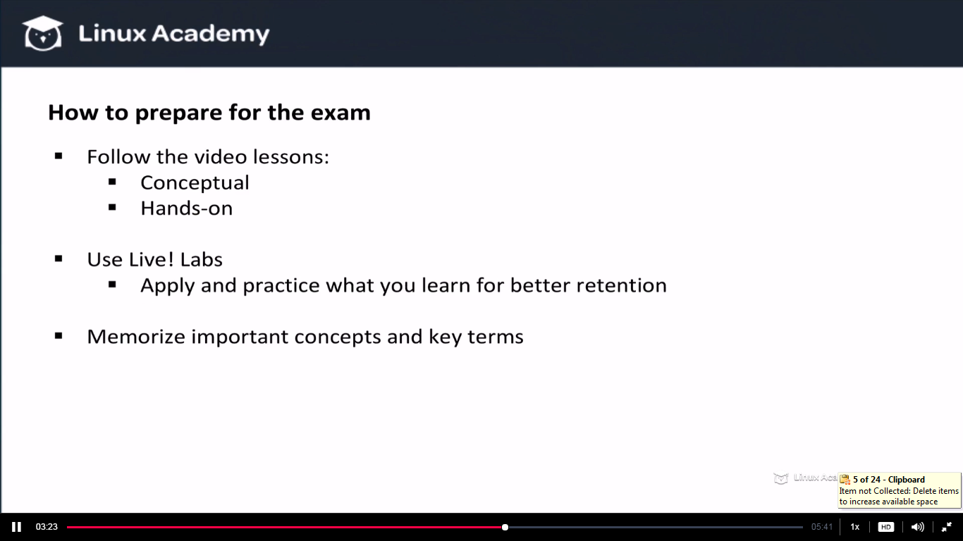

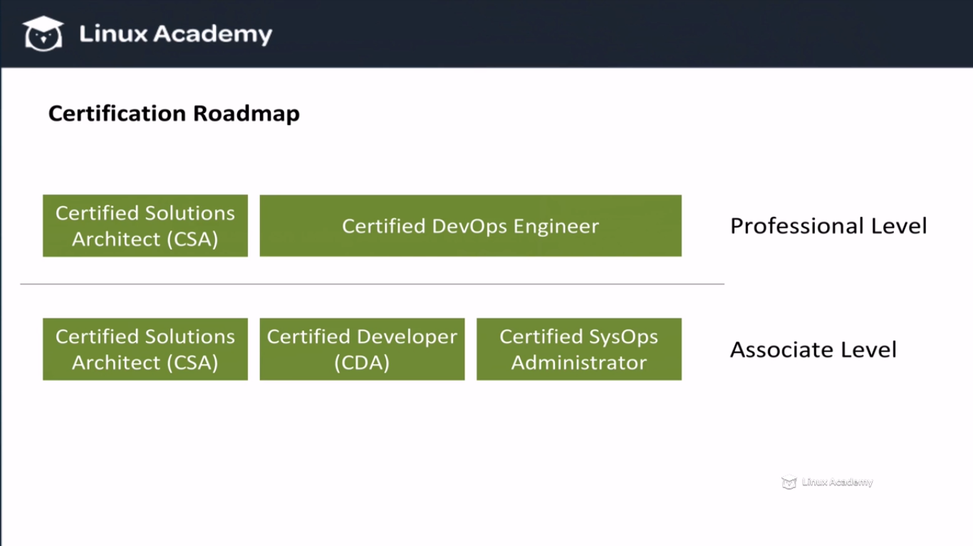

**IAM Roles and API Credentials with the Python SDK: Boto3**

**Lecture: IAM Roles and Access Keys for Development**

In this lesson, we walk through the difference between using IAM Roles and API Credential Access Keys when it comes to development. We also take a look at real-world examples of when it makes sense to use one method over the other.

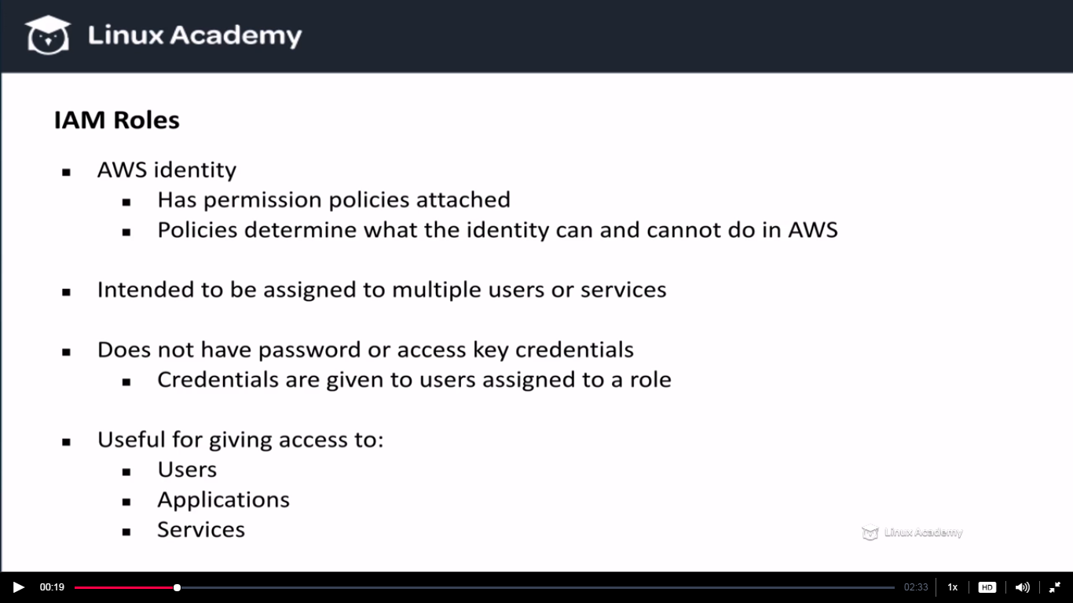

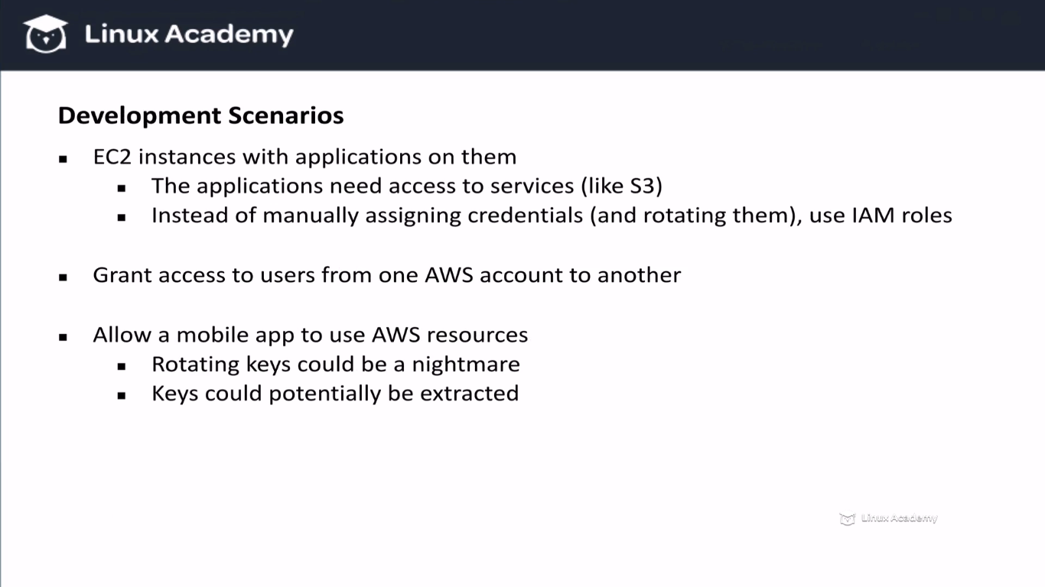

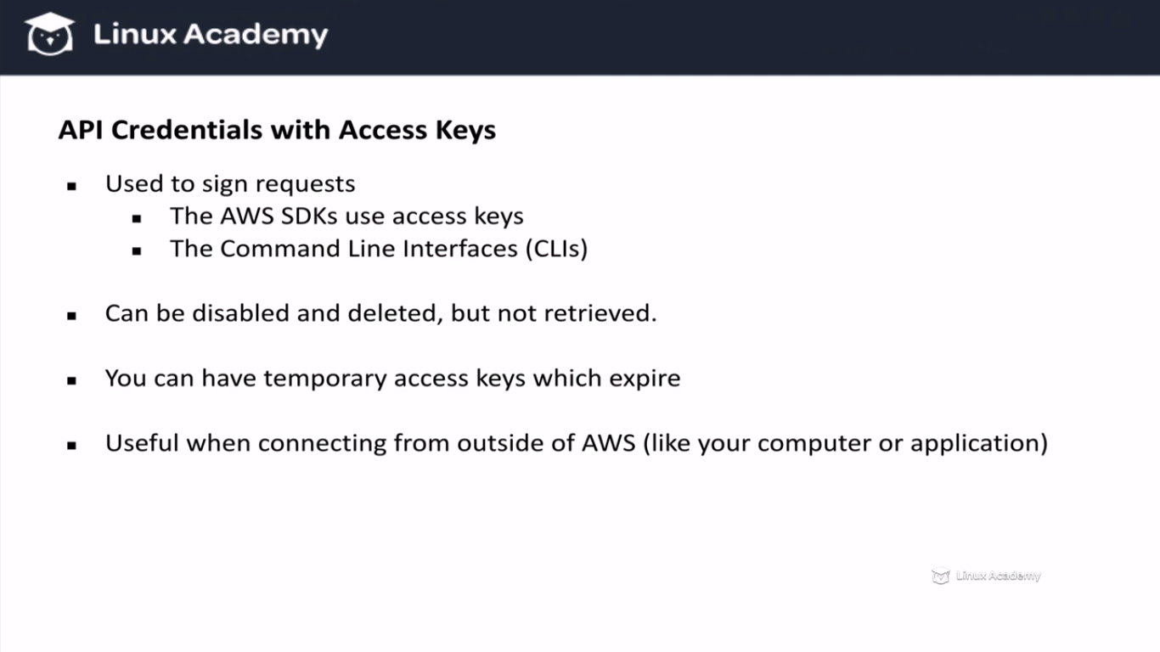

Roles can be used inside the Amazon Web Services but outside of it like on your computer or external application you need to sign your API request using a access key and a secret aces key.

**Lecture: Setting up an EC2 Instance with IAM Roles and the Python Boto3 SDK**

In this lesson we are going to learn how to set up an EC2 instance with the proper IAM roles. We will use the instance to perform any API requests needed by the course. Once our instance is set up, we will walk through installing and testing the AWS Python Boto3 SDK.

Go to IAM

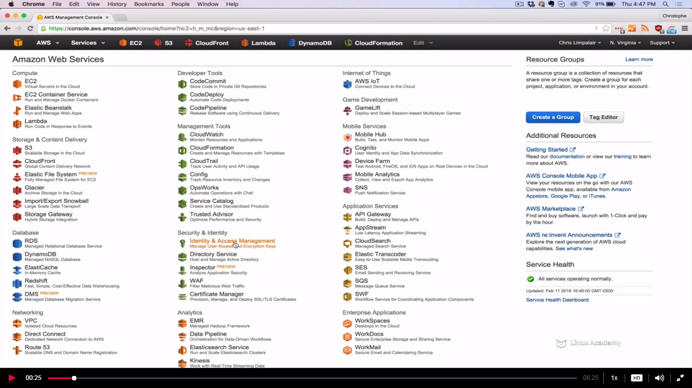

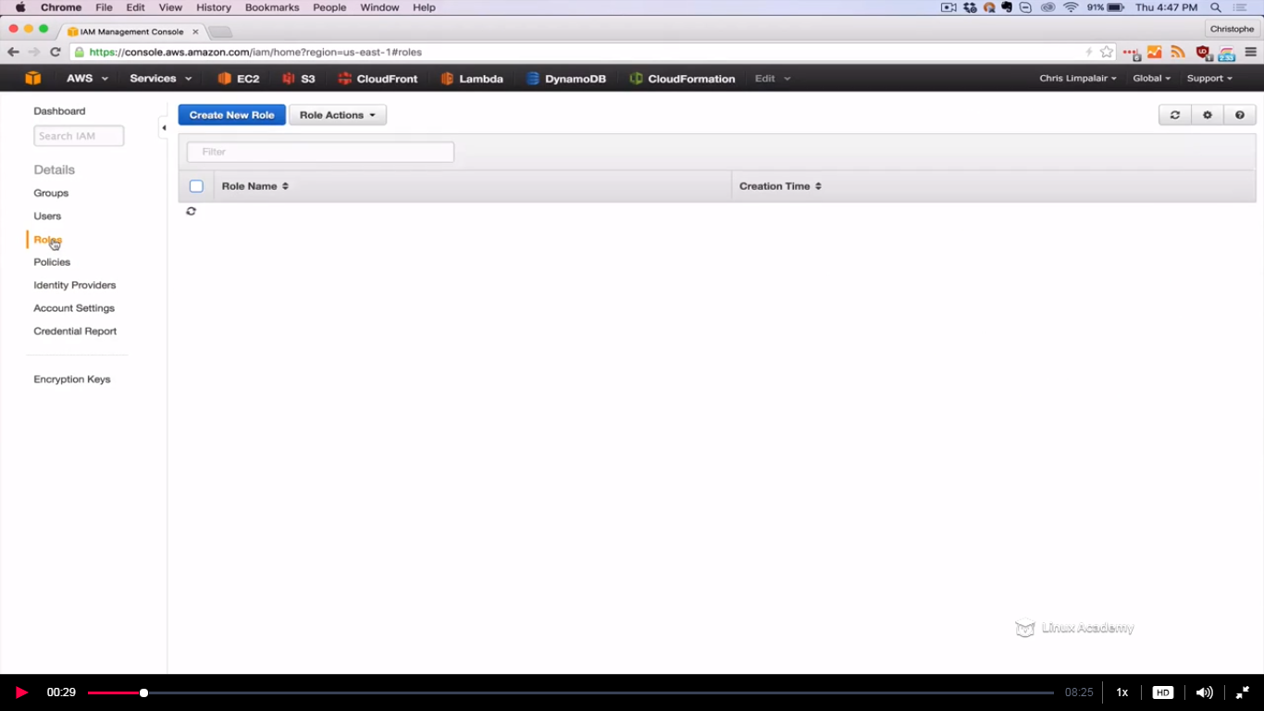

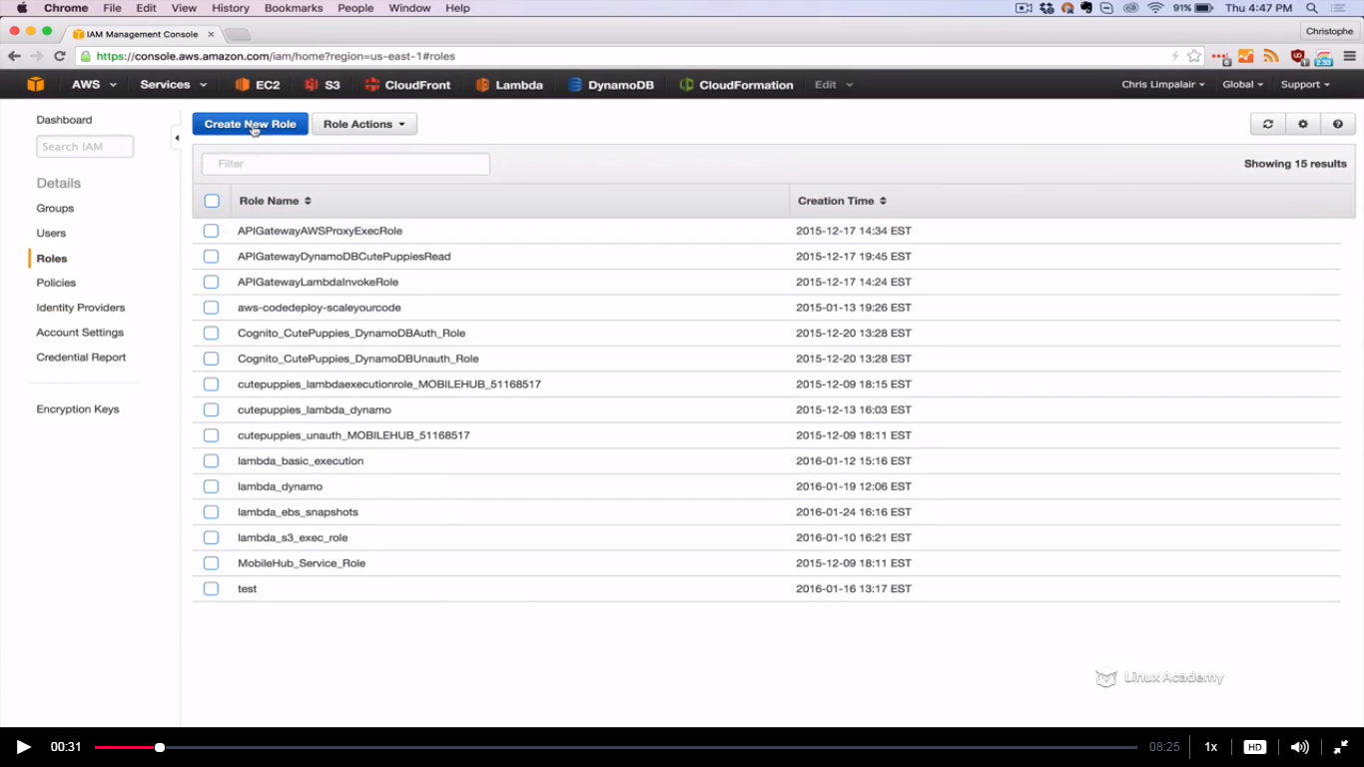

Give name as ec2-admin and hit next step

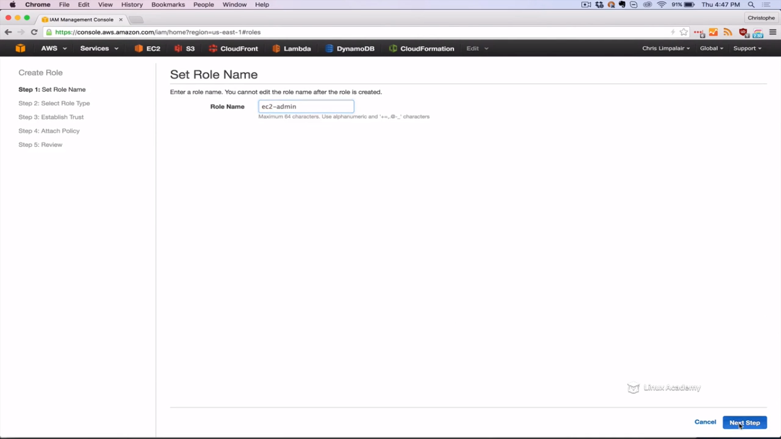

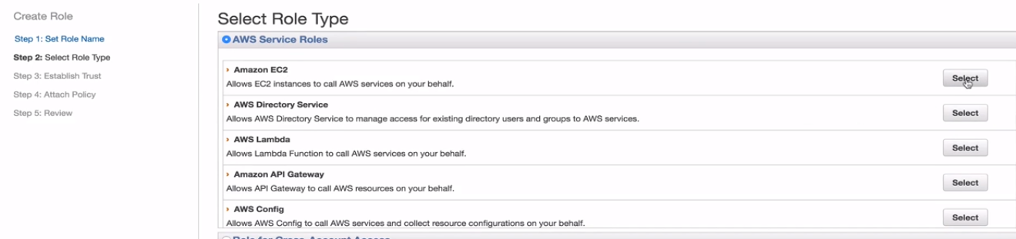

Select administrator access

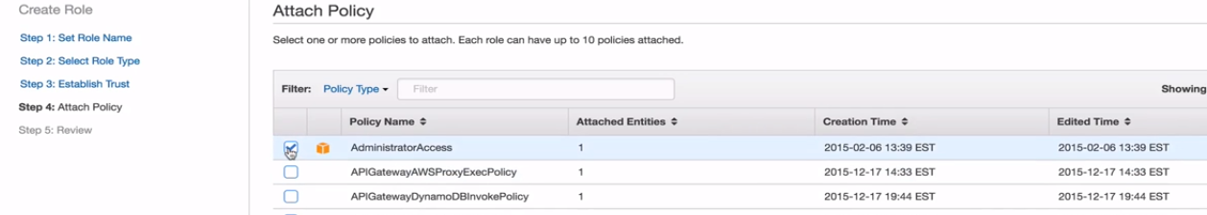

Hit next step

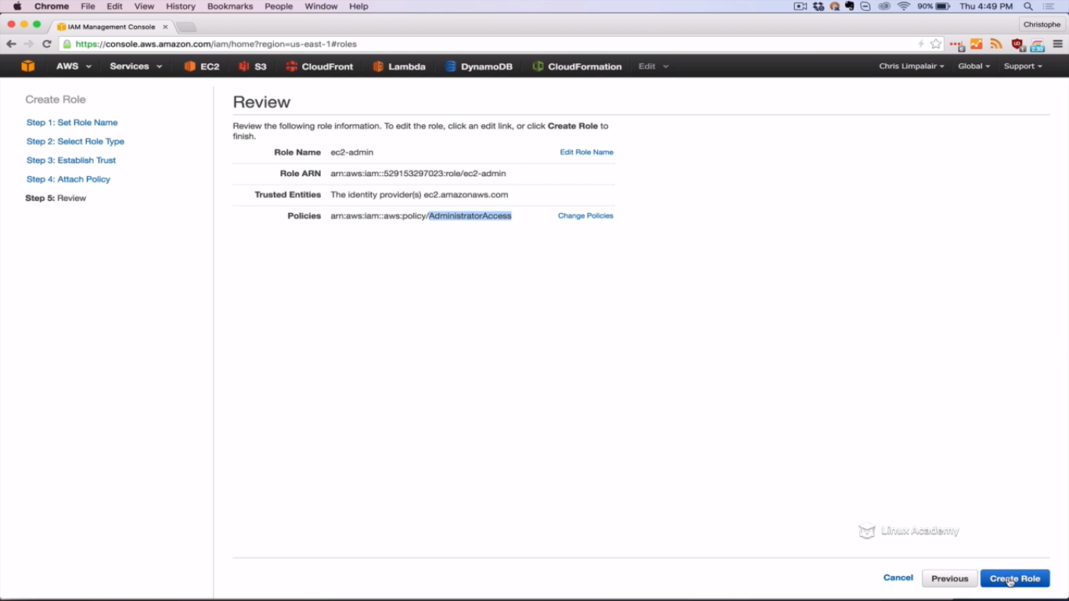

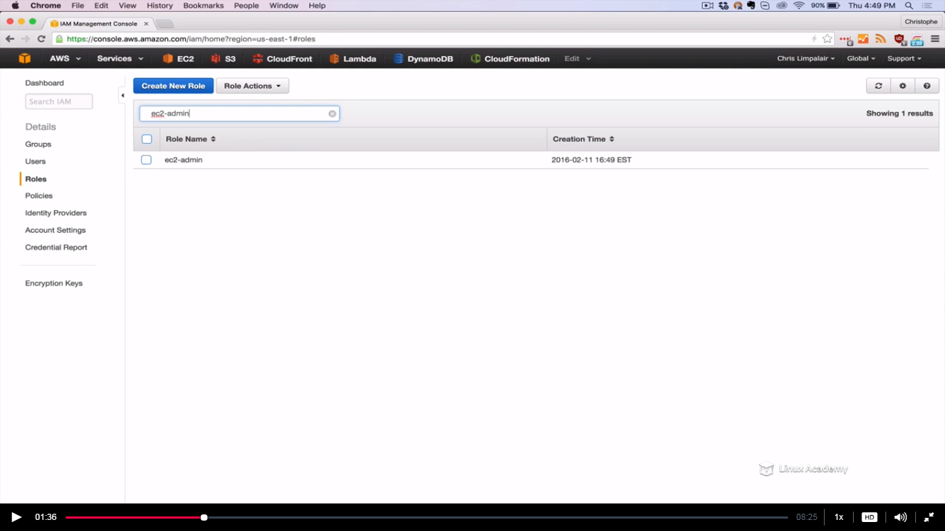

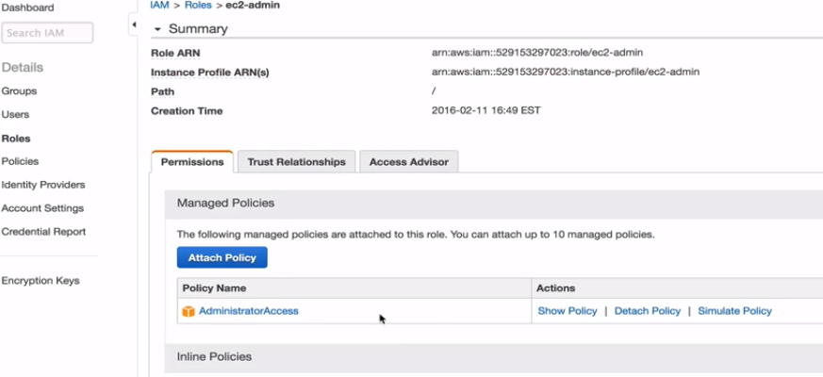

We can see the policy attaché to the role we created.

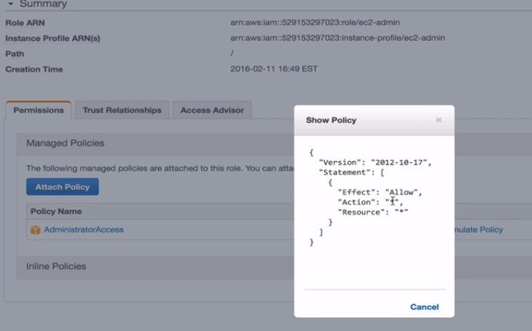

We can attach a different policy as well.

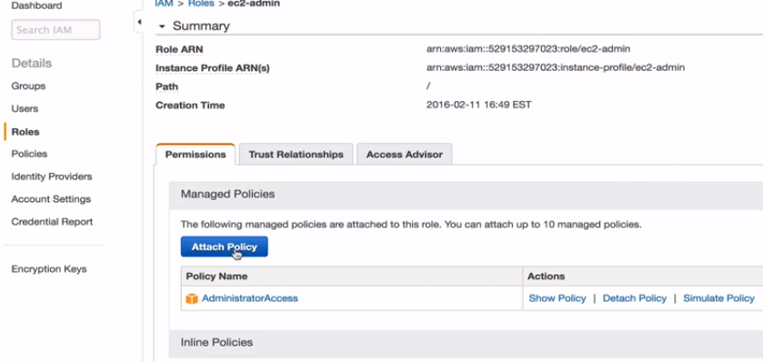

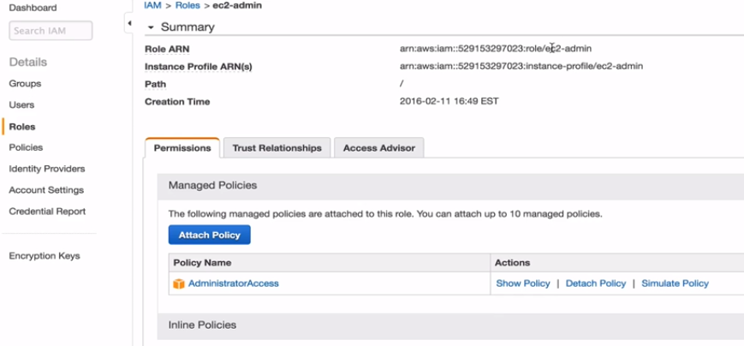

You can show, simulate and detach a policy.

Fire up a instance and give the above role to it.

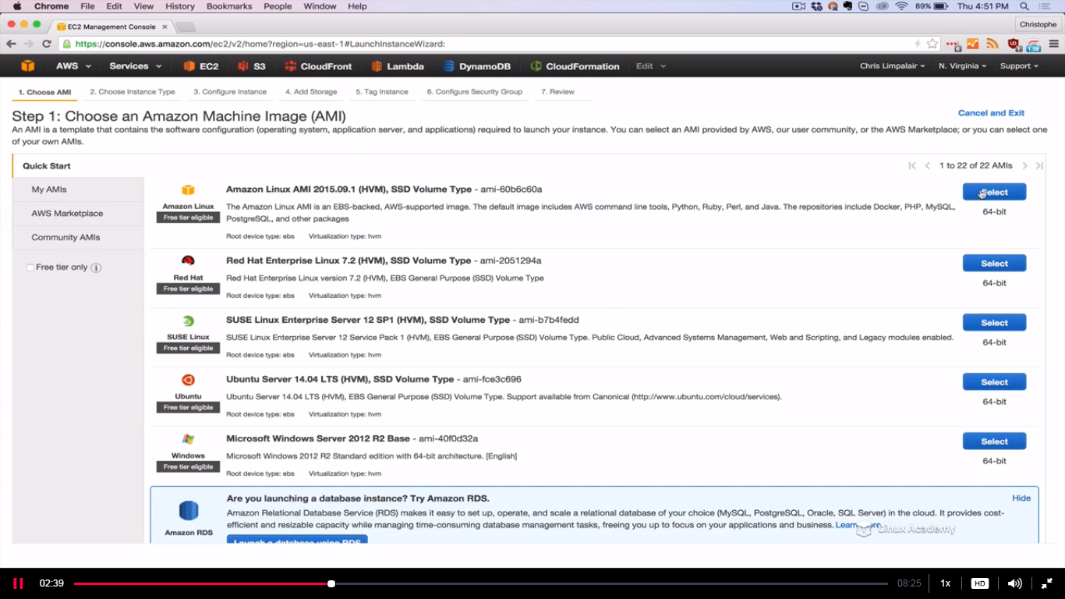

Use t2 micro

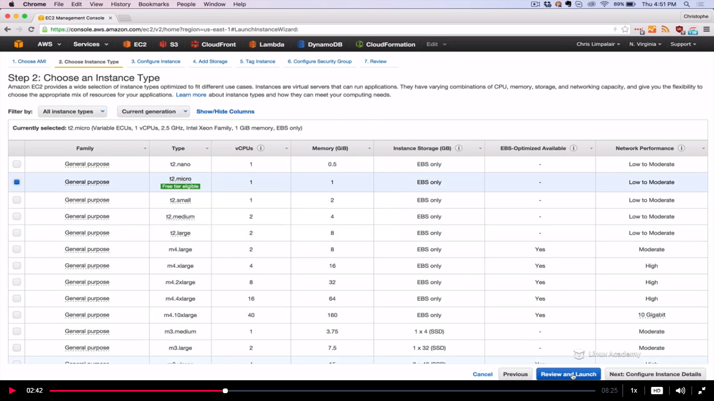

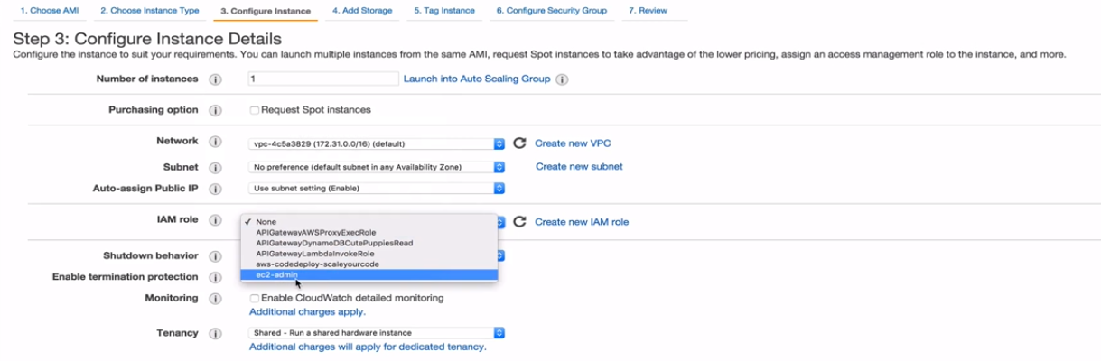

If we haven’t created a role yet we can create it here as

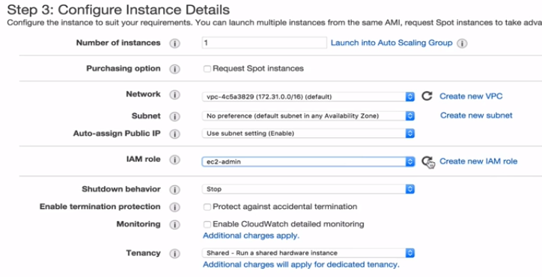

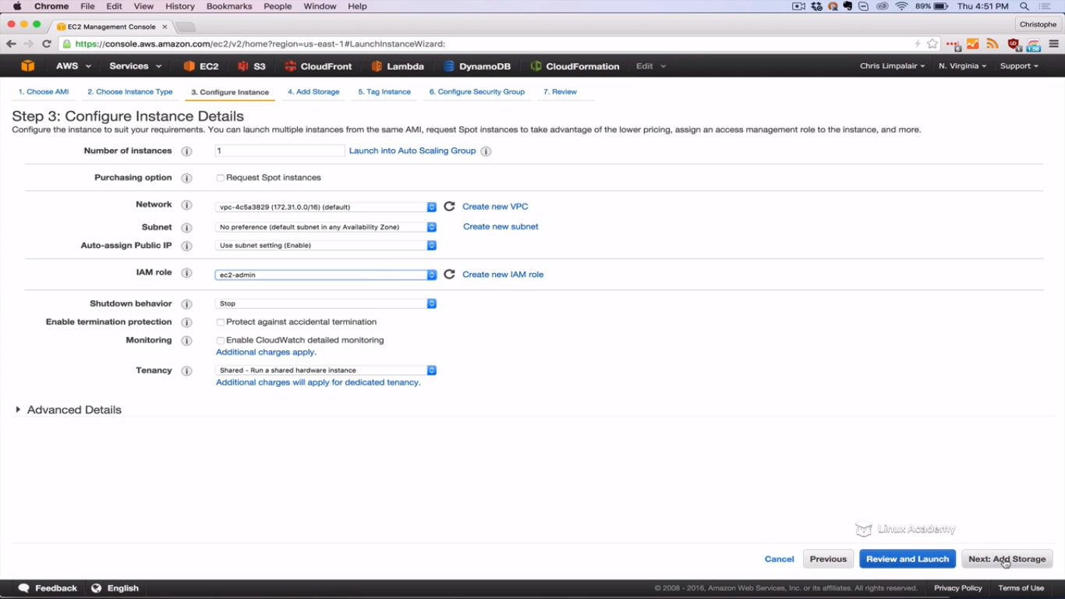

Make sure ssh acces is enabled

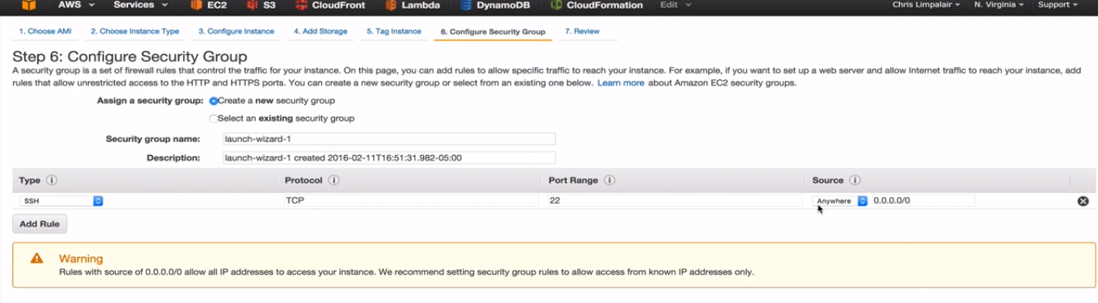

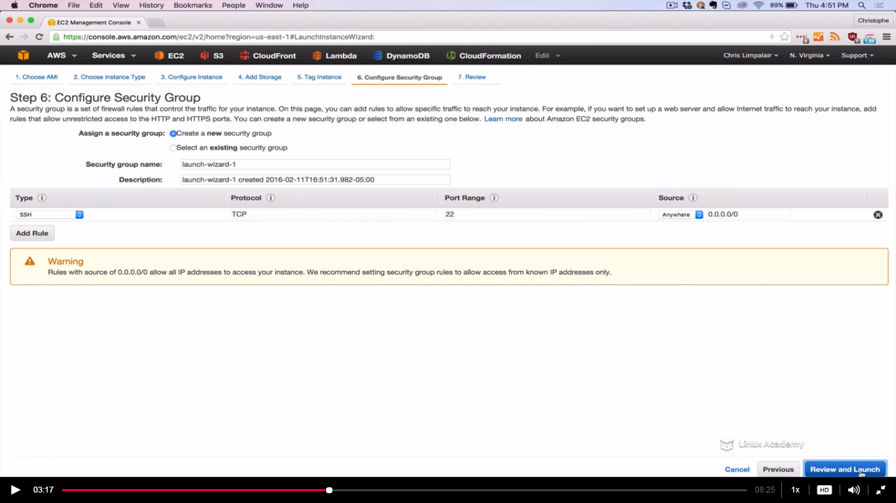

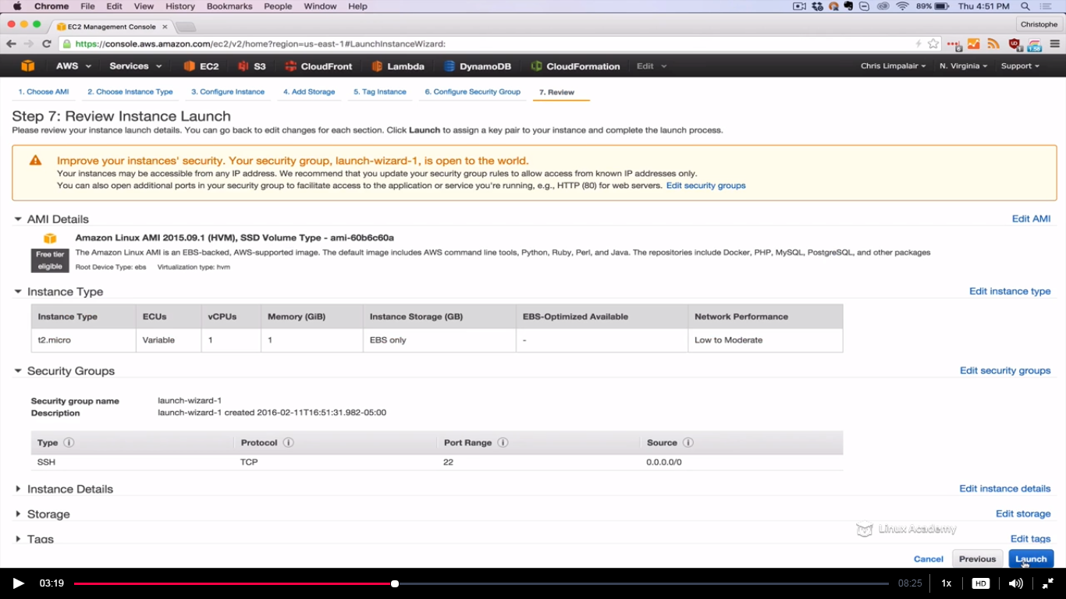

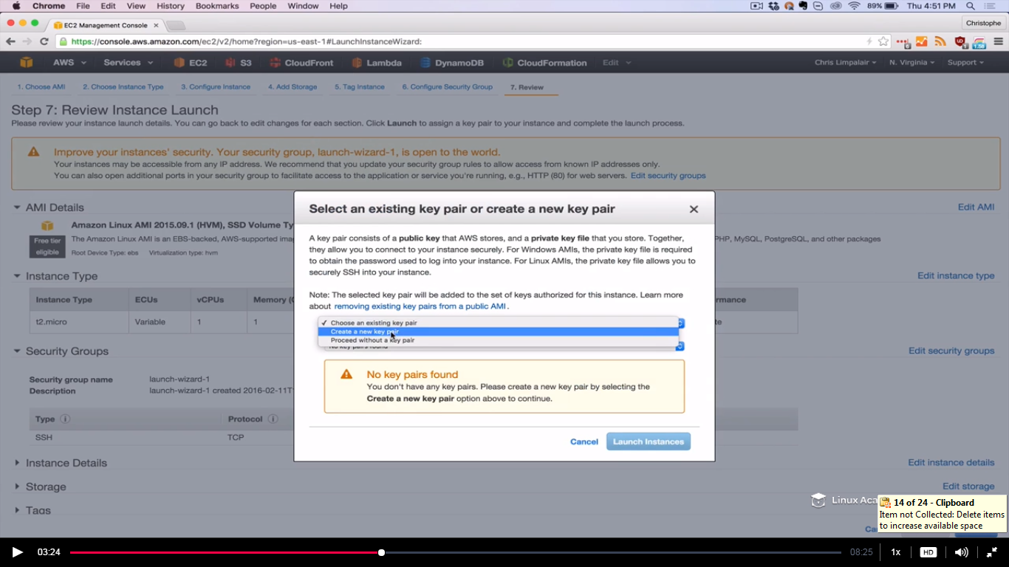

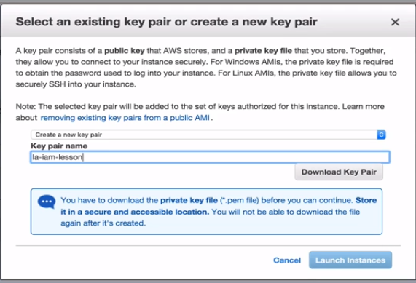

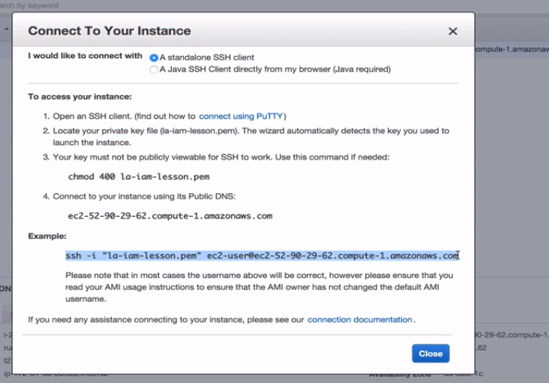

Copy the command inorder to ssh to the running instance.

Make sure you are in the same directory in which the pem file is while ssh.

Paste the command

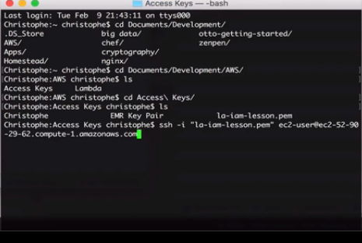

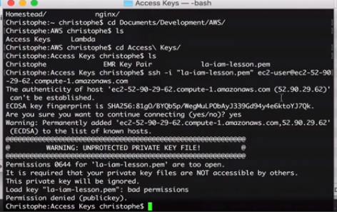

We have an error as pem file has 644 permissions, we need to rectify the error by changing the permission on pem file.

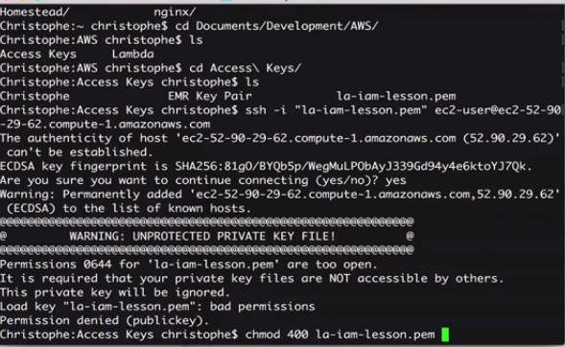

Owner of the file can read it.

Now try the commad again

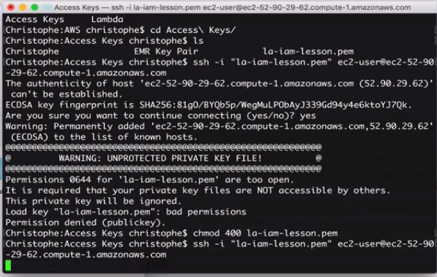

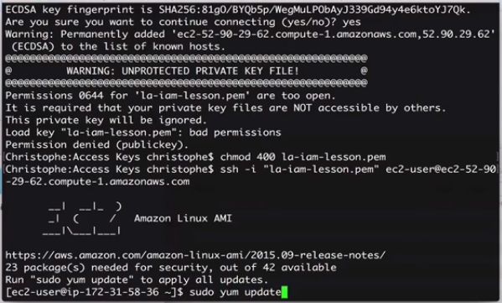





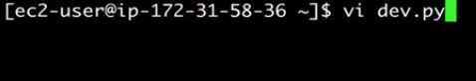

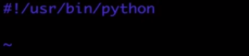

This line tells which python interpreter we are going to use later to run this script.

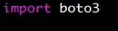

This is just importing our sdk

Once we have imported our sdk we can create a connection to our S3.

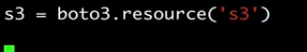

The above command would create the connection. Once the connection is established, we can then go ahead and create our S3 bucket.

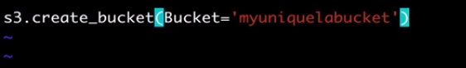

We haven’t passed the credentials here because we have defined a role so lets save it.

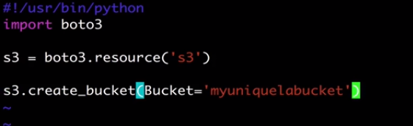

Give the executable permission to the script we just created as

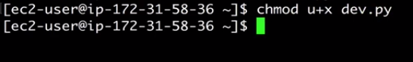

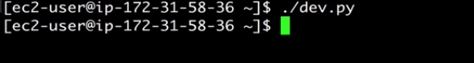

Go to s3 and see if it creates a bucket.

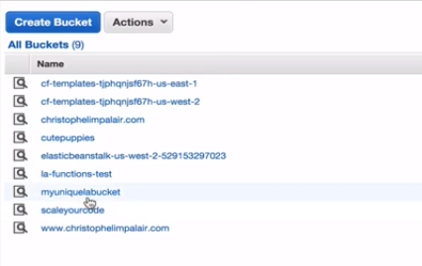

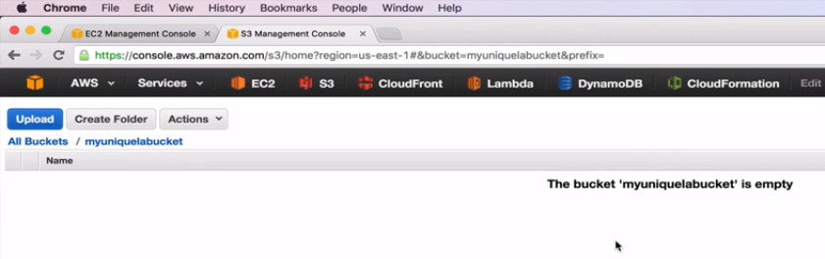

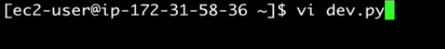

I can create a second bucket this time.

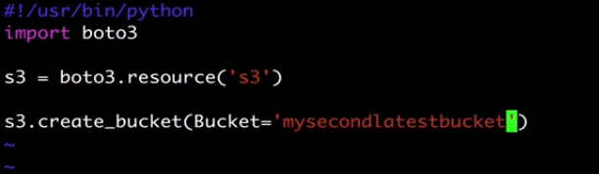

Save and exit.

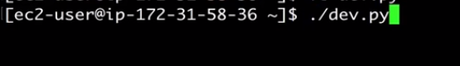

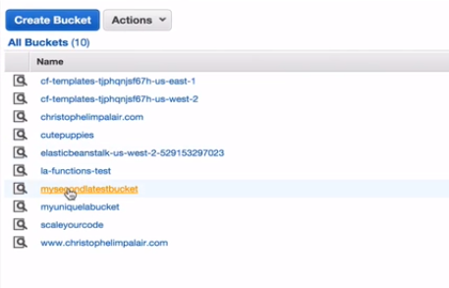

**Lecture: Configuring the Boto3 SDK With API Credentials**

In this lesson we will learn how to set up the Python AWS Boto3 SDK and connect to S3 using an API access key and secret access key.

**If we want to access outside AWS environment services like s3 so wat we can do is we can’t use IAM roles but we can use is access keys**.

**Now we have the same file but this time this file or script will not work.**

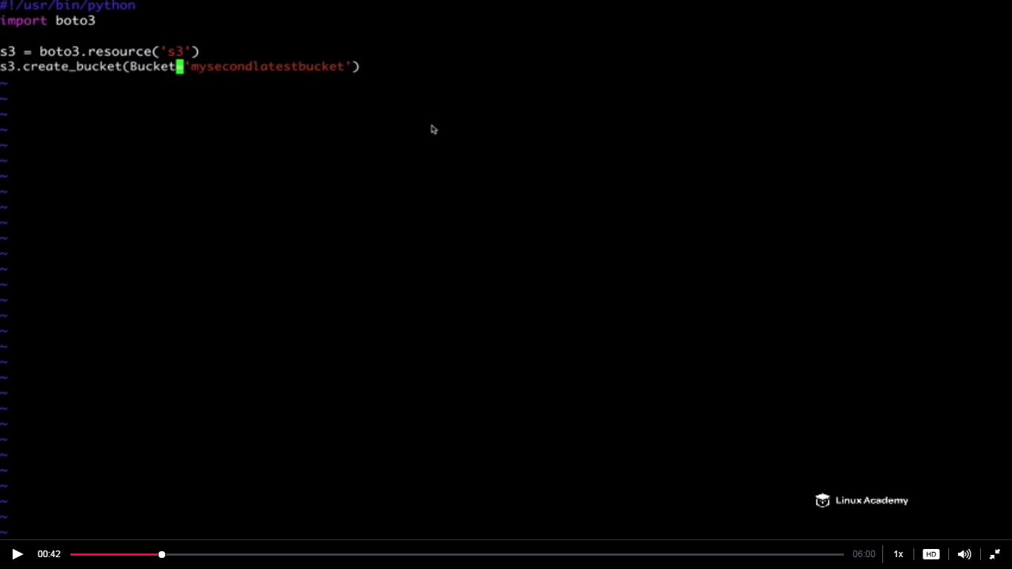



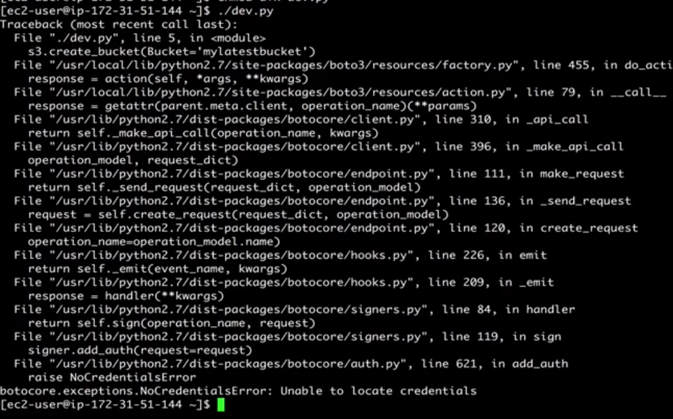

**We have errors while running the same script without roles. Unable to locate credentials is the error as seen on the last line above. We need to have credentials to access the s3 bucket resource.**

**Lets just delete this script**

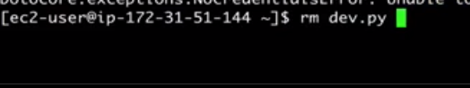

Go to AWS console and into IAM

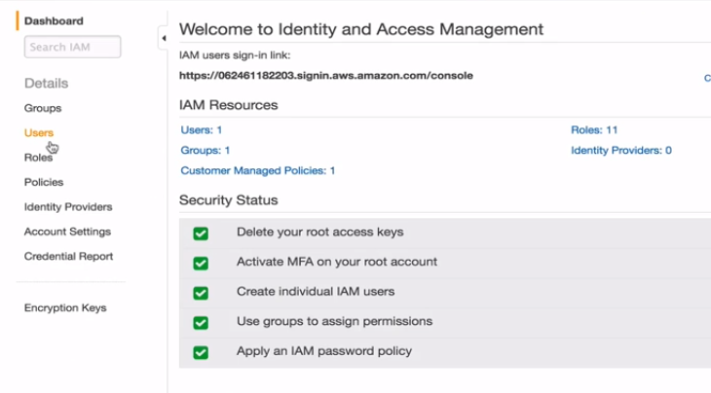

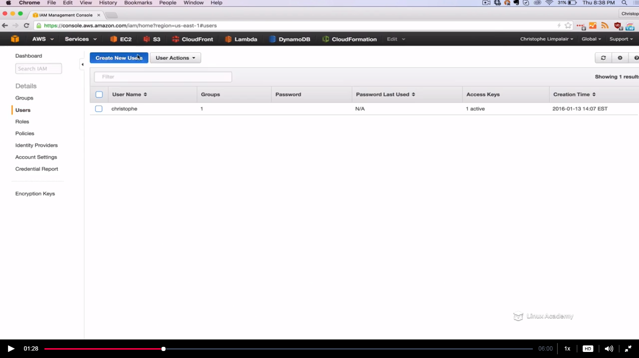

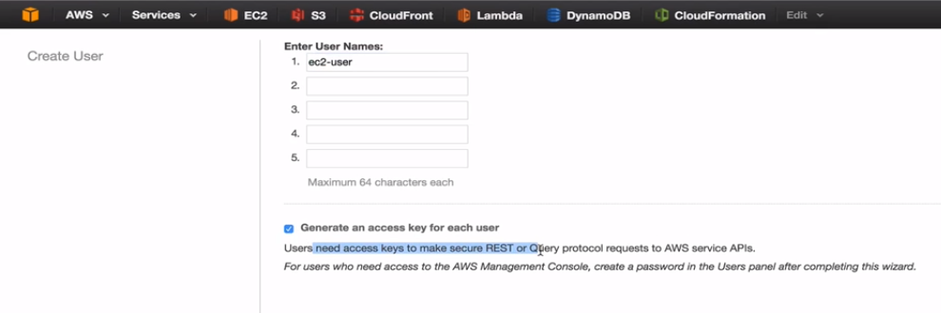

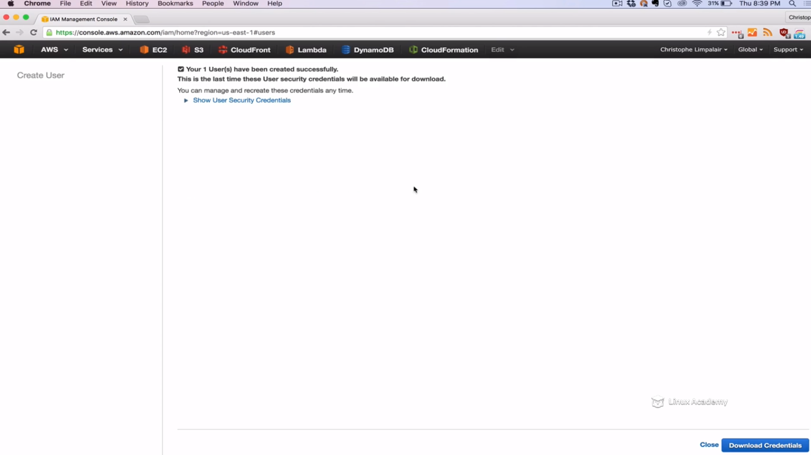

You can hit download credentials.

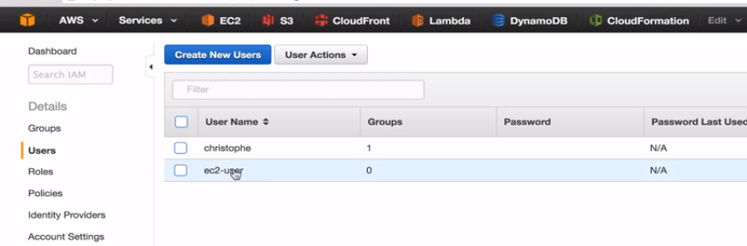

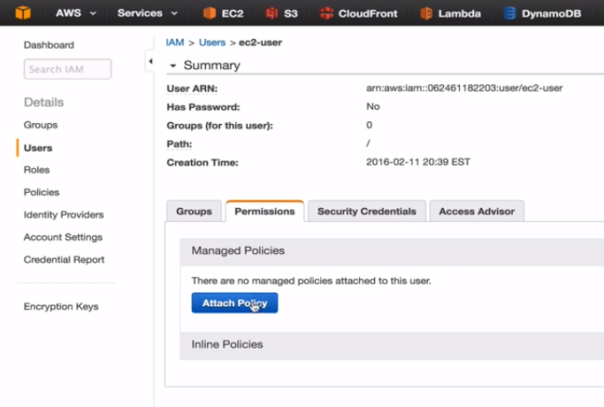

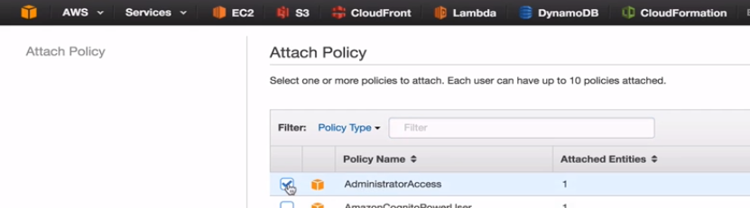

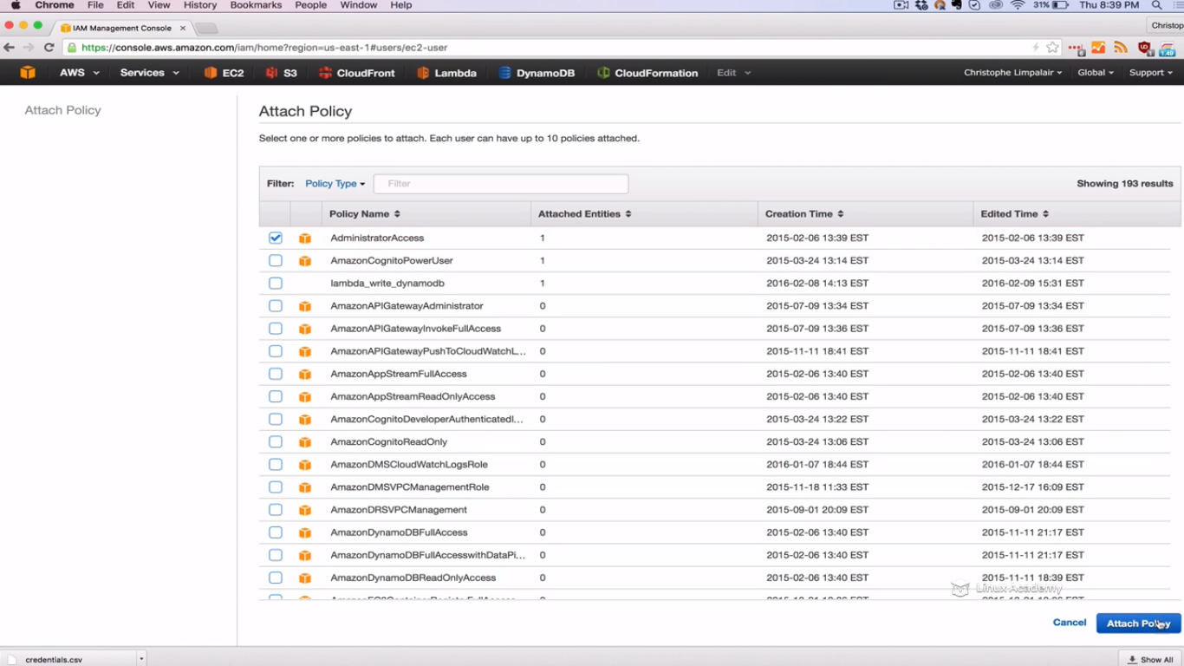

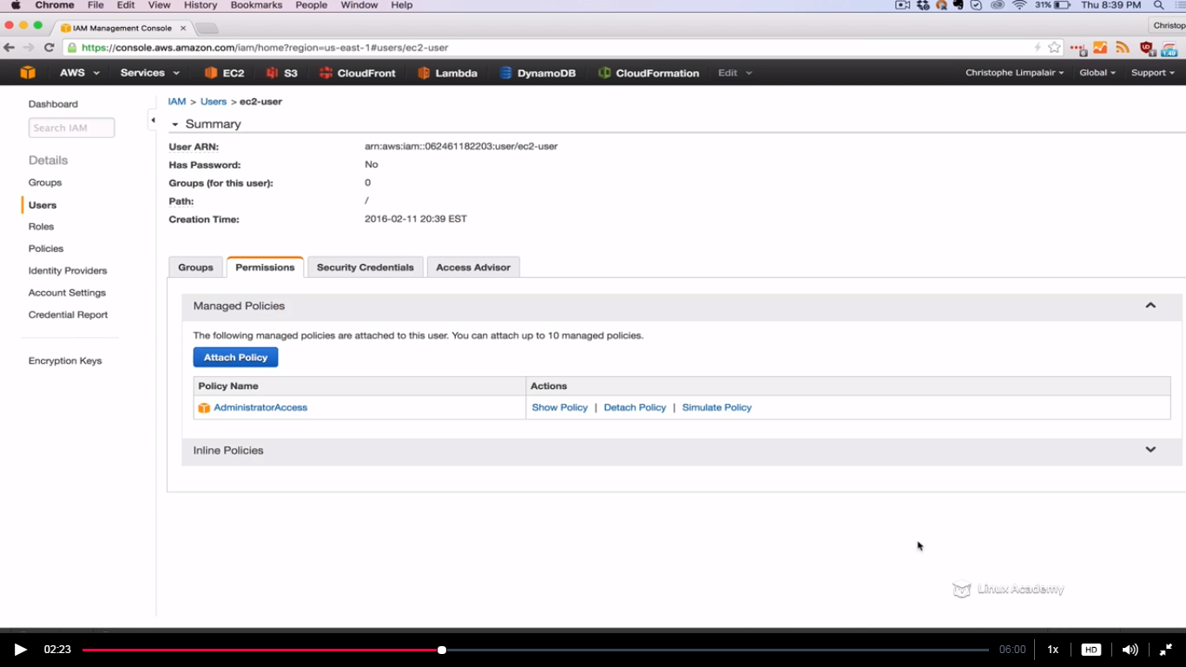

Open the downloaded csv file which has our credentials

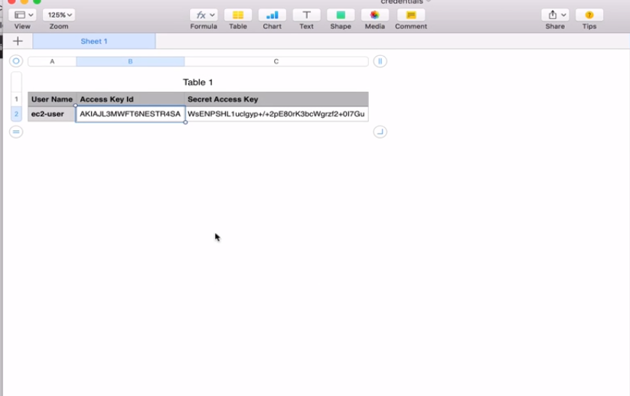

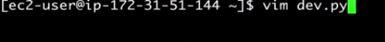

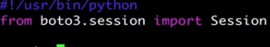

First lines point to the directory where the python interpreter is. Second we are importing session here because the session is going to give the access to pass in our credentials .



After this we are ready to set up a connection to s3

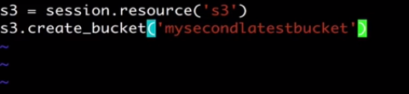

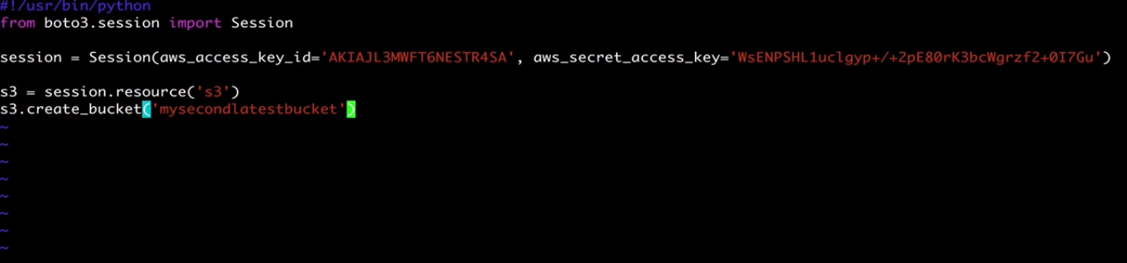

Save and exit.

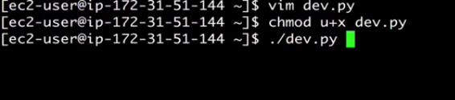

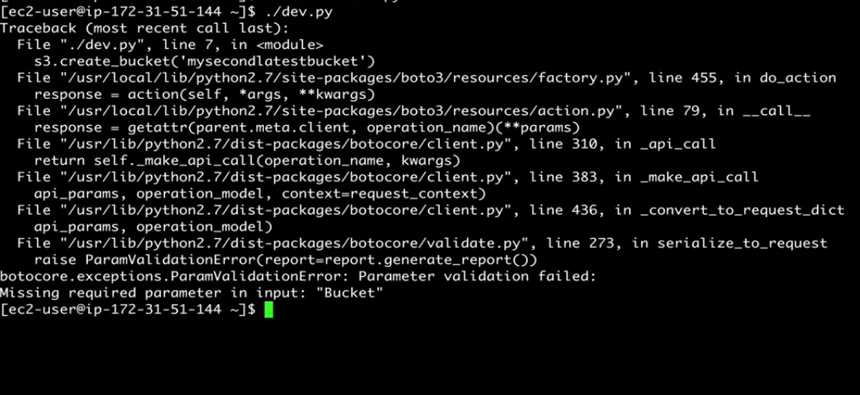

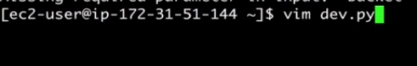

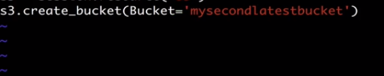

Bucket keyword was missing in the script file. Correct the syntax or error and save again.

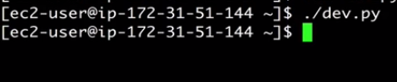

Go to s3 and check it out.

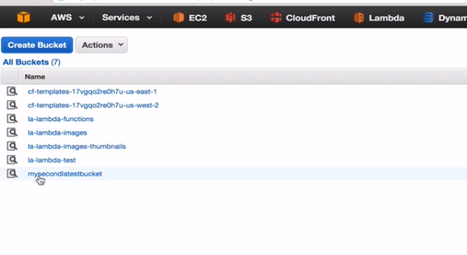

**Amazon S3 (Simple Storage Service)**

**Lecture: Introduction To S3 Developer Requirements**

In this lesson we are going to discuss some of the required knowledge for the AWS Certified Developer certification.

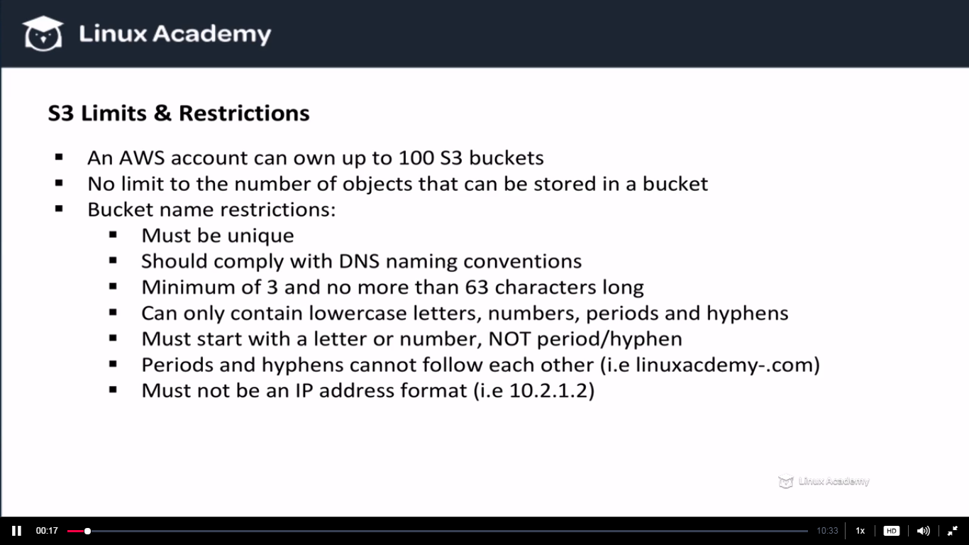

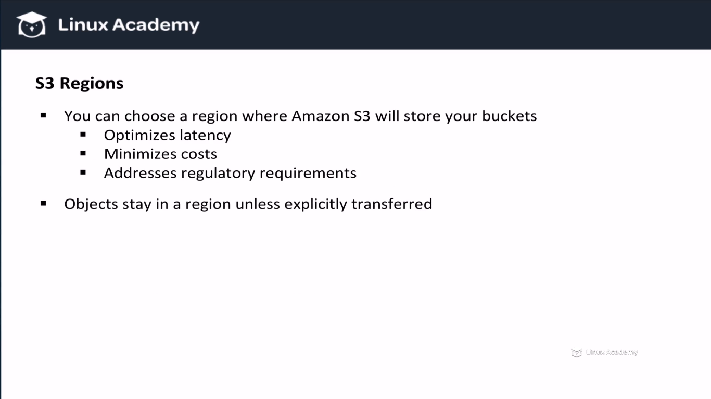

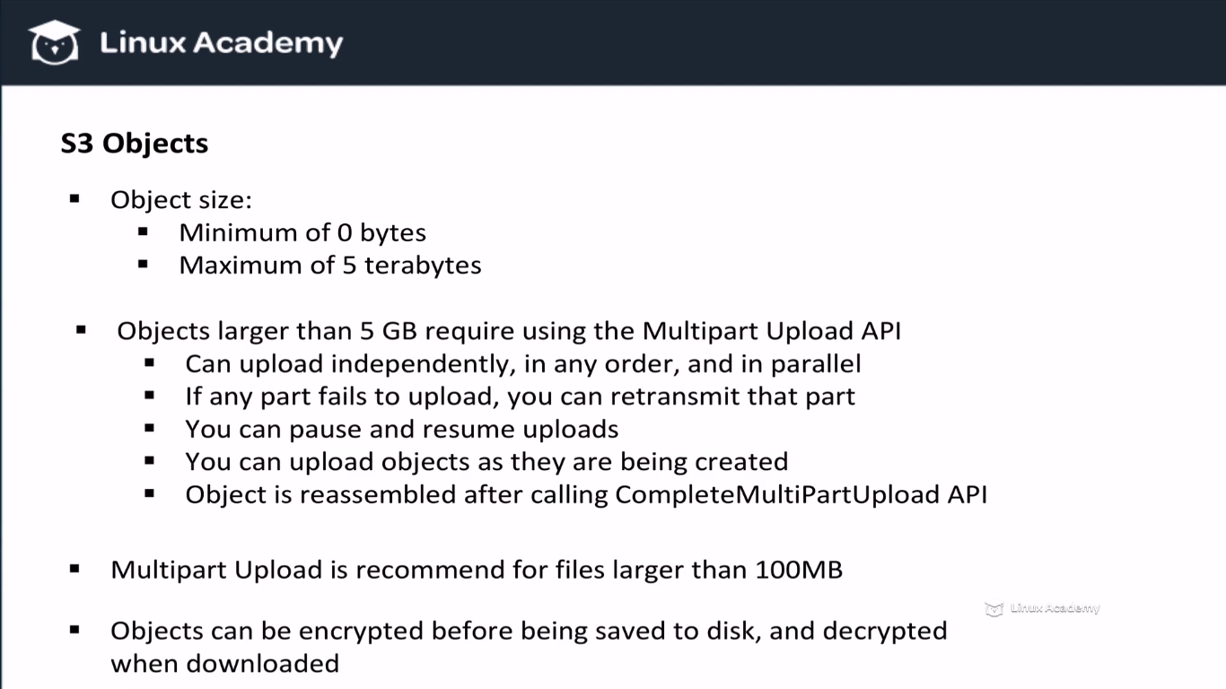

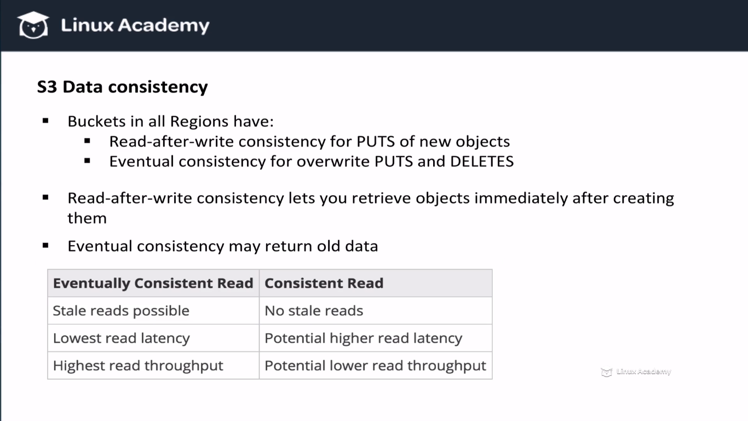

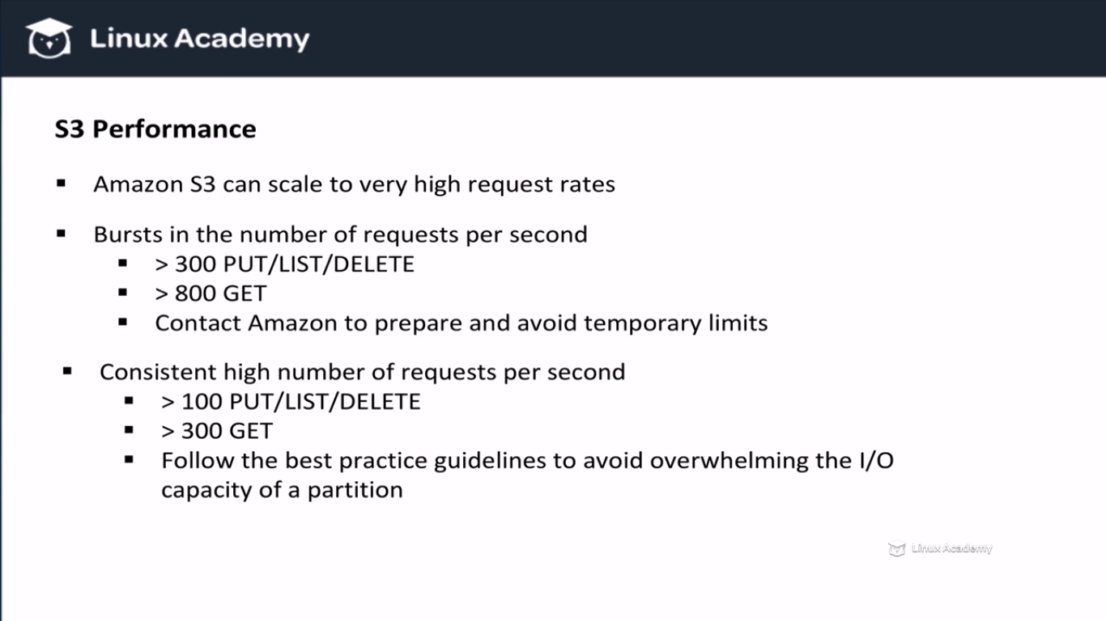

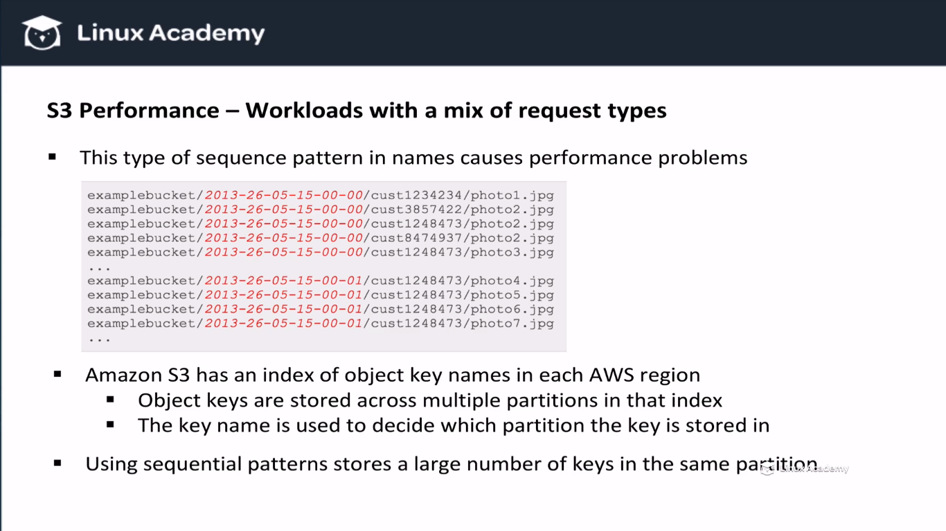

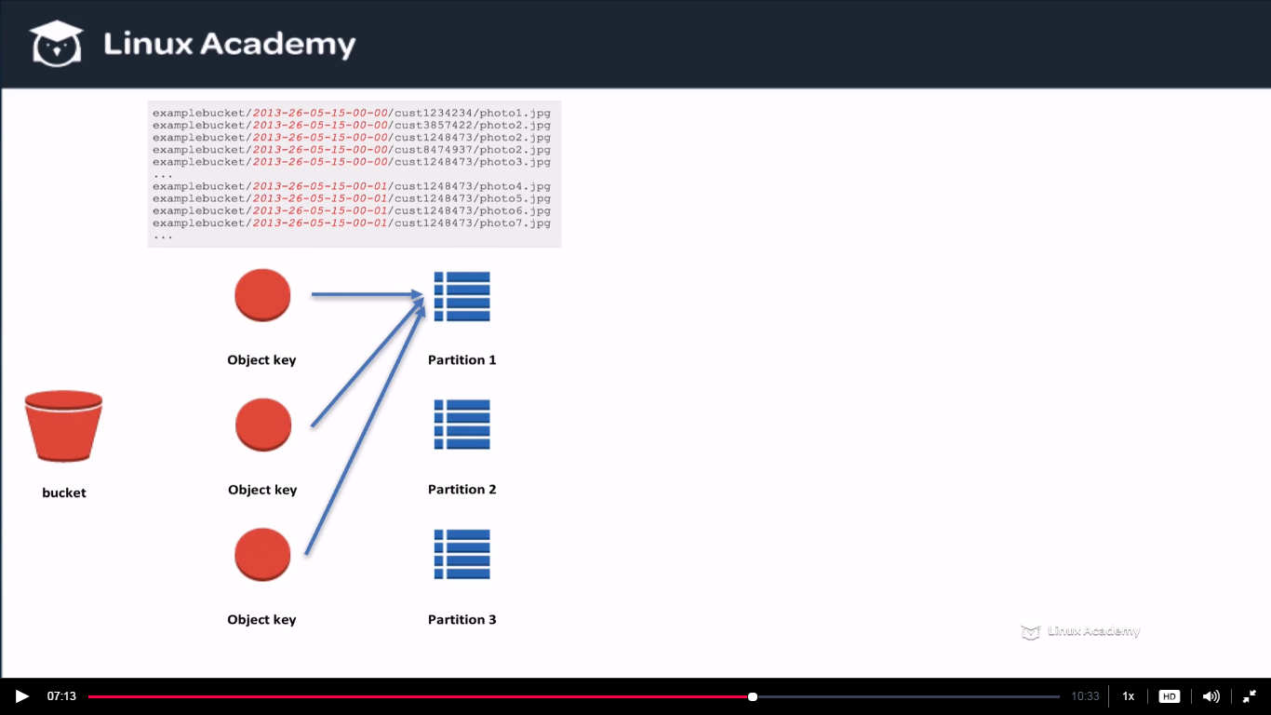

The above scenario we wouldn’t want and we want to avoid it.

And the scenario which we want is

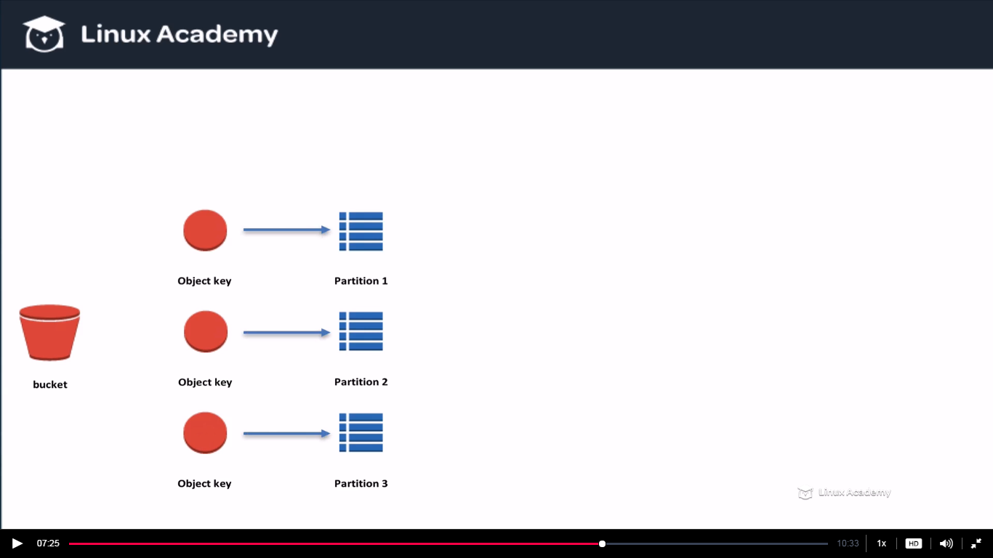

An even spread of object across multiple partition so that we don’t overwhelm our resources.

So we know the problem, now how to solve it

**We can solve it by introducing randomness.**

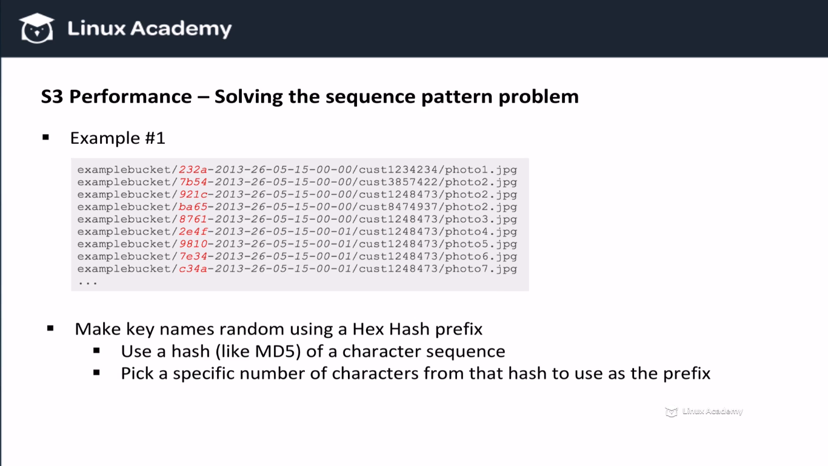

**Hex means hexadecimal.**

**Another solution is to reverse the key name strings**

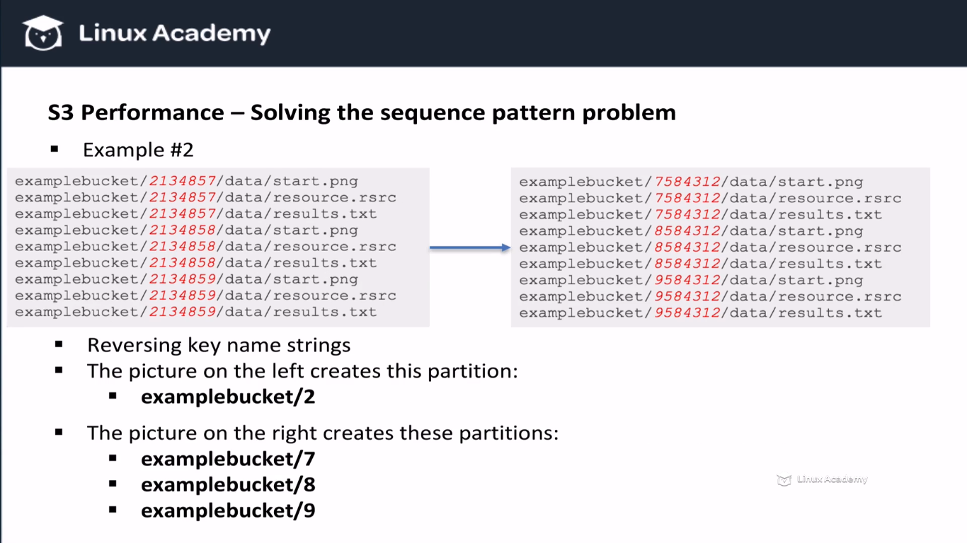

**This method wont always work because sometimes you will reverse the string and end up with fewer or same number of partition so there is no real benefit there. We have seen 2 ways above to solve the list/put/get request but lets say we have a high workload of only get request. So in that case we can use cloudfront.**

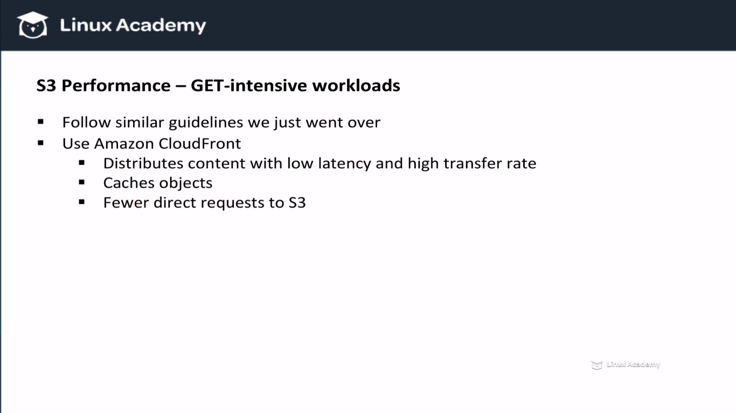

**We can ude cloudfront as a CDN in front of S3 and we would have a lot of benefits.**

**Before wrapping this lesson lets talk about important errors we should know when it comes to S3.**

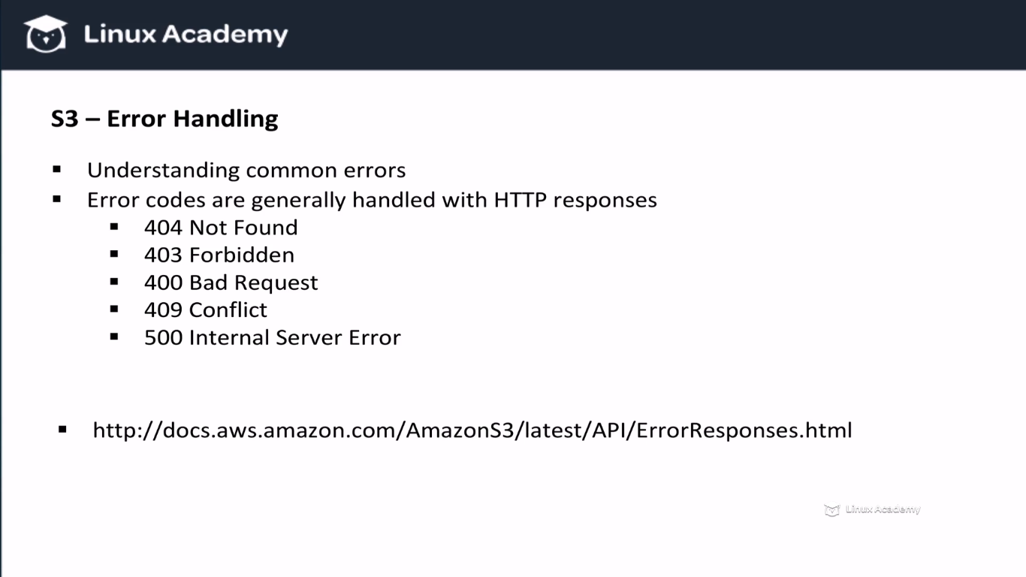

**Lecture: Concept: Hosting Static Websites**

One of Amazon S3's features is the ability to host static websites. In this lesson, we take a close look at this feature and limitations we should be aware of.

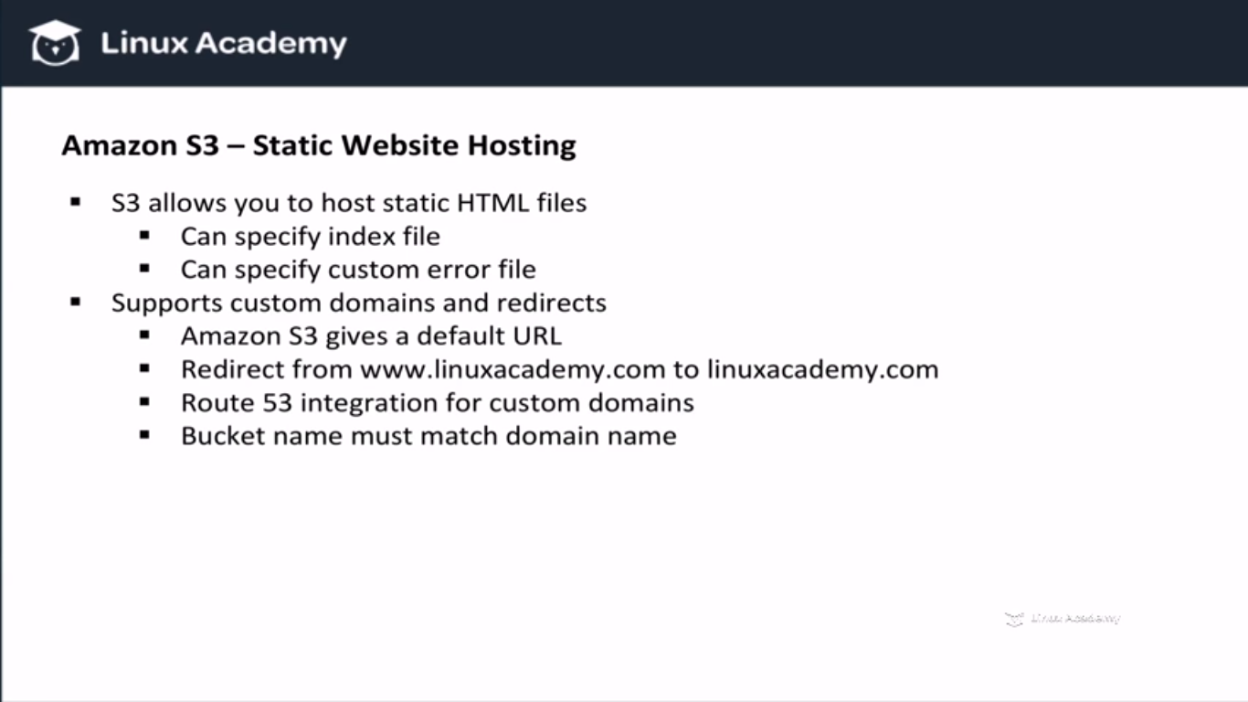

If we want to host a website name i.e linuxacademy.com on s3 then we would create a bucket name as linuxacademy.com. We would also create a bucket name as [www.linuxacademy.com](http://www.linuxacademy.com) and then we will set up a redirection so that all of our request lead back to one of those 2 buckets. This also means if someone already have a bucket name of what we are trying to name then we can’t create a bucket name which already in use or already created.

So once we have set up our buckets then we need to create an alias in route53 to point to our buckets.

IF we don’t care about having a specific URL or if a bucket name is taken so we can map our custom domain name to our static website. We can still use the custom URL that s3 gives us. And below is the custom URL format .

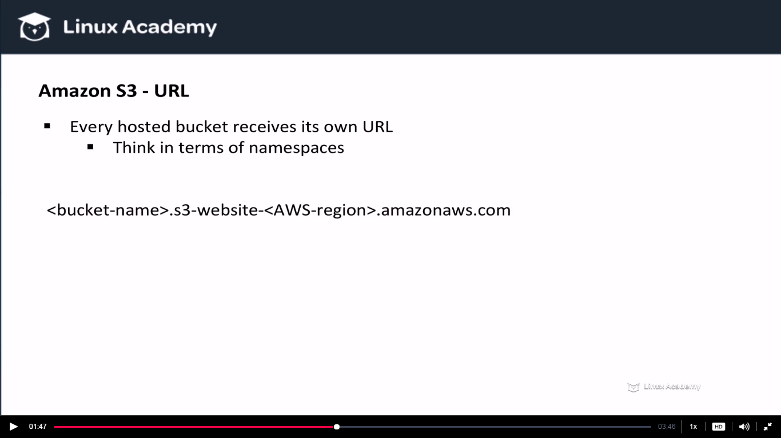

Think of the above URL as your namespace and your most local namespace is your bucket name . Next we have our s3 website followed up by your AWS region which runs on Amazon AWS. We don’t have to create the above URL manually because AWS already provides it.

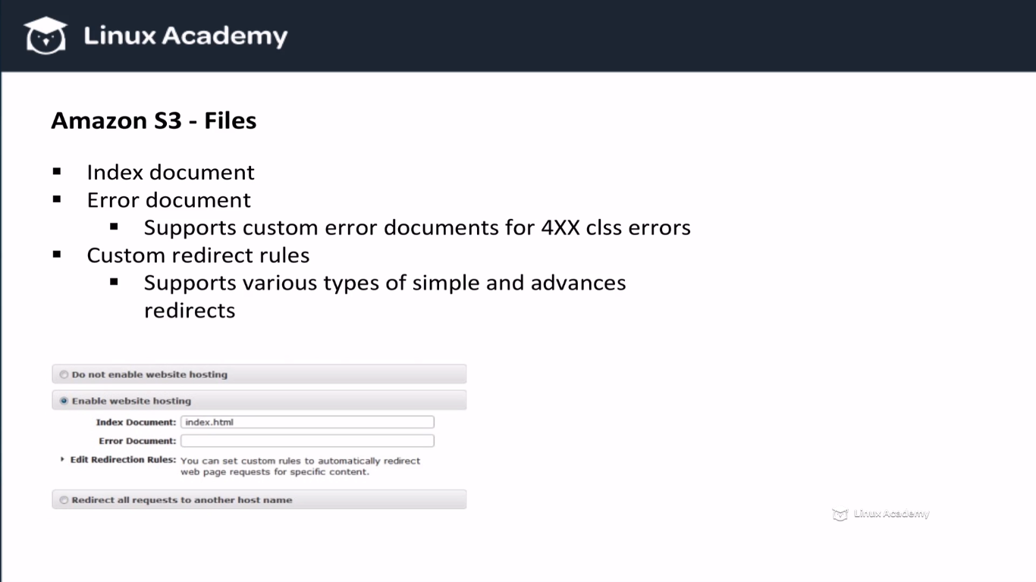

**Lecture: Creating A Static Hosting Website With S3**

We've gone over the concepts of hosting static websites on S3, so now let's set it up in AWS. We'll use Route53 to setup our custom domain to point to our S3 bucket and serve static files.

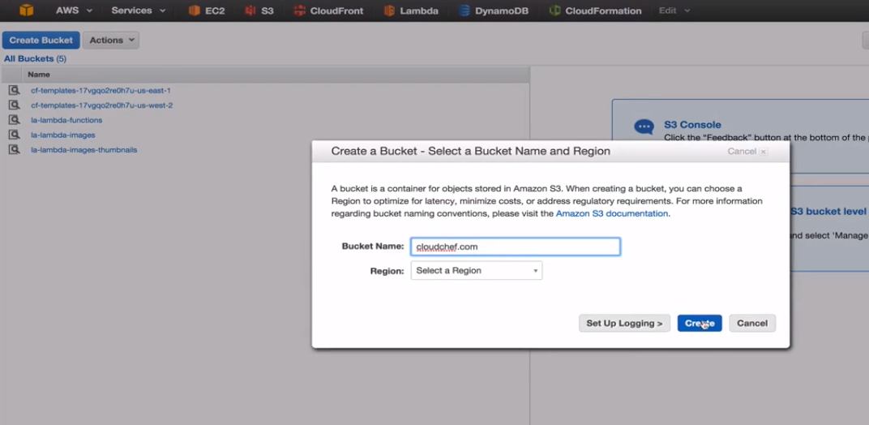

**We are creating a bucket cloudchef.com because the bucket name should match the Doamain name.**

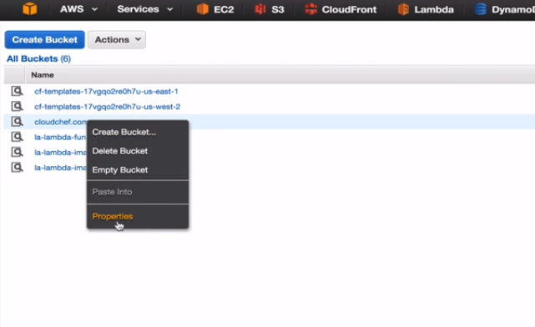

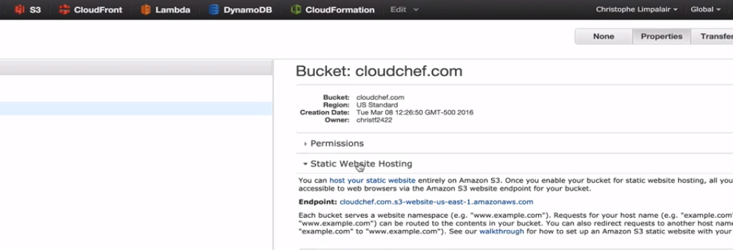

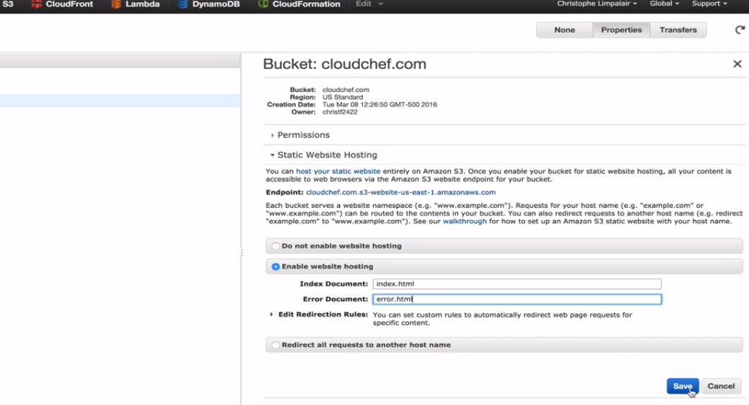

**Index.html and error.html**

**Save it and the custom url that s3 gives us is here on the top of the above page as**

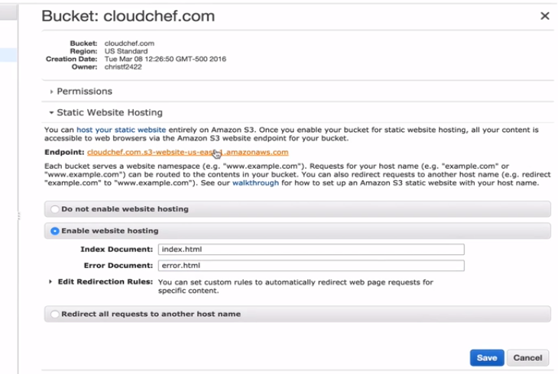

**We can click on the custom URL and it would take us to our website.**

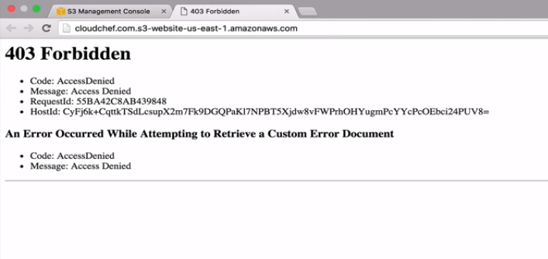

**We get a 403 error because we haven’t uploaded index.html files and we don’t have evern access to them.**

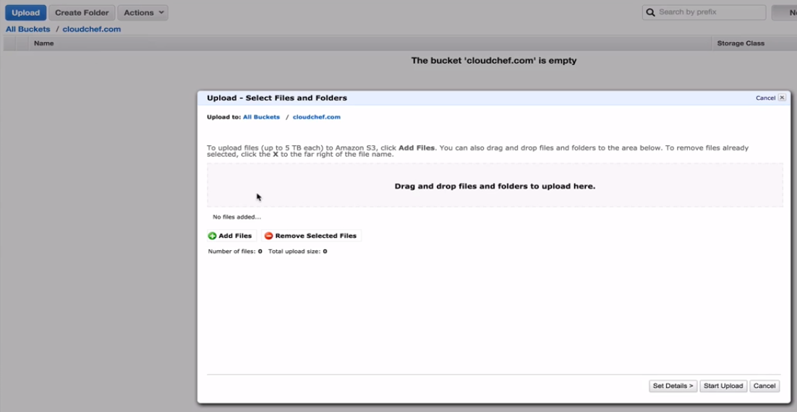

**Upload those files.**

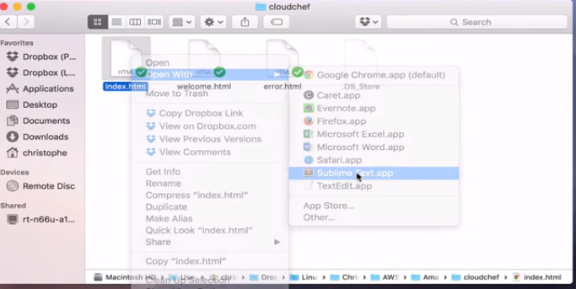

**Index.html contents**

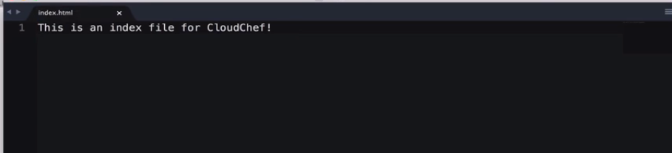

**Error.html file contents**

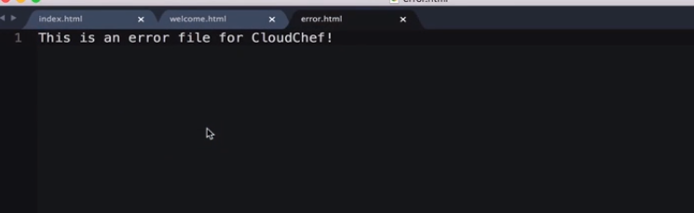

**Welcome.html**

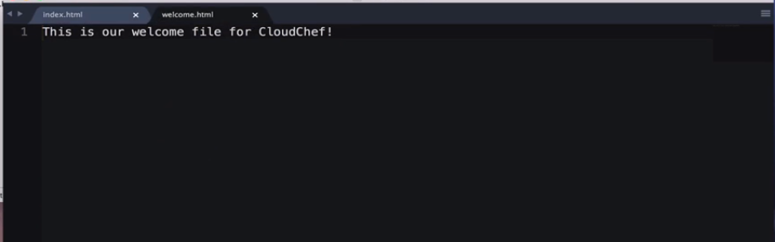

**Create these file and let them have .html extension.**

**Upload these to s3**

**Set permissions as**

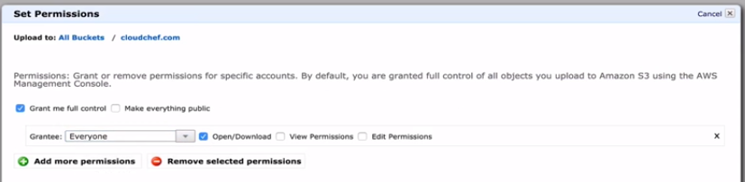

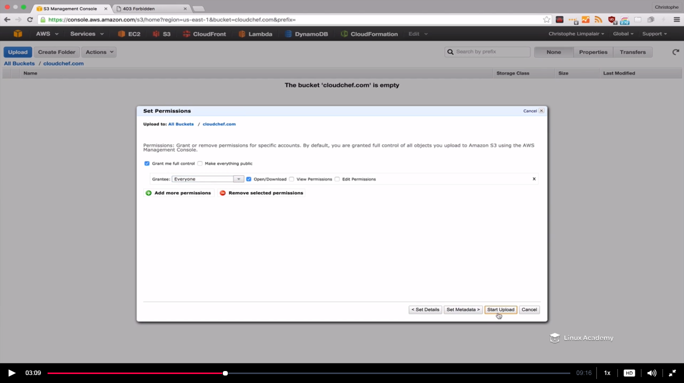

**Oncle uploaded go back to the browser and refresh it**

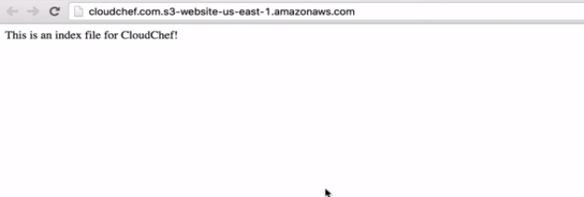

**What if I go to some other page lets say add something to the end of the same url used before then we would get the below error message.**

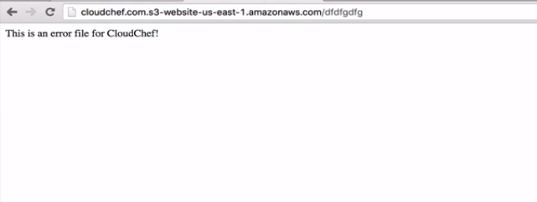

**IF I go to a file which exists let say welcome.html**

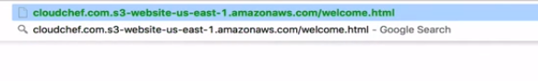

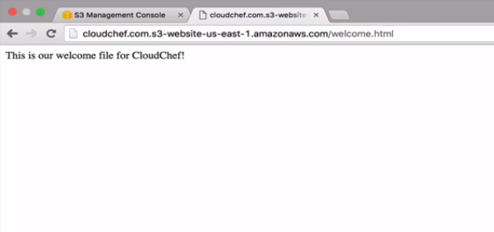

**So this works with the url that amazon gives us. But what about using the custom domain cloudchef.com.**

**Lets do that by using route53.**

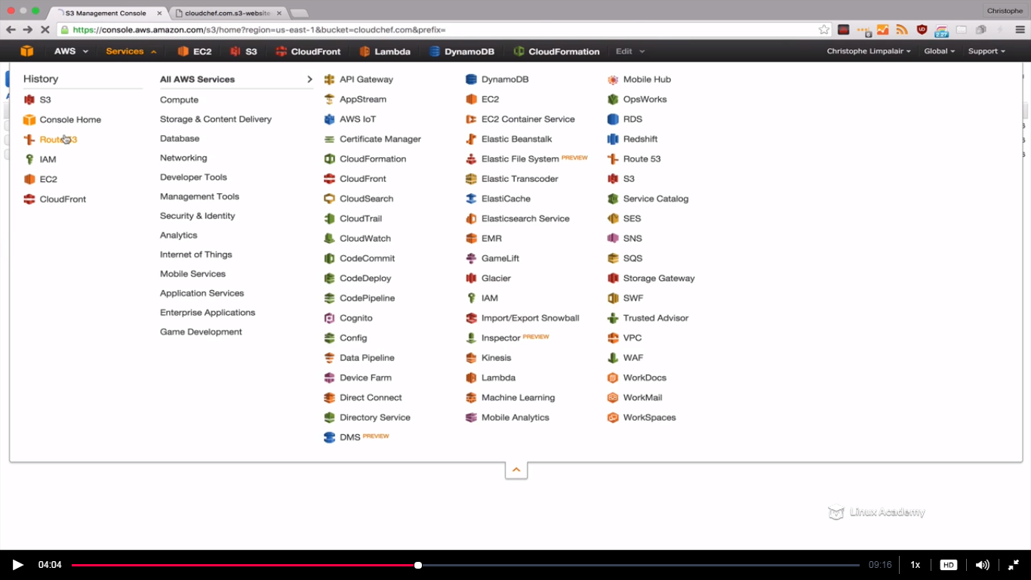

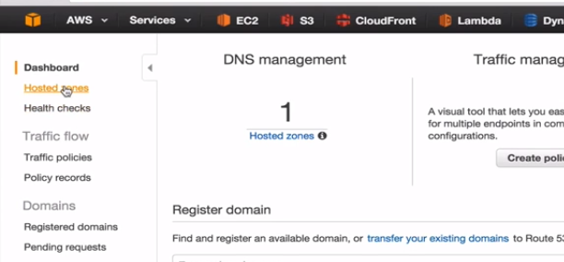

**First thing is that you need to have a domain setup pointed to route53. How you can do is by clicking on the create hosted zone as**

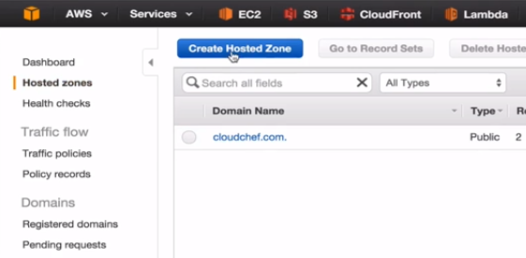

**Give the domain name for e.g we have given cloudchef.com and now just for demo im giving a**

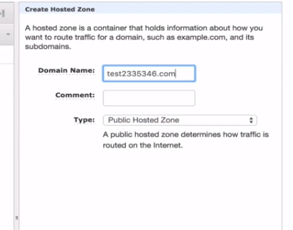

**Hit create below**

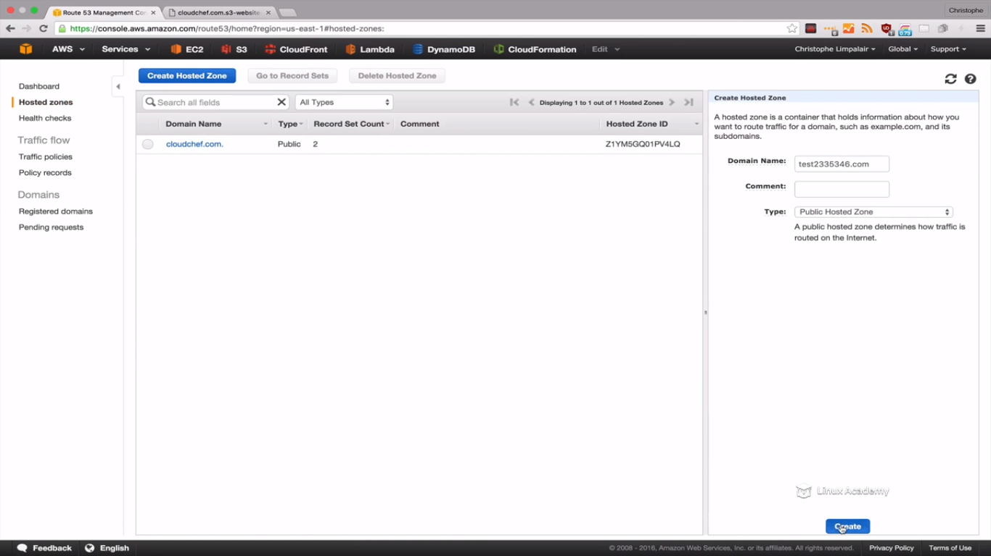

**Once you are done the AWS will give you the nameservers.**

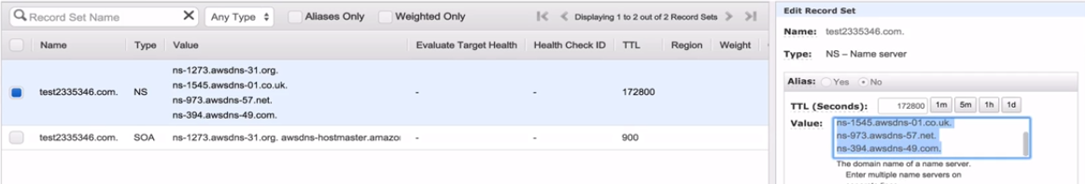

**You can copy these and paste to your domain registrar which is from where you have purchase your domain.(for example godaddy.com so paste it there in godaddy.com)**

**What it does is that it tells your registrar that whenever someone hits our domain name look at these name servers to see what it suppose to do with the request. And we can define in our recordsets here as what it should do.**

**So once you have your domain name created and pointing to route53 you can move ahead. So to go the hosted zone again and click the cloudchef.com**

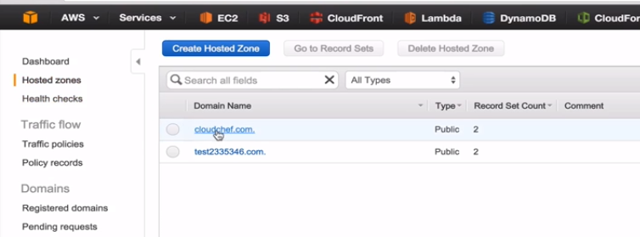

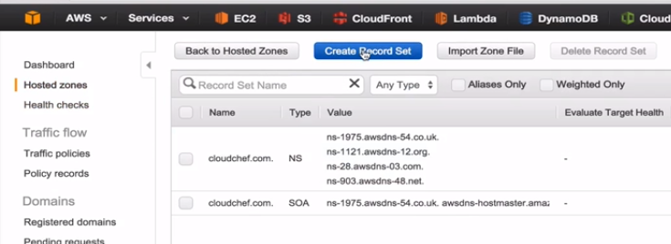

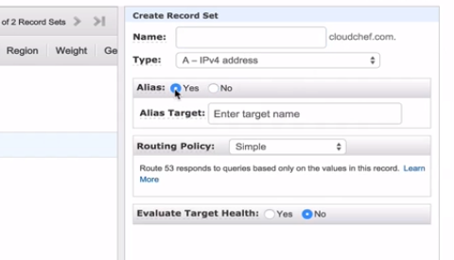

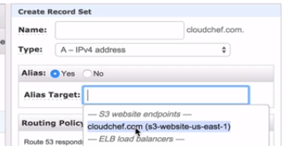

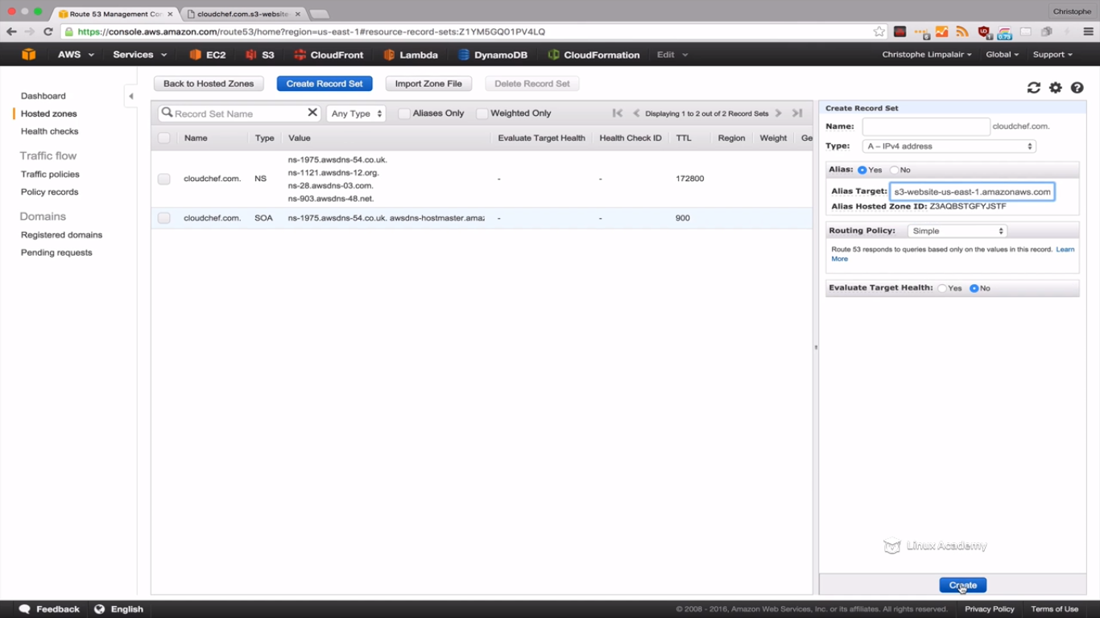

**We see that it added the record set to our hosted zone but we need to wait for it so that it can propagate.**

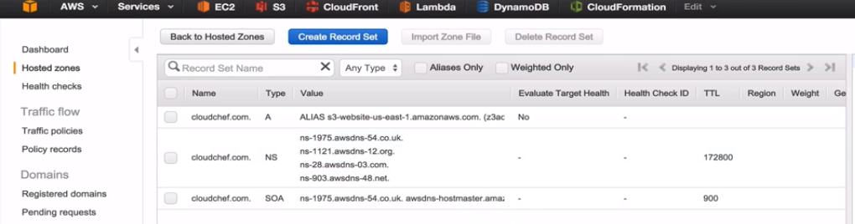

**While its propagating lets go back to S3**

**Though we have cloudchef.com what if customer type** [**www.cloudchef.com**](http://www.cloudchef.com) **, we would like to redirect the request to cloudchef.com.To create that lets create a second bucket.**

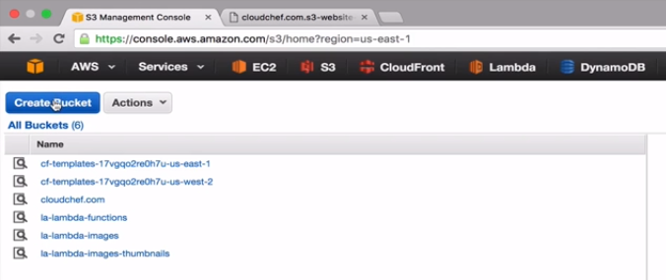

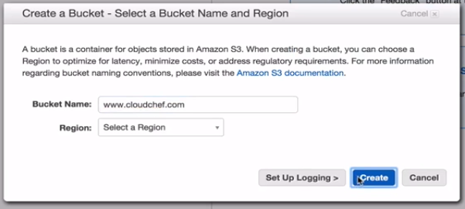

**Once create we don’t have to replicate each file from our cloudchef.com, instead we can set up a redirect rule.**

**Click**

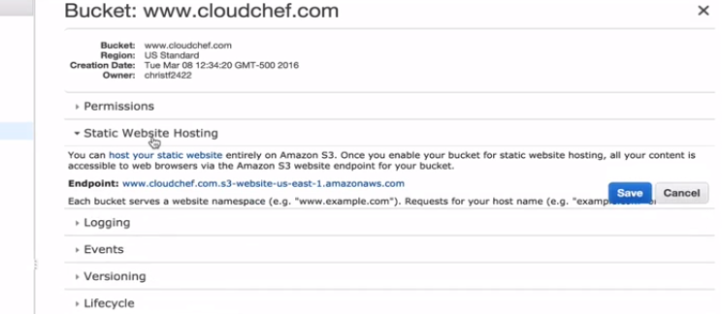

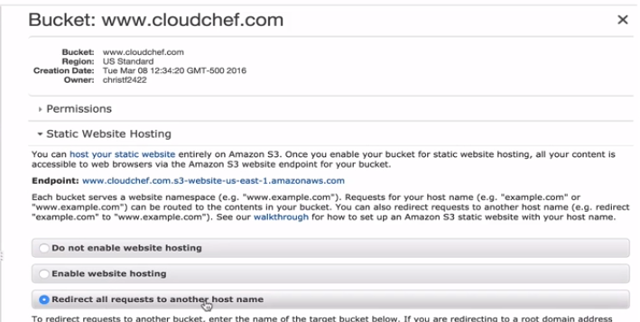

**We see it already pre-populates to cloudchef.com**

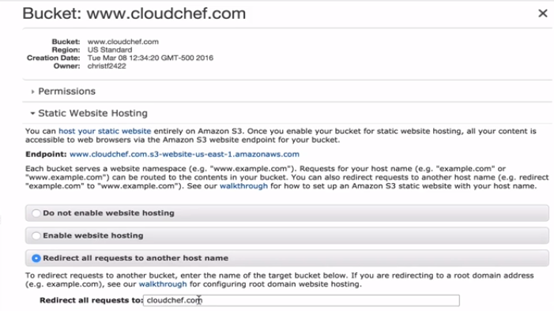

**Hit save**

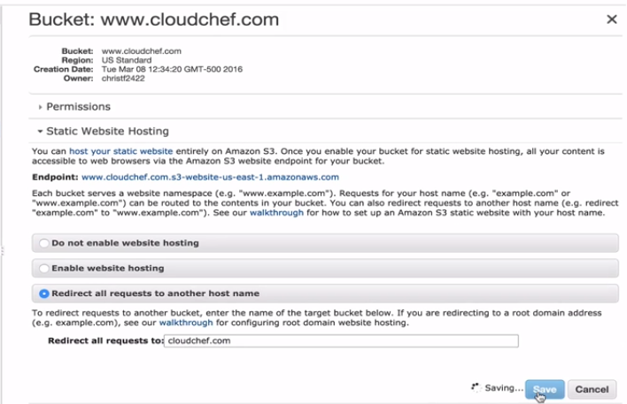

**Go back to route53**

**Click hosted zones**

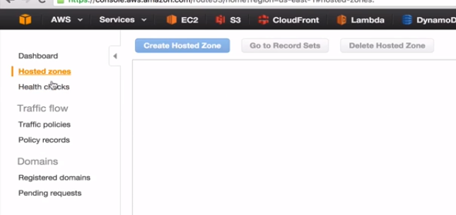

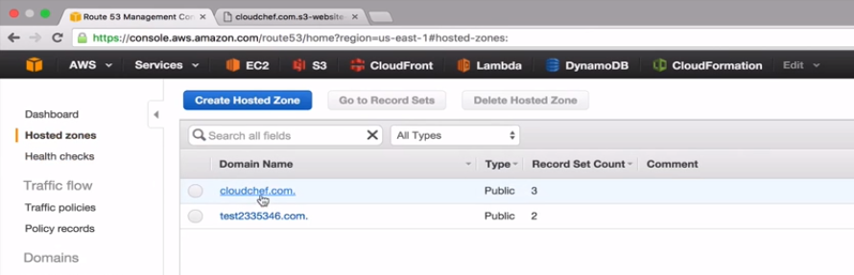

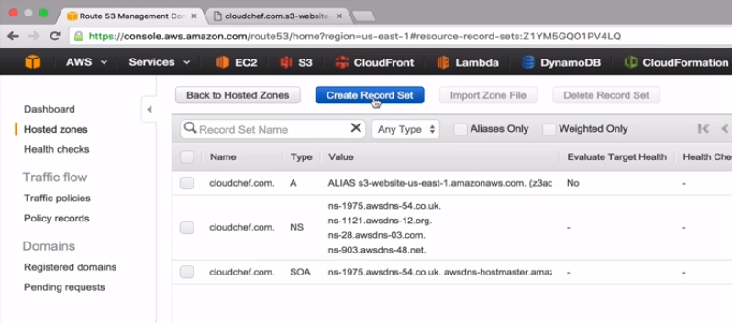

**In the name put a www as**

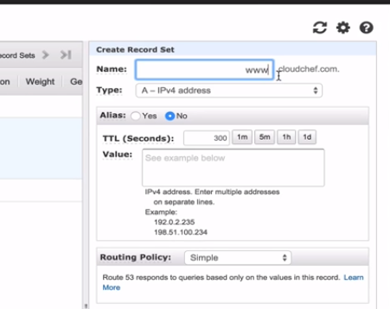

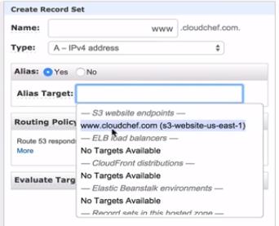

**Hit create below.**

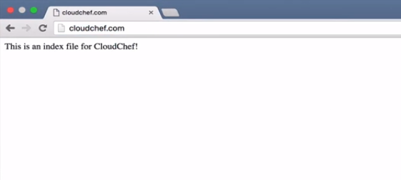

**IF get some another page try on another browser.**

**What if I go to** [**www.cloudchef.com**](http://www.cloudchef.com)

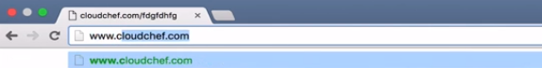

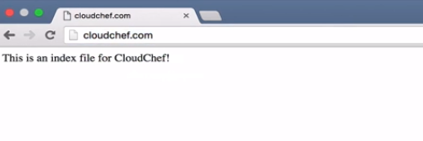

**It redirects to just cloudchef.com.**

**Lecture: Enabling CORS Configuration**

In this lesson we are going to learn how to enable CORS (Cross-Origin Resource Sharing) configuration. This will allow us to share resources from one bucket to another while using S3 buckets for website hosting.

**Lets say we have a website hosted in s3 and an object from a different bucket want to access a web page from a different bucket. This can be a bucket from a different amazon account . Lets say a resource in a domain called linuxacademy.com wants to access a page from the domain cloudchef.com. Our request would be blocked due to security region, however we can solve this with CORS.**

**The below is the new index.html file**

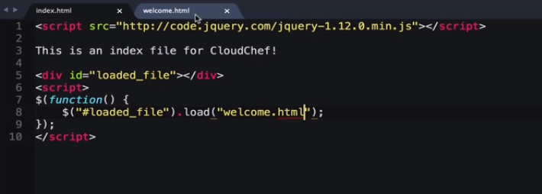

**Earlier we have this output on the browser.**

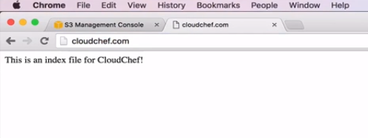

**Lets now upload the new version of index.html and see the changes.**

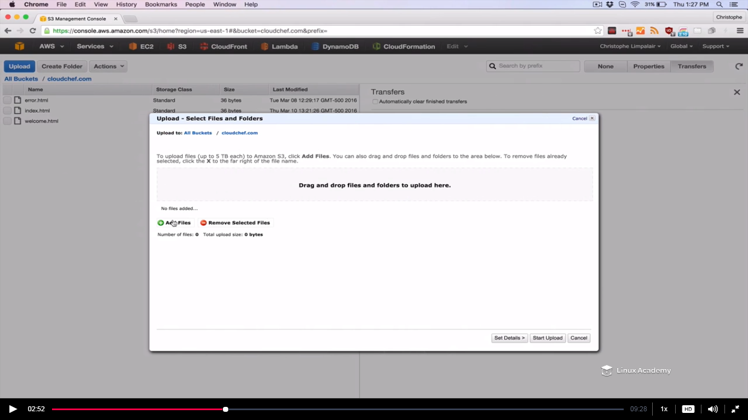

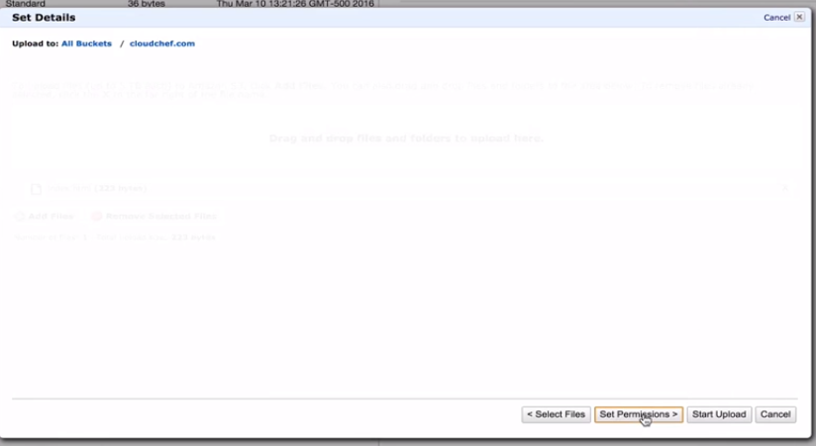

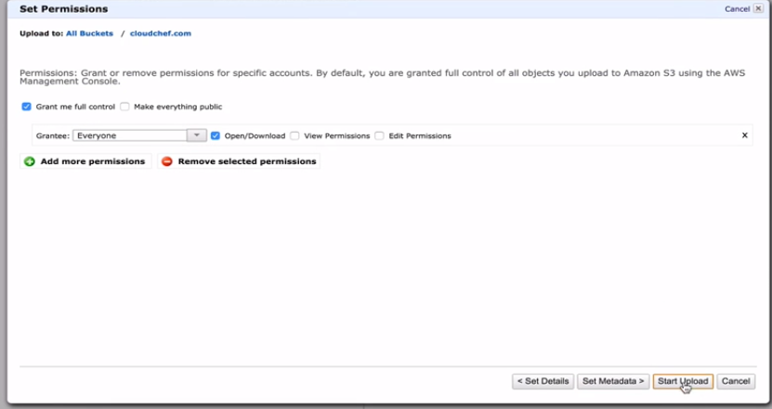

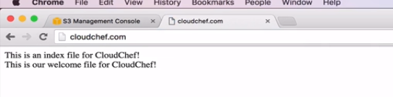

**Here my welcome.html whose content is being displayed on the browser is inside the same domain(bucket ). But if I go inside a completely different bucket which is on a different domain and upload welcome.html here as**

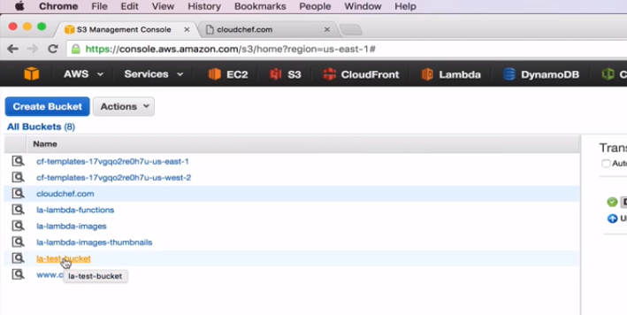

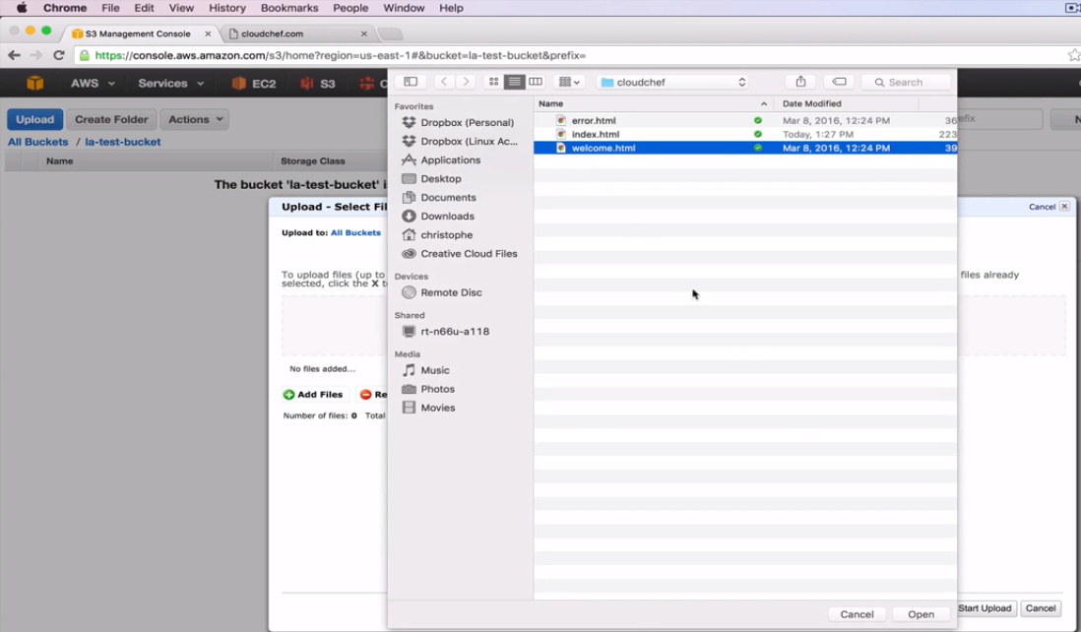

**Set permissions before upload as**

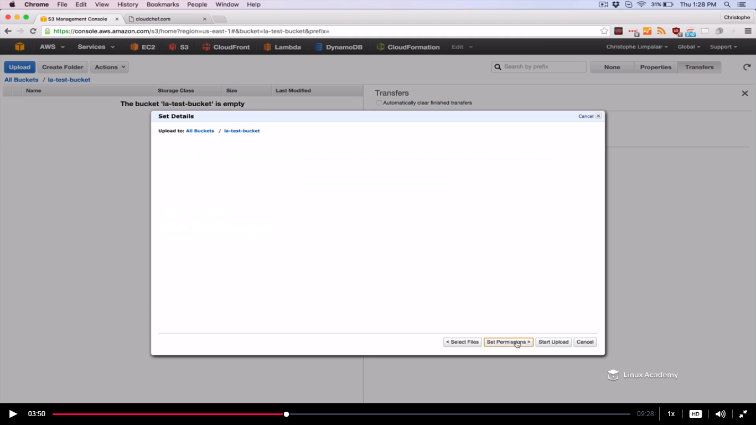

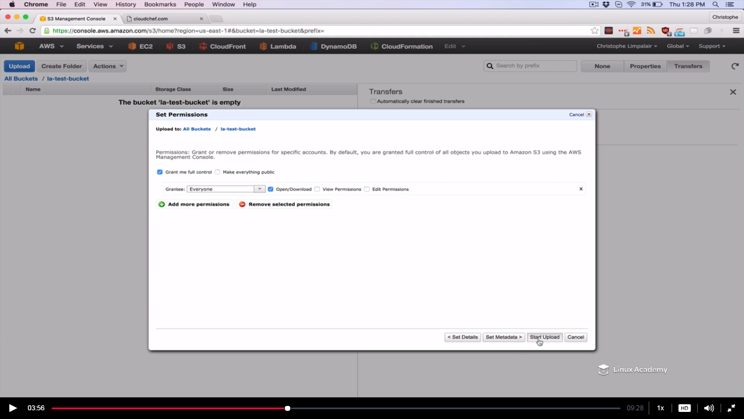

**After upload go to properties**

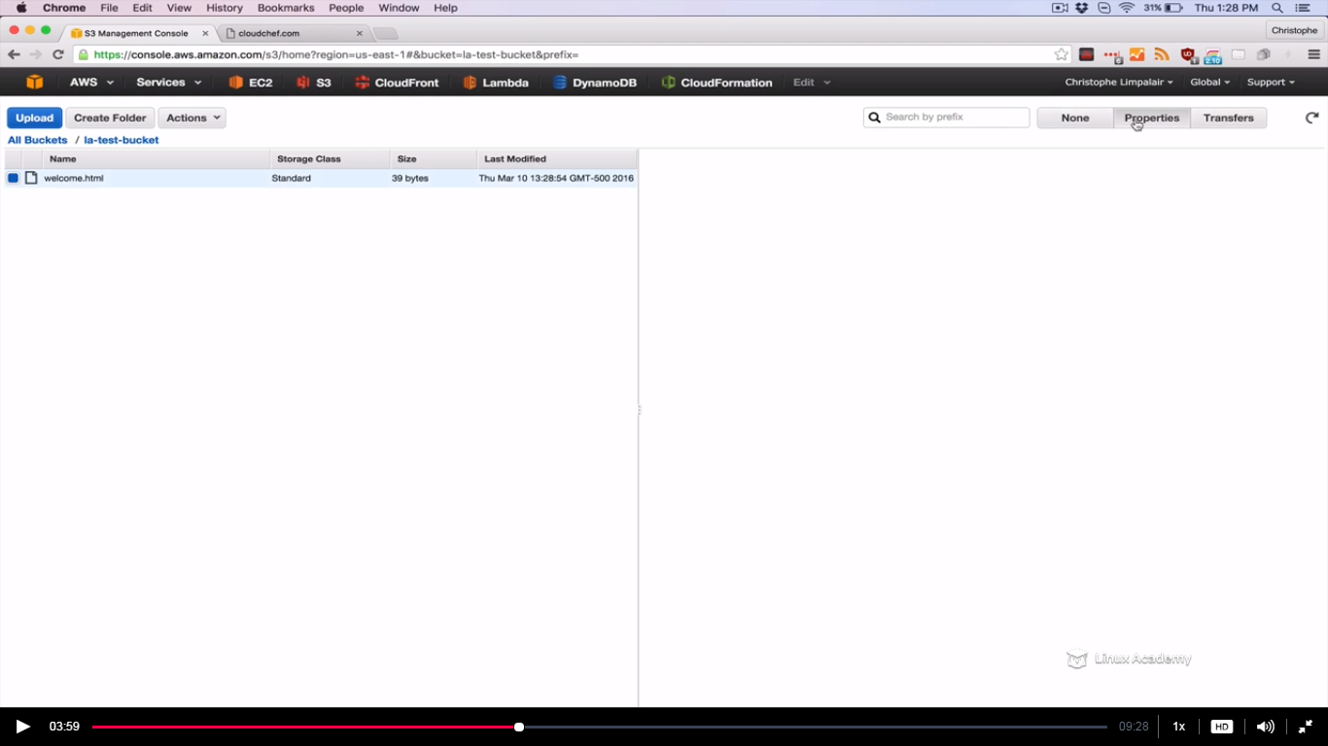

**Click on its url**

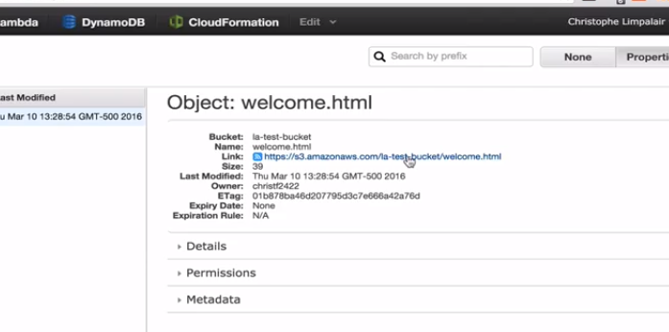

**It works we can access it.**

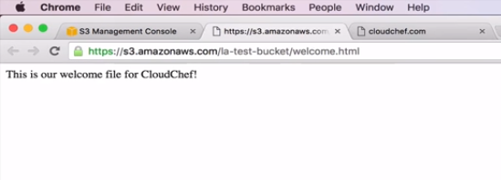

**Now what I’m going to do is try to load this url i.e**

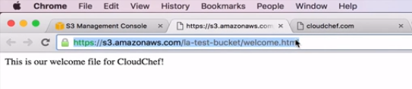

**From inside the index.html file**

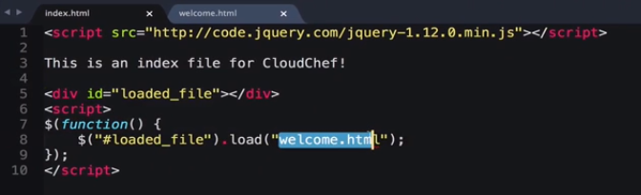

**Replace the welcome.html with the URL we copied**

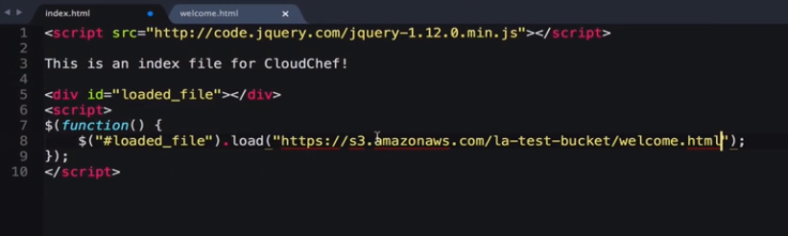

**Lets go again to our cloudchef.com bucket**

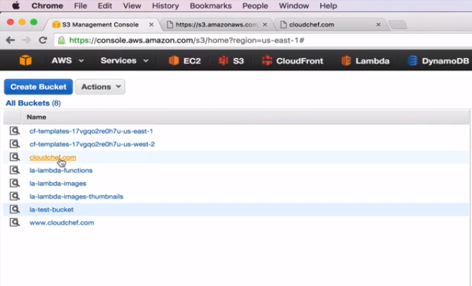

**And Im going to replace the index.html file with the file we just updated.**

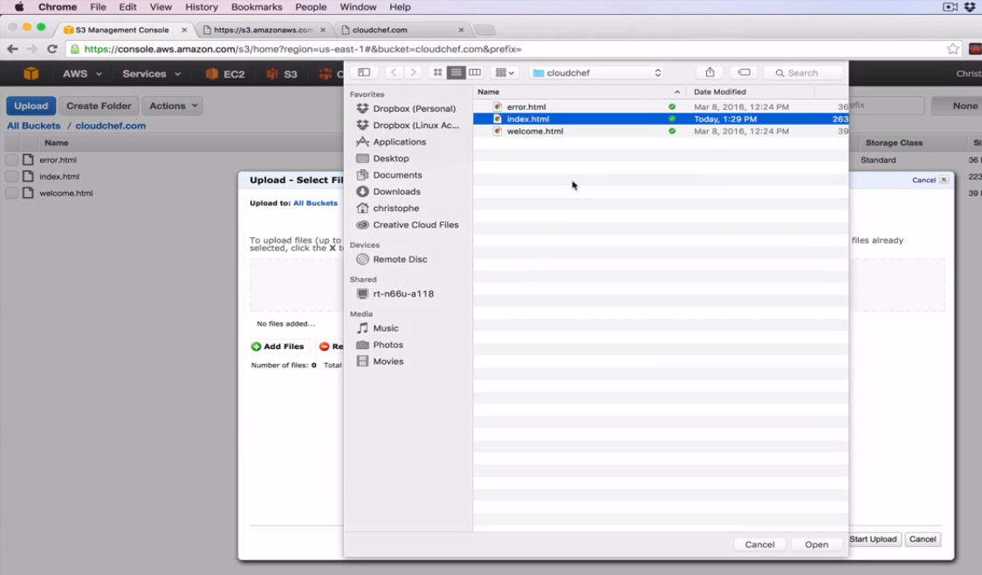

**Set the permission like earlier.**

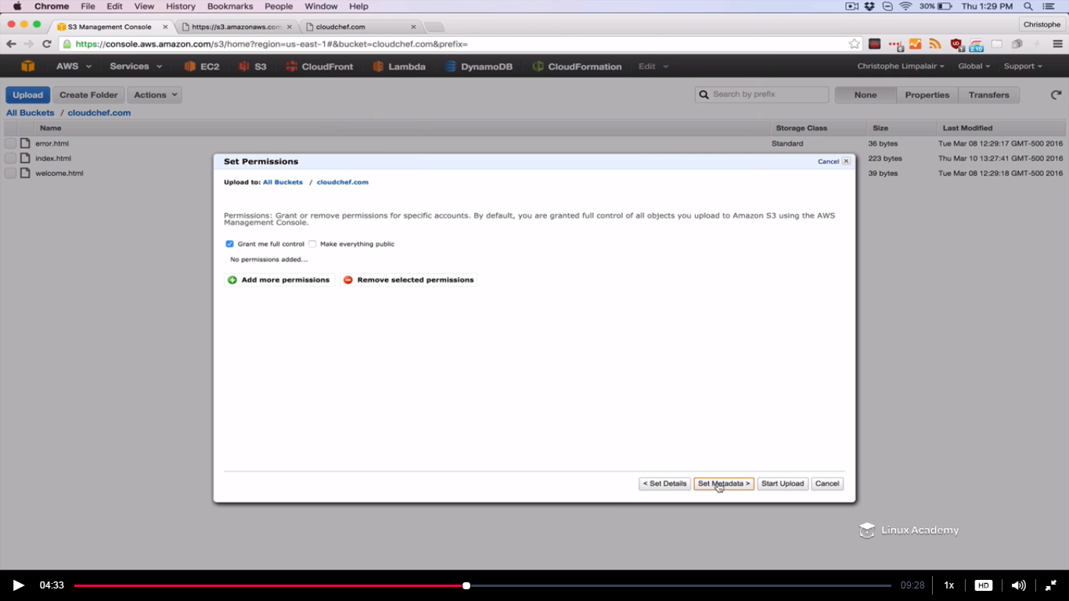

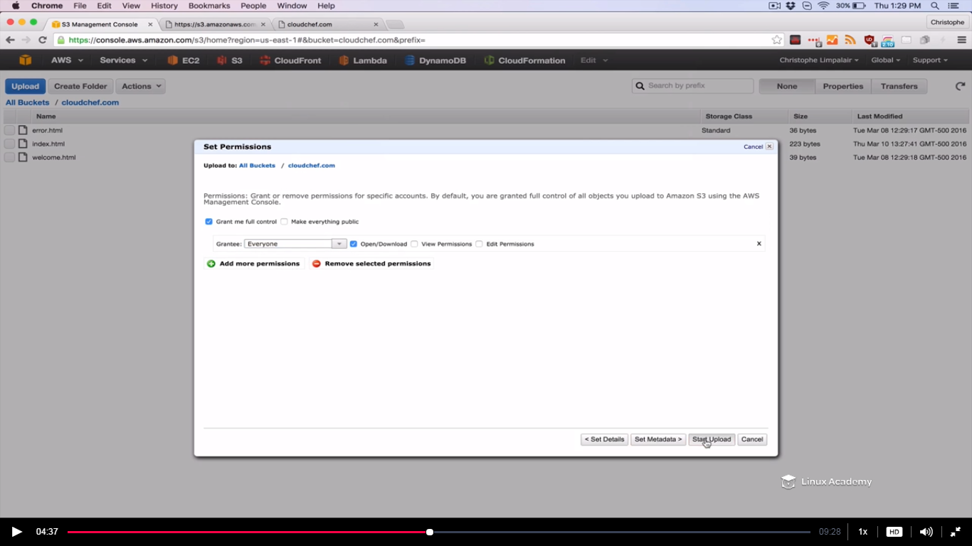

**Now if we go to the browser and refresh the page**

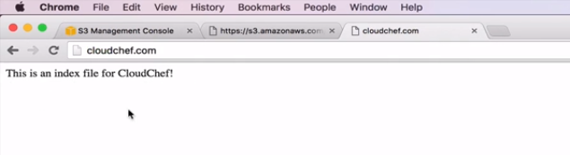

**We don’t get the contents of the welcome.html file because the bucket url that we pasted inside the index.html is of a different bucket.**

**Right click and inspect**

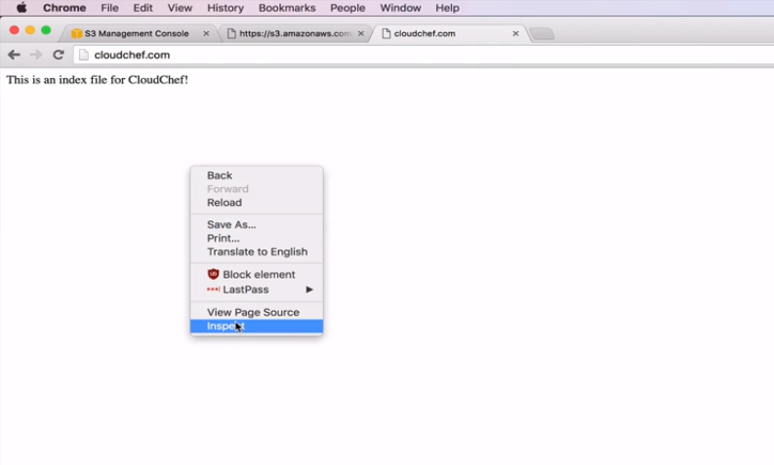

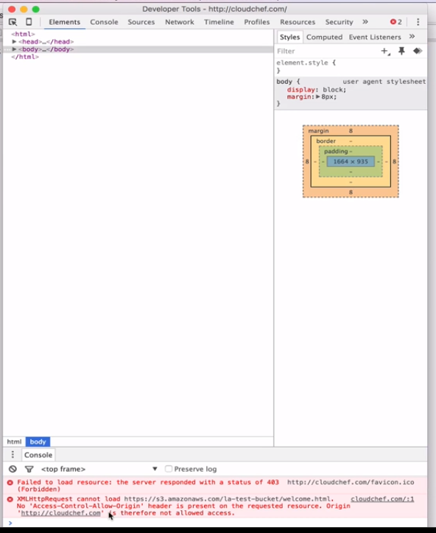

We get the error. We are not allowed to pull the resource for cloudchef.com. **This is where CORS come into play.**

**Get back to the bucket which we are accessing from the cloudchef.com . Right click and properties**

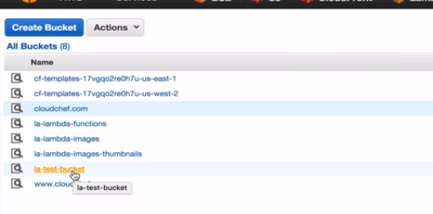

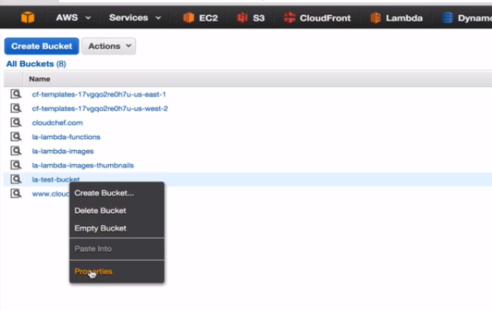

Go to permissons tab

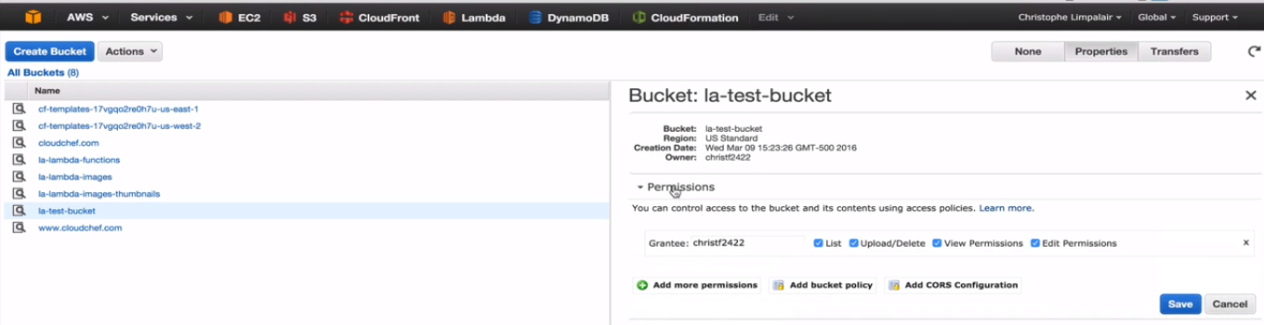

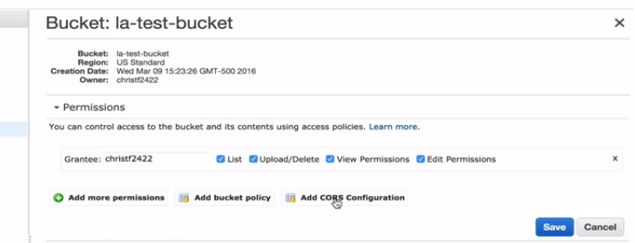

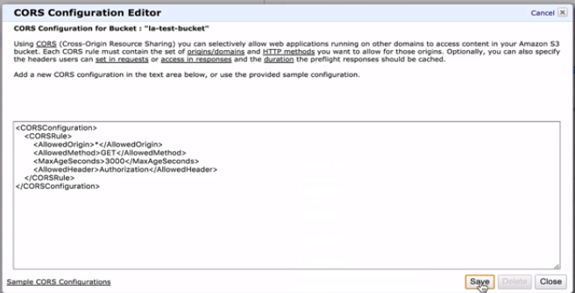

Any resource is allowed to access and the GET method is allowed from any domain request.First 2 lines says this.

But we want only two 2 urls to access this.So for now close it and go back to

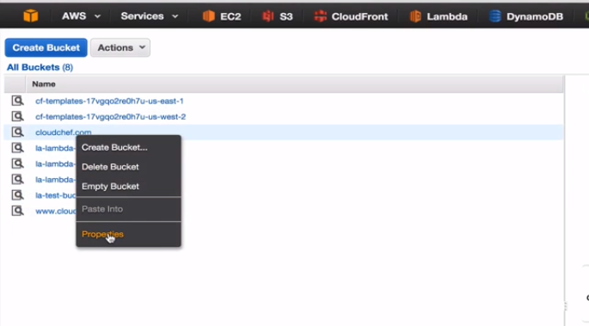

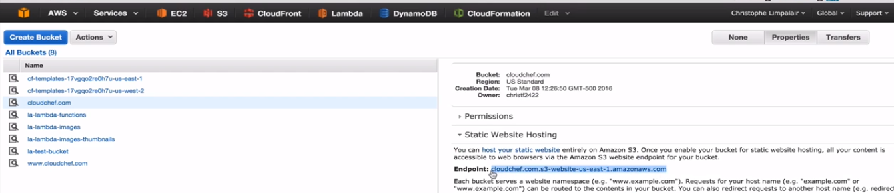

Copy the endpoint here.

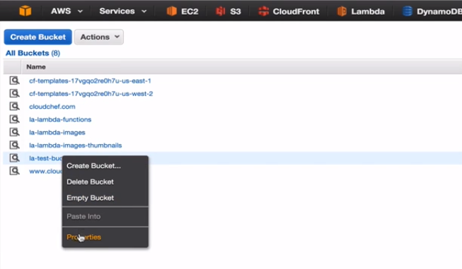

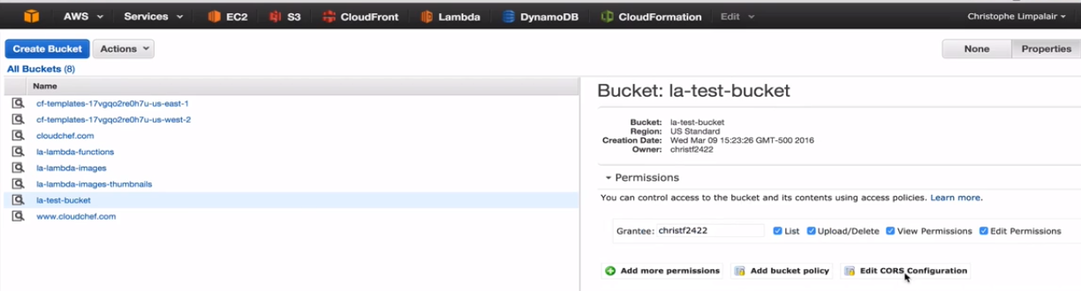

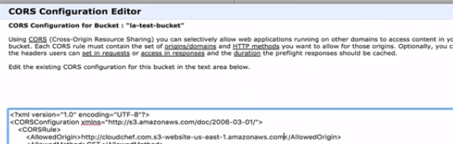

Replace the * in the Allowed origin with http:// followed by the url we just copied from the cloudchef.com bucket.

Then again copy the below

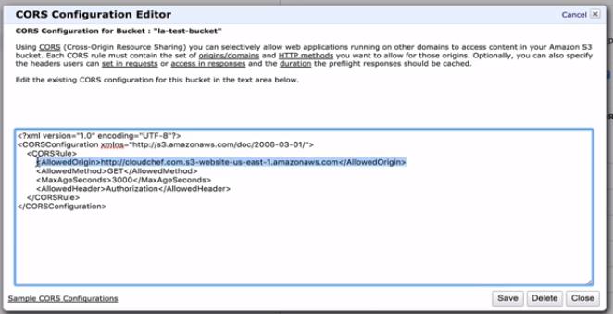

And paste it right below as

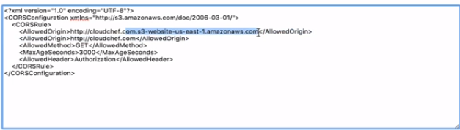

Just remove the url prefix contents and let it be just <http://cloudchef.com> in the second AllowedOrigin tag.

Go to cloudchef.com and refresh

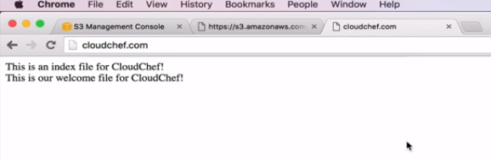

We now see we successfully able to access the welcome.html contents from a different bucket.

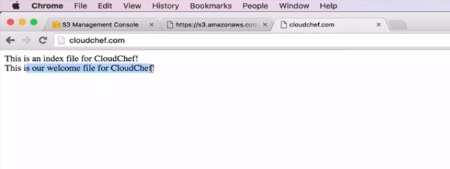

**Lecture: S3 IAM and Bucket Policies**

In this lesson we are going to learn concepts as they relate to S3 permissions with IAM, ACLs, and Bucket policies.

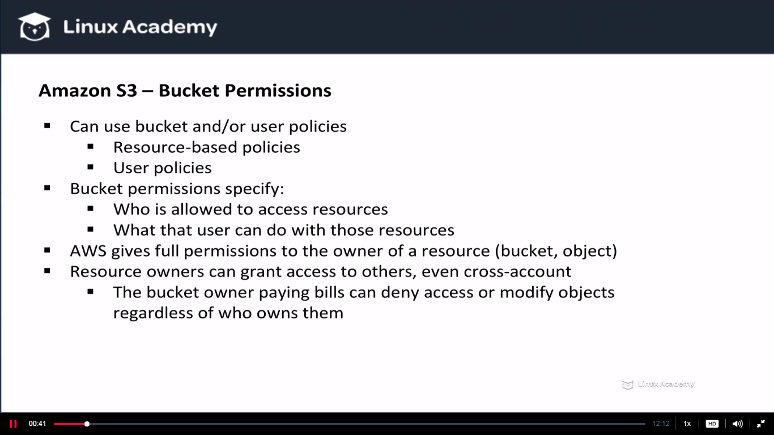

**We can have an IAM policy which applies to the user level and is referred to as a user policy and then we can have a bucket policy which applies more to the resource level and is referred to a resource based policy. Buckets owners can allow the other users even the cross-account users to access the bucket and to do things like uploading their objects inside that bucket. Cross-account users are bdw users from different accounts. Now when another user upload objects bydefault they own that object and again bydefault object may be private so that only the person who created it can access it. There are even exceptions to that.**

**If you create an IAM user in your Amazon Web services account that AWS account is the parent owner. If the IAM user uploads an object the parent account owns the object. Now if you grant access to a cross-account the account that upload the objects owns the object. The buckets owner doesn’t have the permissions on the object that other accounts own. Again there are a few exceptions. Whoever that pays the bucket bills can deny access to any objects or even delete any objects in the bucket they are paying for regardless of who owns them. Also the bucket owner can archive any objects or restored archive objects regardless of who owns them.**

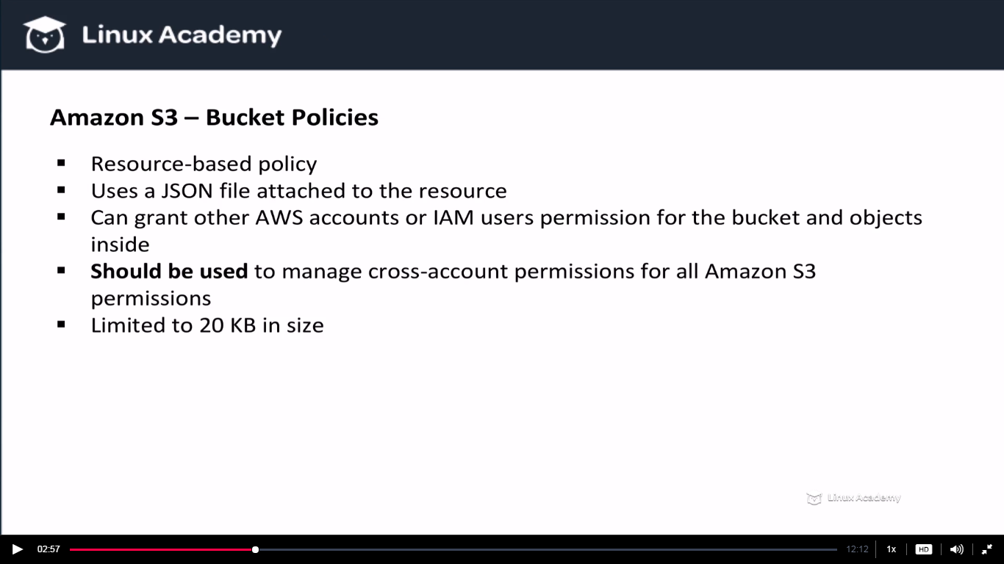

**We will see in a moment we can use ACL , the only time we must use bucket policies is when we want to grant cross account permissions for all amazon s3 permissions. ACL’s don’t have access to all s3 permissions. For e.g ACL can’t grant permissions on a bucket sub resource. Sub resources are things like life-cycles and static website configurations. One restriction to keep in mind with bucket policies is that they are limited to 20KB in size.**

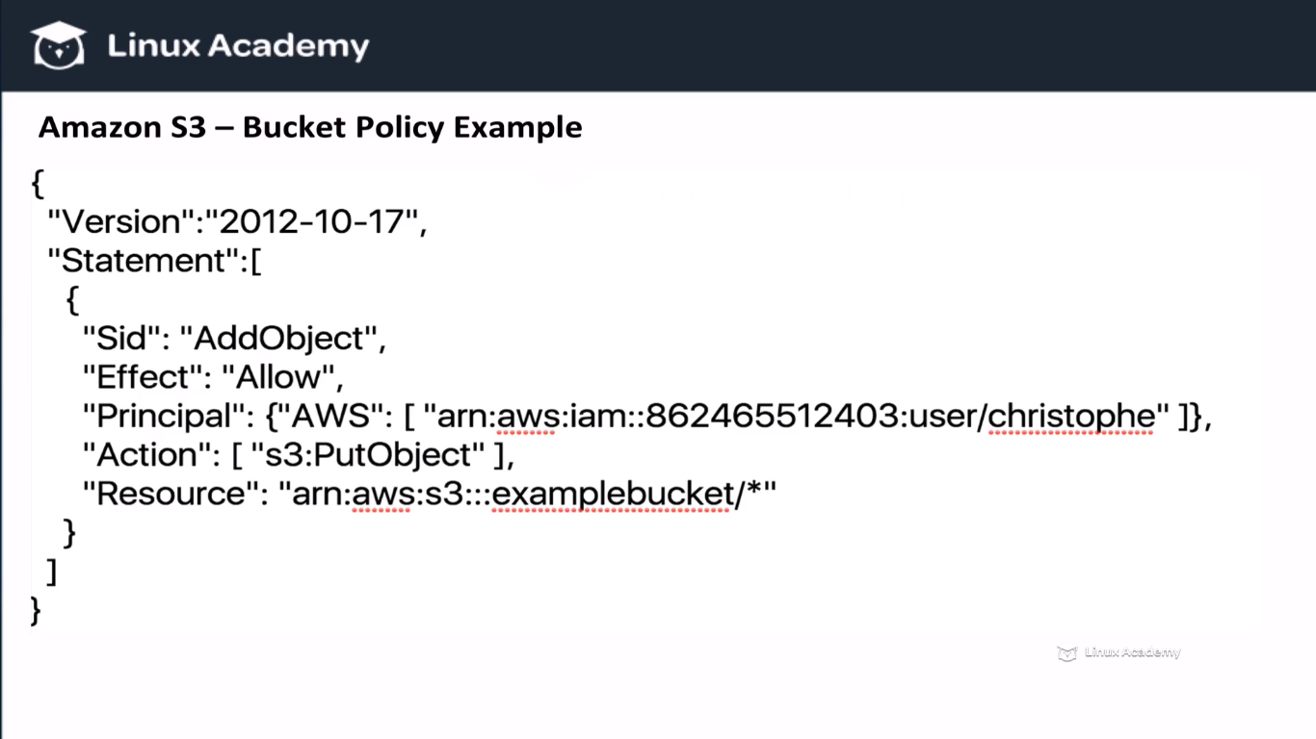

**Here the effect is allow and the principal is the Christophe user. The whole principal line is the ARN of the user Christophe. Action is PutObject and the resource is the s3 bucket which is examplebucket. The * after the bucket names says all the objects inside the bucket.**

**Lets look another example**

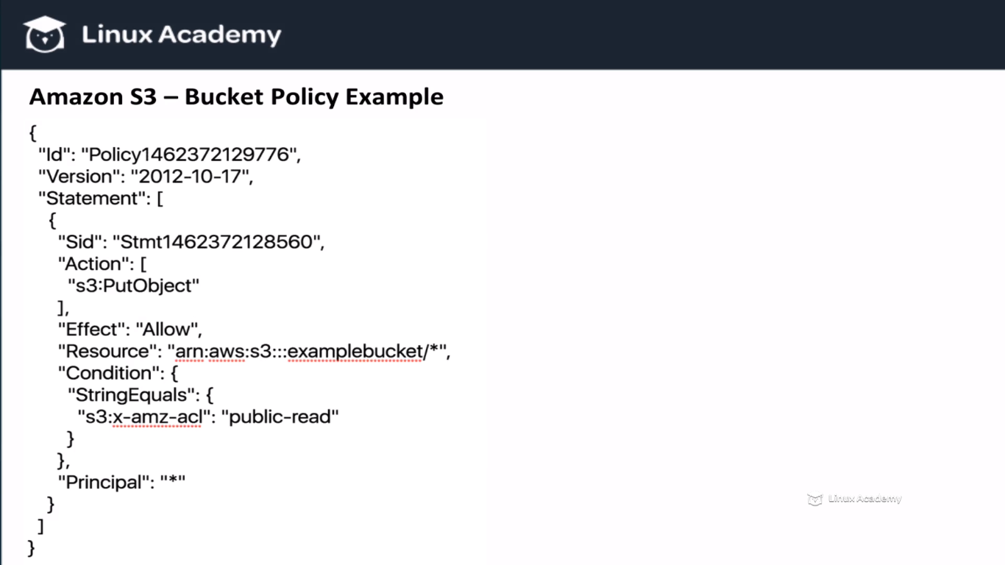

**Here in this we have added a condition. So what we are saying here is any user(as we haven’t specified any user in the principal) that tries to put an object in the example bucket must make the ACL policy public read which means the public can read this object. So keep in mind we can put condition in our bucket policies.**

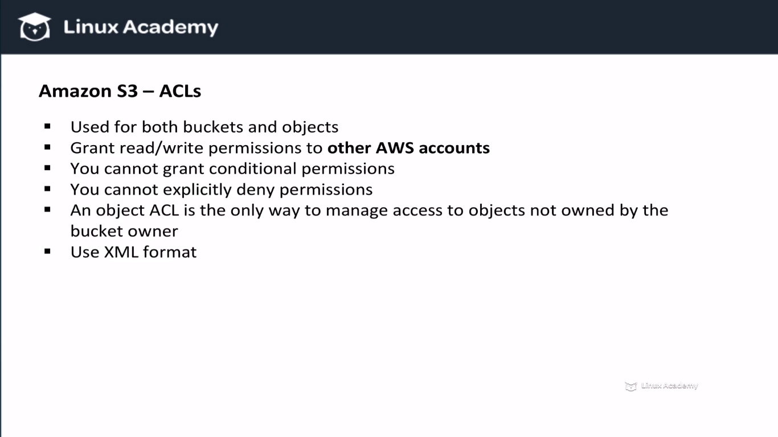

**ACL-**Stands for Access Control Lists. **They can be used to manage bucket policies and objects policies. ACL are a bit more restrictive than bucket policies. For e.g they can’t grant conditional permissions, and they can’t explicitly deny permissions. They do are of certain advantages. The advantage is lets Imagine you gave a cross account access to upload objects to your bucket so that means that the cross account has access to the objects bydefault. The bucket owner doesn’t own the object. Sure the bucket owner pays the bills, they can still delete the objects or write a policy to deny access to the object but they can’t do anything else with the object unless the cross account explicitly grant permission with object ACL policies. So there ACL policies come in.**

**You can also set a bucket ACL policy. The only recommended usercase for that though is to write access log objects to a bucket. So with bucket ACL you can grant write permissions. Another interesting fact about ACL is that they do not use JSON, they are XML based instead.**

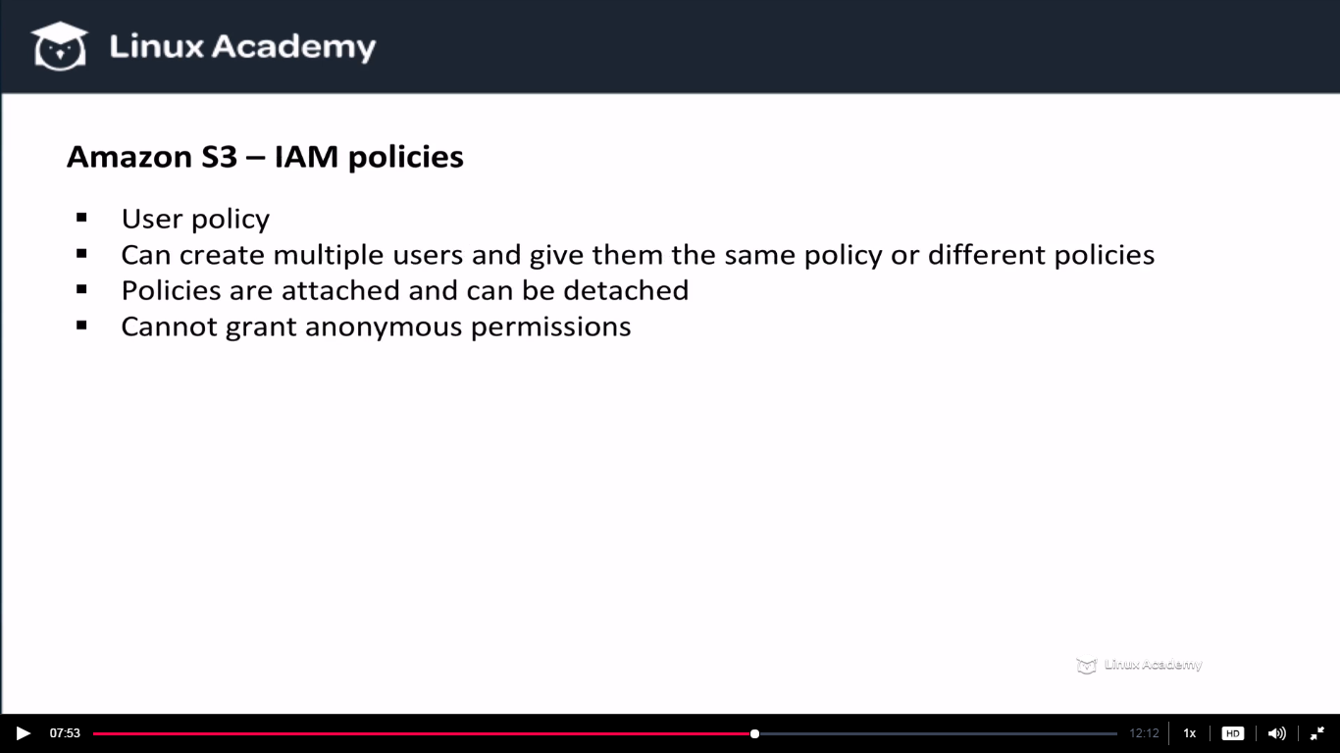

**IAM policies falls under the user policies while earlier in bucket and ACL we were talking with respect to the resource level policies. Now we are looking at the user level policies because we can grant policies that have specific permissions to users. Bucket policies and user policies infact can often times be used interchangeably. With IAM policies you can create multiple users and assign them the same policies or even different policies.**

**Keep in mind that with IAM users the AWS account that creates the users is the parent account and it has control over objects. Since IAM policies are attached to users they can’t be used to grant access to anonymous users.**

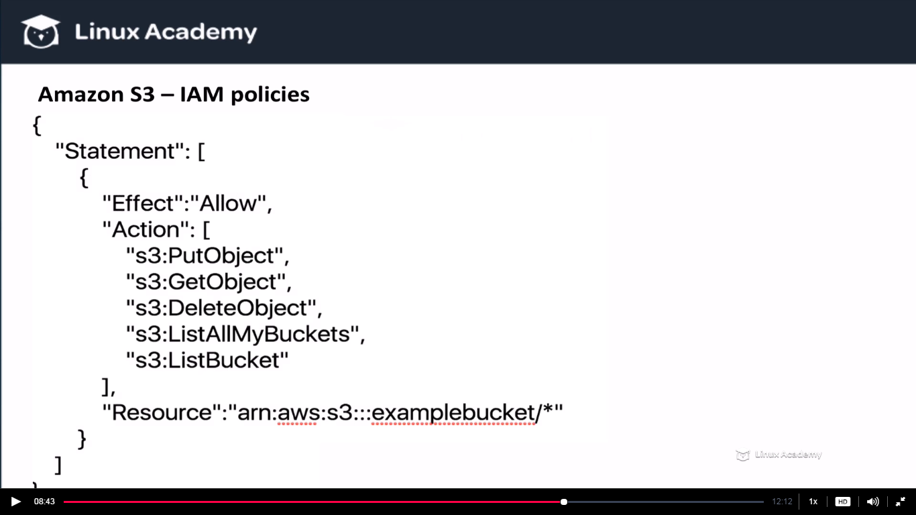

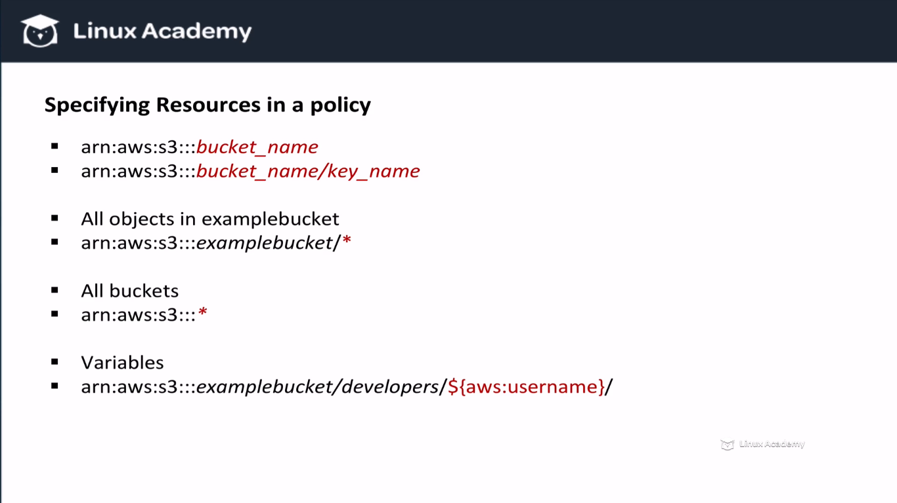

**Lecture: S3 IAM and Bucket Policy Example**

In this lesson we are going to walk through creating basic IAM and Bucket Policies together on S3 buckets.

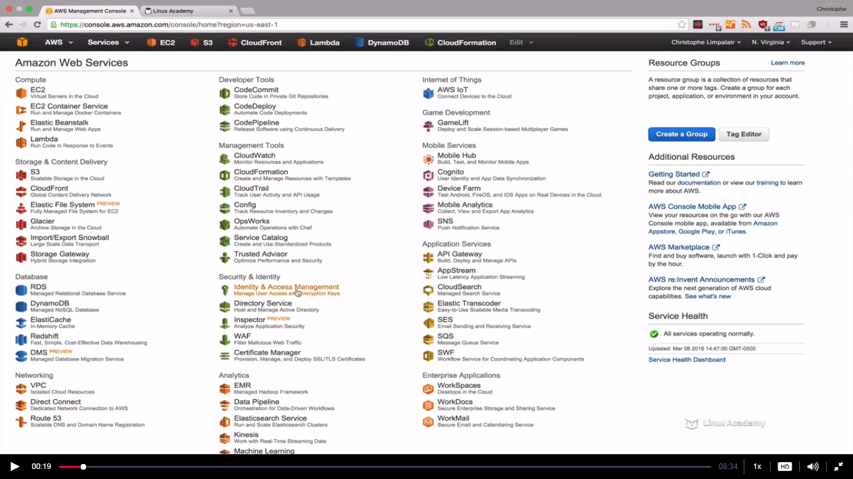

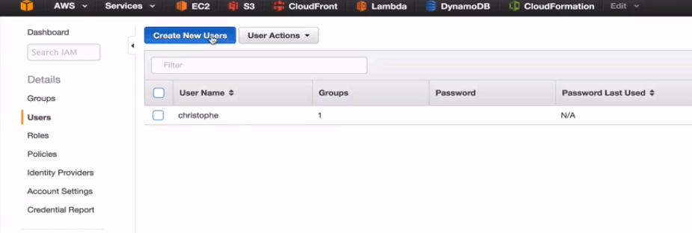

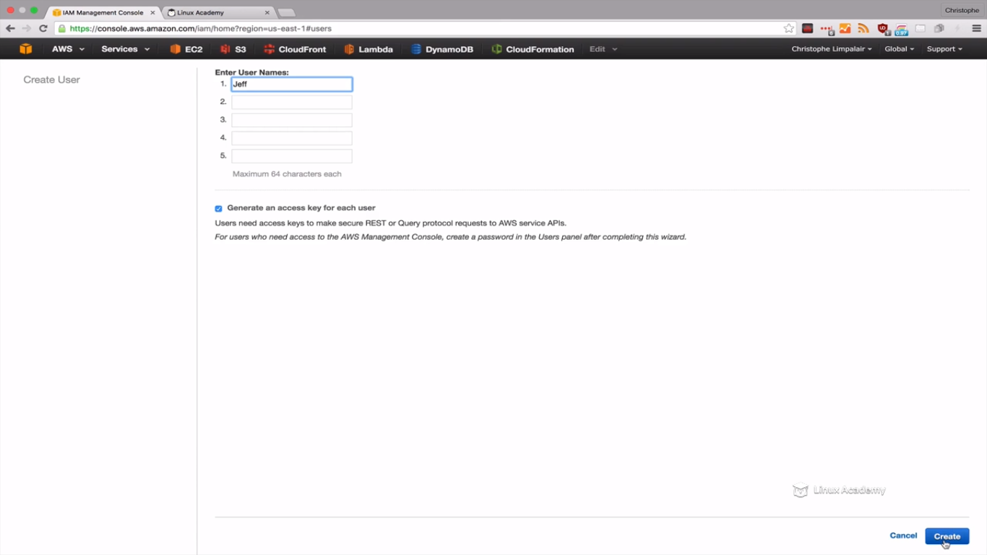

Download the credentials.

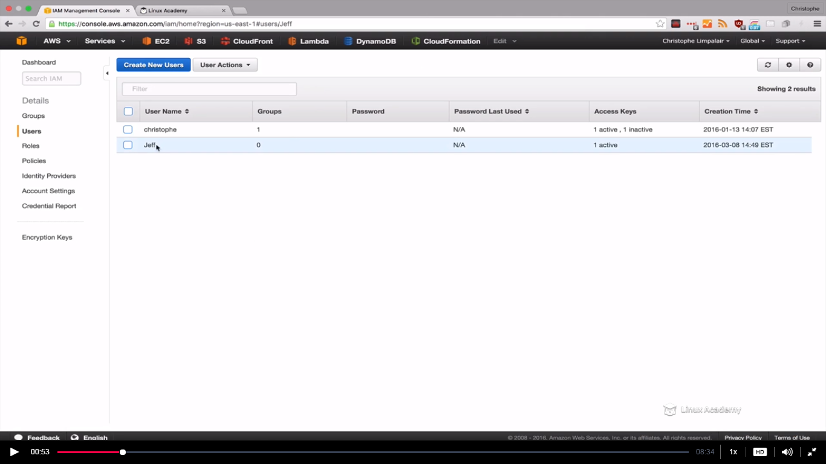

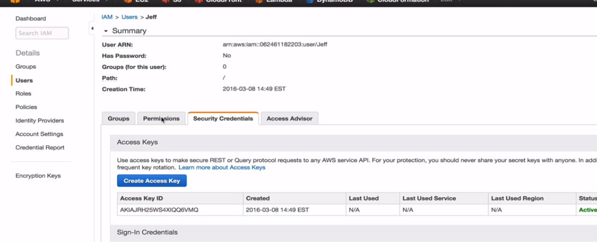

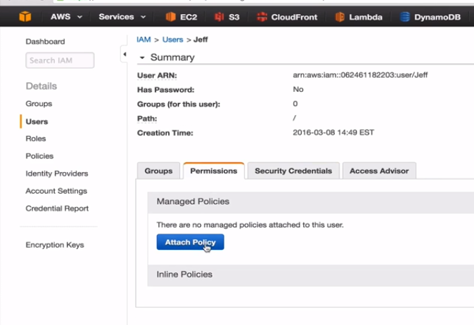

We need to create a custom policy for this user jeff so just cancel out of here

So go to policies and create custom policies.

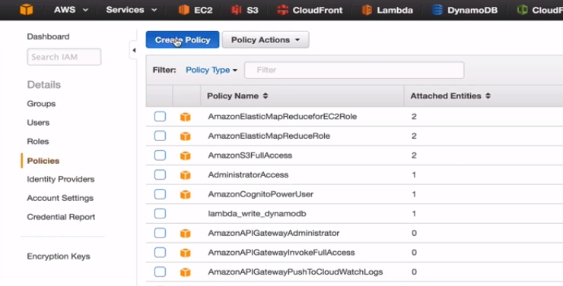

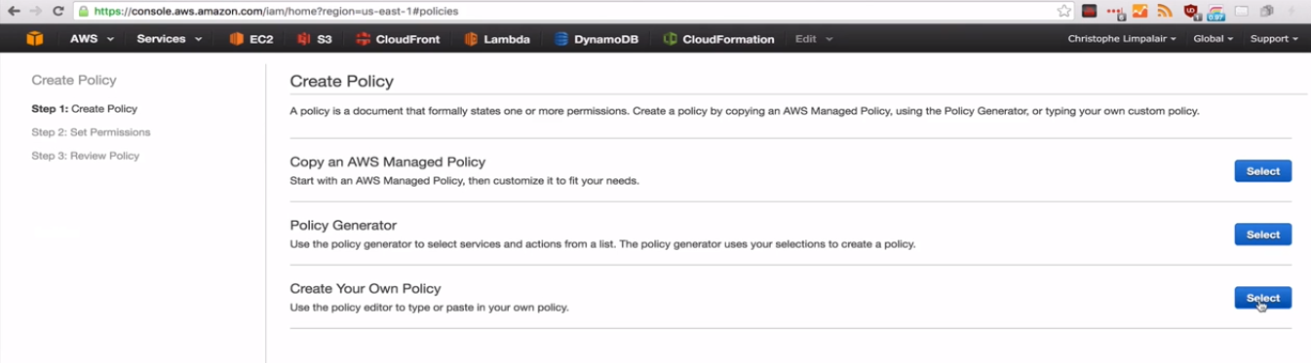

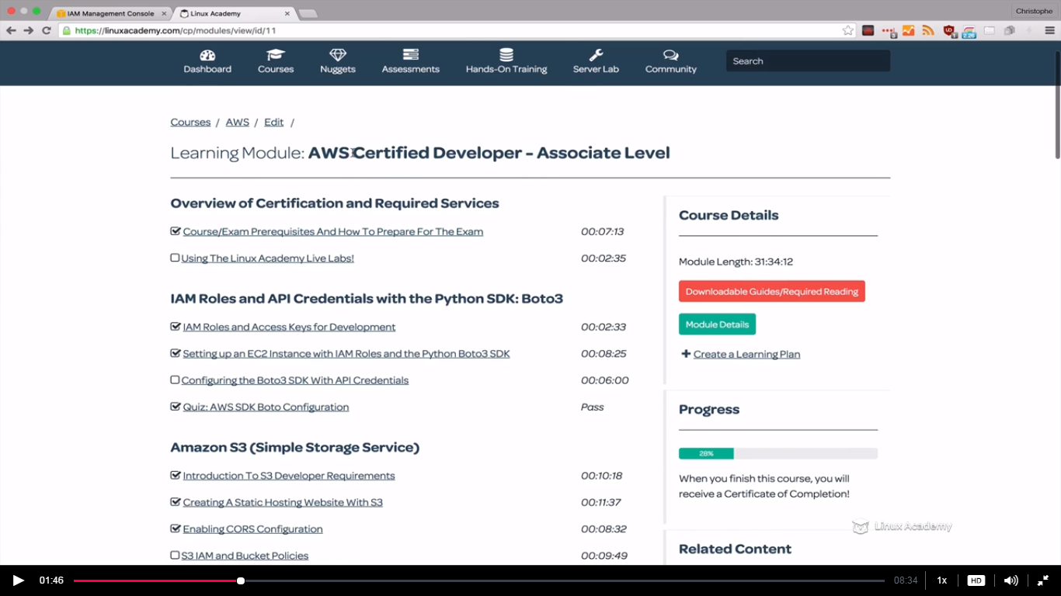

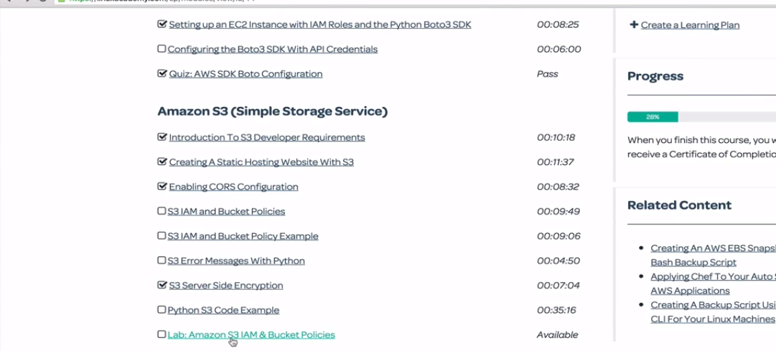

We will copy the policy from here

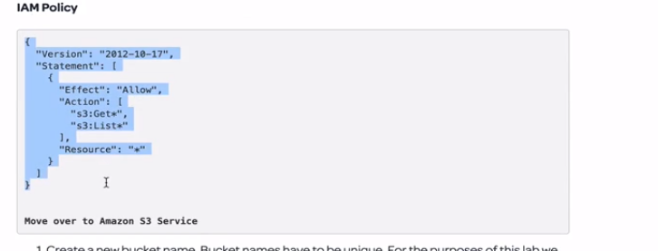

Copy this and paste it in the AWS s3 custom policy which we are generating.

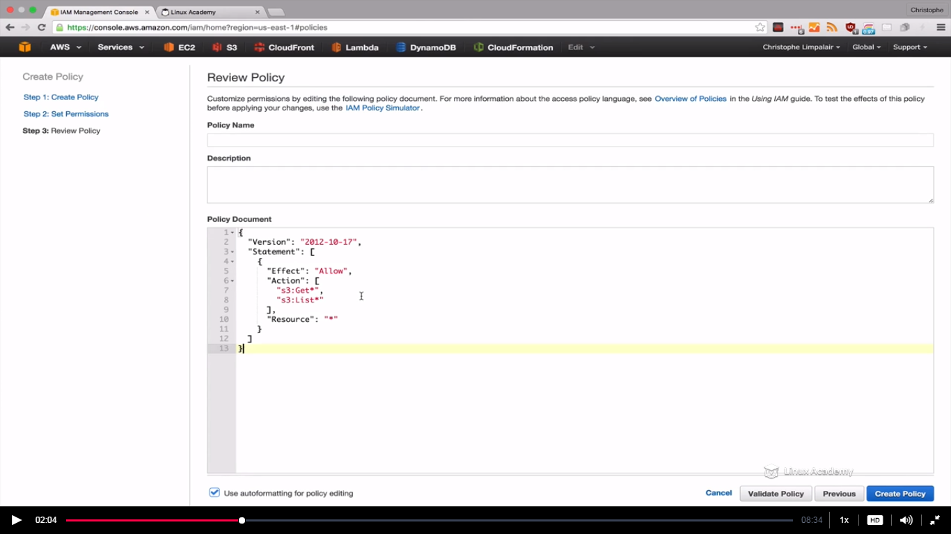

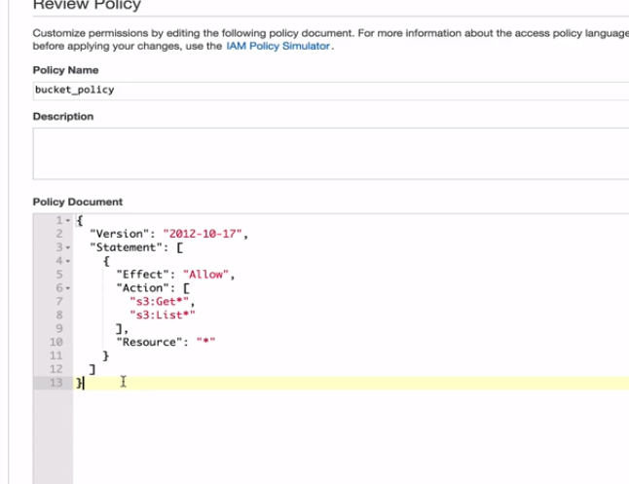

All the users whom have this policy can get and list all the objects in all of our s3 resources. Its always a good idea to validate our policies before attaching.

So validate the policy and then attach to the user jeff.

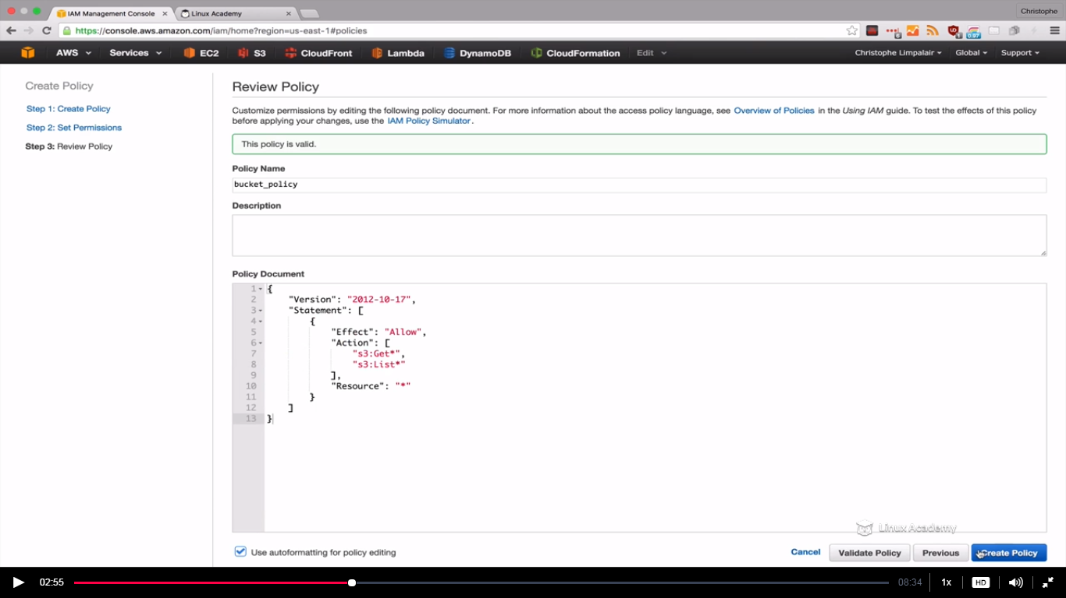

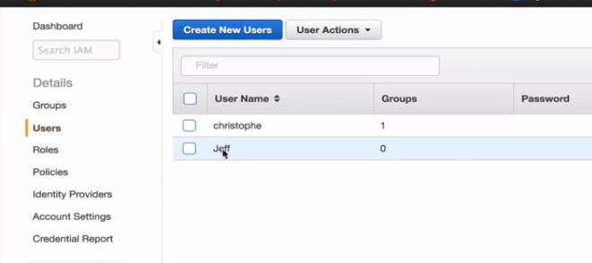

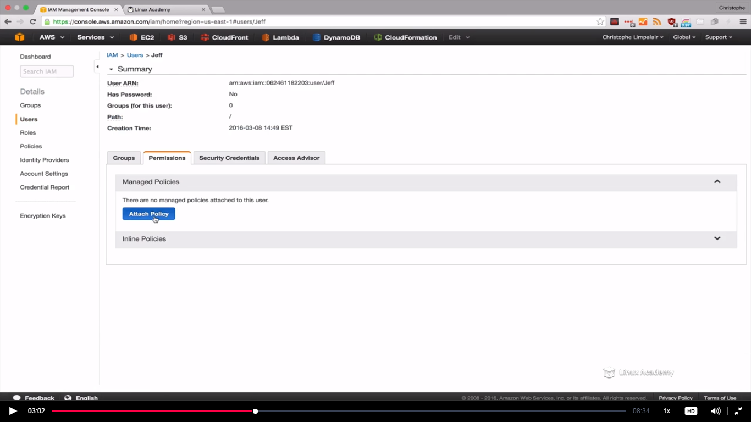

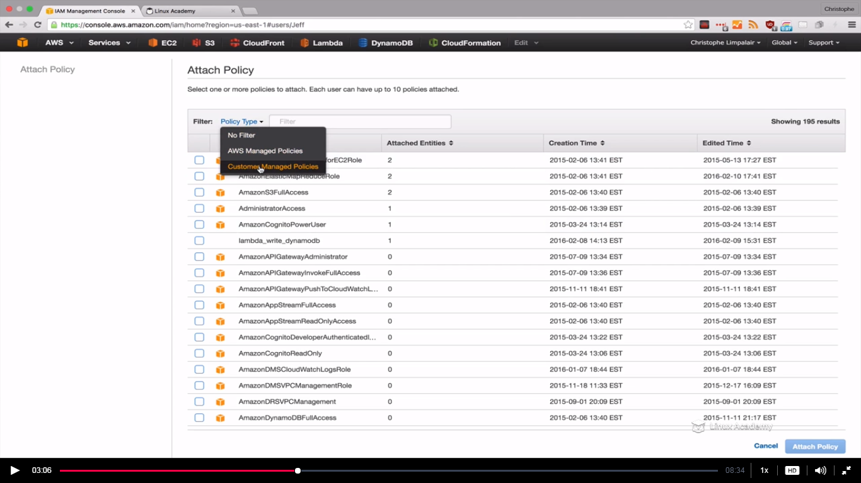

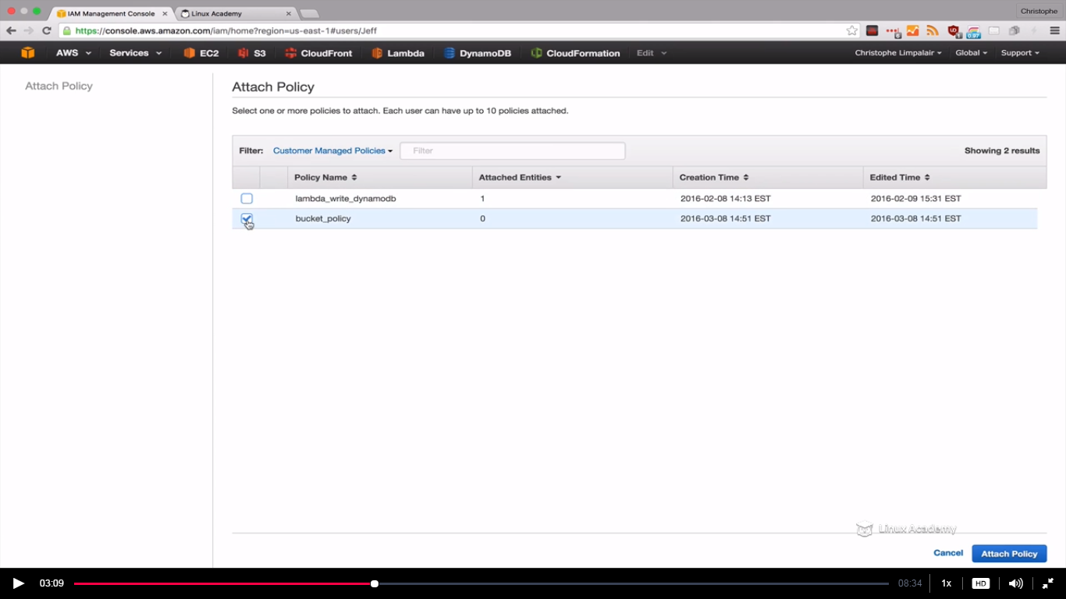

Select the policy we created and attch policy.

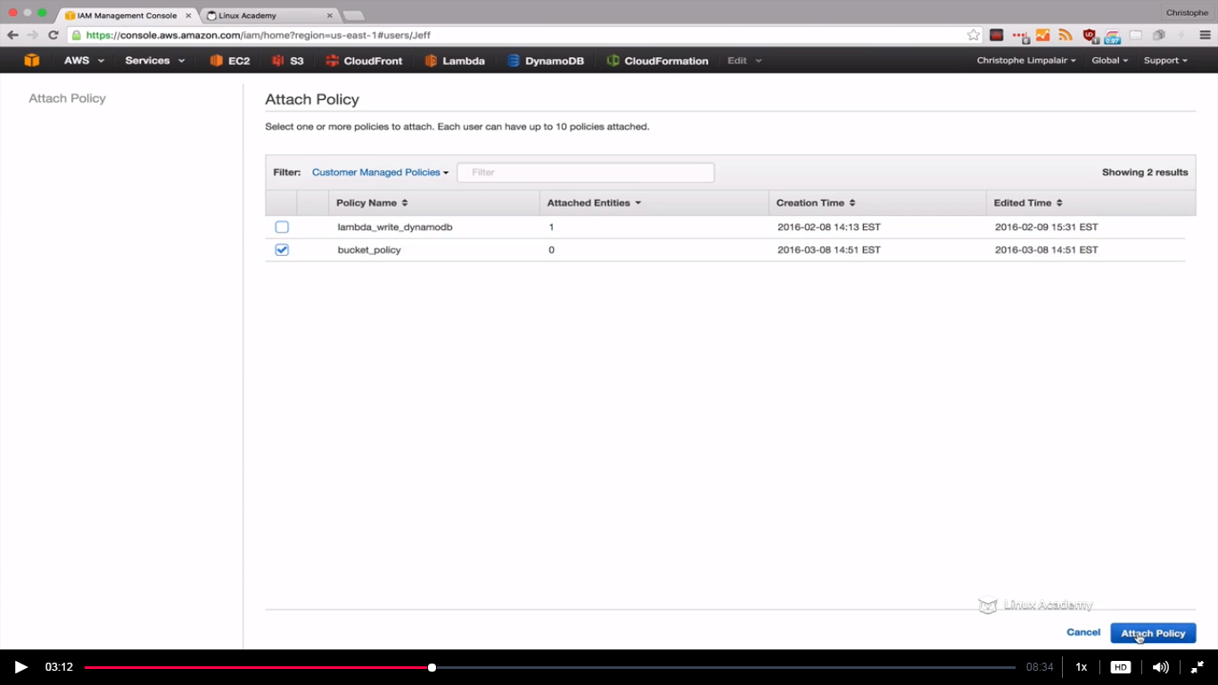

Now since jeff has a policy we need to give jeff sign in credential so that we can login as his account.

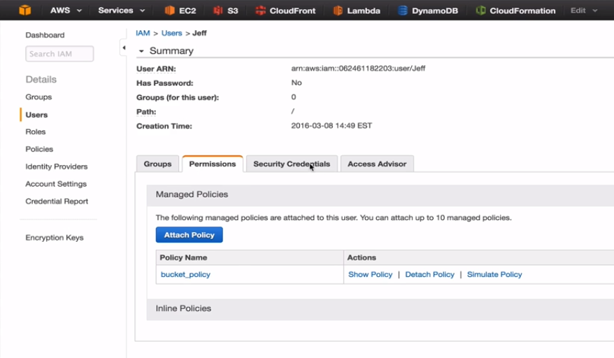

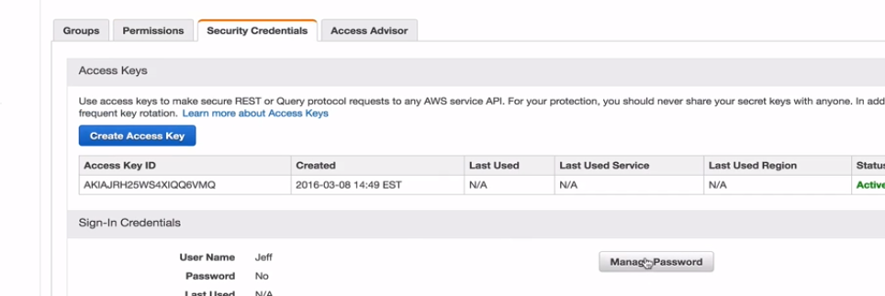

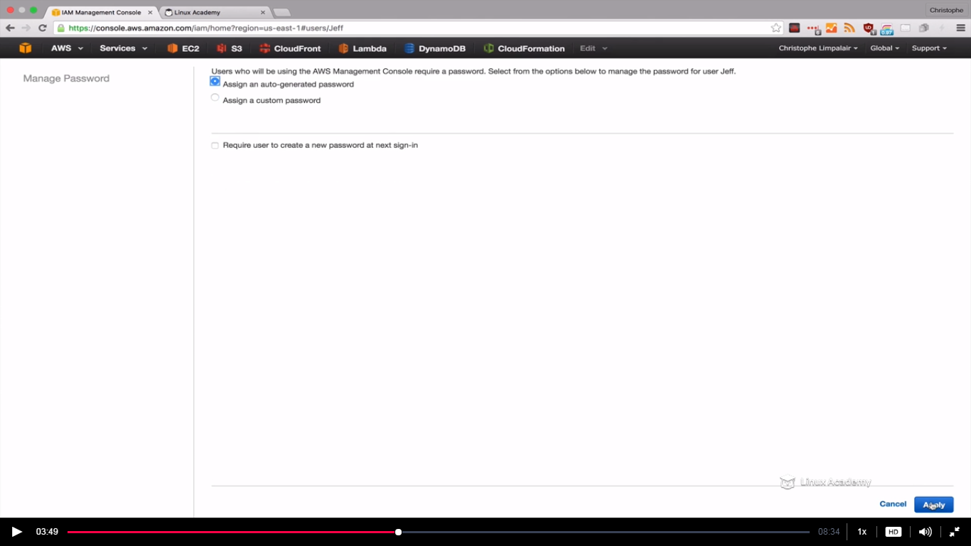

Then download the credentials.

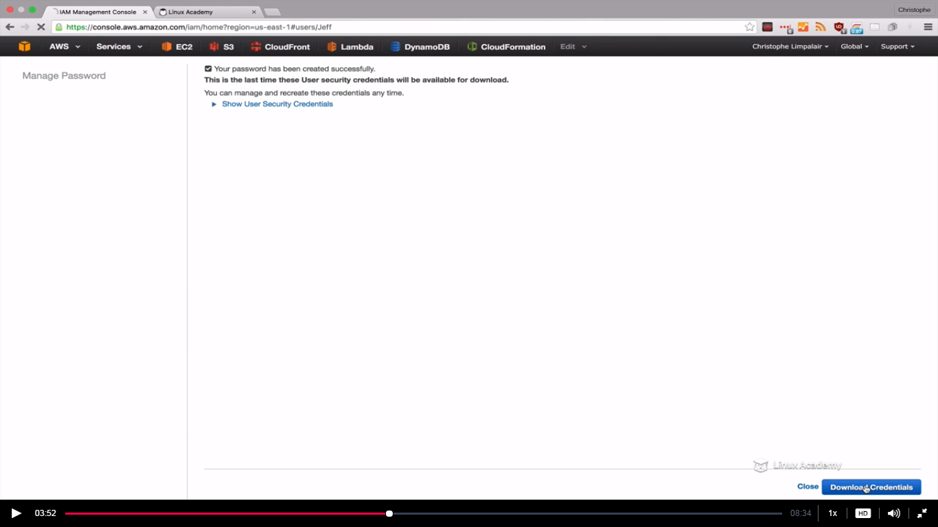

These credentials are different from the access keys because access keys gives authentication for jeff to access the API. These credentials here let jeff login to the amazon console.

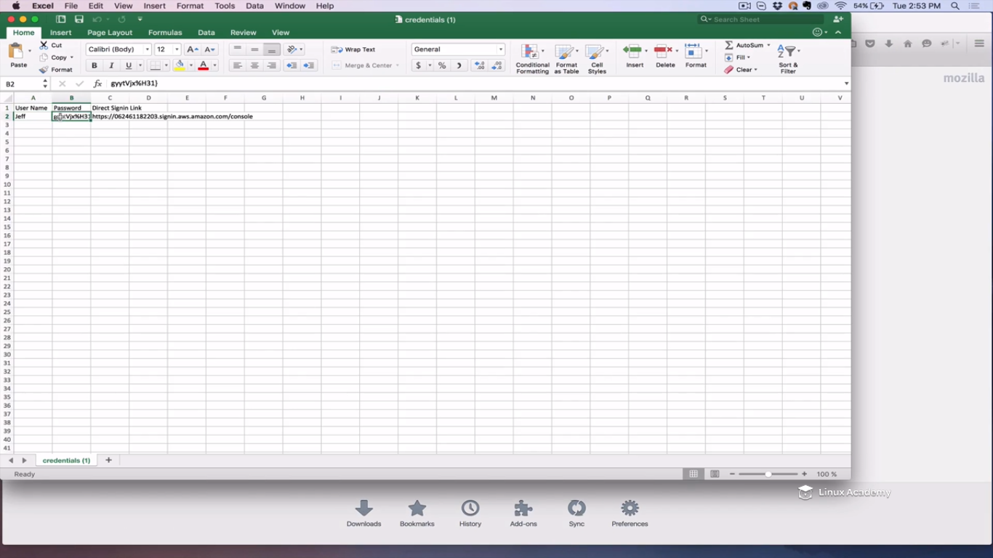

I have opened the credentials that I downloaded which gives username, password and the signin link.

Before we login as jeff we have one thing still to do. We need jeff’s ARN.

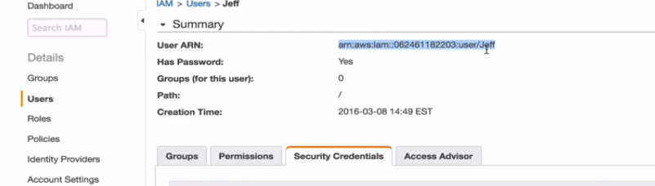

Copy this ARN and save in the same spreadsheet as we would be needing it.

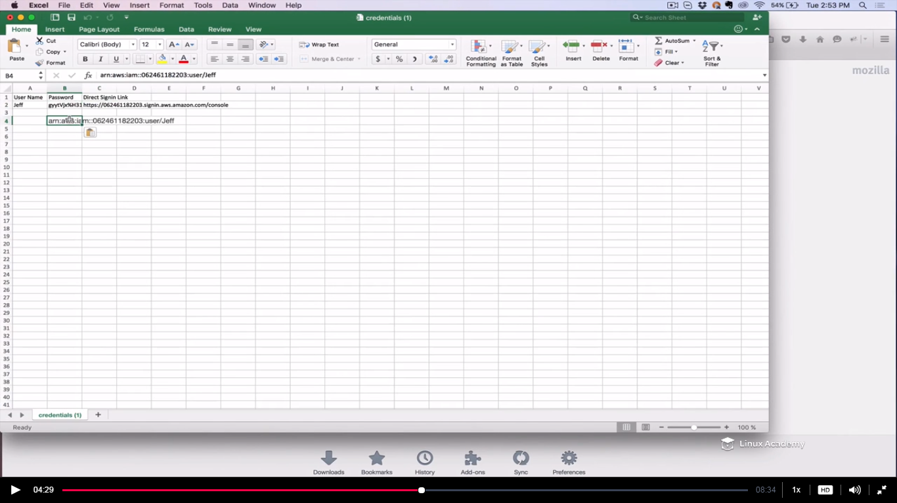

Copy the sign in link to login in the browser.

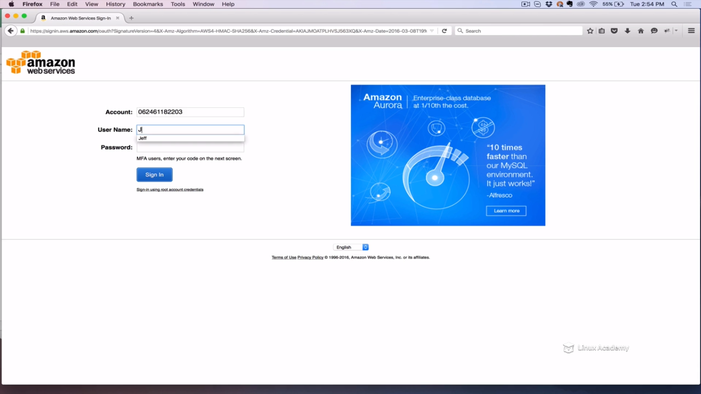

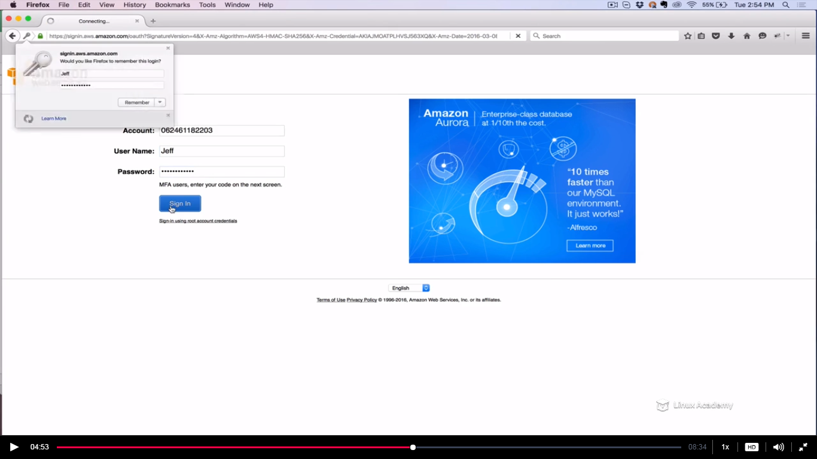

Go to s3

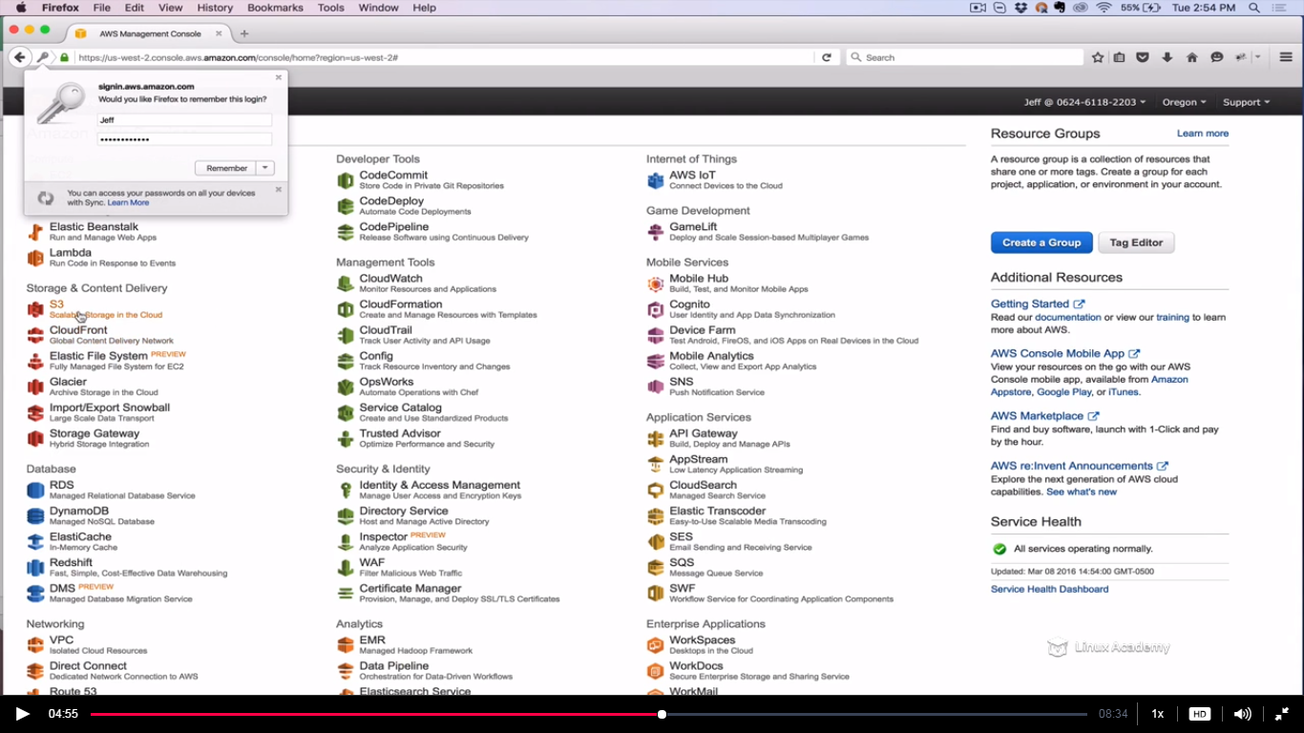

I can see all the buckets that I was able to see with the administer account and I can click on them to see the information inside them as

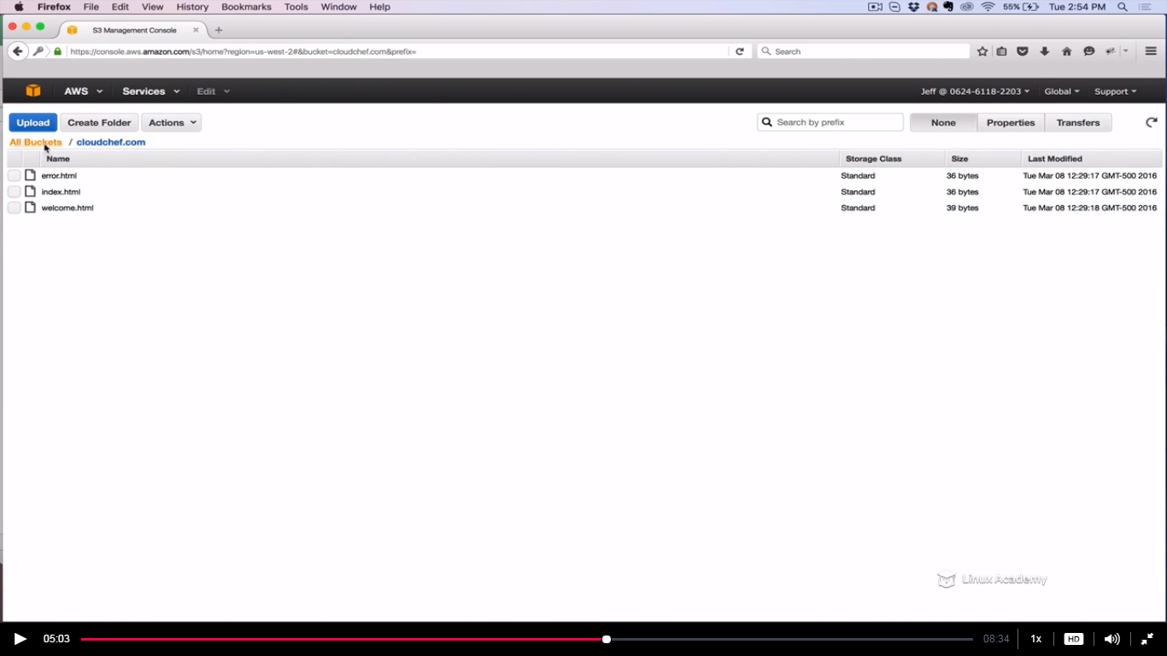

So lets say if I want jeff to not to see information inside few buckets let say cloudcheff.com and [www.cloudchef.com](http://www.cloudchef.com) buckets. I can do that with the help of bucket policies on those 2 buckets and then jeff won’t have permissions on them any more.

So I’m doing it here however I can do that from the IAM policy we created earlier. But here I want to demonstrate how IAM policies and bucket policies can work together hence I’m doing this from the bucket policies.

So I’m going to create a bucket policy.

Go to S3 in the administrative window and click on the bucket cloudchef.com and right click and select properties.

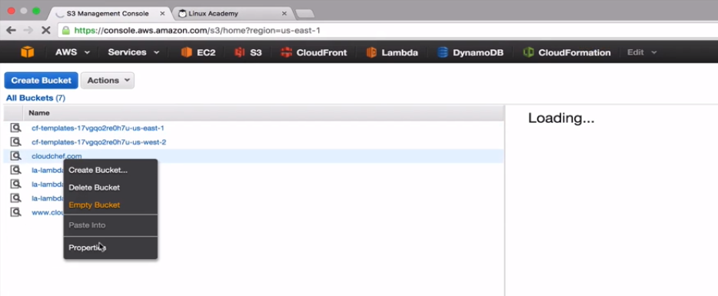

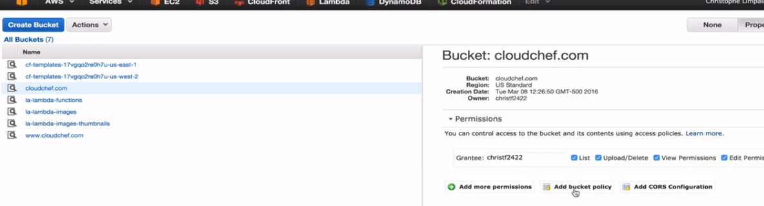

The bucket policy is already created for you so back to the developer course as earlier and copy the policy from there.

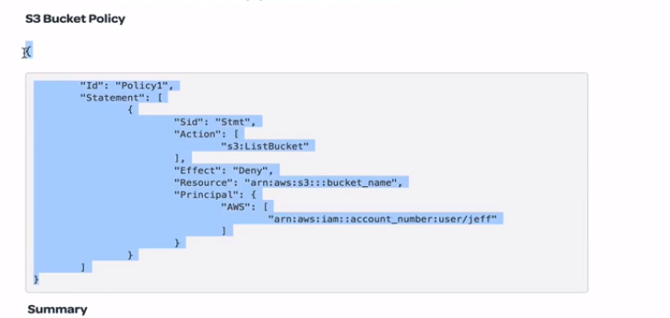

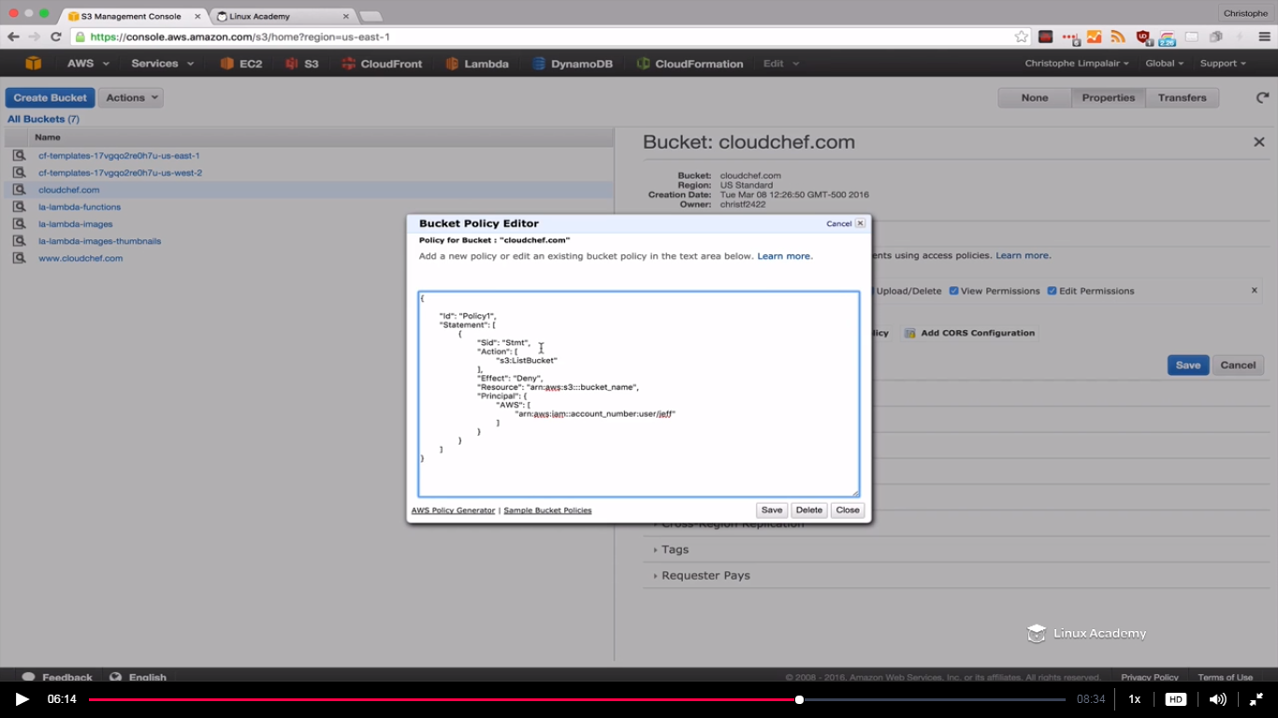

Paste the copied contents on the bucket policy.

In the above policy we are denying listing for a resource called the bucket in which we are in and for a specific user by giving his ARN and that’s why we copied jeff’s ARN earlier.



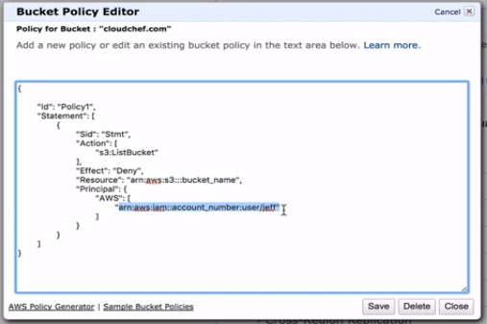

So paste the jeff’s ARN on the above selected. We also need to change the resource name.

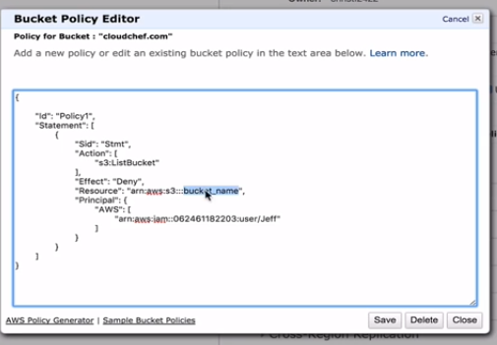

Put cloudchef.com there.

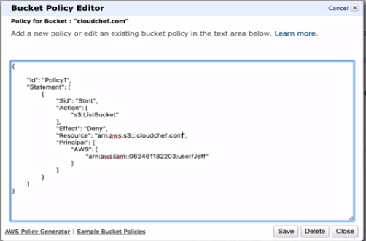

And copy this policy again so that we can paste it in another bucket.

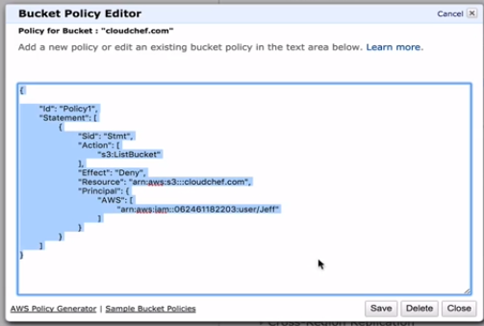

And save it.

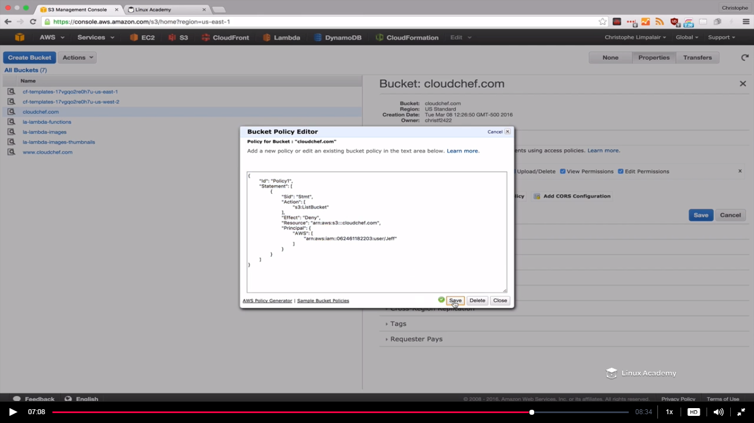

Go to the second bucket which we don’t want jeff user to access

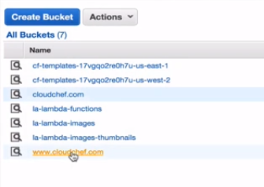

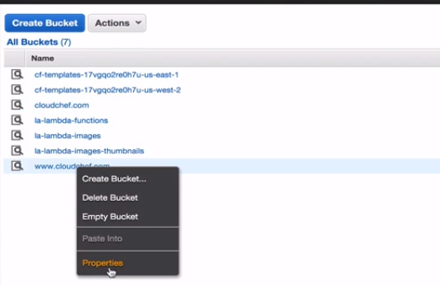

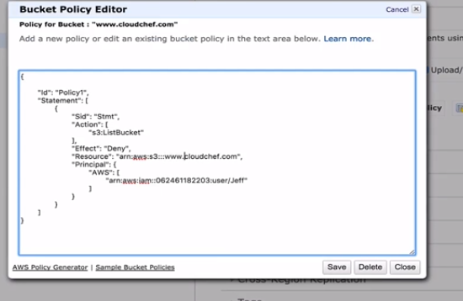

Make sure change the bucket name as [www.cloudchef.com](http://www.cloudchef.com) as this is another bucket.

Go the browser where we login as jeff and click on the bucket which we restricted with the bucket policy.

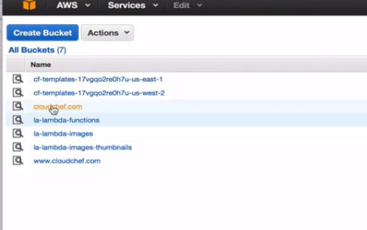

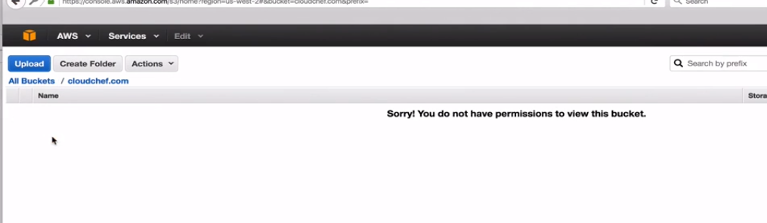

You can check to the other bucket as well.

This is how we can restrict users with bucket policies. Whatever we did here via the console we can do it via the API. Console also uses the API. We could have done this via IAM policies as well what we did here via bucket policies.

Something interesting we noticed that is we have given jeff permissions to get and list all of our buckets but as soon as we explicitly deny it in the bucket policy it overrode the IAM allow policy. An explicit deny always overrides an allow.

**Lecture: Logging S3 API Calls**

From bucket-level to object-level API calls, it is important to know that we can create logs of every action. This lesson walks through the available options, and how they're different from one another. We then walk through enabling these different logging methods.

So we might have people who would be accessing s3 via API calls. It would be nice if we could keep a track of API calls including information about who generated the request. Infact we can do this using both AWS cloudtrail and Amazon s3 server access logs. Cloudtrail captures API calls made from the s3 API which includes the console for the bucket level operations, it then stores those logs in a s3 buckets of your choice. Server access logs on the other hand gives you visibility for object level operations. So using all these information you can tell who made the request, what IP it came from, what time it was made, and more details like that. So this is useful for a number of scenarios may be you want to keep track of calls comply with regulations or event to make troubleshooting easier. If your code doesn’t seem to be working you can ger more visibility to whats causing the problem. **Now the main difference between the cloudtrail and the server access logs is that that the cloudtrail logs are a bunch of different API calls not just s3 calls. For eg you will see when users login to the console, when users gets created etc.**

**You can however user cloudtrail logs with cloudwatch logs to filter out s3 calls and send email notifications when specific API calls are made. You can also use amazon SNS to send notifications.**

**Now with server access logging we can enable on a specific bucket to get information for objects in that bucket alone. Lets enable both cloudtrail logs and server access logs in this lesson.**

Go to cloudtrail

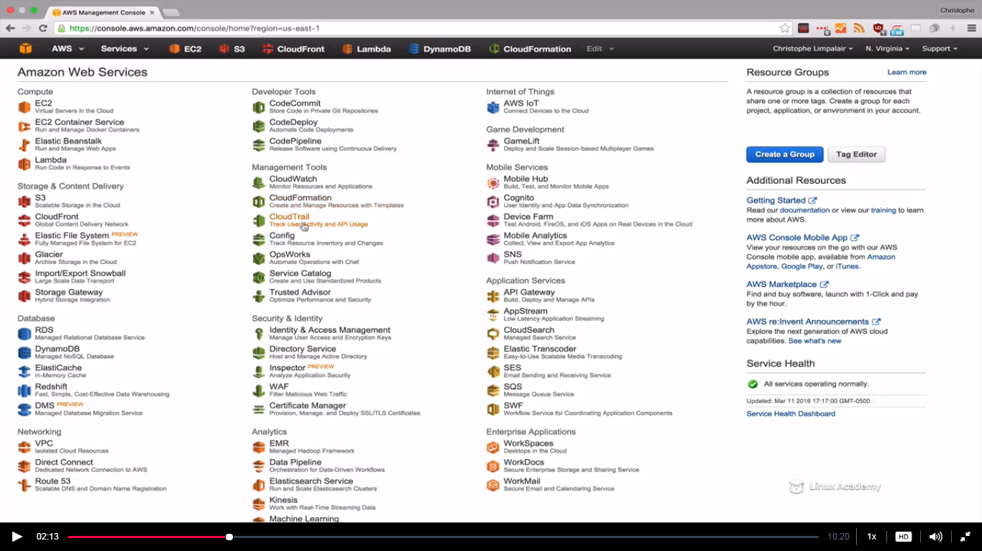

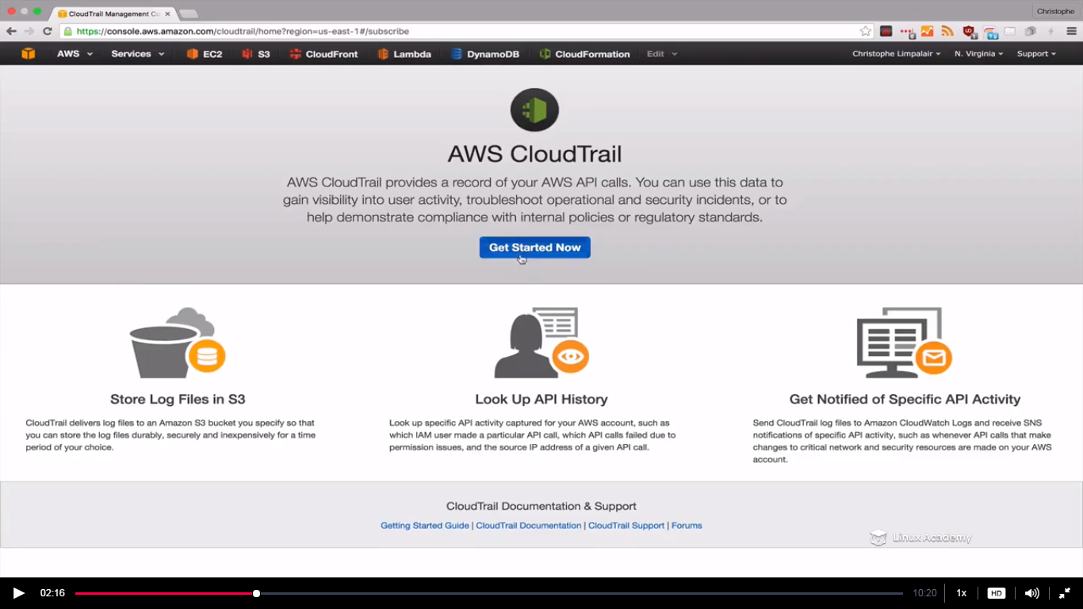

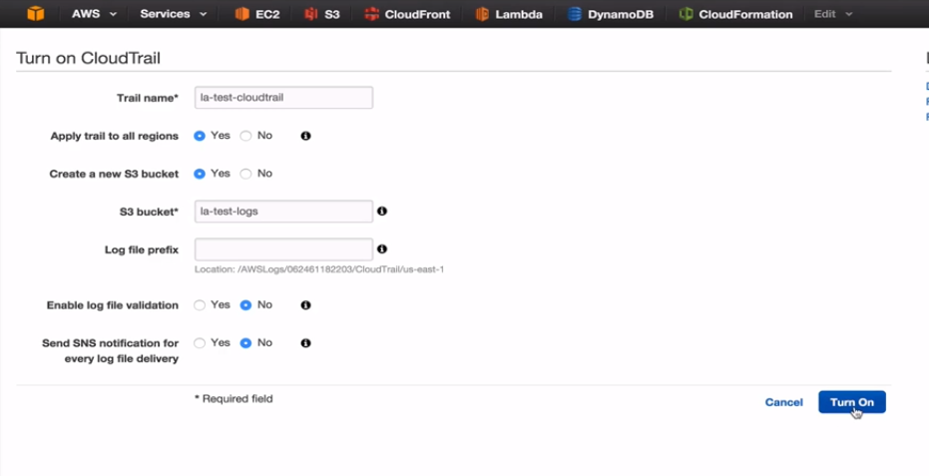

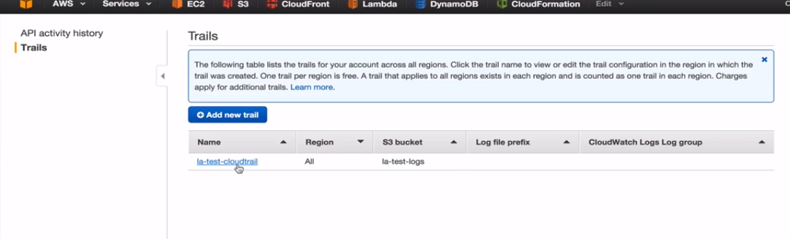

So now we have one trail. We can have multiple trails if we want to.

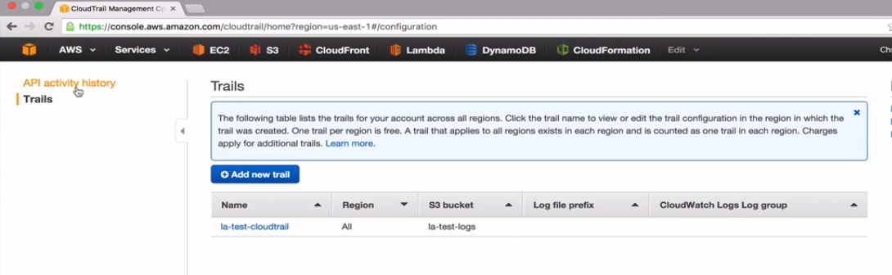

I have already enabled the cloudtrail hence I have some API activity history.

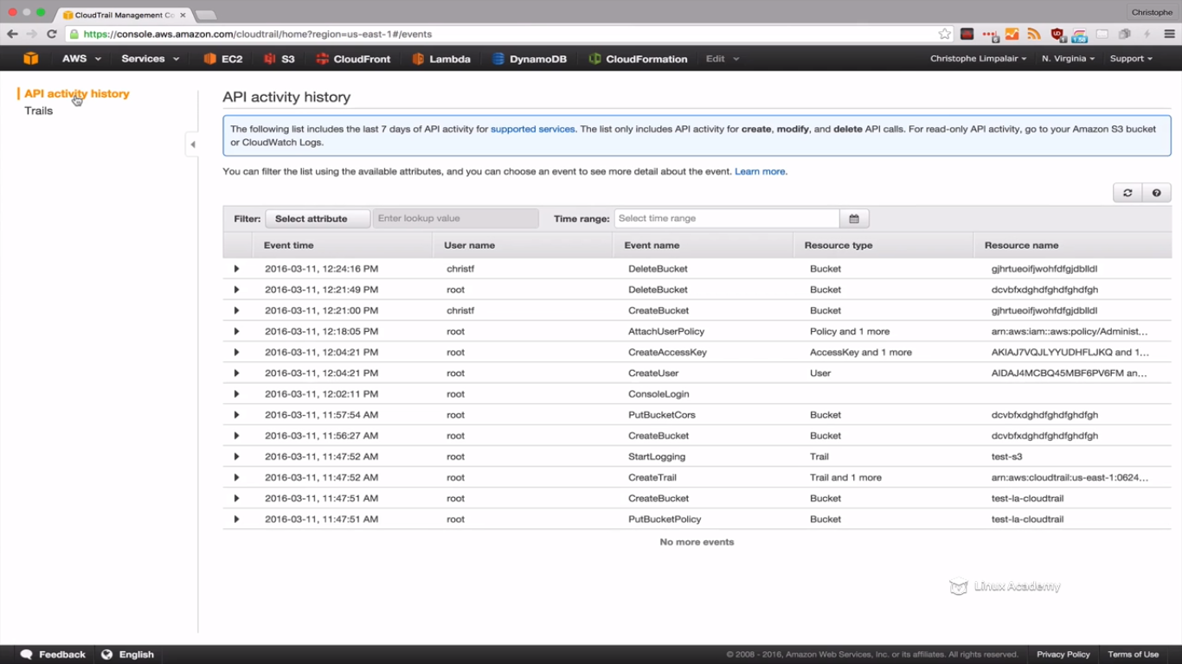

So we can go to different window and can use a python script with boto3 sdk for amazon and I may create a new bucket and then I would be deleting that bucket. And instead of spinning a instance for this I would be using my python interpreter on my local computer. This is just an example, no need of doing this. So I have already a python interpreter installed on my system

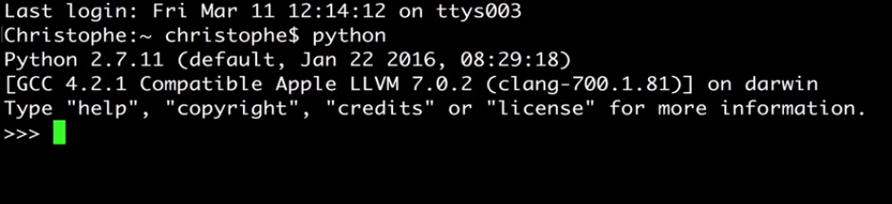

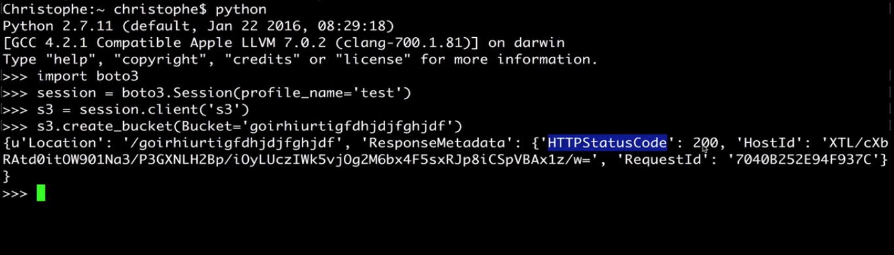

We are not in the amazon environment. So the profile_name is a user created and we are accessing its secret access key to access the S3 service of AWS.

Status code of 200 that’s means we are done. Lets go and verify.

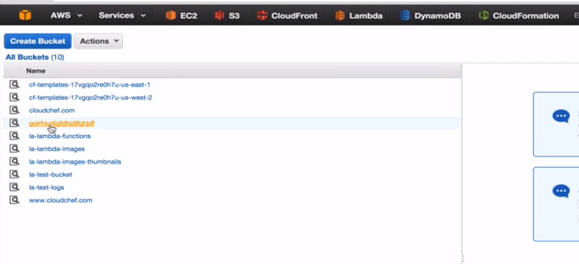

It successfully completes. Now lets just go and delete this bucket.



Status code of 204 that’s means the bucket is deleted. Lets verify.

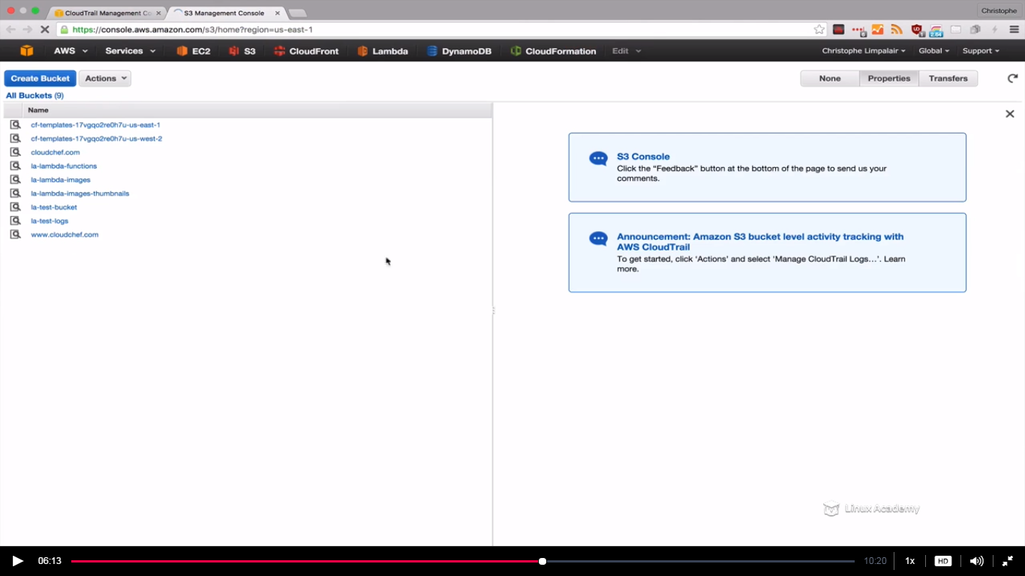

Bucket is deleted.

Now we can go back to cloudtrail and refresh. Wait for 5-7 minutes to see the new changes there.

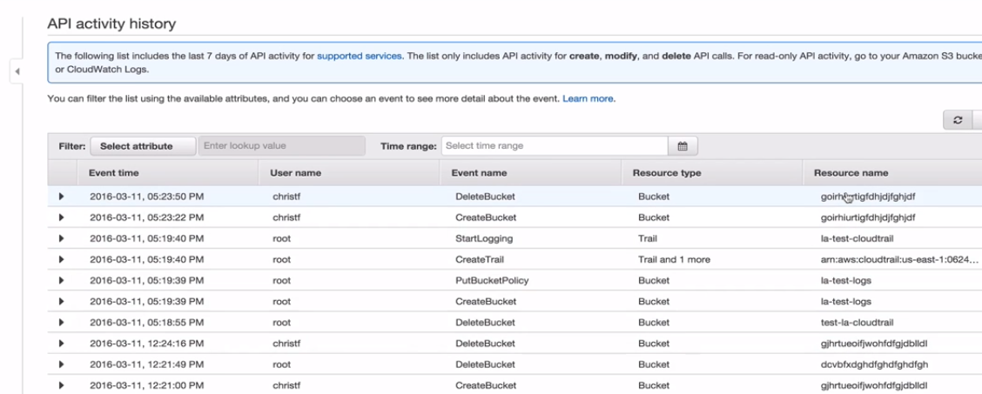

We see bucketcreate and bucketdelete, that’s means we have successfully enabled cloudtrail and it did log the bucket actions. **Now remember cloudtrail only logs in bucket actions not object actions.** If we create or delete any object we wont see any actions here. For that we need to use server access logging. So lets do that.

Go to s3 console and take any bucket which is there or create a new one

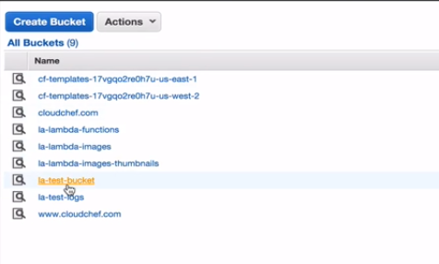

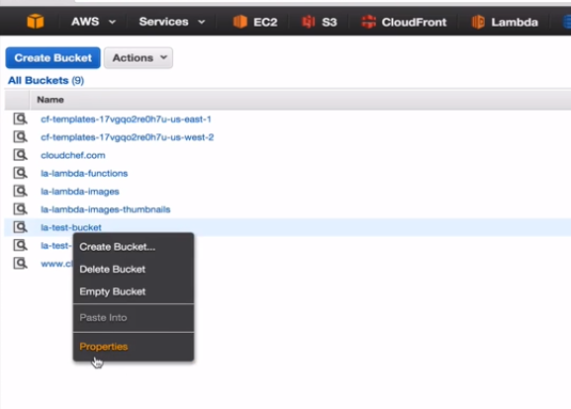

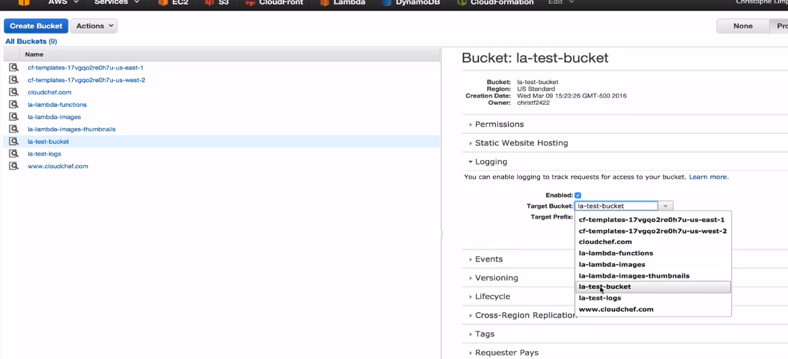

Go to logging and enable. Give a target bucket bucket. This is where we are going to log our files to. You may save these log to a different bucket but for this exercise im using the same bucket.

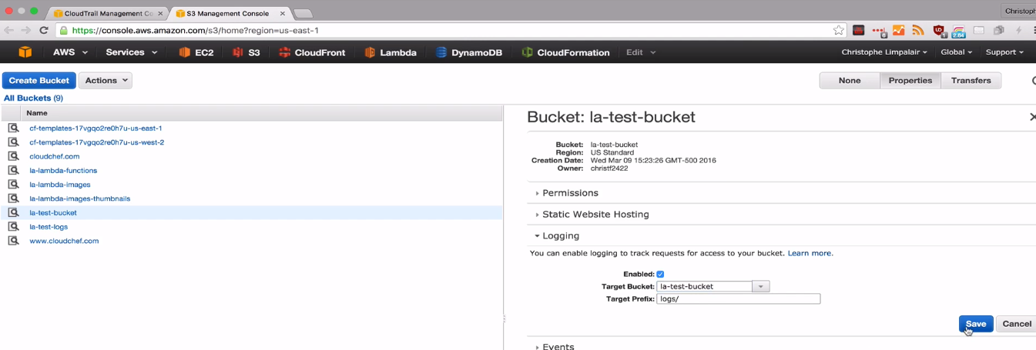

Since we have logging enabled lets go to the bucket and modify objects.

Go inside la-test bucket and there we have 3 objects

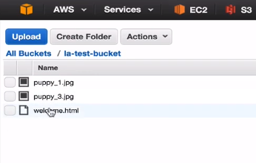

Delete one of the object.

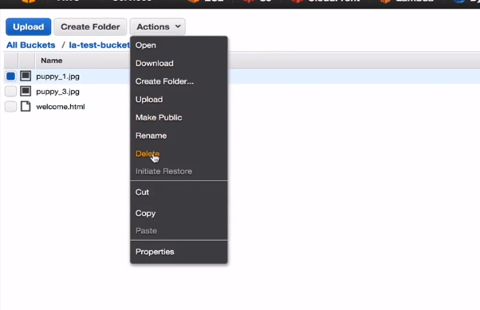

Rename one of the object.

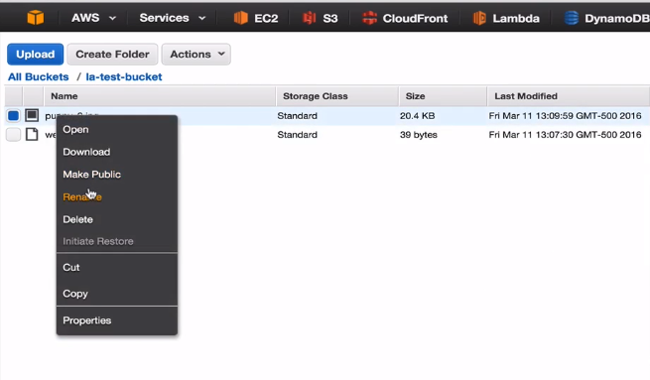

All these changes are being logged. So after performing a number of actions we will see all the logs in the target bucket. However keep in mind the server access logging doesn’t display right away. IT could take an hour or more to even these actions logged and some of the actions may even not be logged because it takes some time to start logging. Server accessing is not meant to be used for completely accurate logging. Just lets see sample of how the logs in the server access logs would look like



It shows us the date and time when it happened and the ip address followed by that. The ip address is of the person who modified the object.Also we get the REST.GET.BUCKET



And the get method for the bucket named as la-test-bucket.

**Lecture: Object Versioning**

This lesson explains the concepts of object versioning in Amazon S3. With versioning enabled, we can keep multiple different versions of the same file. It does change how you delete files and access files, however, so it's important for developers to understand these differences.

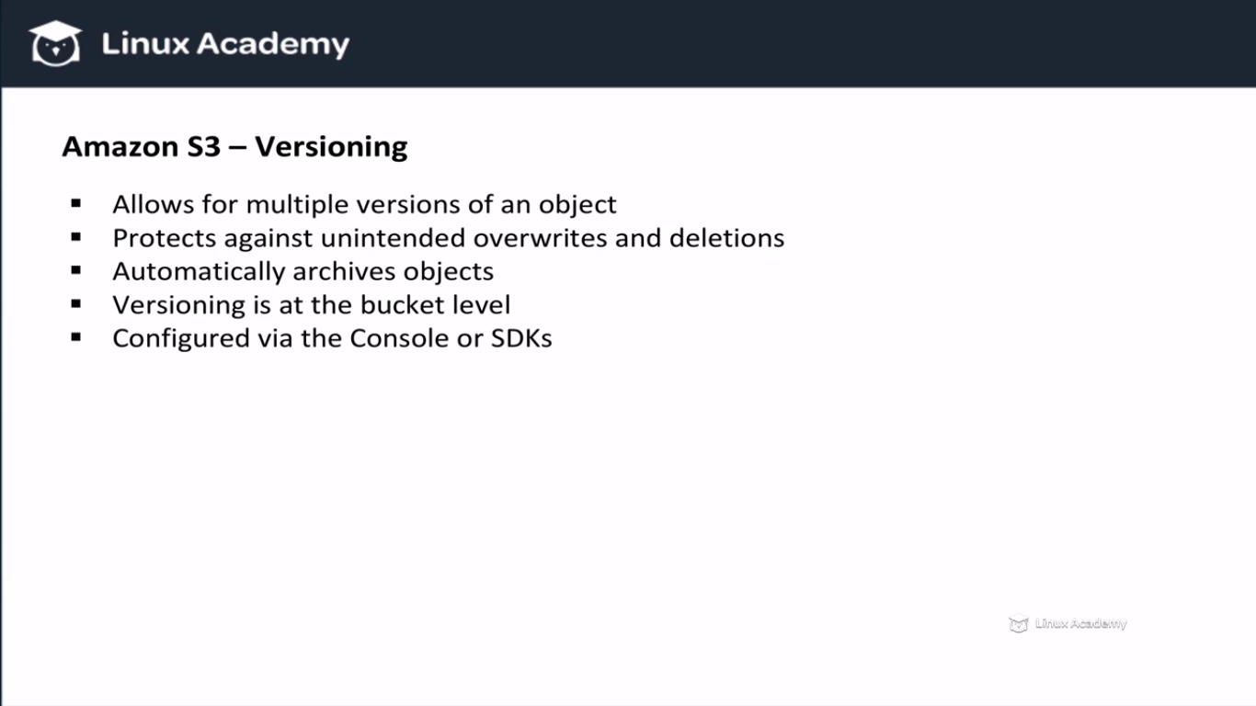

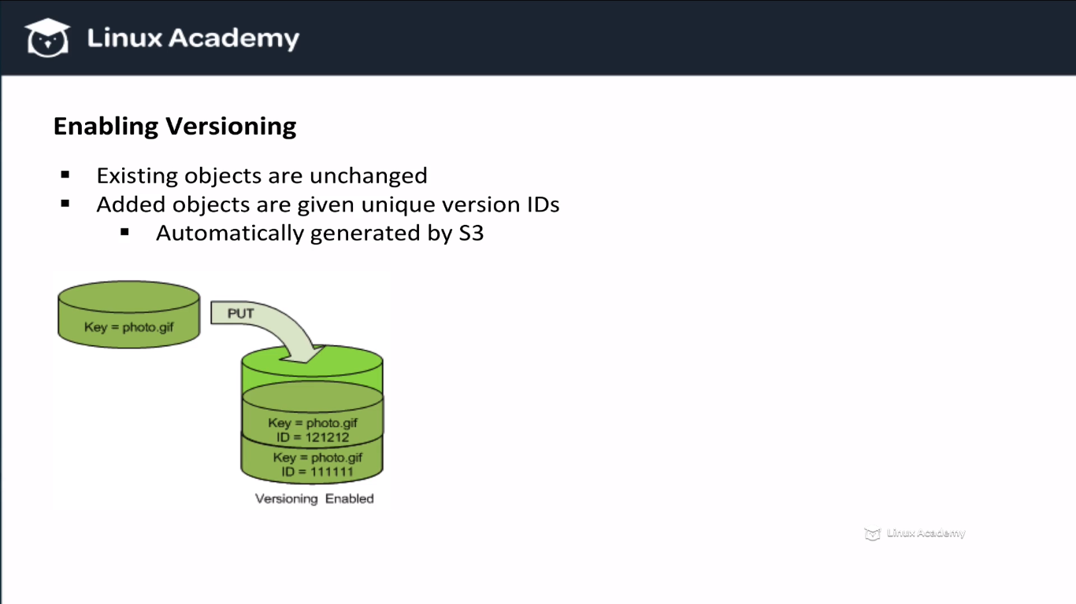

If we get a GET request on our object then the latest version of the object is delivered to the request.We need not to specify any version id for that. But if we want a specific version we can get it from its id.

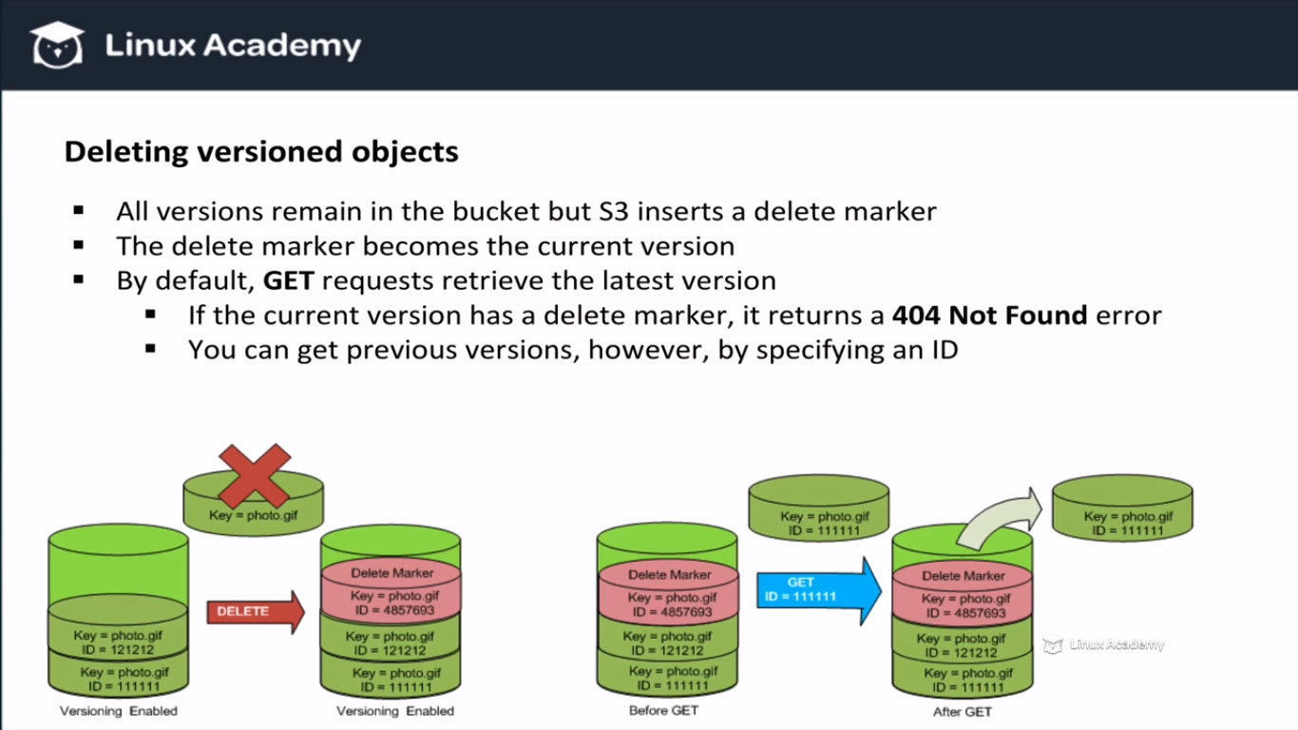

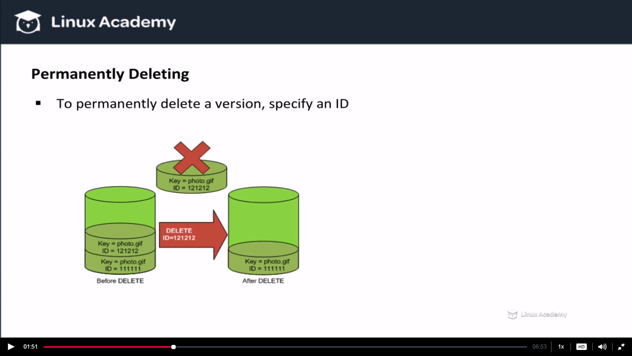

If we specify the object-id of the object to be deleted then the amazon s3 will not set a delete marker, it will instead automatically make the next version the default current version.

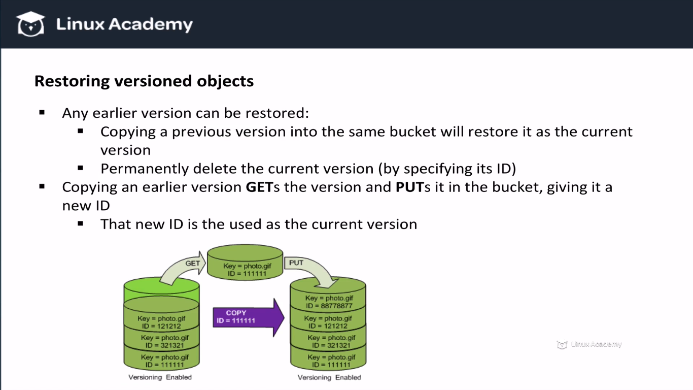

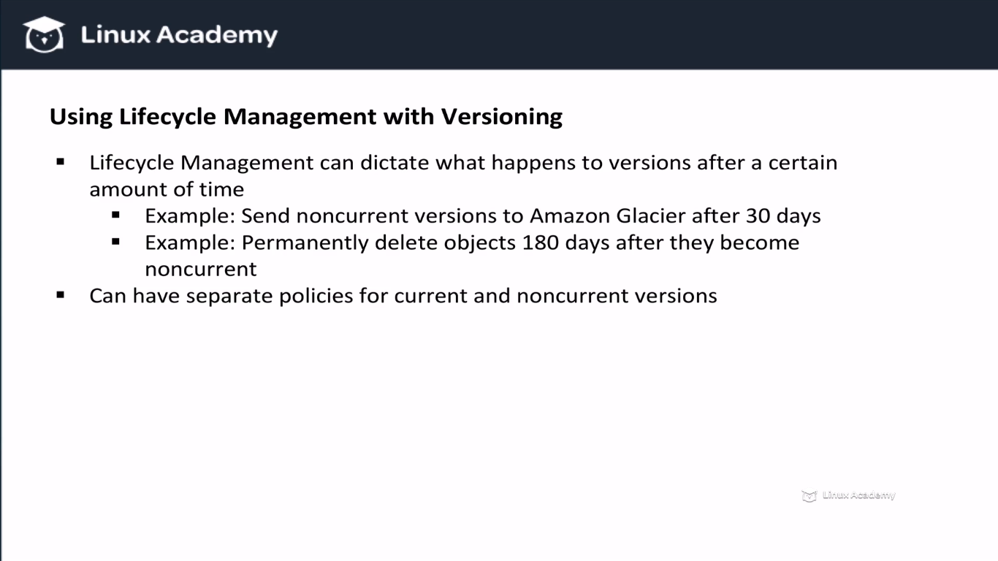

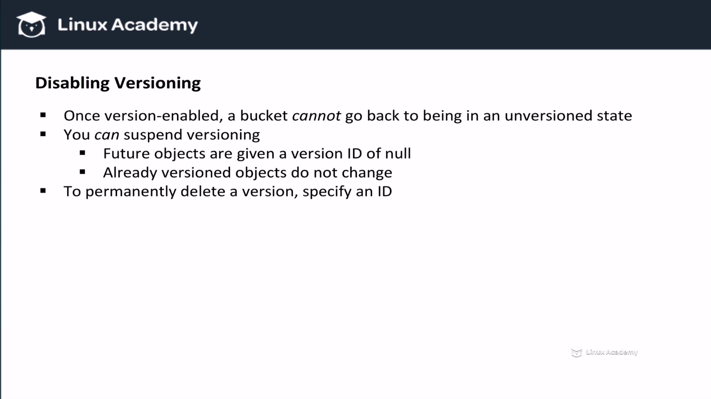

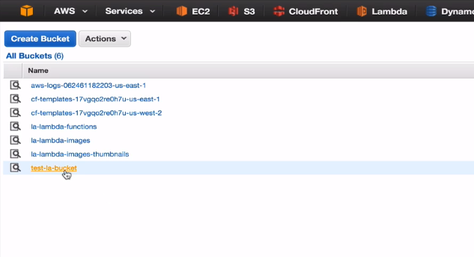

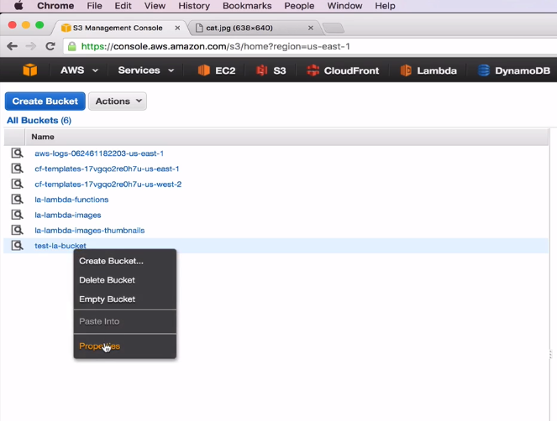

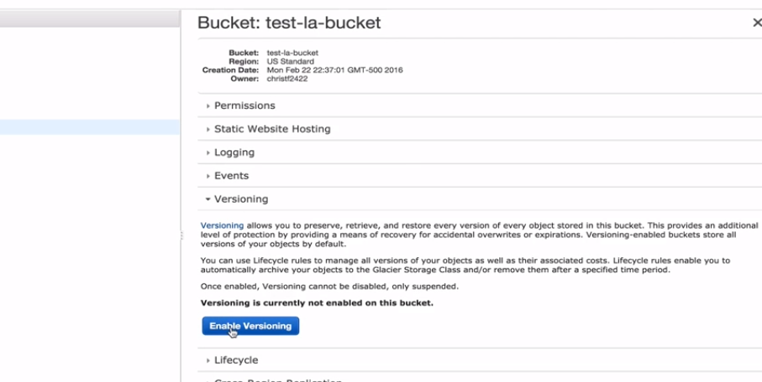

Since we enabled versioning, go into the bucket and upload a file multiple times.

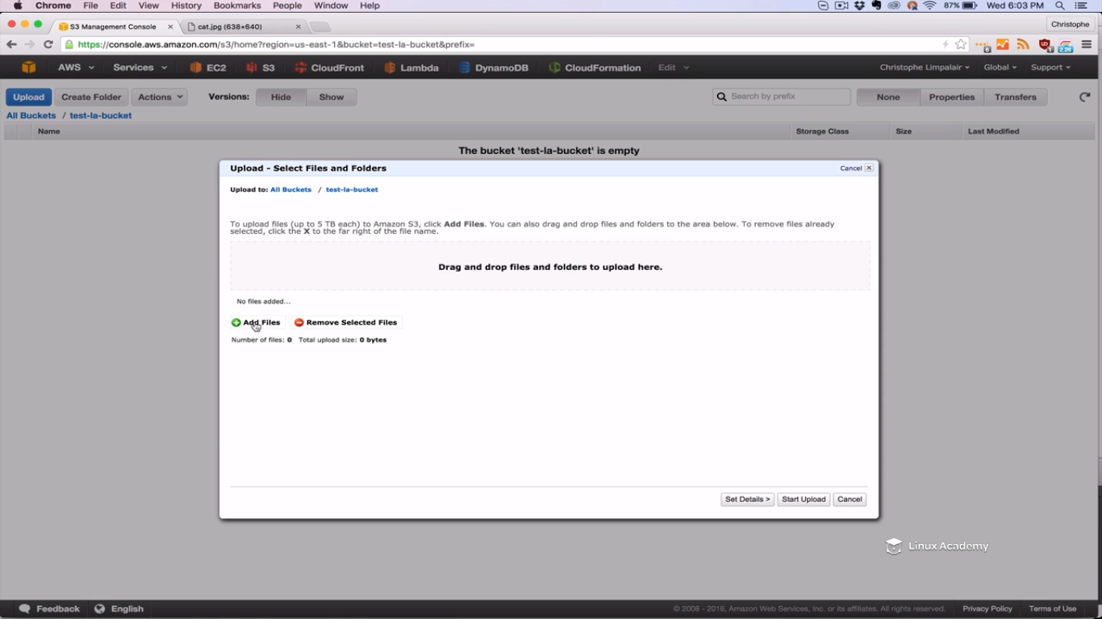

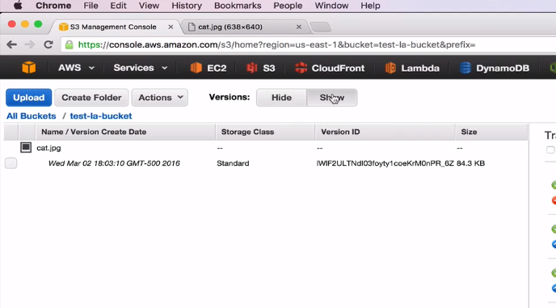

We see we have to options of version-hide and show. Bydefault it is hide and we clicked to show.

Upload same file again

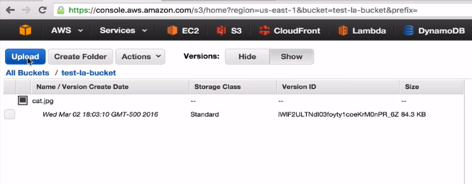

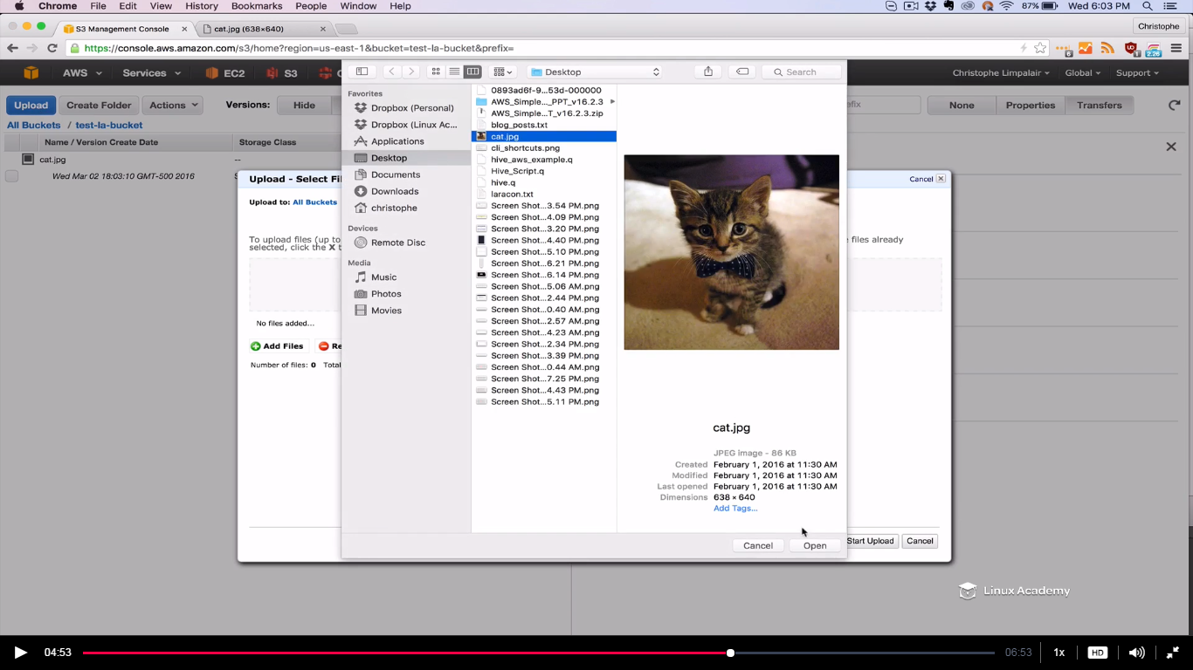

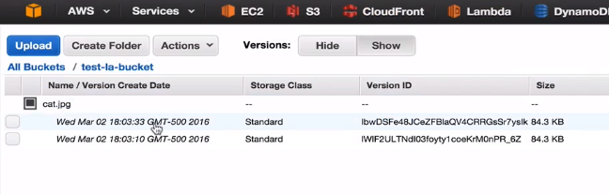

We see 2 different versions.

So I can hide as well. IF we hide we don’t see the 2 versions

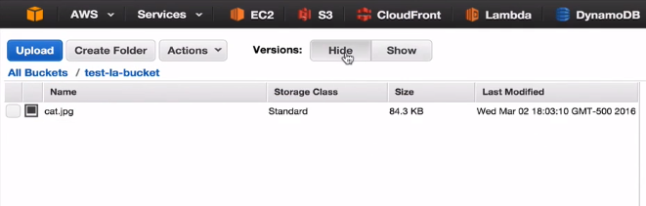

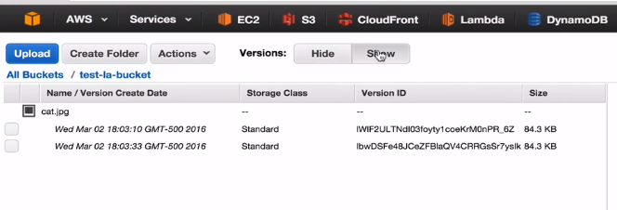

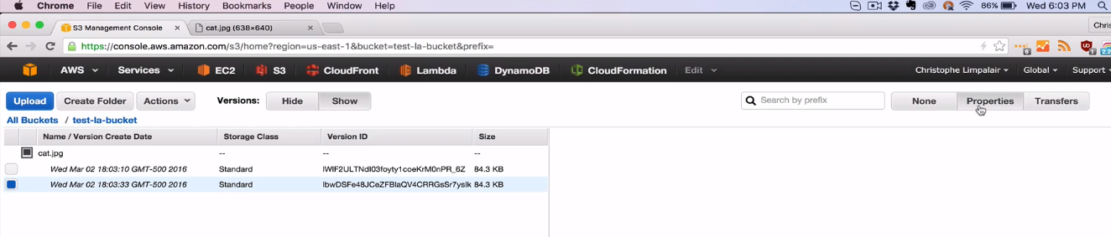

The permissions are private on the object however we can make it public by

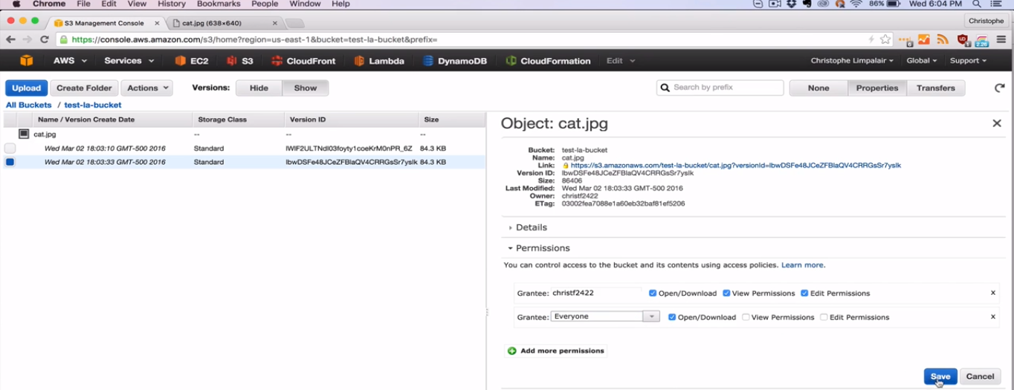

As soon as do that I can access the url

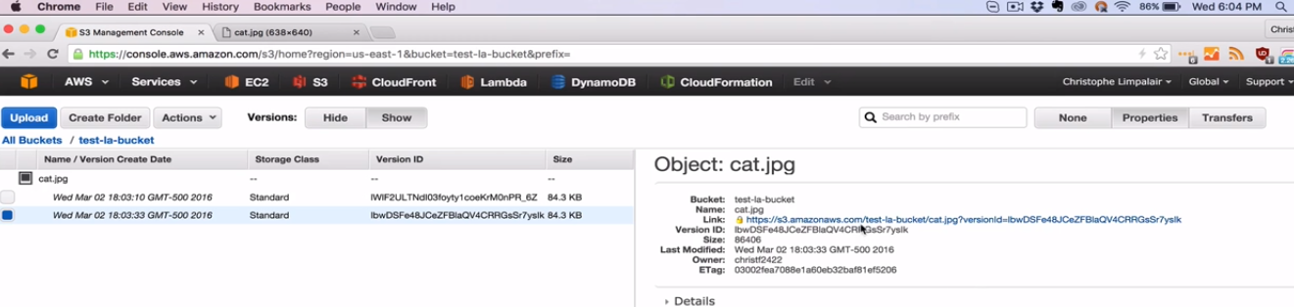

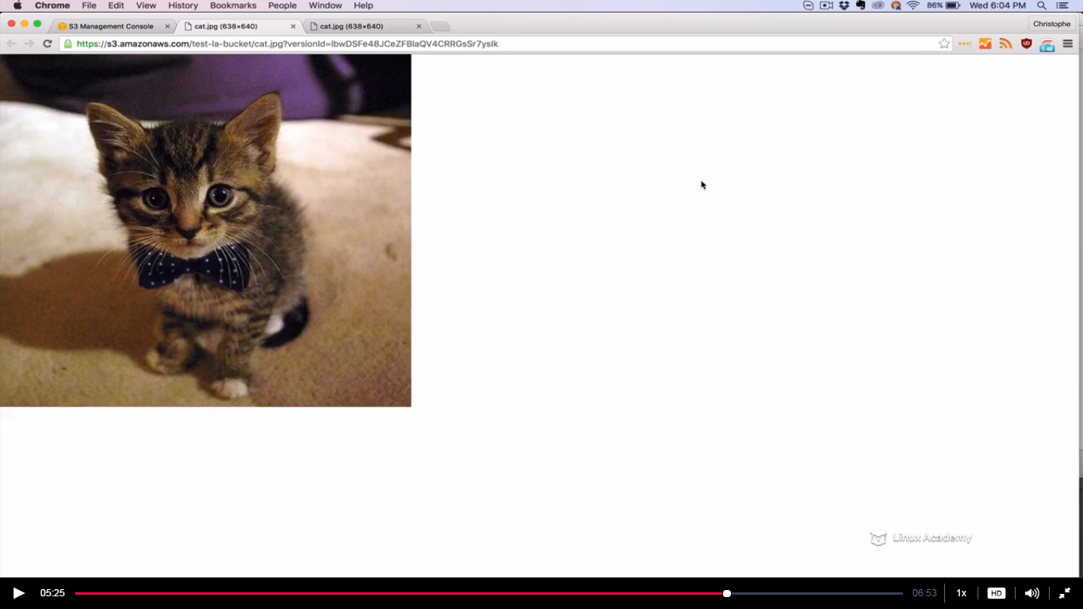

But if I go to another version

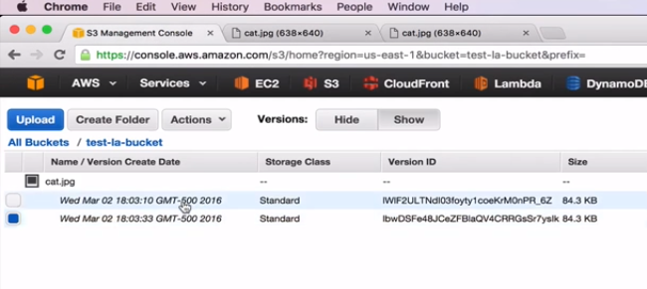

That one is still private

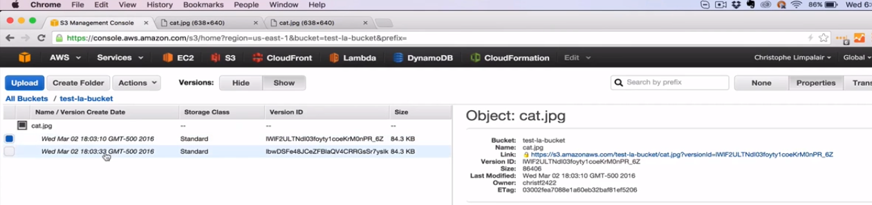

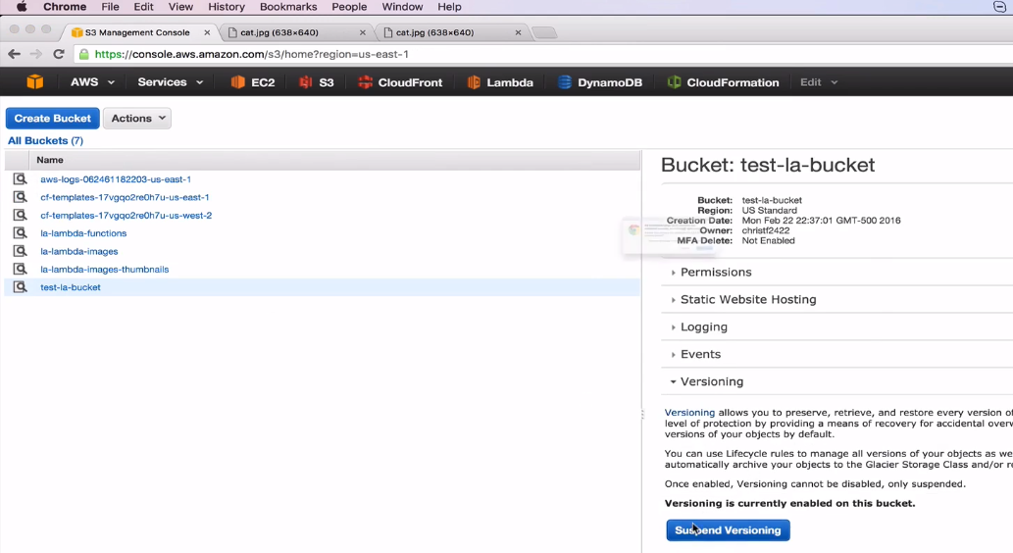

After suspending versioning still if we go to the bucket we have the previous 2 versions as

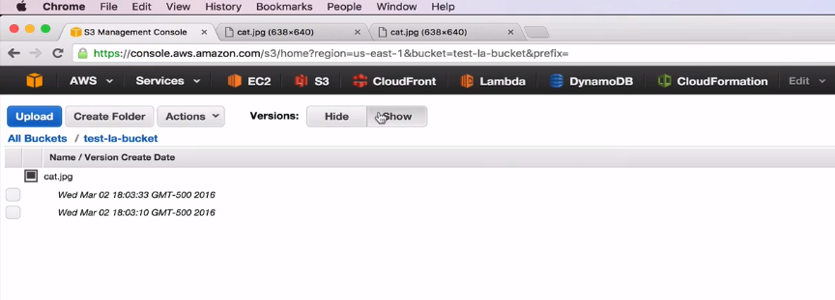

Now if I upload a different file

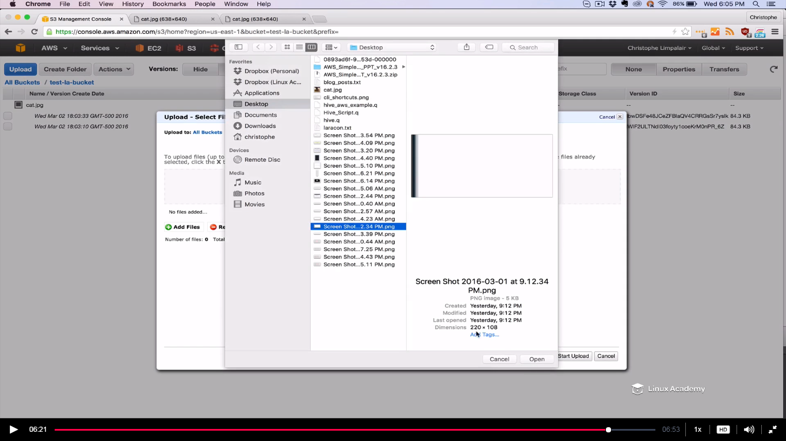

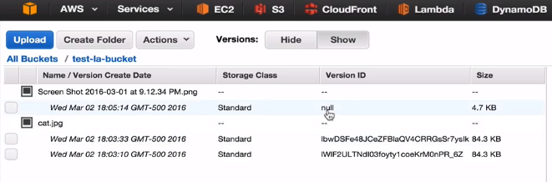

This new file have only one version and the version id would be null because that the default if don’t have versioning enabled.

**Lecture: Amazon S3 Encryption**

There are two ways of protecting information when it comes AWS S3.

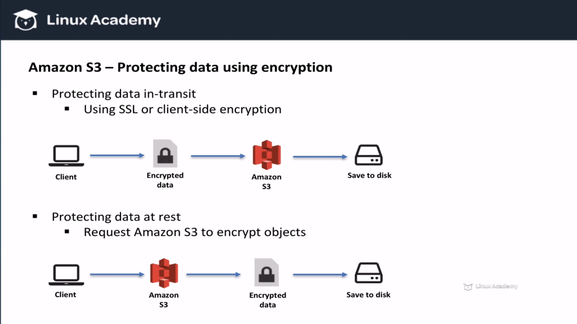

Even we can have both above types of encryption at the same time. Lets take a look how to protect data in transit.

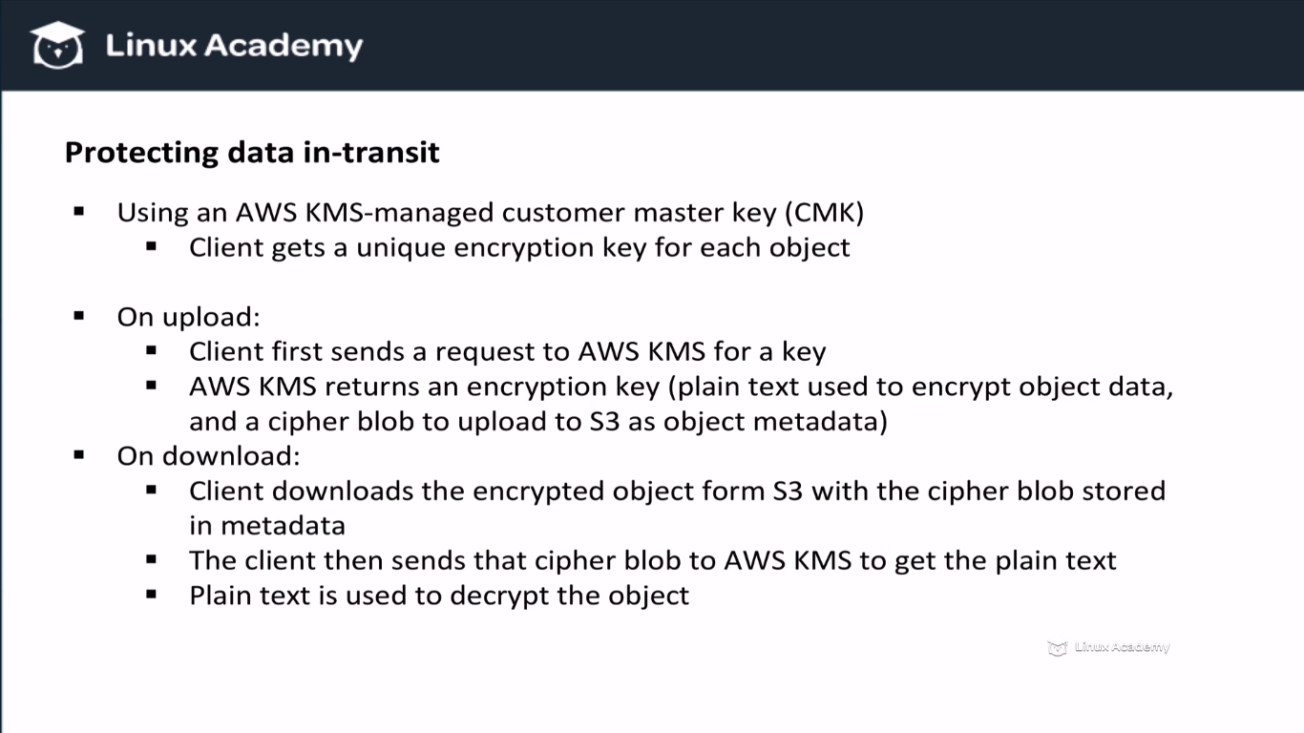

Above is the method1 and now method2 is

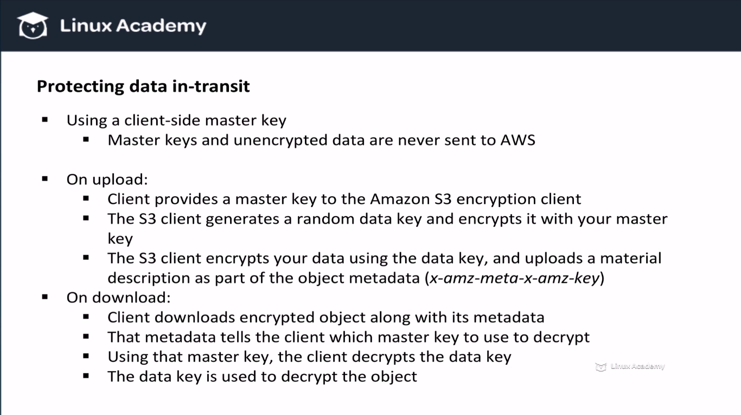

One of the difference between the 2 method is that with this method master keys are never send to AWS. So above were the two methods which can be used to encrypt data at transit and don’t forget we can even use SSL encryption.

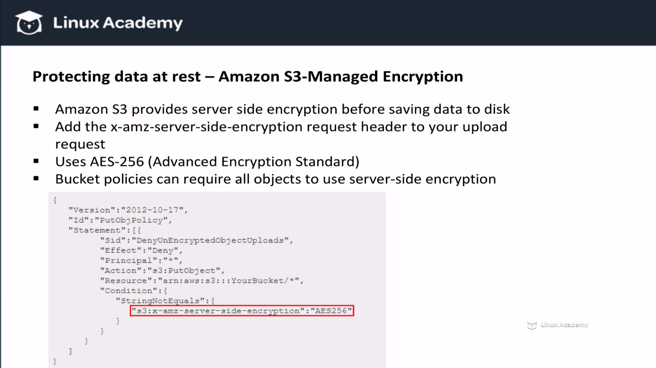

Instead of letting Amazon S3 managing our encryption keys for us we can select alternatives like KMS Managed encryption and Customer-Provided Encryption key.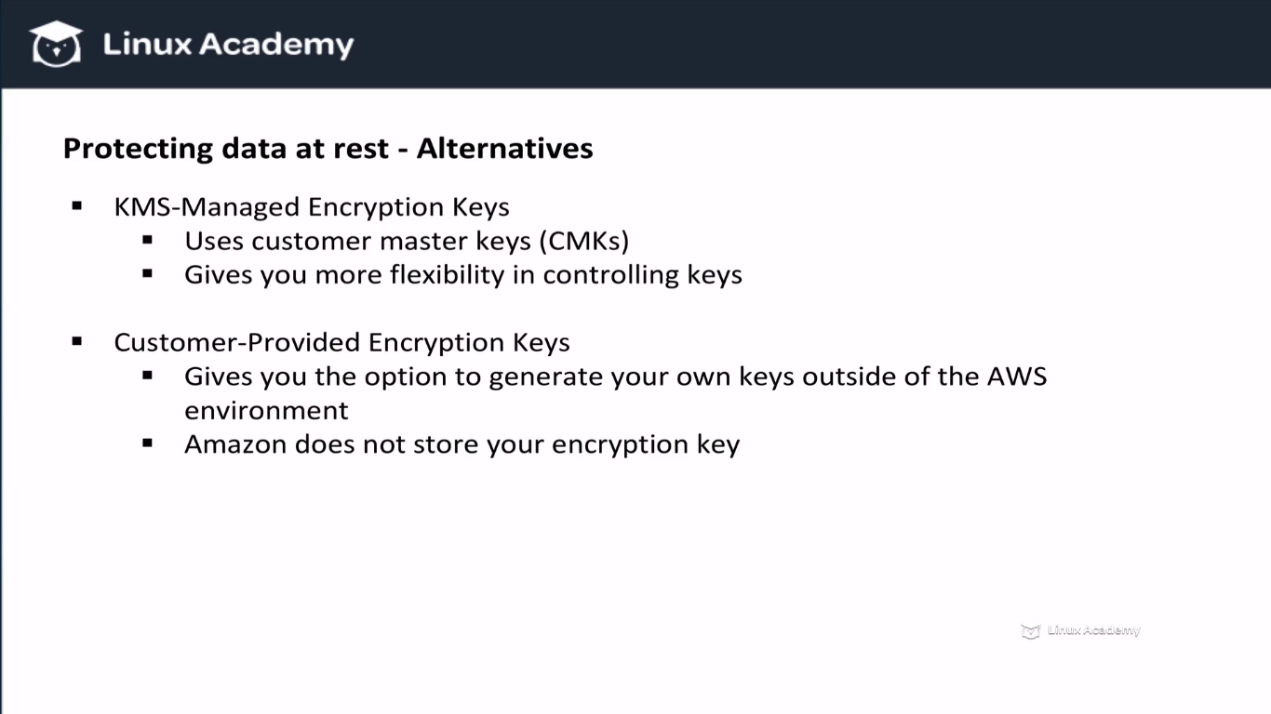

How server side encryption looks like

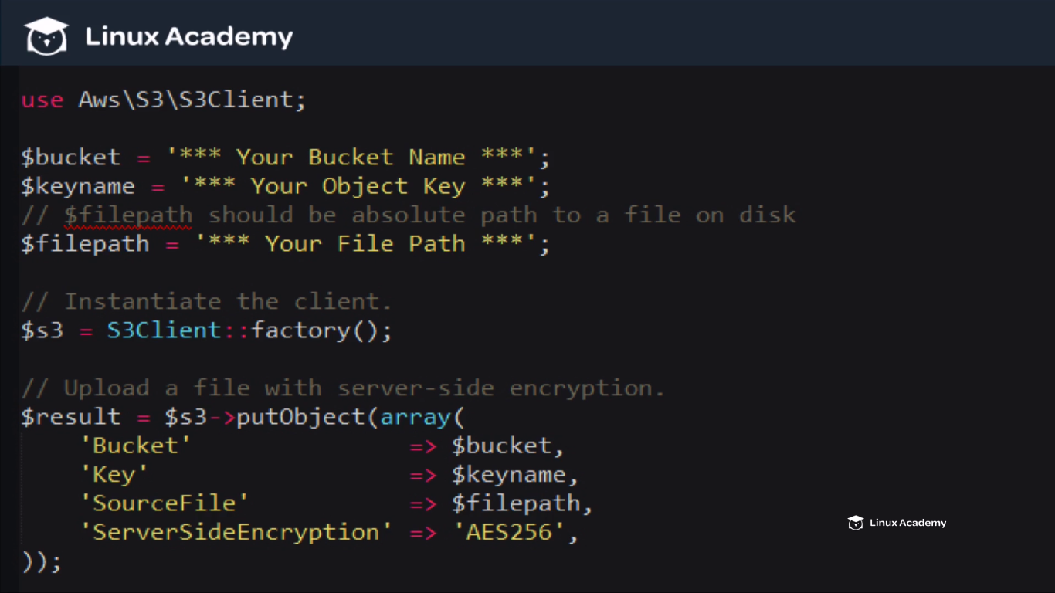

Above is the Php script which uploads an object to s3 using Amazon’s managed encryption.

How it looks in AWS console lets look into it.

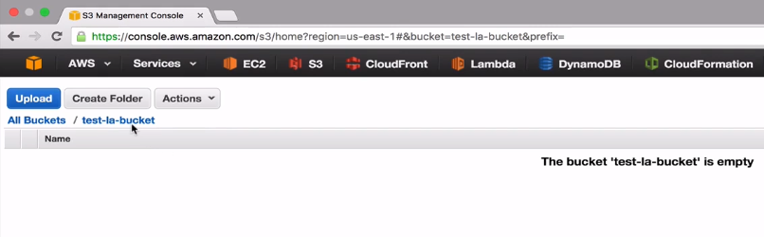

Already created an empty bucket. Now upload an object.

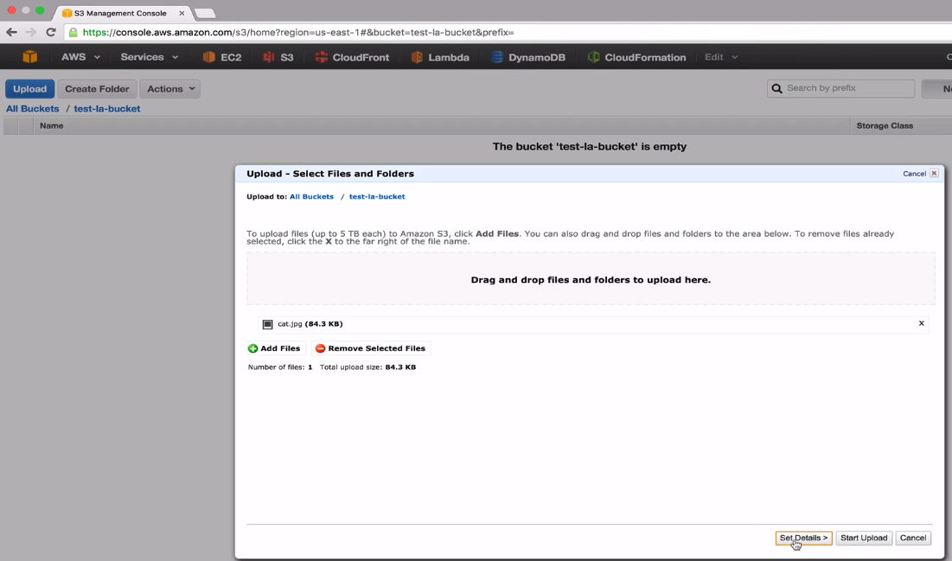

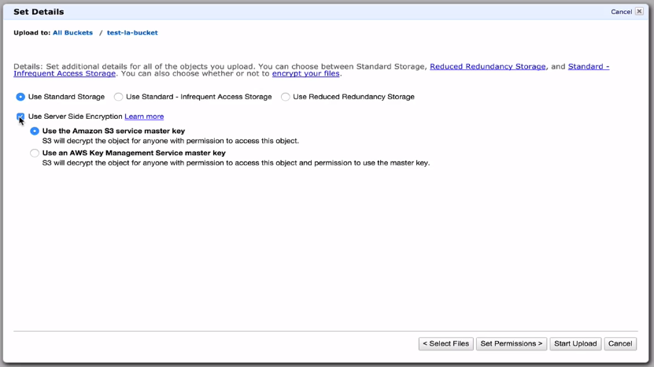

When you check the Use Server Side Encryption then you have 2 options to choose from.

IF we use the first option then we need not to do anything else and we are done but if we choose the second option then we need to choose the key

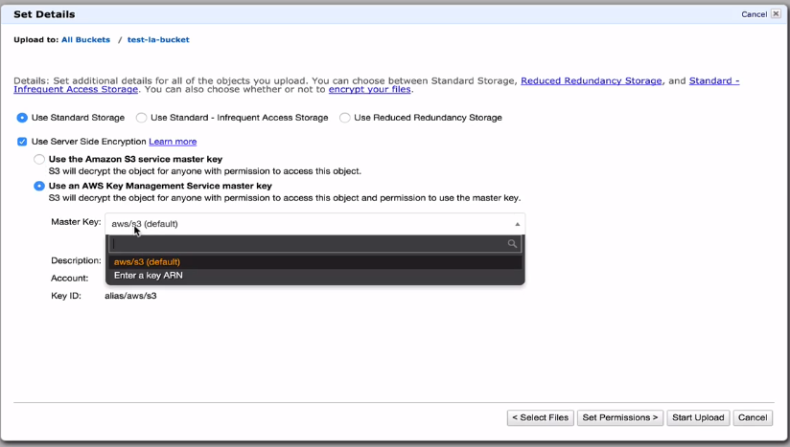

Lets choose the first option

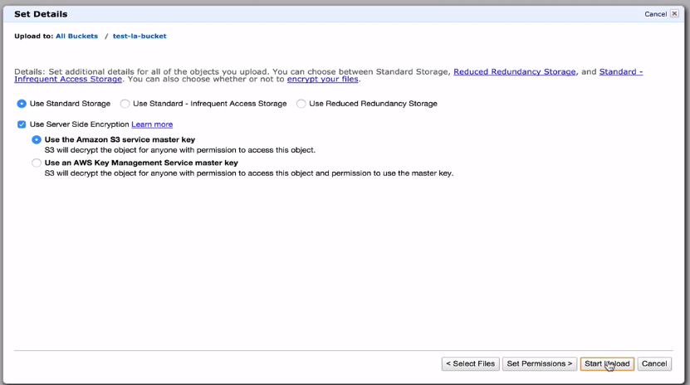

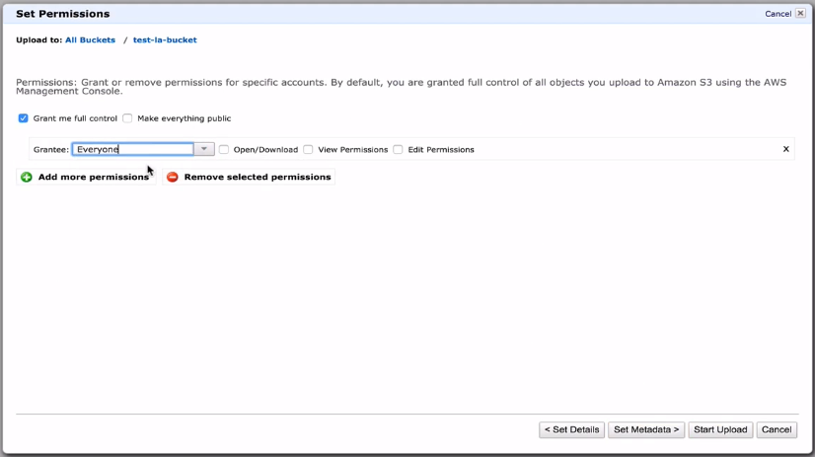

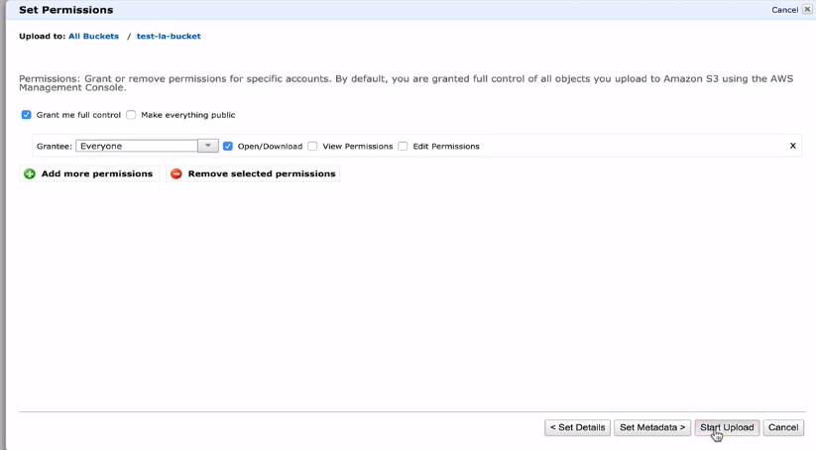

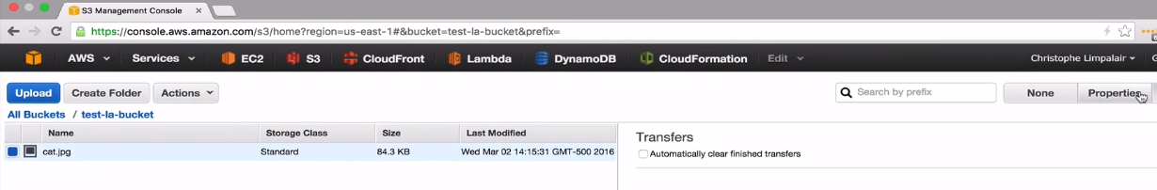

IF we go to properties and click details we see that it is encrypting using AES-256

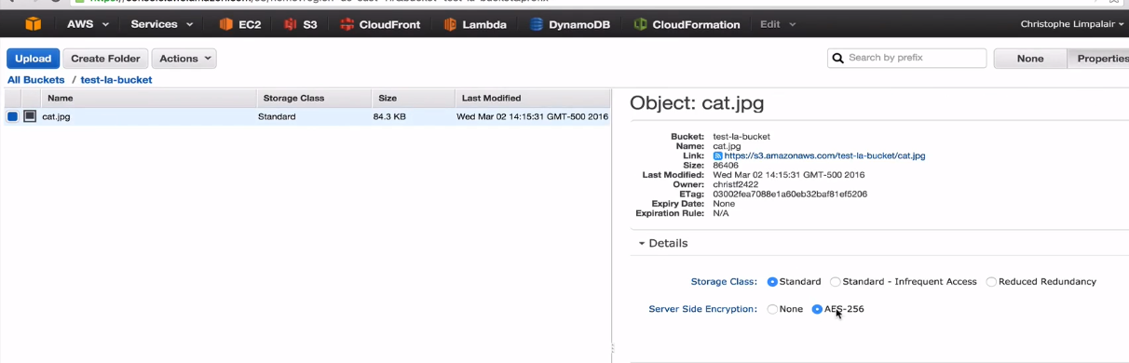

But if you click on the url to view it we can still view the image.IT decrypts on the fly so as you request the information even though its encrypted on disk amazon will decrypt it as the object is requested.

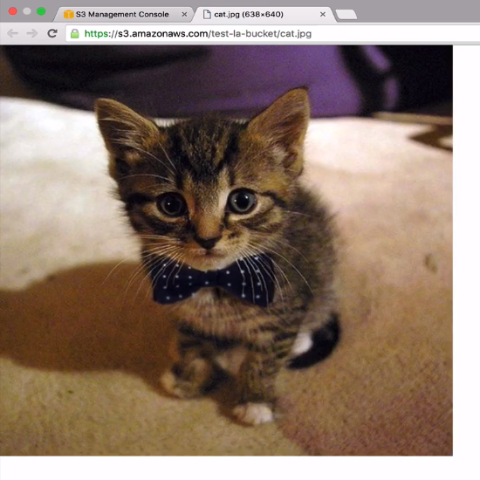

Now I can go back and disable this encryption by selecting none as

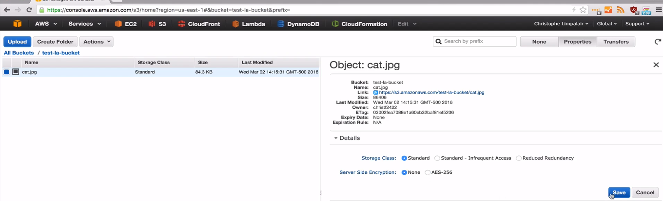

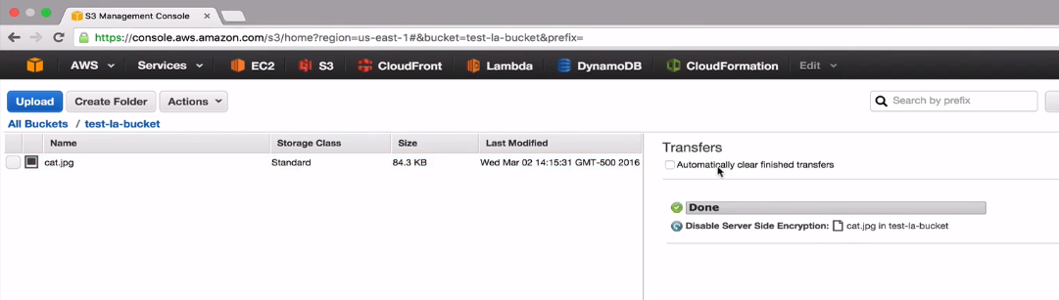

We still have the access to the object and we can again encrypt the object by going to properties and select AES-256 and save as

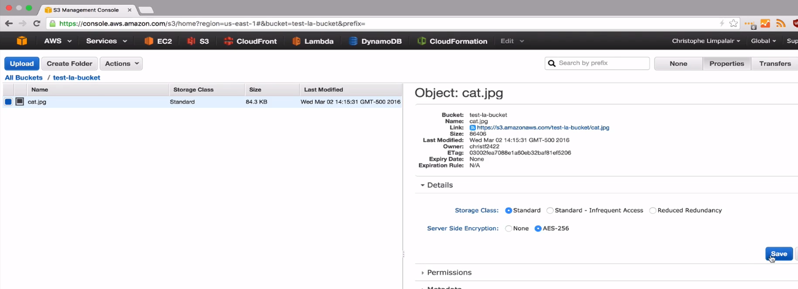

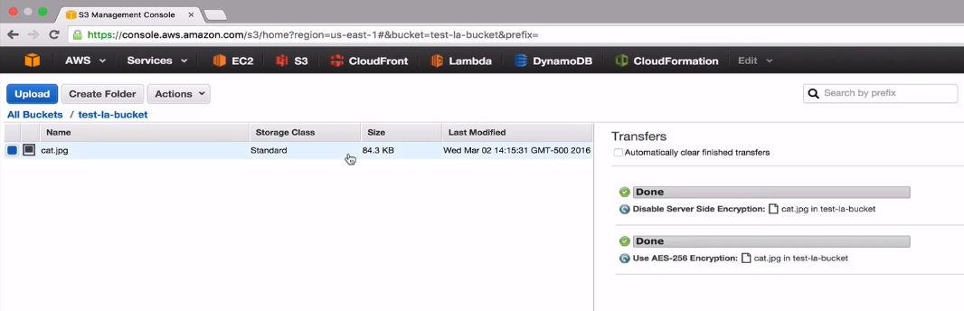

We still have access to this file.

**Lecture: S3 Error Messages With Python**

In this lesson we are going to use a few simple Python commands to demonstrate S3 error messages.

Here Im connected to an EC2 instance which has an IAM role that gives the ability to write code and execute that code against the s3. Lets create a script called s3.py

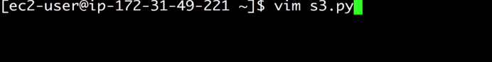

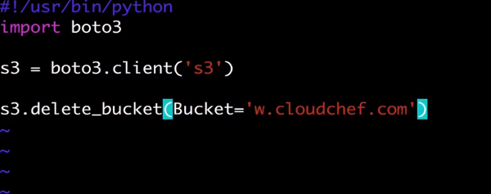

We have already installed boto3 on our machine and we already have done a lecture on this previously. We are here trying to delete a bucket which is not even created or the bucket that doesn’t exists.

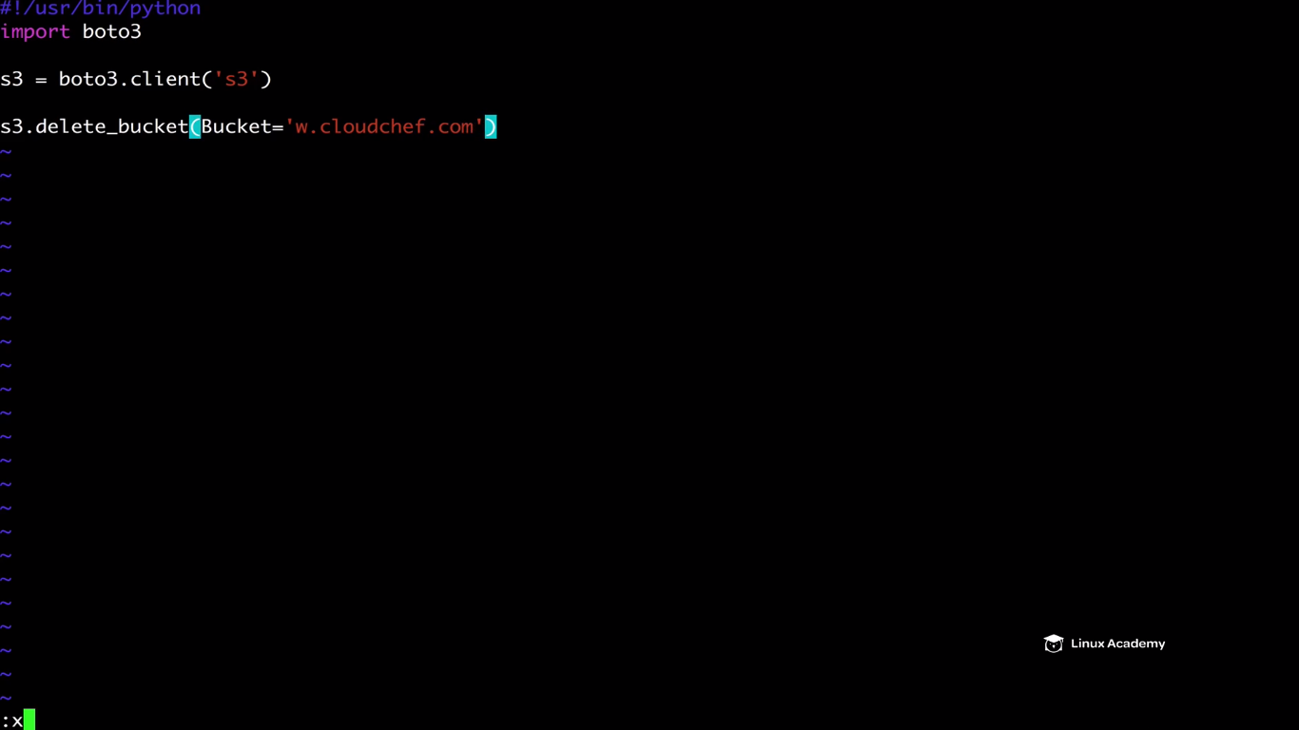

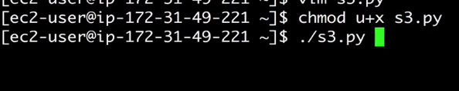

We get an exception

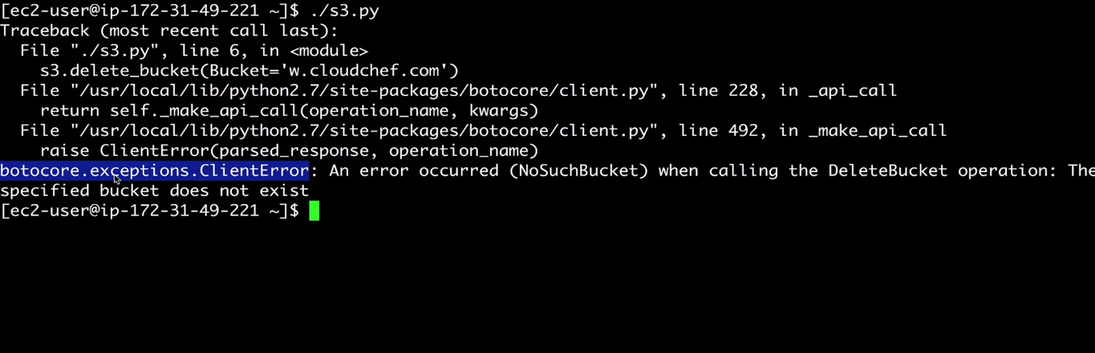

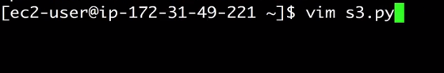

Now Im trying to delete a bucket which is not empty

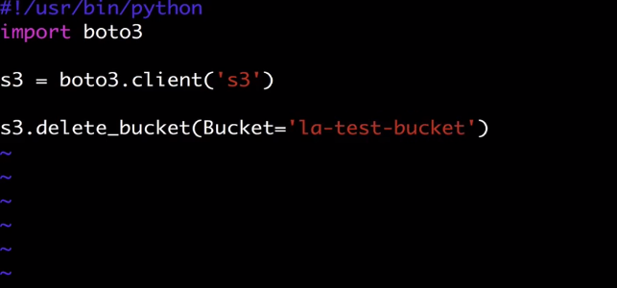

Save this by :x and run the script again.

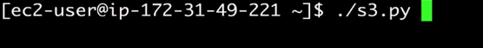

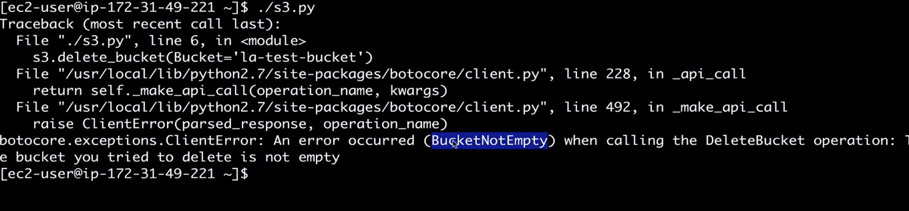

For more you can go to AWS documentation and look for the API errors as

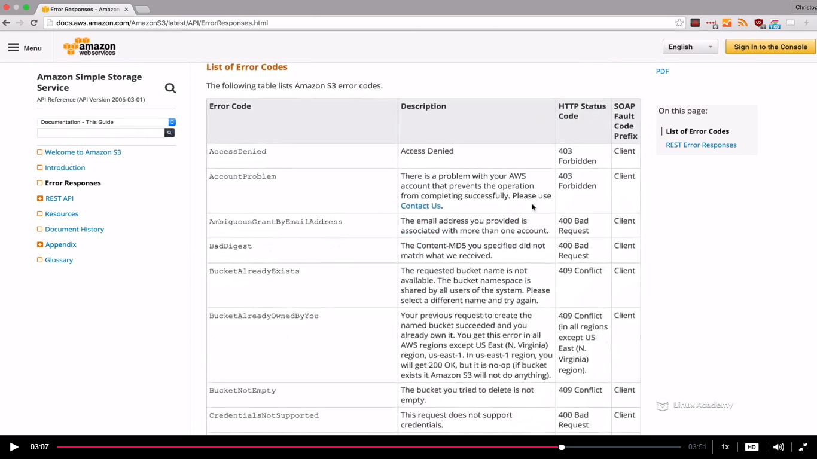

**Lecture: Python S3 Code Examples**

In this lesson we are going to use basic Python code to create S3 buckets, upload files, and delete S3 buckets, all with the Python Boto3 AWS SDK!

Now what we are doing doesn’t require to pass the certification.



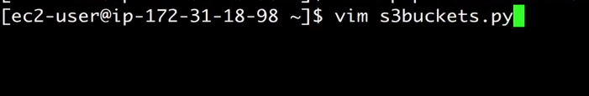

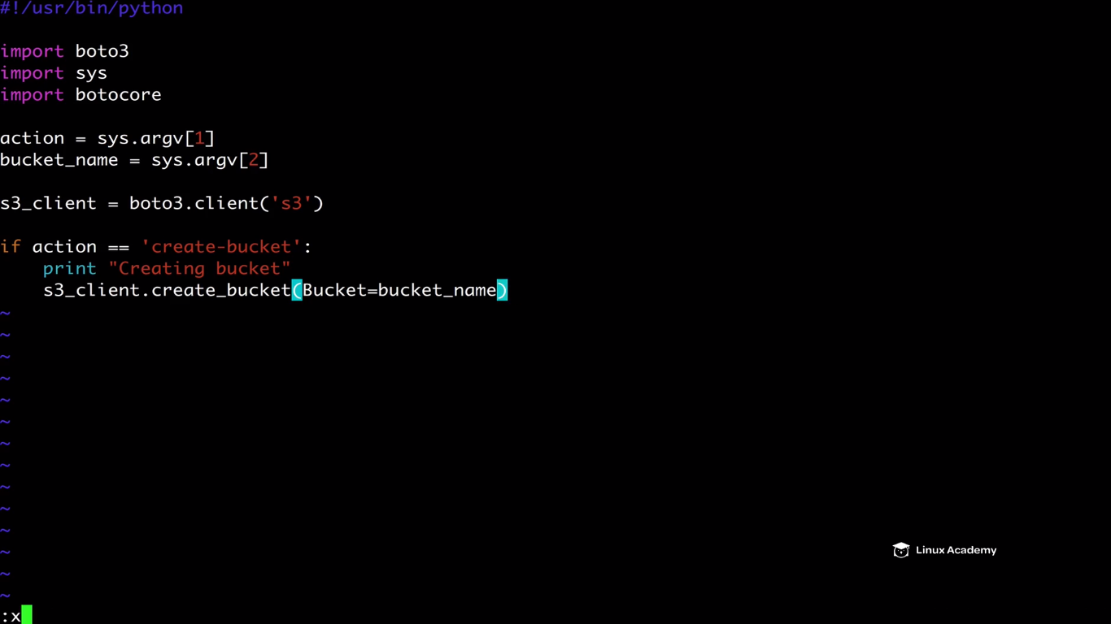

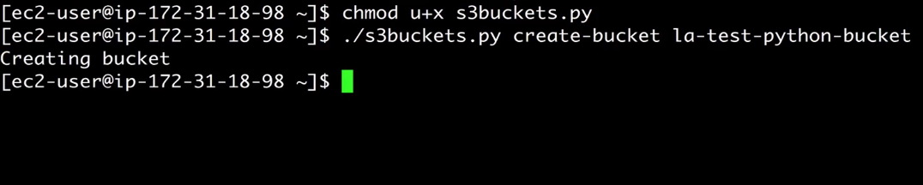

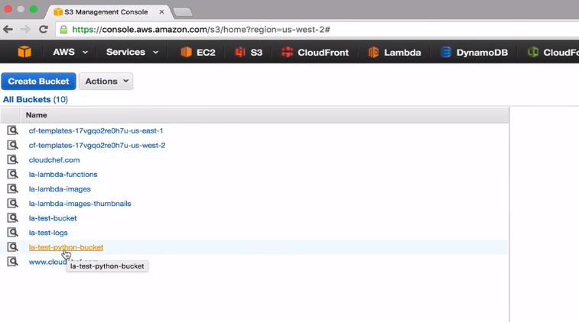

We can run the create bucket command again and again and it wont give any error or message if the bucket even exist however for delete it has a different scenario .Lets see what happens if we delete a bucket and run the delete bucket command again again.Now modify the script for deleting a bucket.

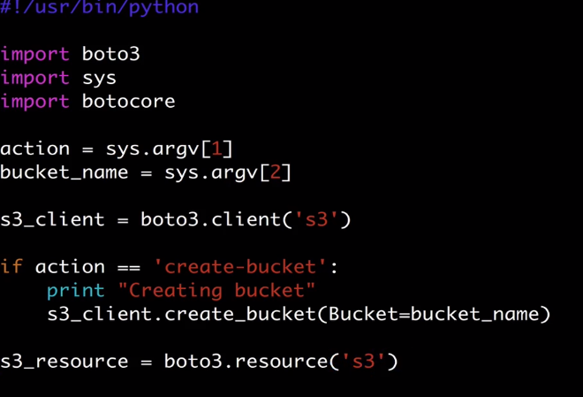

We are using s3_resource which gives us access to do others actions that we need to use.

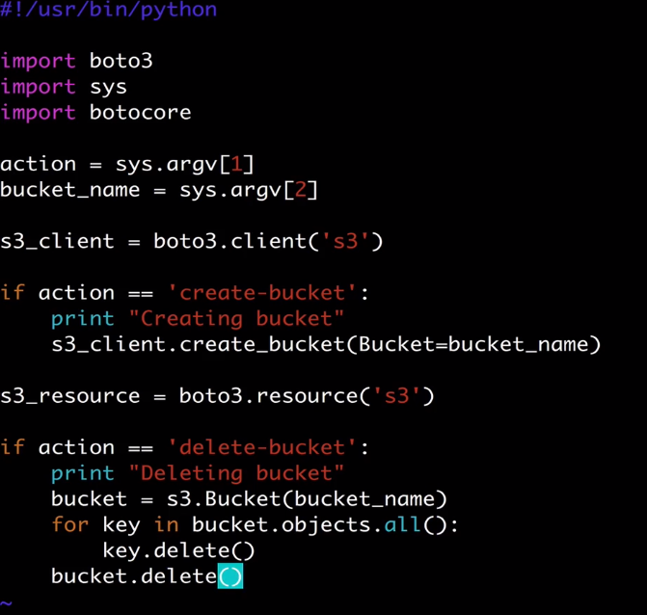

Save and exit.



Just change the create bucket to delete bucket.

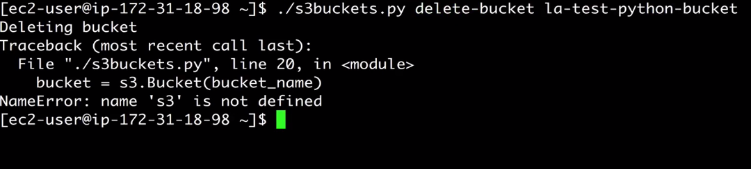

Error. Go back to the script we need to change something there

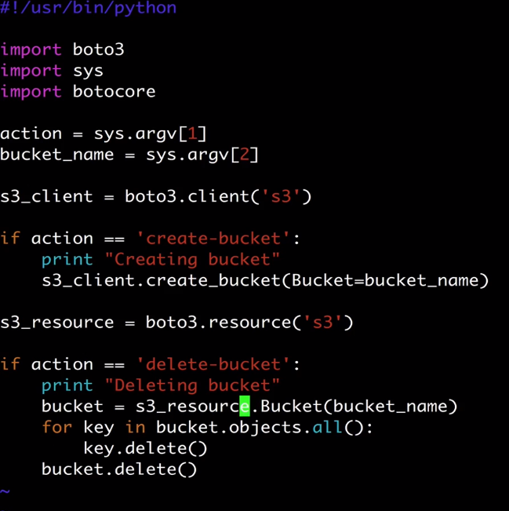

WE put the wrong variable as we were using s3 resource. Save this and try again

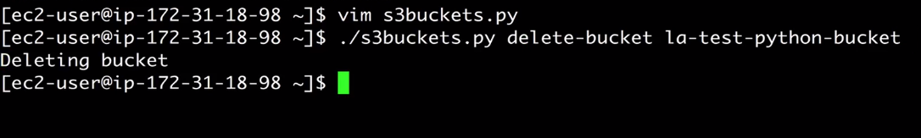

So if we verify from the amazon console the bucket is gone.

So lets try running the same command again as

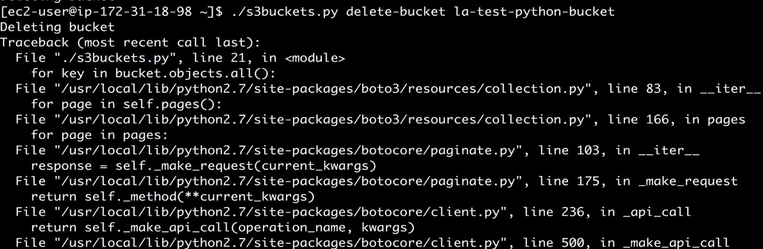

So instead of our code to fail if we want to grab the exception and do something with that. We can do that . Lets check it out. So because we imported boto core we have access to exception handling in our boto3 sdk. Boto core is the underlying core engine of boto3. Boto3 is actually built of it.

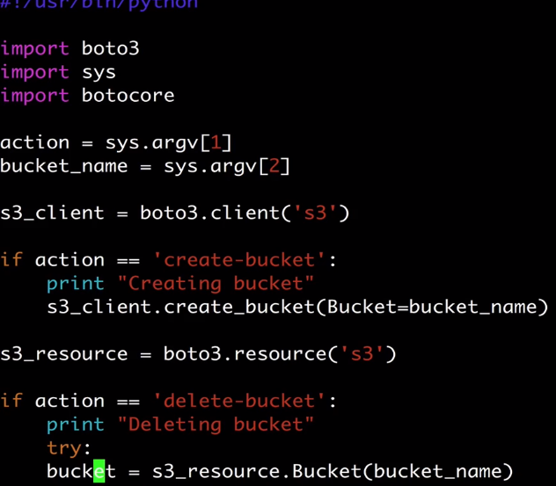

Go to the line as above as we need to indent the 4 lines so there is a trick to do that. Go to the line where the cursar is and then “press 4 ++>> “

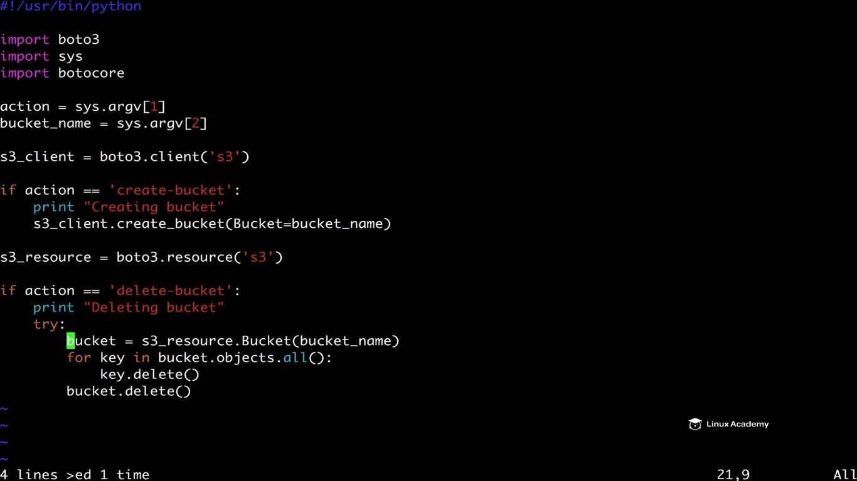

The 4 lines would indent.

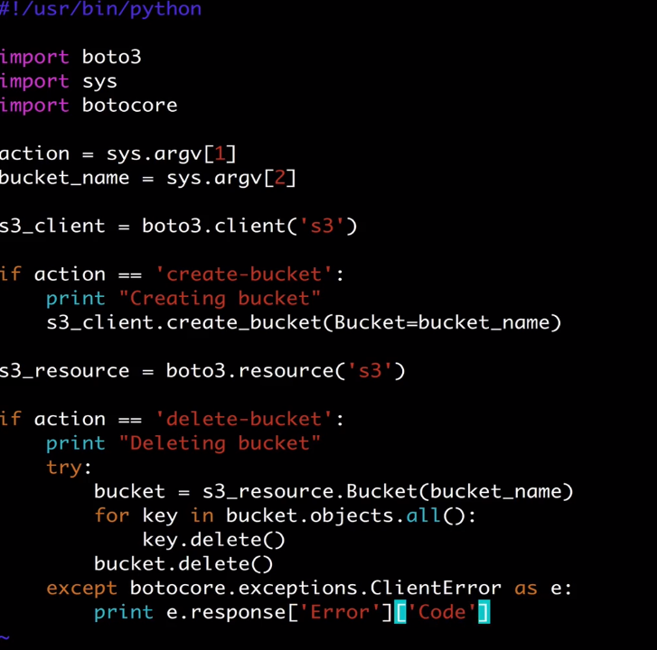

Save and exit.

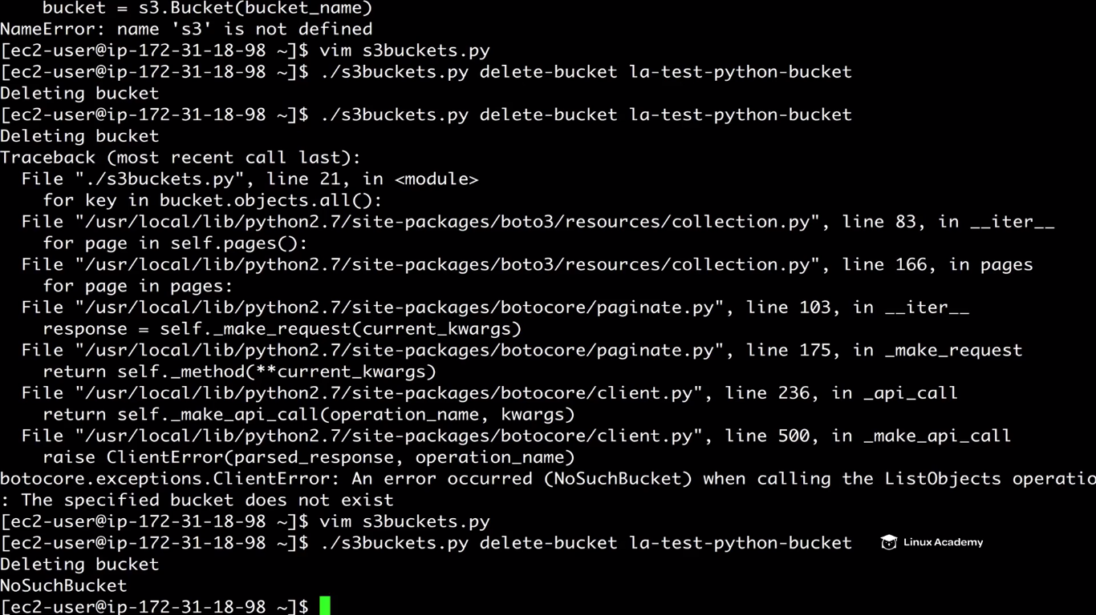

This time we just get the error message no errors like earlier.

Now lets try to upload a file to s3 bucket as we have completed creating of bucket, deleting of bucket.

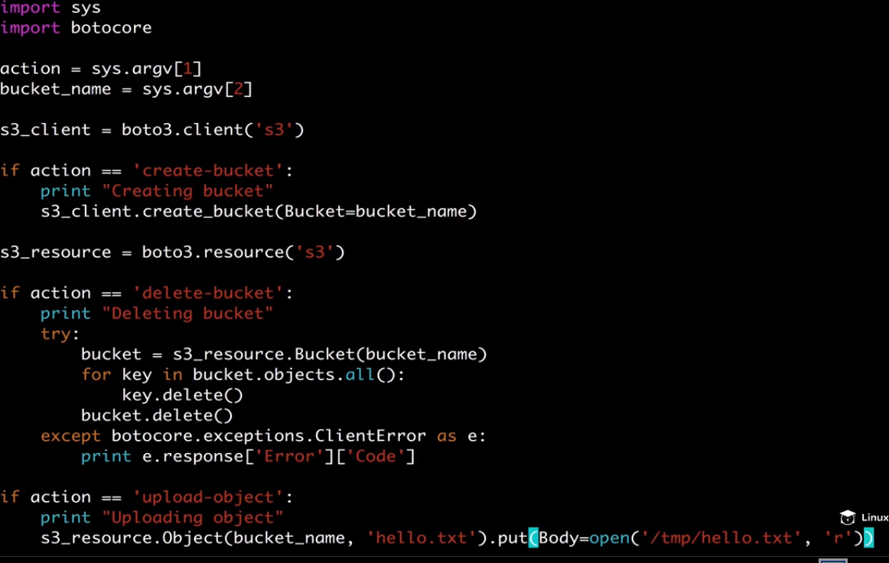

Save and exit.

Now we need to create the file /tmp/hello.txt as

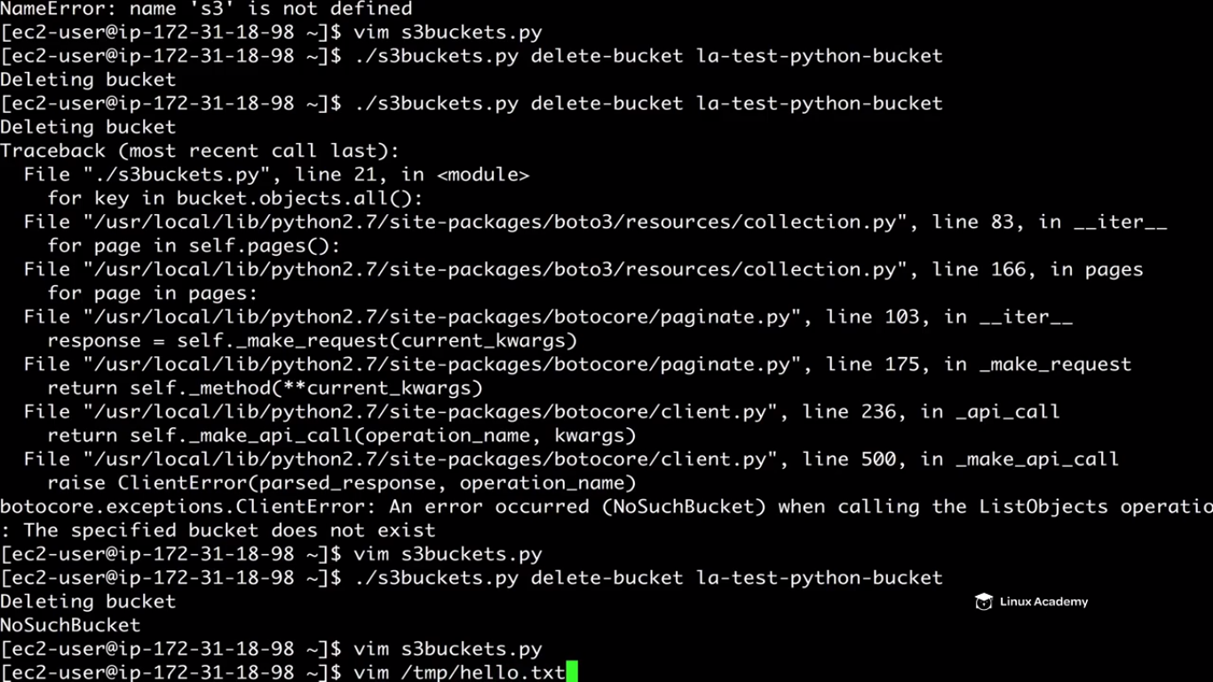

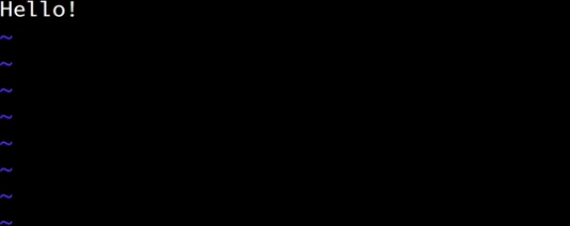

Save this.



IF you go to the la-test-bucket you would see the hello object.

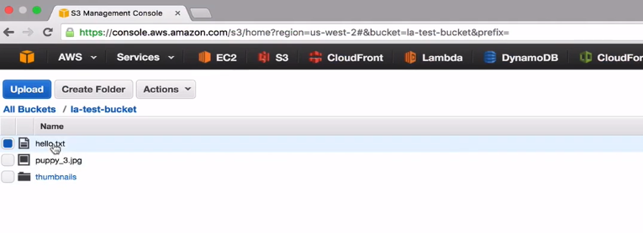

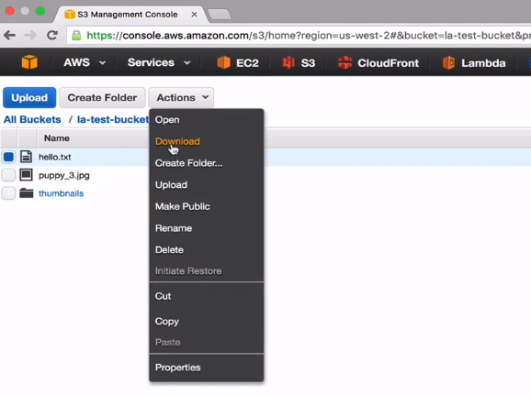

Open the downloaded file and we would see



**Lecture: Local and Global Secondary Indexes**

Secondary indexes can offer us a lot more flexibility when dealing with DynamoDB. This lesson walks through local and global secondary indexes, and when it makes sense to use one over the other.

**We have two types of indexes global secondary indexes and local secondary indexes. The main difference between the global secondary index and primary secondary index is that the local secondary index still uses the same partition key but gives a another sort key to work with it. On the other global secondary indexes gives a different partition key and a different sort key. They also change how the read and write capacity are changed. With local ones we consume the same read or write throughput from the original table whereas with global indexes they have their own provisioned throughputs for read and write which you can specify when you create the index.**

Some important information to know about the local indexes is that you can create upto 5 per table. And as we have just said the partition key must be the same as that of the source or original table. On top of that the source key must consists of exactly one scalar attribute which is a single valid attribute so not just a json document and a sort key of the source table is projected into the index where it acts as a non-key attribute. In fact every local secondary index automatically contains the partition and sort keys from its parent tables. And top of that though you can project non-key attributes into the index when you query that index dynamodb can retrieve those projected attributes efficiently. But even your application ends up querying, an attribute which is not projected into your index which can happen sometimes , the query can still retrieve the attributes. Unfortunately that will come at a greater latency and higher provision throughput cost. So you really want to minimize querying attributes that are not in your indexes if you can help it.

Lets create some indexes.

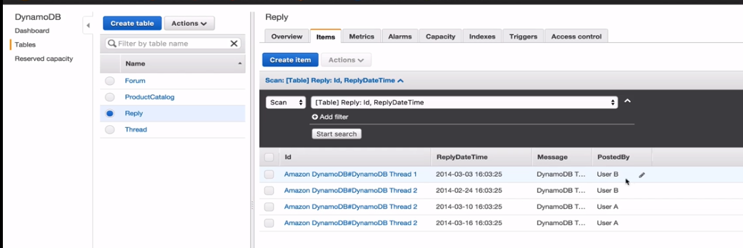

Lets say we wanna query with User, so we have a posted by attribute and we have two different users that is User A and user B. But as it stands if we want to get any information about any users we have to scan to an entire scan on the table. So if you have an application and you are doing that to retrieve the user information and you have millions and millions of items that’s going to be very costly and it could take a while to retrieve those items. That’s not a good idea. So what we want to do instead is that we want to create a global index or a local index.

Go to indexes while table selected as

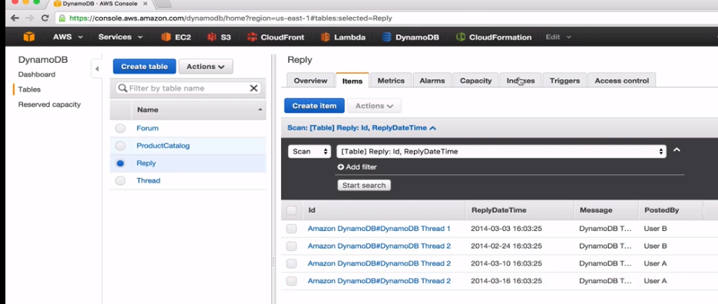

Create an index

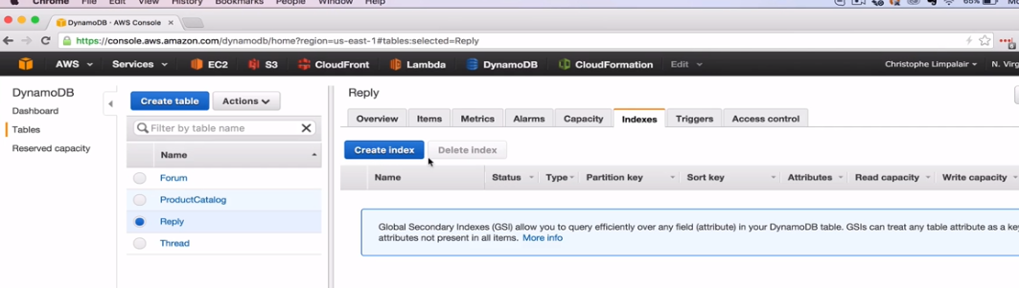

Take note this is going to be a global secondary index, you can’t a create a local secondary index after the table has already been created.

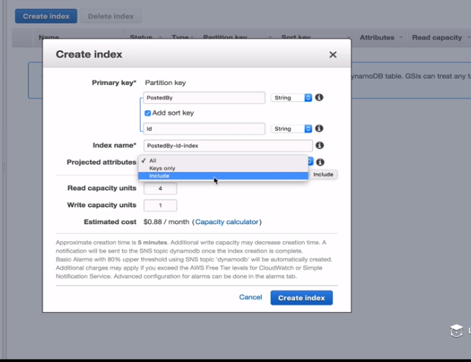

**What is a projection and an projected attribute**. A projection is a set of attributes that is copied from a table into our secondary index. So the partition key and sort key of the table will always be projected into the index as we already mentioned earlier. You can also project other attributes that might be needed in your application quarries. So when you query your index dynamodb will also be retrieve those attributes as if they were in the table of their own.

We have 3 options all, keys only and include to choose from. If we choose keys only, this is only for the table partition key and sort key values plus the index key value which gives the smallest possible secondary index. If we select only include then its like the keys only plus the other non-key attributes that we can specify. And we can specify them here as

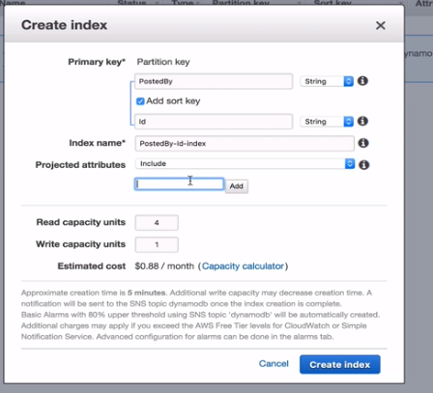

The last option is clicking on all. This is largest possible secondary index and includes all the attributes we have in our table. So whats the point of the attributes really then.

As you might be able to imagine it gives us a performance advantage and that’s something you must keep in mind as a developer because if you are fetching attributes that are in your index and it will still pull them in automatically bdw but if you are constantly doing that you wont get a performance benefit. So if you have certain attributes that you often query in your application it may make more sense to have them as a secondary index. However if you only planning querying on that attribute on occasion then the extra cost for projecting it may not be worth it. So in this case I select all as secondary attributes and a read capacity of 1 and write capacity of 1. Keep in mind that the global secondary index has completely different read and write capacities then the table.

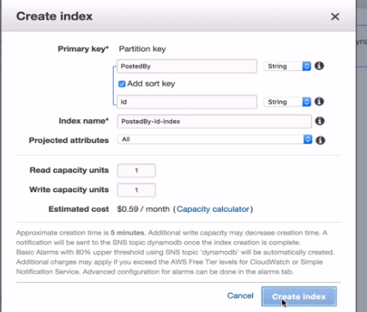

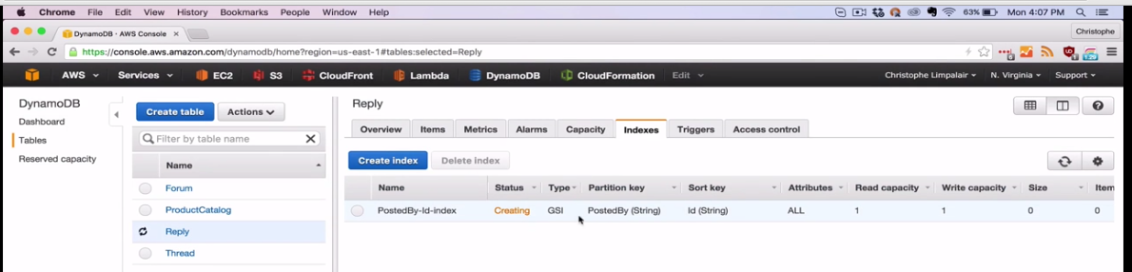

Its creating

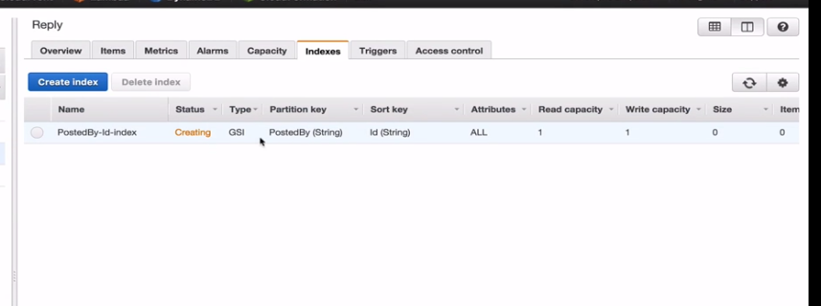

We have a type as GSI(global secondary index).

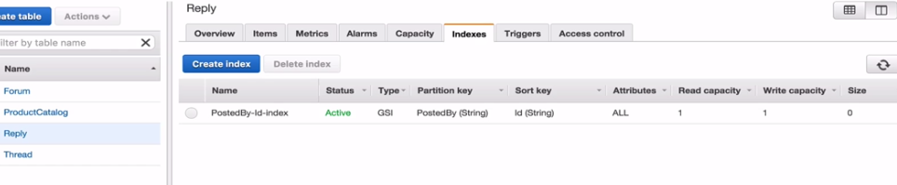

Its active now. So one thing to remember as a developer is that you never write to the index. So dynamodb automatically keeps all secondary indexes data synchronized. So with global secondary indexes data is updated asynchronously using an eventual consistency model. So changes usually update in a fraction of a second but your application should be built under the assumption that data may not be upto date. So if something happens lets say if there is failure on AWS part anything like that it may take a bit longer then that to update and so your data could be stale for a short amount of time.

Go to reply table or click items

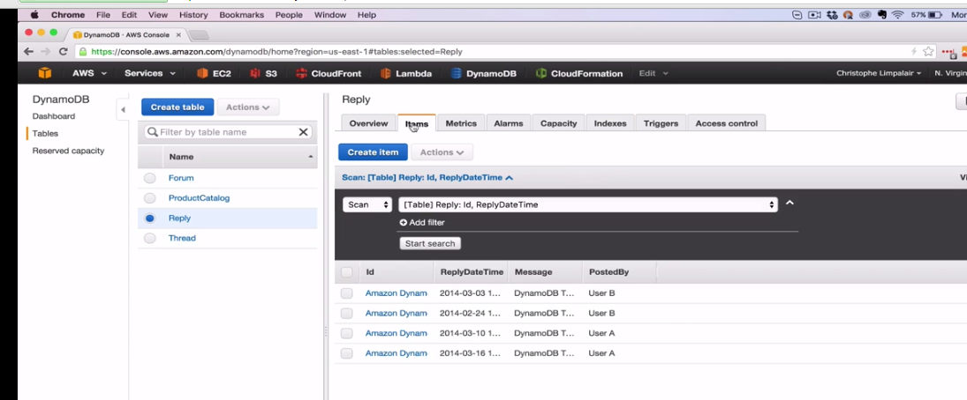

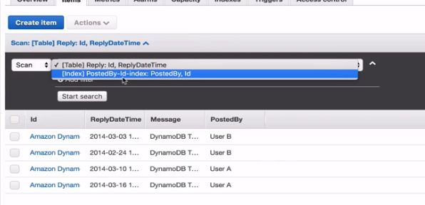

IF we click, we see the secondary index. Sometimes it takes sometimes so you may refresh. Lets click this and do a scan or a query

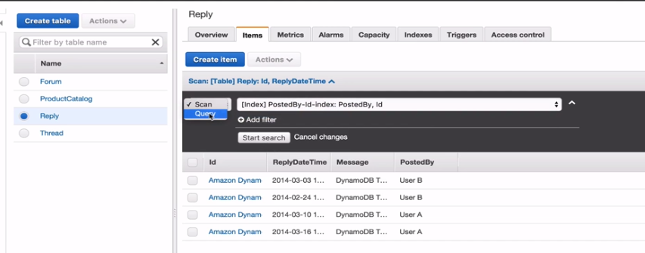

So if earlier we selected our main partition index as

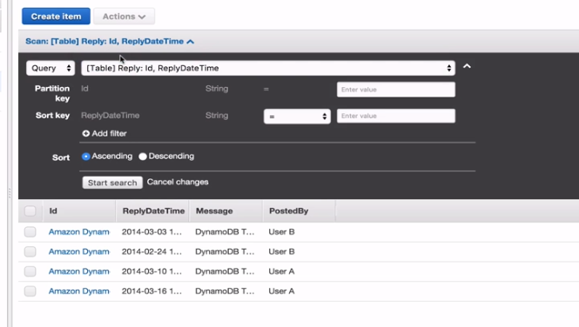

Then we used to search via a id and ReplyDateTime and if now select our secondary partition key as

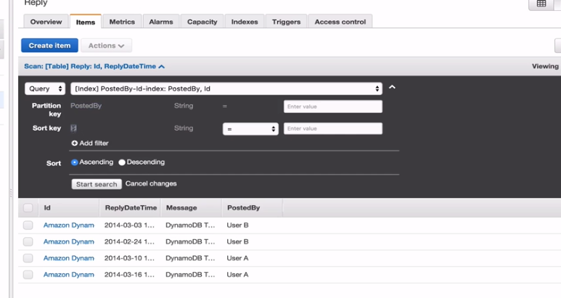

IT changed our partition key as Postedby and sort key as id. Lets try it out. Select User A

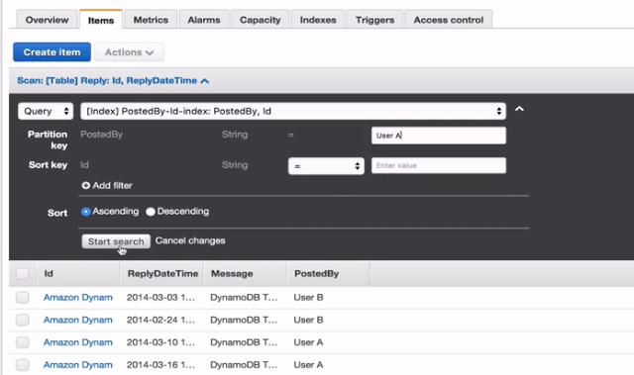

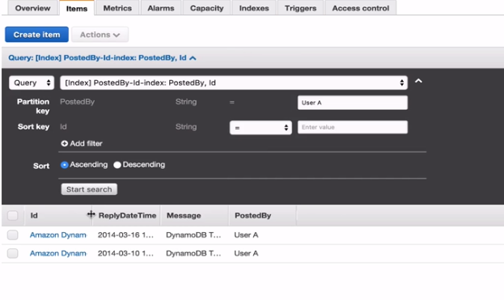

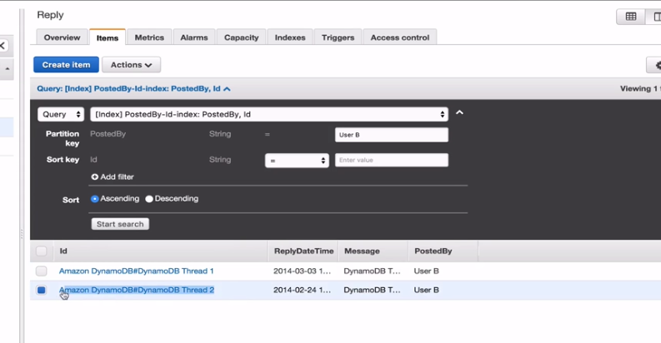

Paste the copied id from the previous step to here as

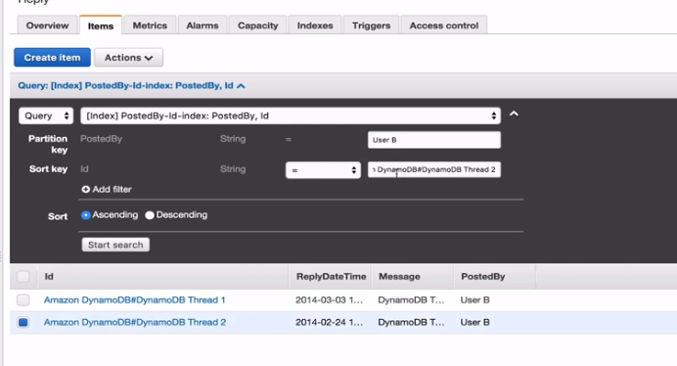

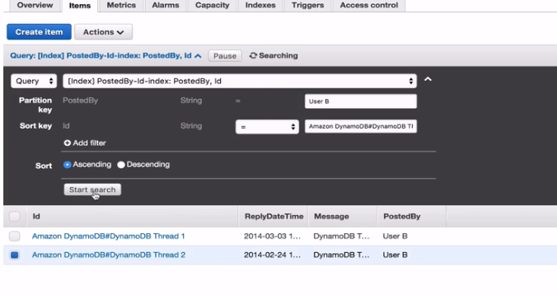

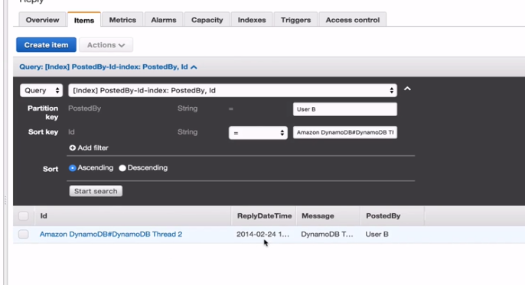

This gives a completely different model of how we can query our data in this table. Earlier we have to scan entirely and go to the entire data that we got back within our application logic and then filter out User B. We can now query userB using a global secondary index.

Now lets look at the local secondary index. Sometimes you want to use that especially if you are trying to change the sort keys so that we have multiple sort keys and since we can have upto 5 local indexes we could have 5 different keys on top of original table sort keys so that makes 6 different sort keys.

Lets go and create a new table.

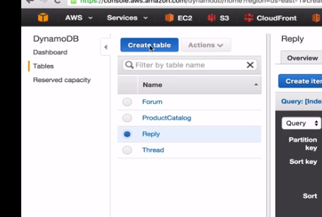

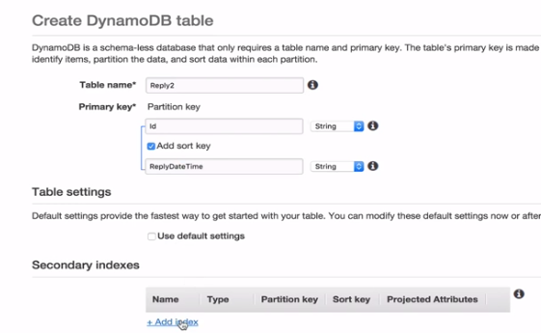

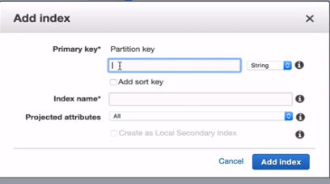

This could be global index or a local index. So the only way we can make this a local secondary index is by using the same partition key

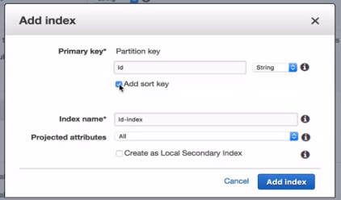

The moment we check the add sort key by putting the same partition key as of the table we get an option of creating this a local secondary index down at the last.

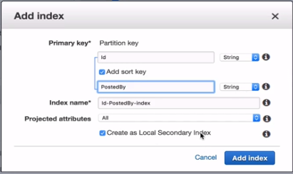

However if we chage the partition key to something else as

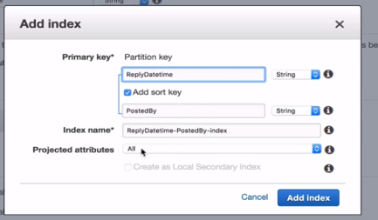

We see that there is no option of making this index as the local secondary index. So lets change it back to previous setting for local secondary index

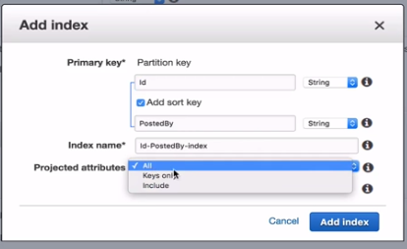

And now here we have an option to choose from and lets choose keys only. And this is again for the table partition key and sort key values and the index key values. So the partition key is id, the sort key value is PostedBy and the ReplyDatetime that we have defined in the sortkey of the table while creating the table as

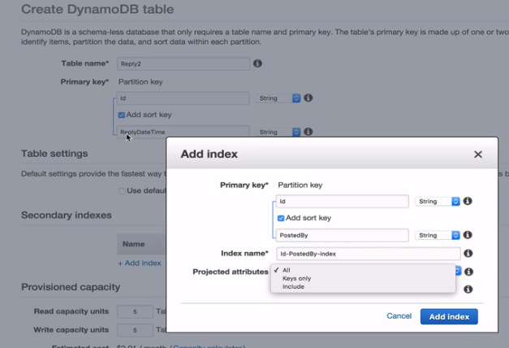

And plus the index key values .

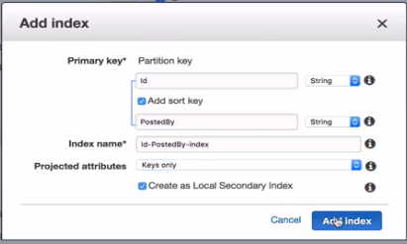

Change the provisioned setting to

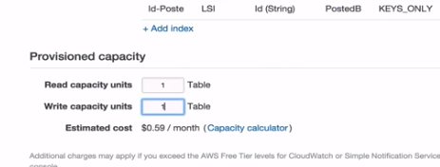

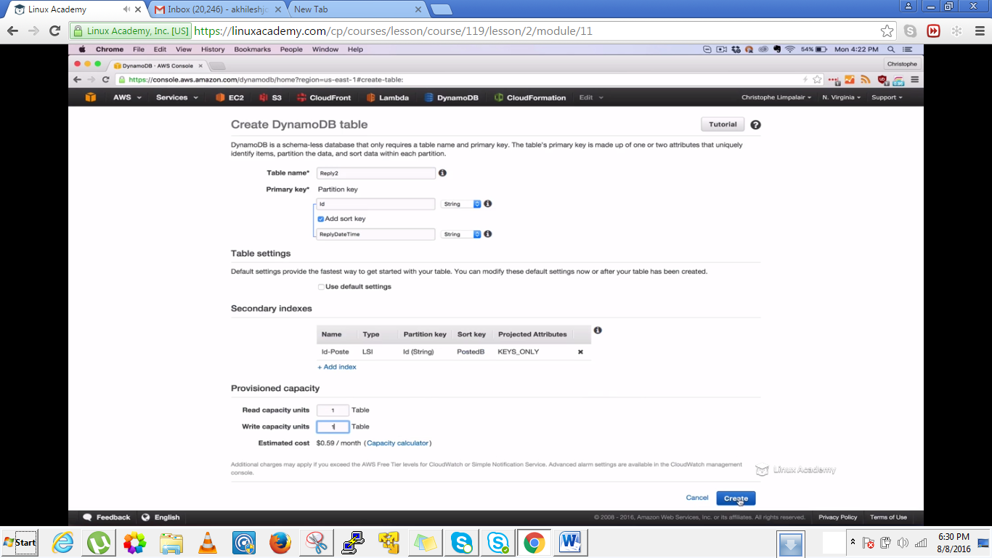

So we will wait for the table to be created and once the table is created we will go to the indexes tab and this time we see LSI(local secondary index) however the status is N/A as it would take time to get into active state.

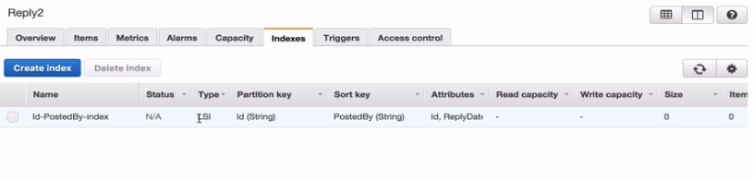

And one thing to remember when we created the local index we selected the projected attributes as keys only so what that means is that if we go to the attributes here as

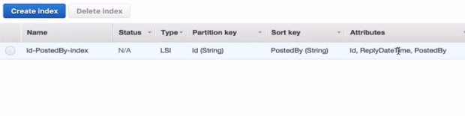

We only have 3 attributes id, ReplyDatetime, PostedBy. This is because only keys include the partition(id) and sort keys(ReplyDateTime) plus the index key values(PostedBy and id)

However in the table reply where we created global secondary index as

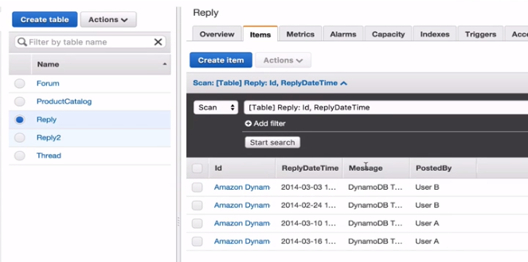

WE have a message attribute here which means that if we need to query this table for information like who posted this message and if we have a local index which do not have this message attribute then that index wouldn’t have of use so we need to have use all attributes there and for the local index to have the message attribute we need to delete the table and need to create a new table with all attributes selected in the projected attribute section. Because if keep querying using the Reply table using our local secondary index which don’t project the message attribute its not going to get the performance benefit that indexes are supposed to get.So I need to either create a global index with the message attribute or need to delete the table and need to create a new table with all attributes selected in the projected attribute section.

And now see how to query using the local secondary index and the primary index

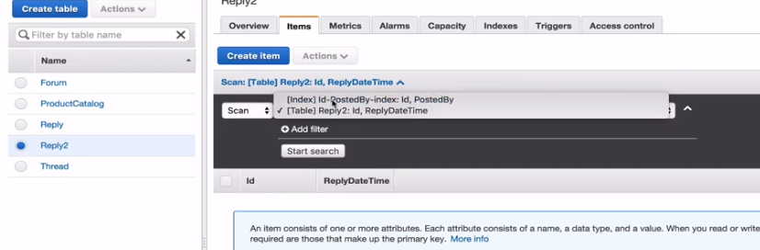

We can select from those and see the difference between the indexes we can search for .

**Lecture: DynamoDB Overview and Limits**

In this lesson we will take a closer look at a few of the concepts we learned from our previous lessons. We'll do another high level overview as well as discuss some of the important DynamoDB limits that Certified Developers need to be aware of.

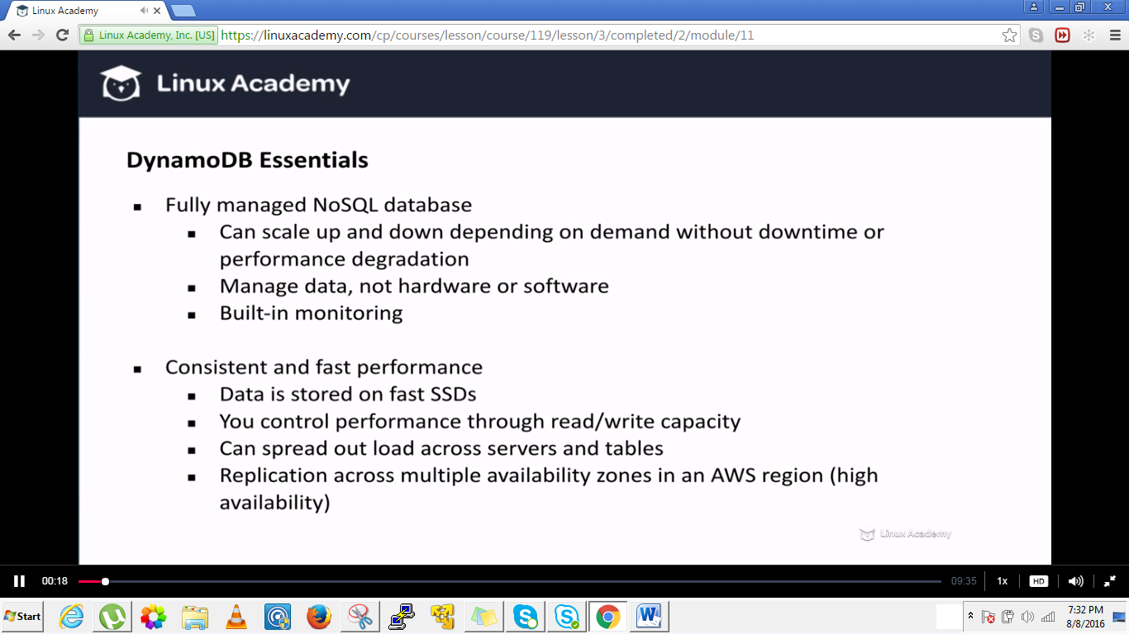

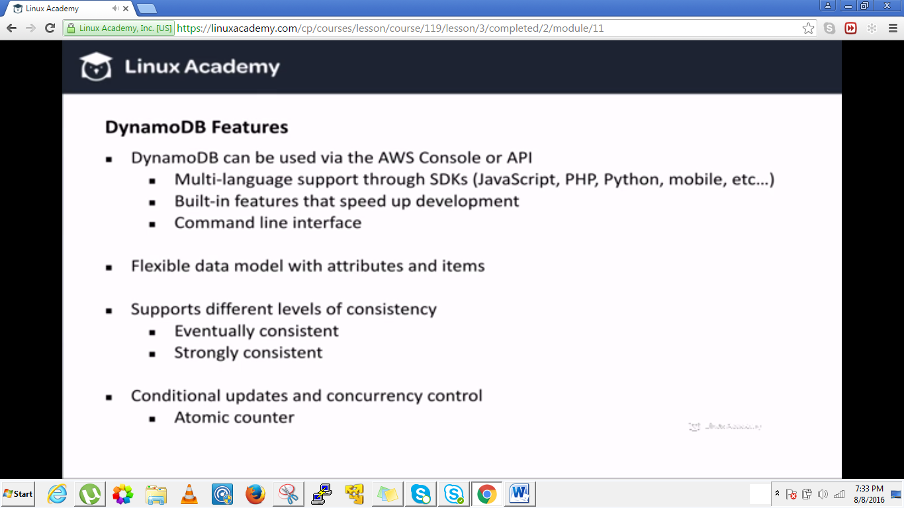

Flexible data model with attributes and items. Data types comprises of scalar types which are single values like numbers, strings, binary values, Booleans and even and document types like lists and maps or even set types like strings sets, number sets, and binary sets.

Conditional updates and concurrency control ensures that data updates aren’t overridden by other users who are updating the information at the same time. So dynamodb for example supports something called a conditional write which gives us the option to specify a condition when updating an item. And dynamodb only writes the data if that condition is met. So if you say you want to write a data under this condition, if the condition is met I don’t want to write the data, I want you to return an error.

Atomic counter are also supported which lets you add or subtract from an existing attribute value without interfering with another update even if they are running at the same exact time.

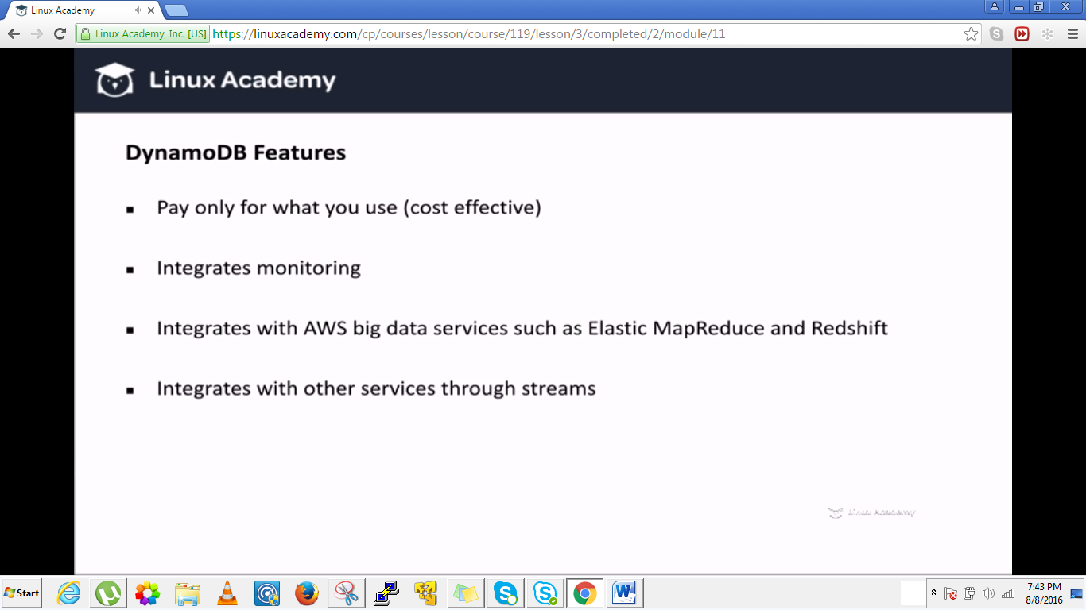

**Integrates with other services through streams lets say with lamda. Lamda can trigger a function when a certain event occurs in dyanamodb. For more on lamda do a course.**

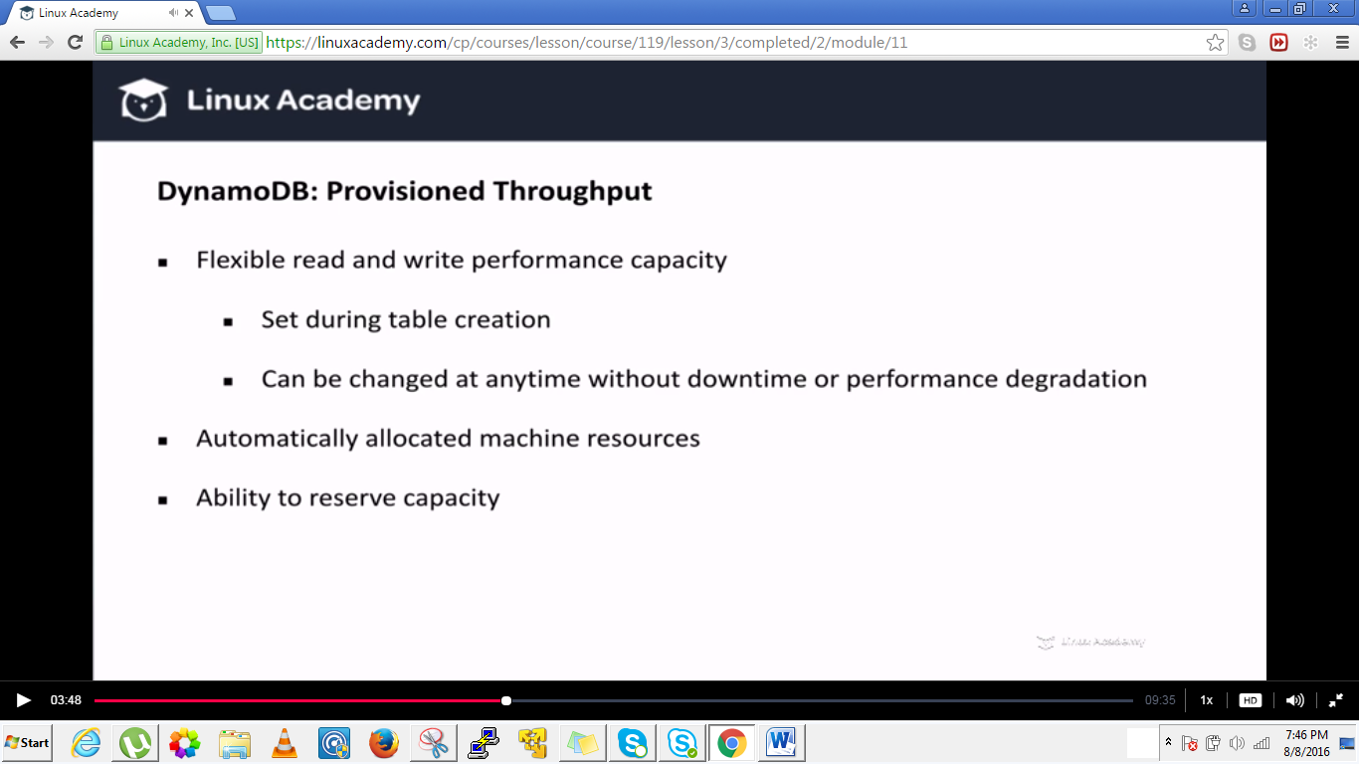

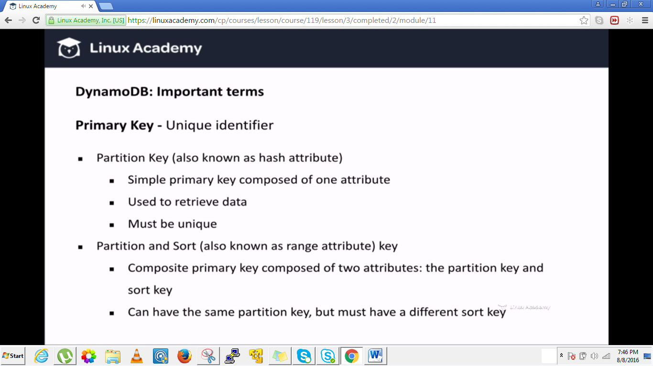

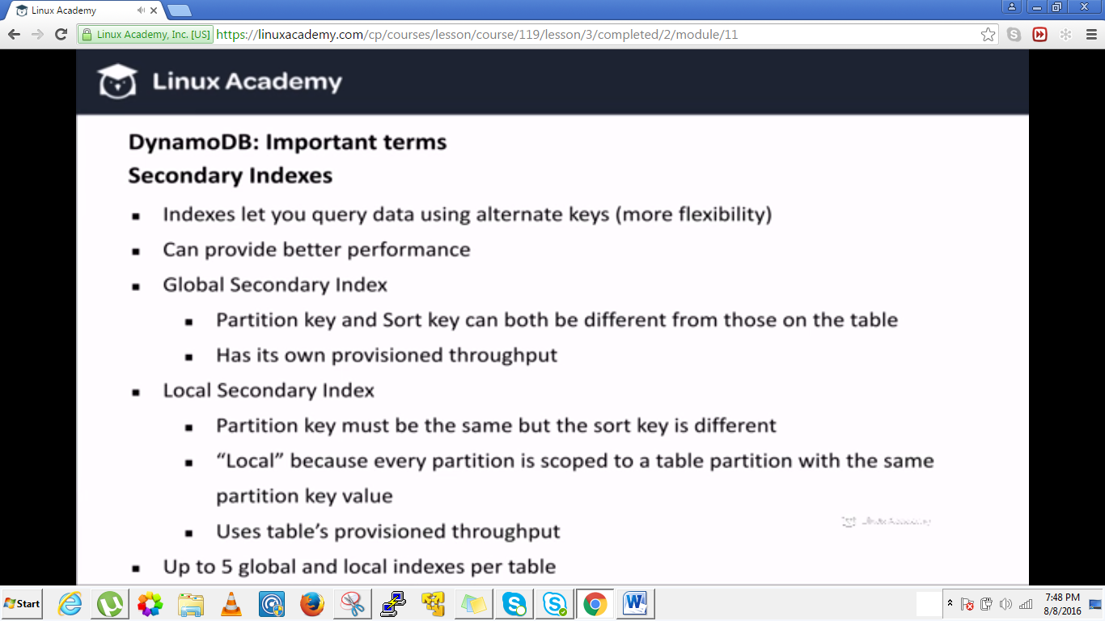

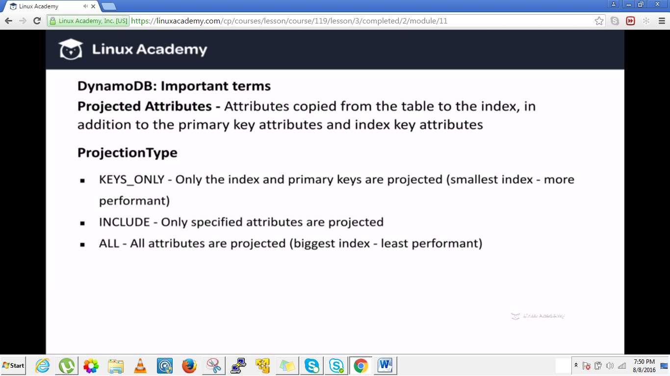

**Upto 20 attributes can be projected in case you select Include in the projected attribute option.**

**Even if you query against a secondary index and use keys only and then you query for an attribute that’s not the index or any other primary keys which means that its not being projected in the index. Dynamodb is still going to query that information, its just gonna go to the main table and set fetching it from the index. So that not a major problem if you are using that in your code, its however does cause more latency and it does cost more read capacity. So keep in mind.**

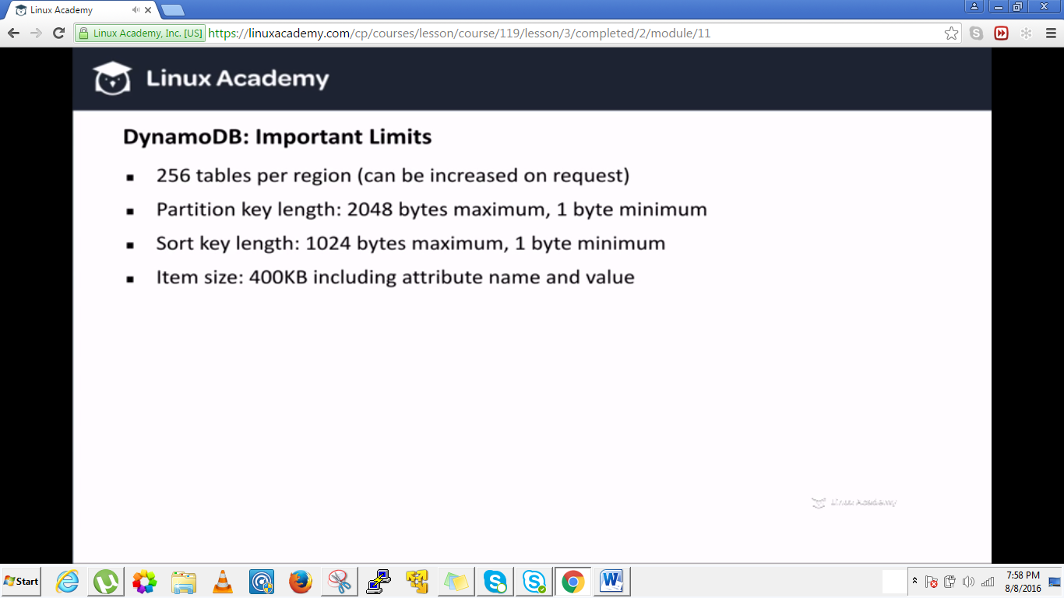

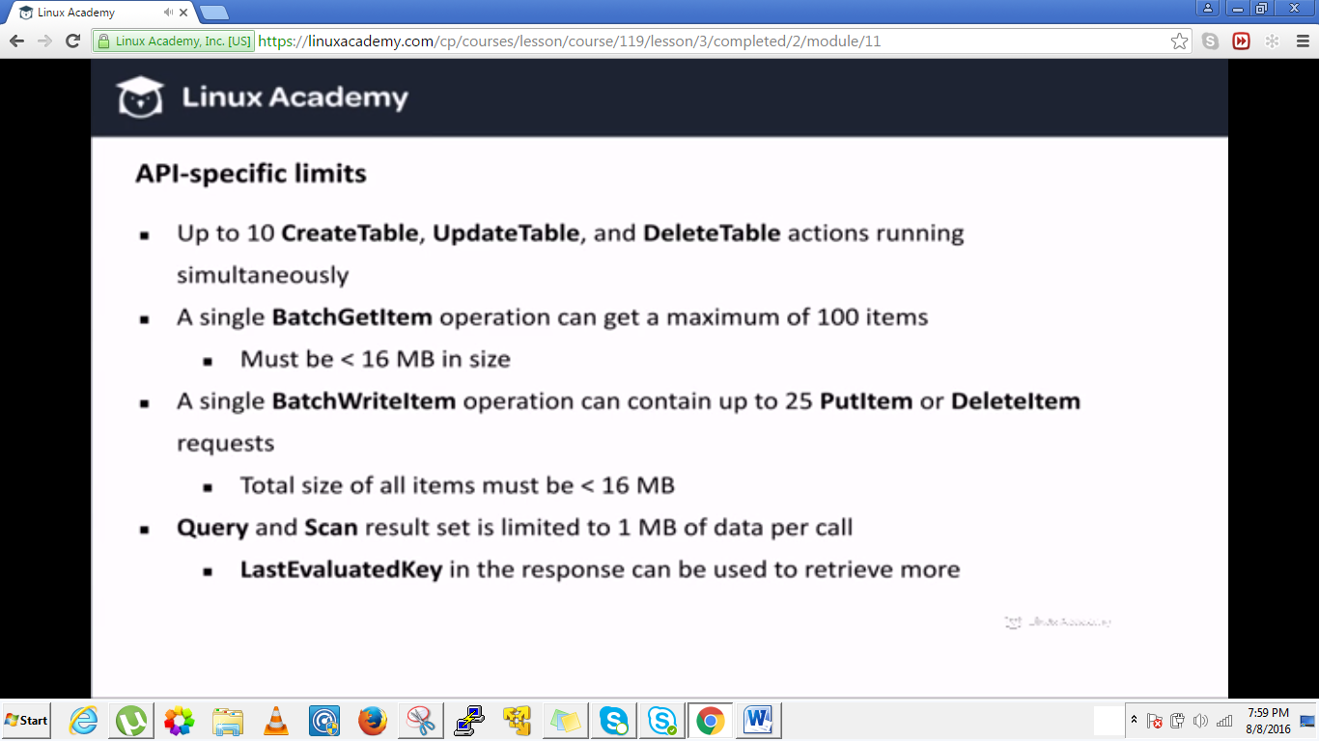

**Lecture: Provisioned Throughput**

In this lesson we are going to learn how to calculate needed provisioned throughput on our DynamoDB tables. This is a very important concept because it directly affects performance from your application to DynamoDB.

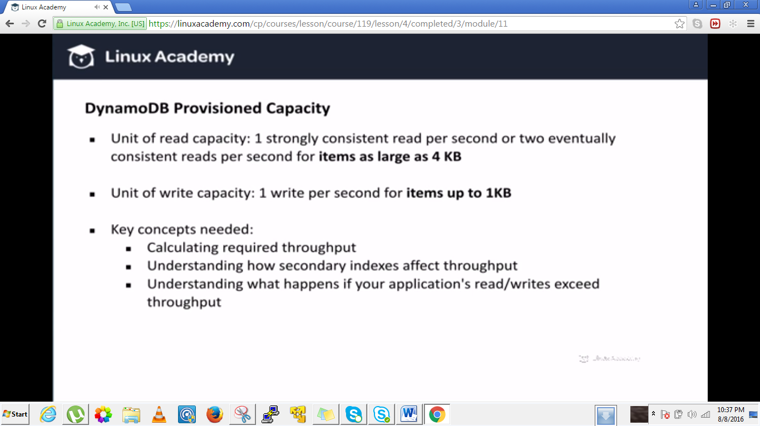

**By setting read and write capacity we can tell amazon web services how much hardware capacity to provision inorder to meet our performance capacity. We have provision to change our read and write capacity during table creation and even after the table has been created without any downtime or degrade performance.**

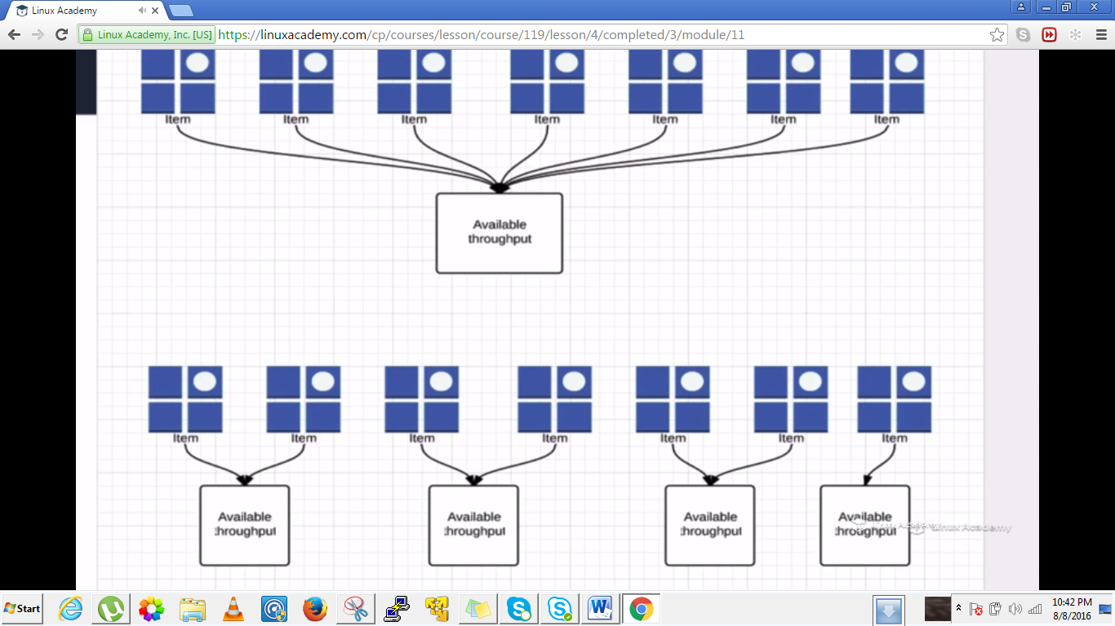

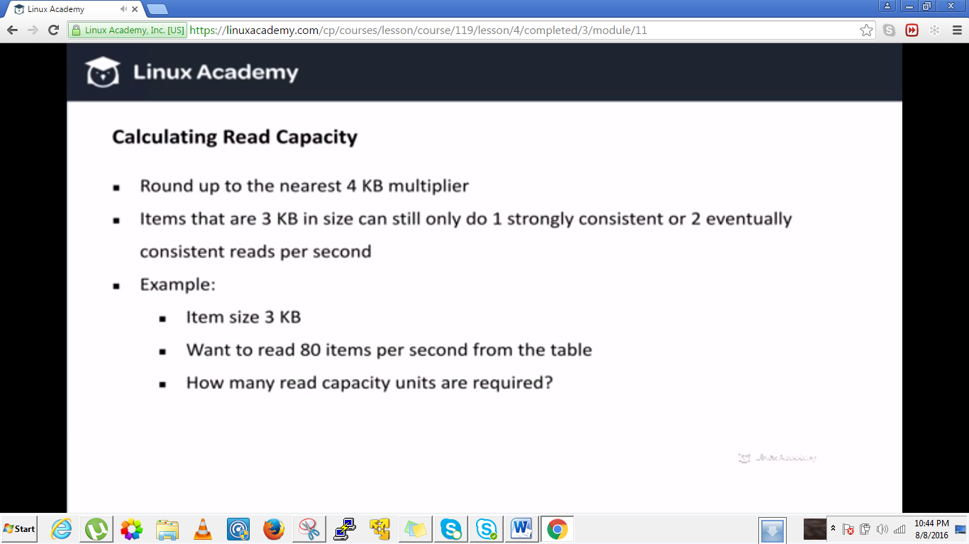

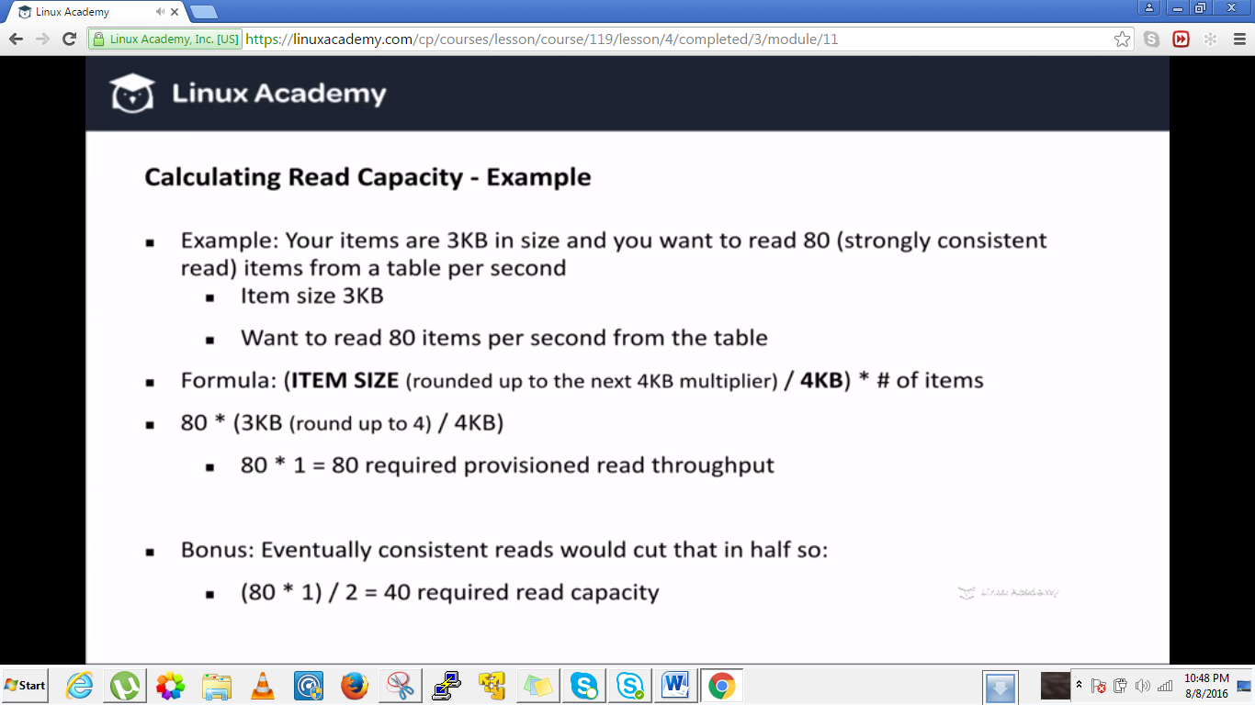

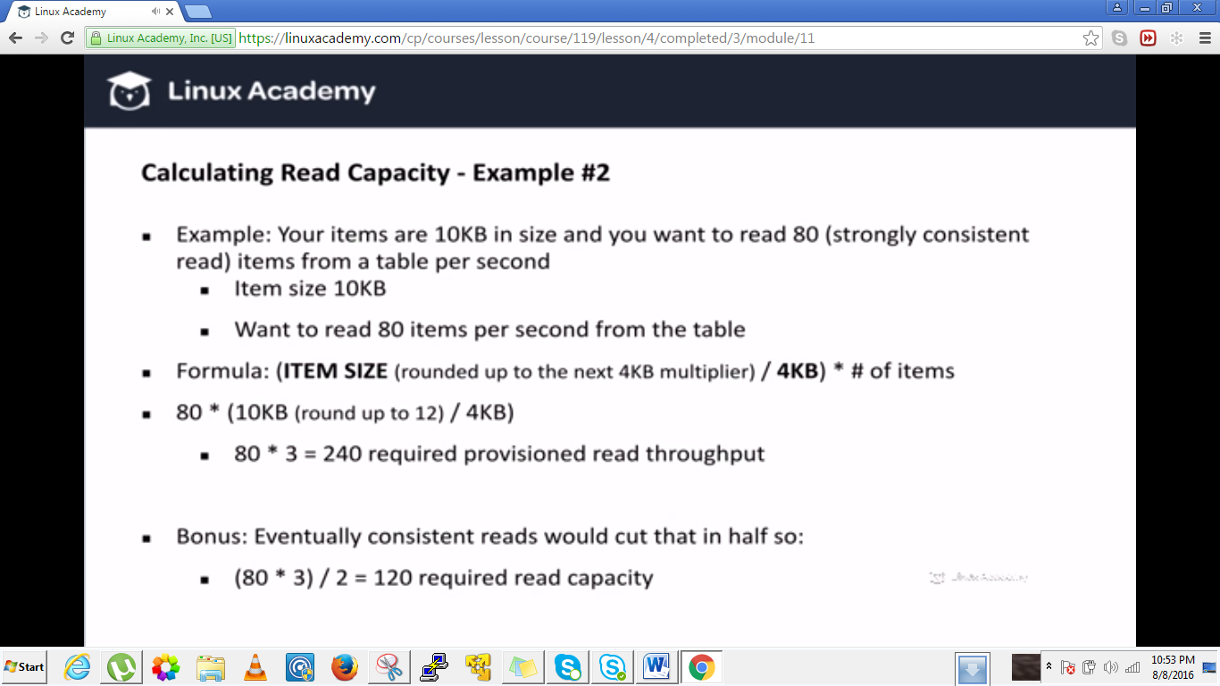

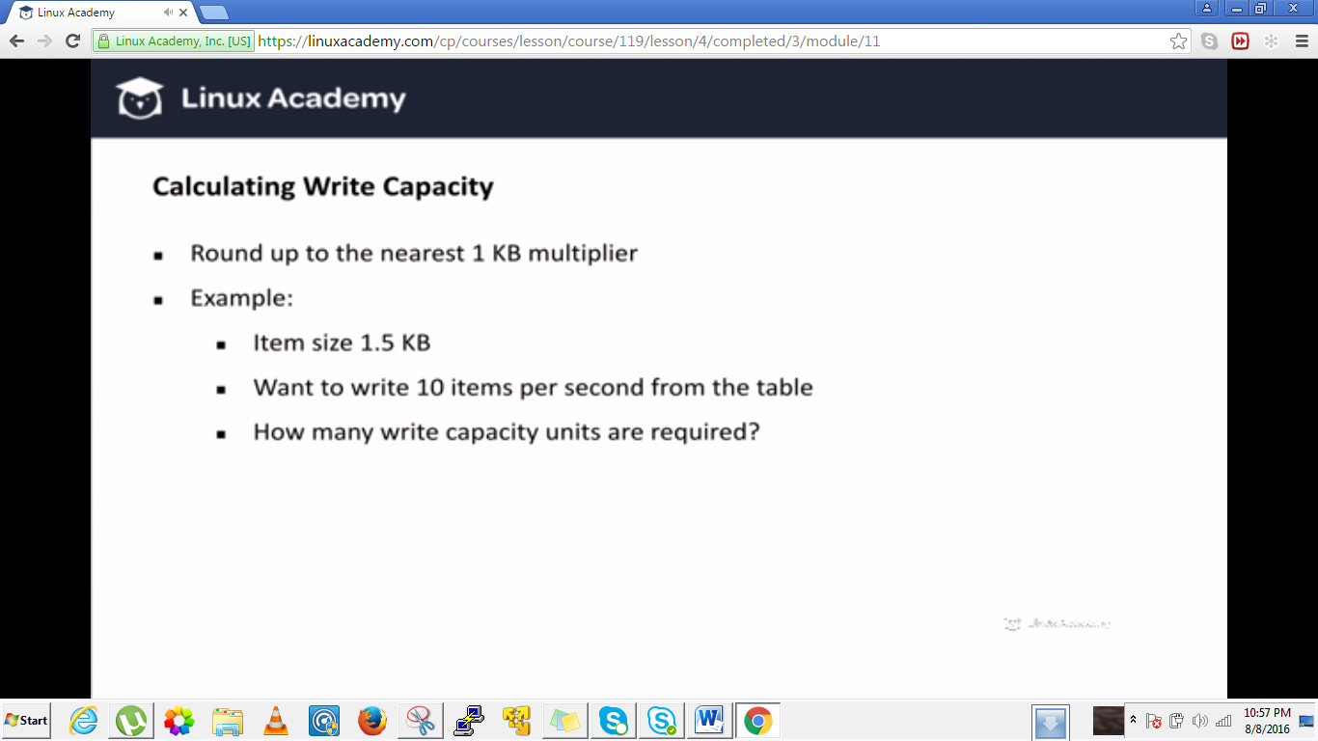

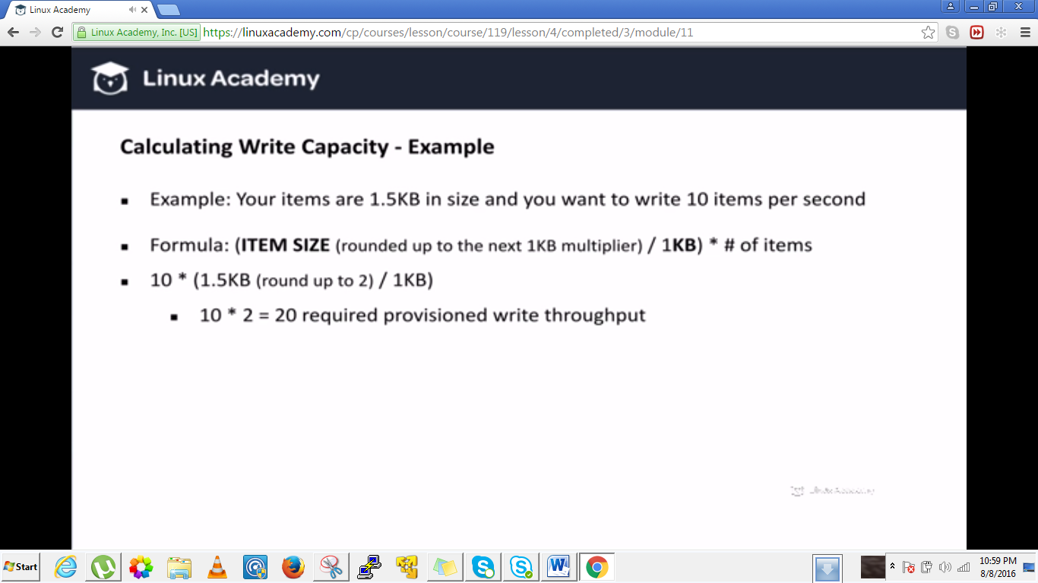

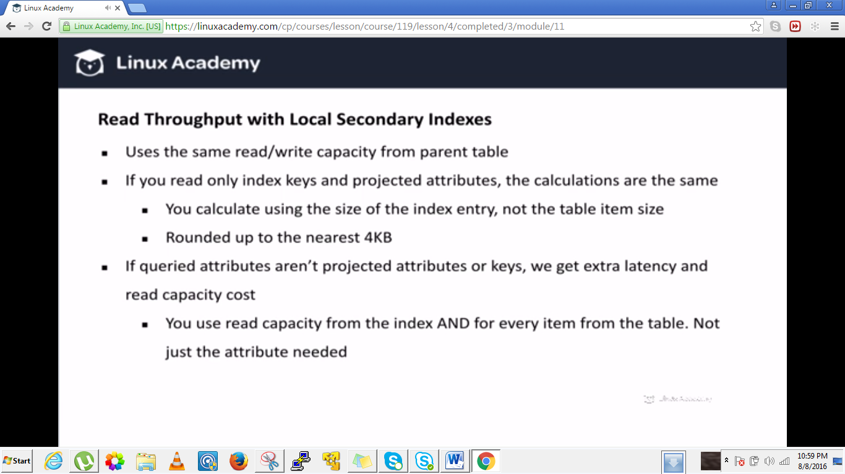

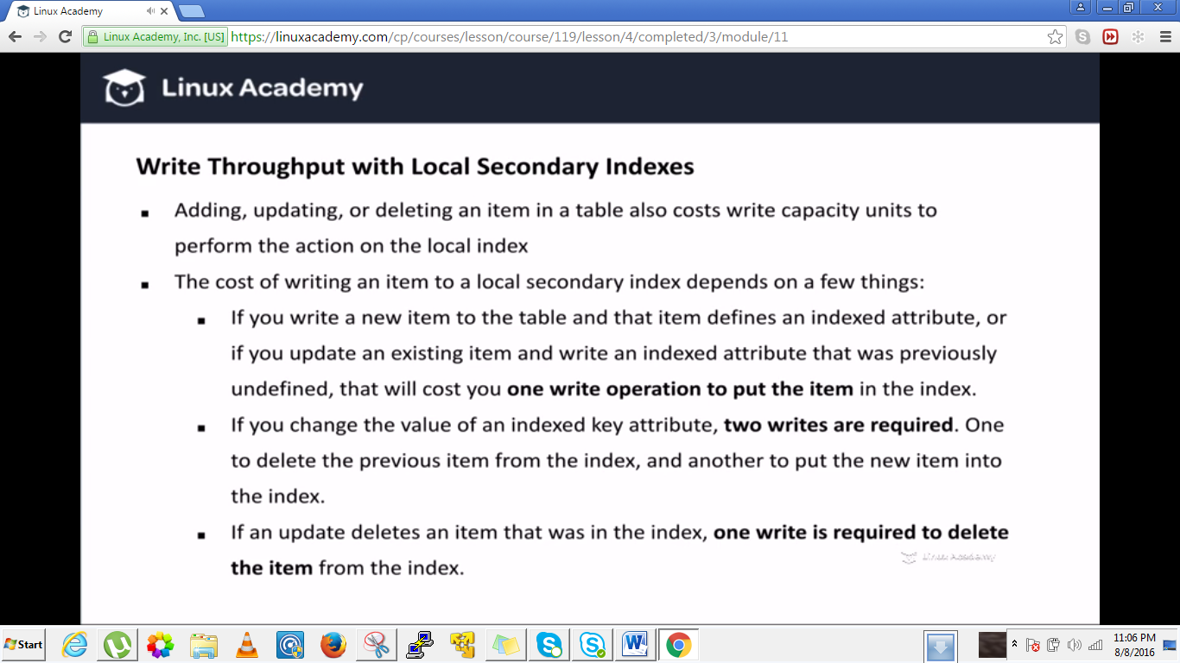

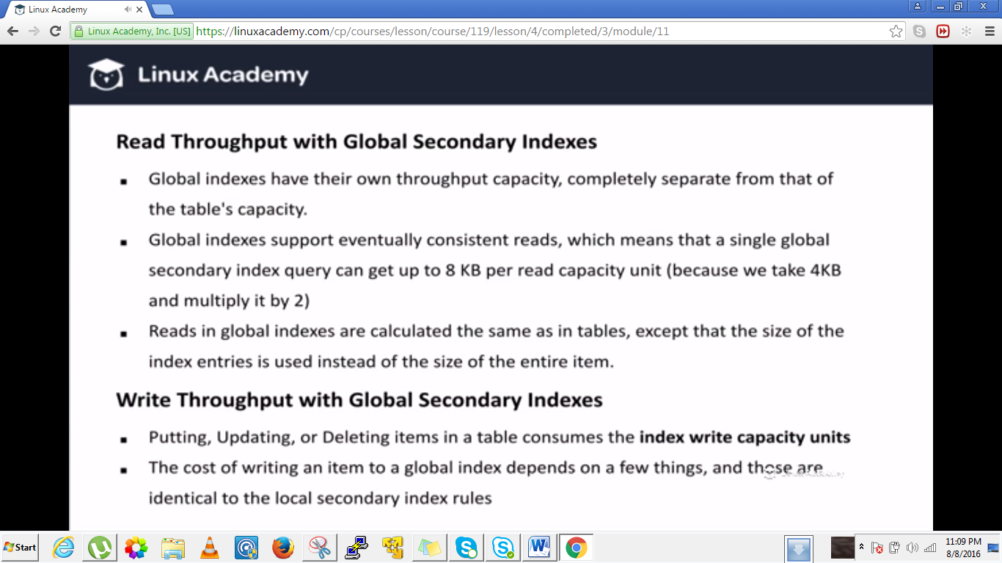

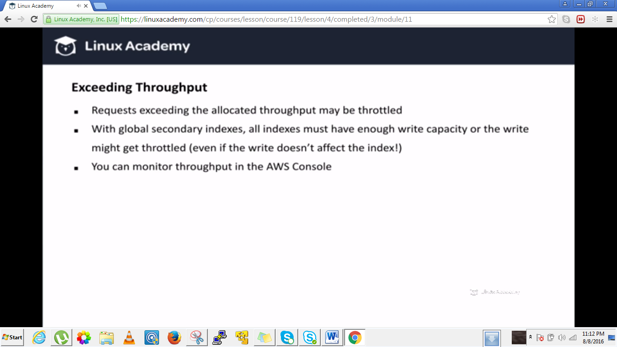

**Lecture: Query vs Scan API Calls**

In this lesson we are going to discuss performance considerations when using a Query API call vs a Scan API call in DynamoDB

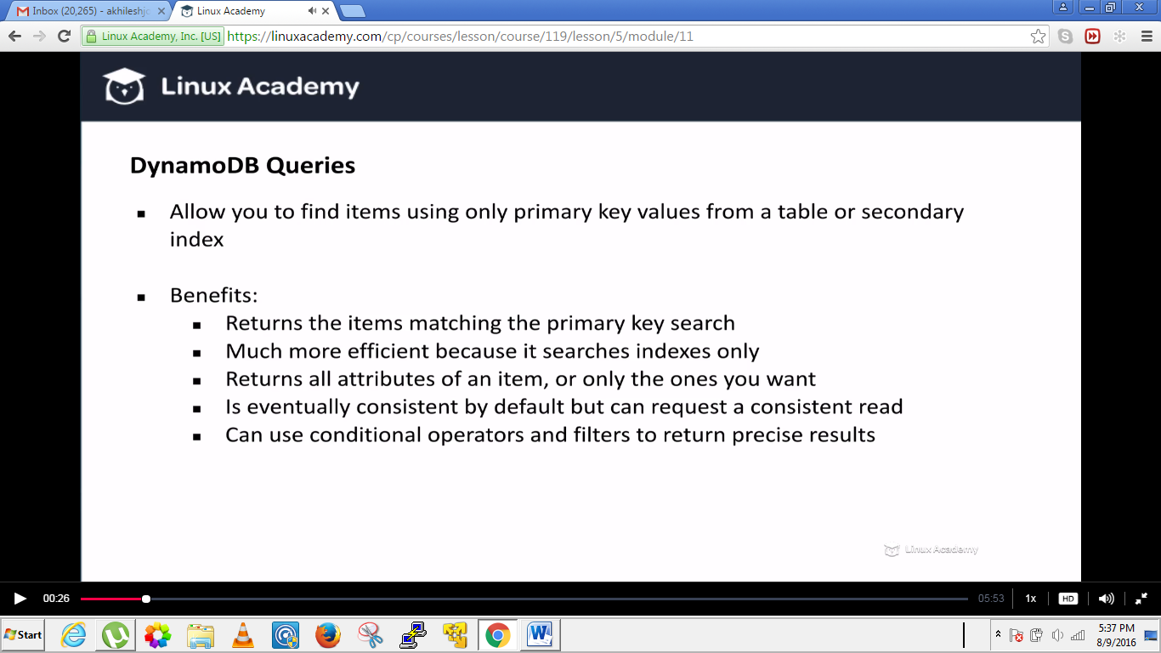

By default query is going to retrieve every attribute for that item but you can also use the projection expression parameter to only return some attribute. IF the result of the query returns items that add up to a size greater than 1MB then the query stops and the query returns last evaluated key in the result so that you can use this to continue retrieving more information.

IF the last evaluated key is set to null then you have no more values to retrieve.

Now quarries on local secondary indexes you can set the consistent read parameter to get strongly consistent reads but global secondary indexes only supports eventual consistent reads so keep in mind.

Also the data is always returned in sorted order by sort key value and the default sort order is ascending howerver you can always change it.

Lets not talk about scans.

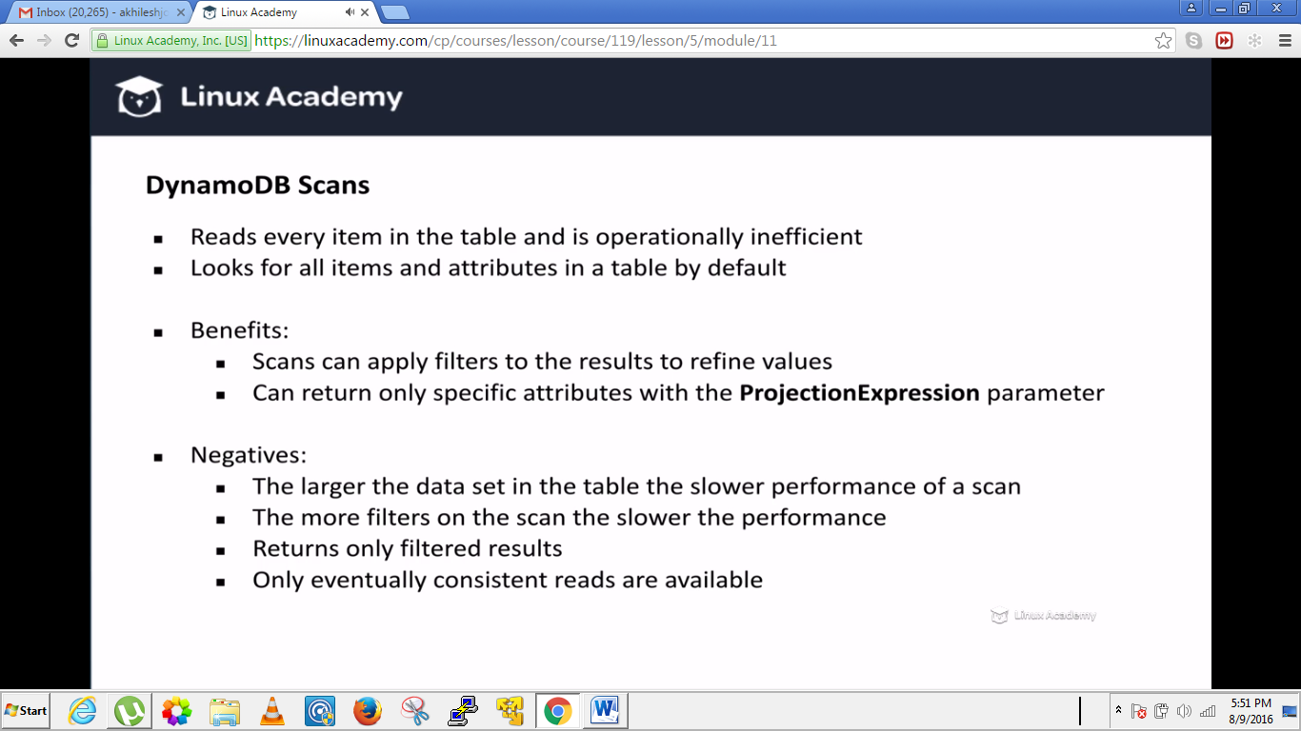

Scan looks for every item in the table or indexes and also return by default every single item in the attribute. Scans always return a result set even if there is no matching item you get an empty resultset again this is quite similar to quarries. And top of it like quarries a single scan can only return upto 1 MB of data but you can use the last evaluated key parameter returned to fetch more data. And also like quarries you may use filters expressions to narrow down results you want. This kind of filtering only fills in only after the data is already queried to scan and so if you have a lot of data then this can be really really costly .

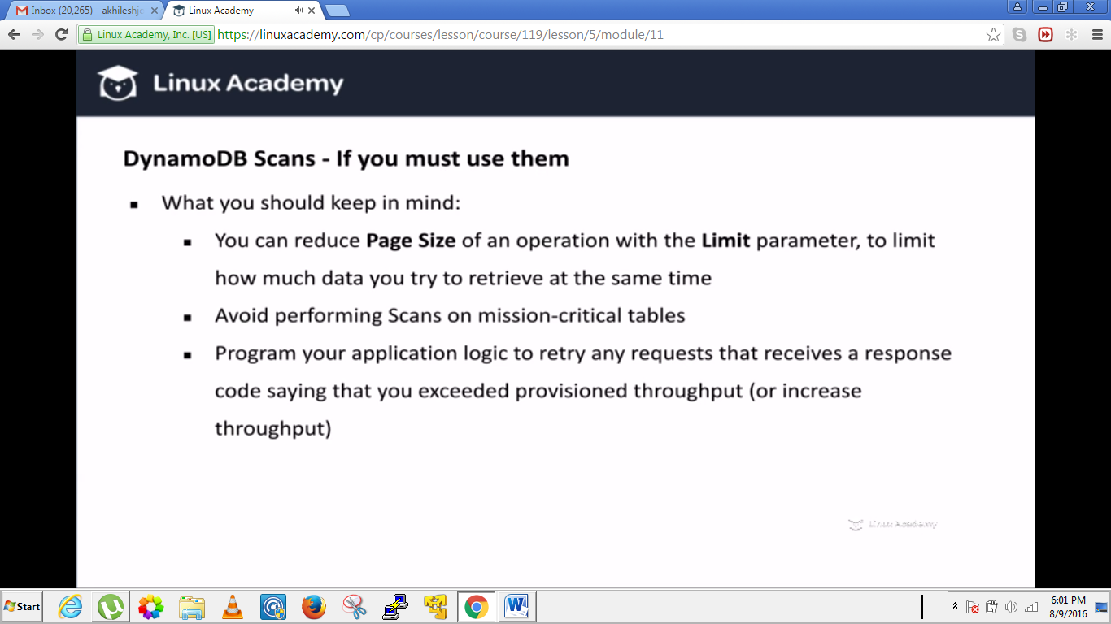

###########################################################################

**Lecture: Conditional Writes And Atomic Counters**

In this lesson we are going to discuss conditional writes and atomic counters inside of Amazon Web Services DynamoDB.

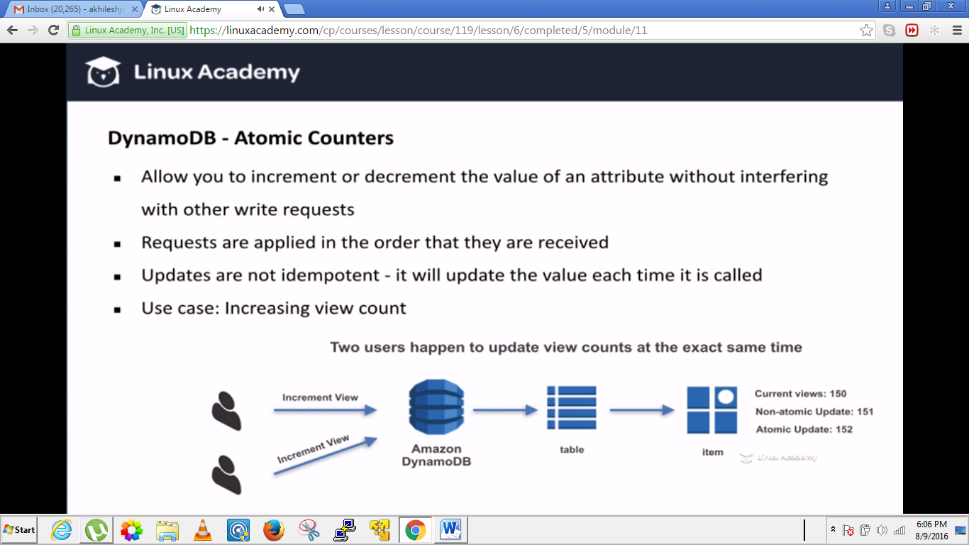

Within a atomic counter though your logic will properly increase the view count to a 152 because one of the increment operator will have to wait before the other is completed, so in this way we do not run into a dreaded scenario where we are missing view counts because we have got multiple users showing up the same time. The atomic counter updates are not idempotent which simply means that if you repeat the action multiple times it will update the value each time so if you for some reason think the operation failed and want to repeat it , know it may increment or decrement the value again. With view conunter that may not be big deal, its okay if that’s not that accurate but with financial information for e.g it could be a problem and there where conditional updates come into play.

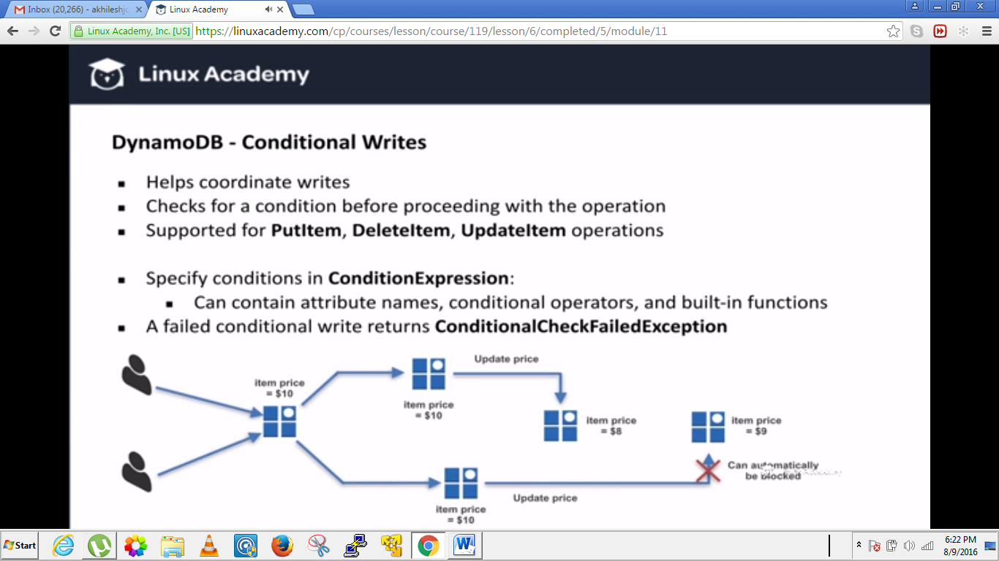

There may be times when you have multiple clients updating the value around the same time and the last client update wipes out the previous client update so to avoid these situations we can use conditional writes.

Lets say you have a client who wants to update the price to 8$. At the same time or around the same time client-2 wants to update the same price to 9$ instead not realizing that the client-1 has already updated the price to 8$ because at the time they checked client no-1’s update had not gone through yet. Without a conditional write client-2 update will still go through and then the client-1’s update will disappear this creates problem. So that’s the condition we would like to avoid so we can set a condition that the client-2 update will only go through if the price item is still 10$. So we can say in our code logic that only perform this write operation if the price still equals to 10$, else return an error and say the price is change. That way client-2 can check the updated price, can figure out what is going on without wiping our client-1’s update. Conditional writes are better for financial matters because they are idempotent meaning that you can perform the same operation multiple times and it wont change the item in any different way. For e.g if you have a condition that says to update a product price by increasing it to a 10% if its price is 10$’s and you think that your update failed for whatever reason so you send the write operation again there is not going to have a different result even if the operation that you thought failed actually went through, its not going to update the value because the price wont be 10$ anymore.

Well how to use these condition updates. Supported for put item, delete item, and update item operations. All you need is to pass a condition expression parameter which is a string containing attribute names and conditional operators like = or > for e.g and even builtin functions like attribute not exist and others. If condition write fails you will receive a check failed exception instead of expected result from the write operation.

**Lecture: Connecting To DynamoDB From Your App Using Identity Providers**

In this lesson we will discuss how to grant read/write permissions to users of your app. Our scenario states that you have built a mobile application and launched it in the app store. The application serves data from DynamoDB. How can we securely grant permissions to each mobile device user to read and write to DynamoDB?

Lets say we have a game application and we need to store information in dynamodb for this game. How to create unique and temporary permissions for each user so that they can access dynamodb resources for a game to work and for their progress to be saved.

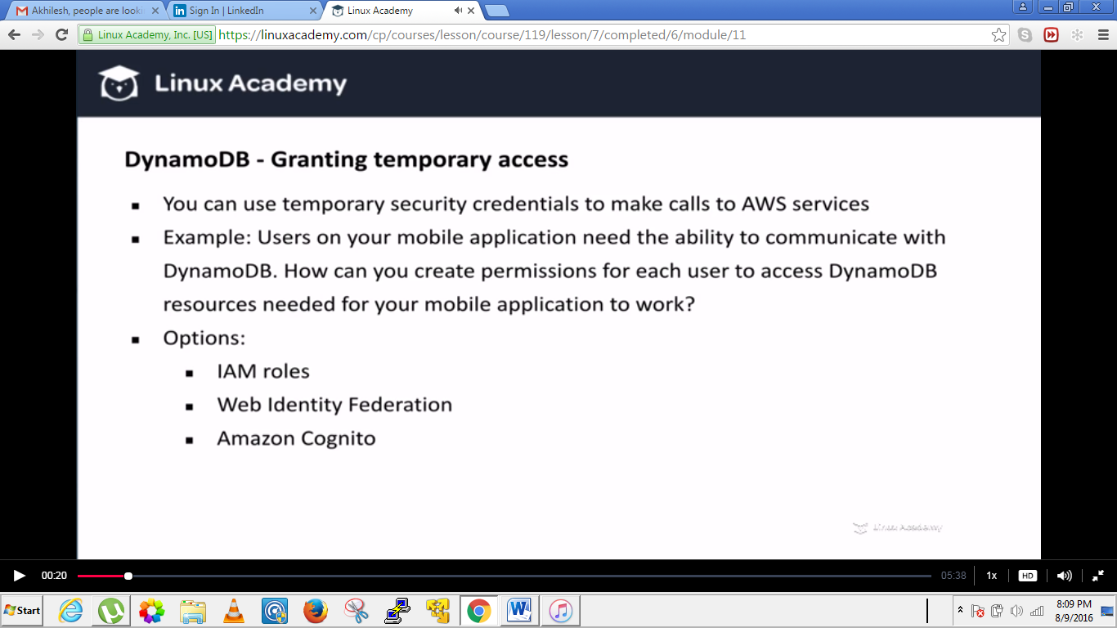

What you don’t want to hardcode API credentials inside of your code because it is security issue. So we want to create temporary credentials on the users end and on the AWS end. How we do that we have above options.

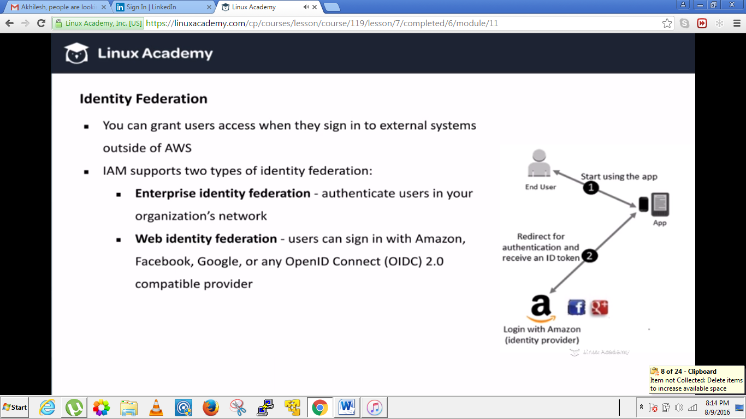

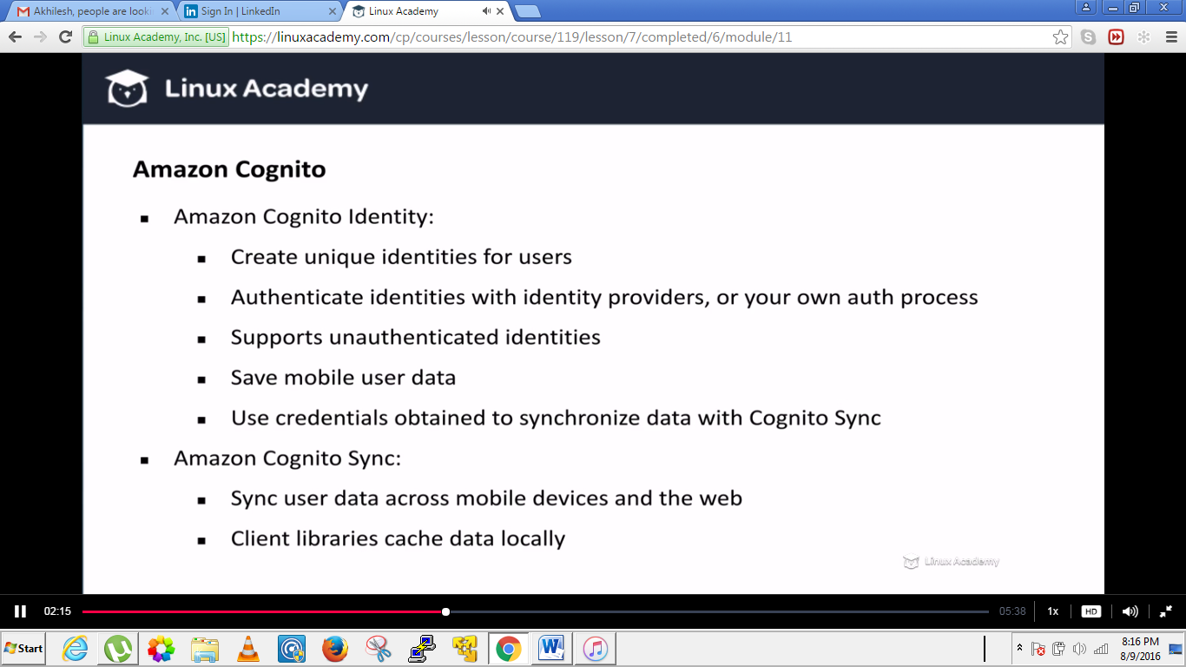

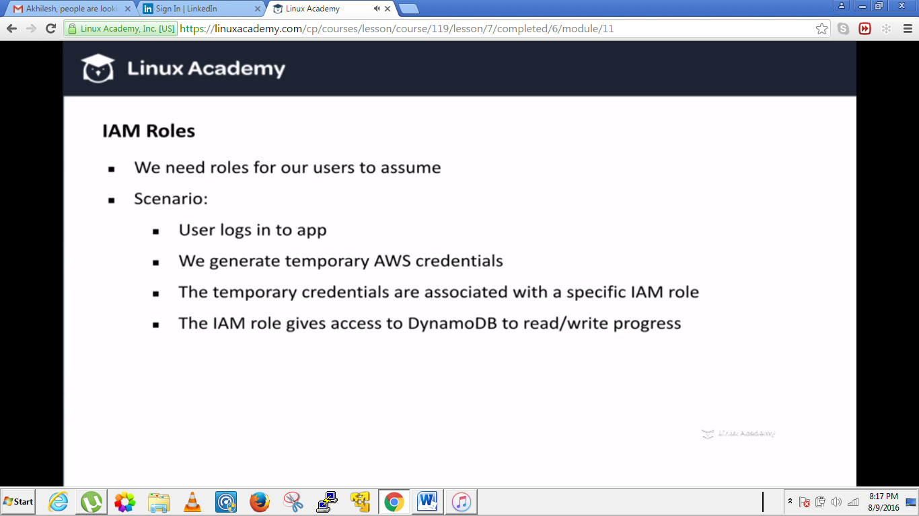

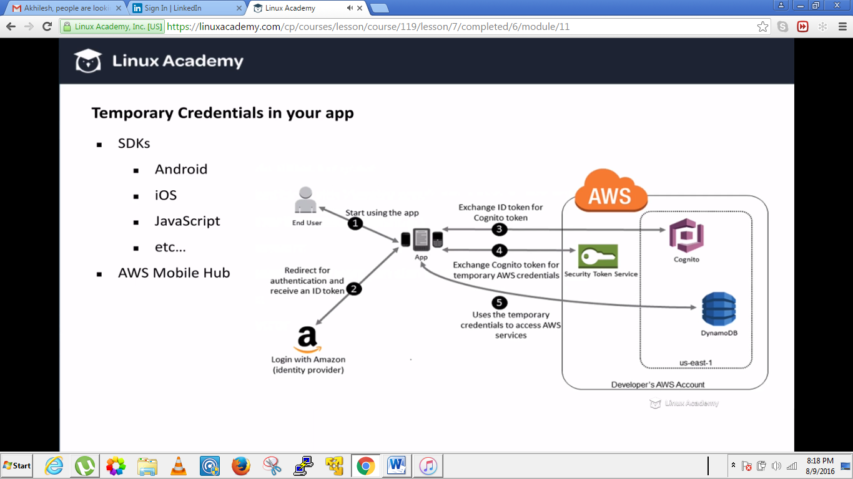

**Amazon SNS (Simple Notification Service)**

**Lecture: Head First: Getting started with SNS**

In this lesson we will dive right into creating an SNS topic. We'll use the AWS console to set up the topic to get an idea of how the SNS workflow is used between AWS infrastructure automation and app development for delivering messages to users of mobile devices, email, SMS, and other endpoints.

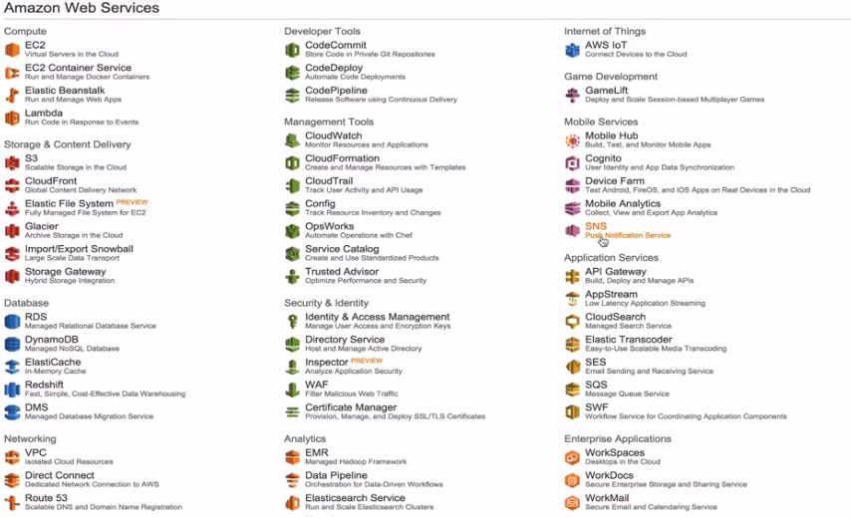

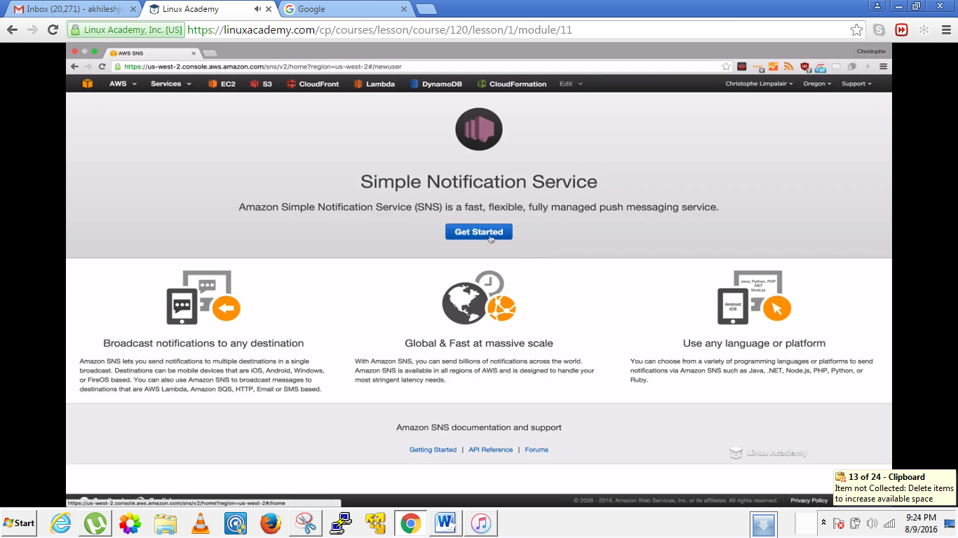

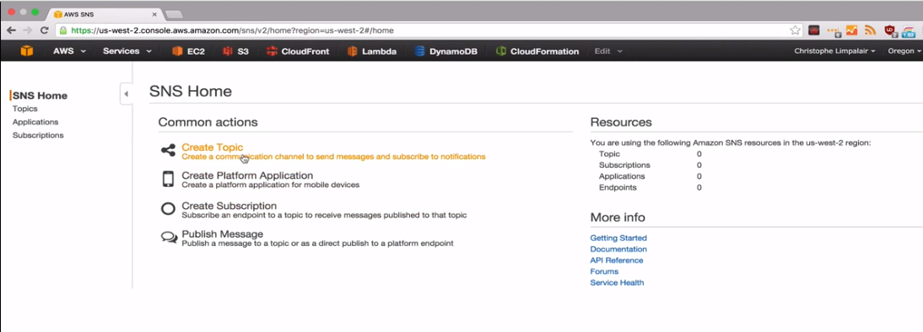

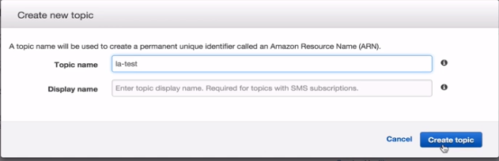

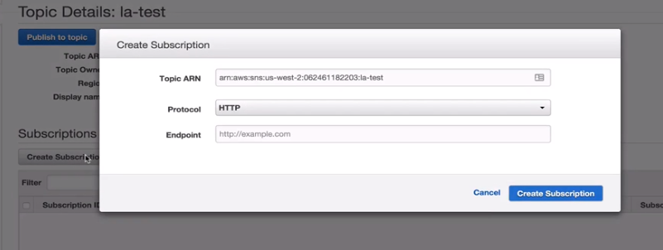

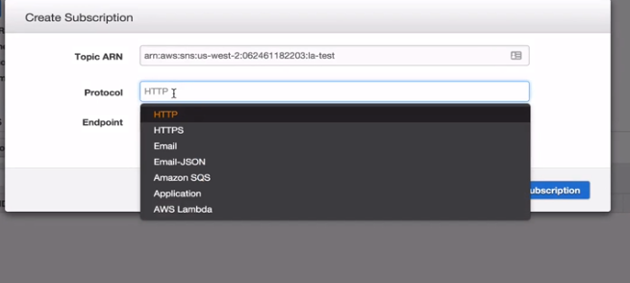

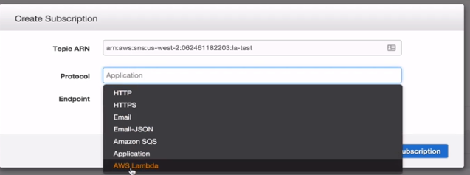

We can pick the lamda function from here.

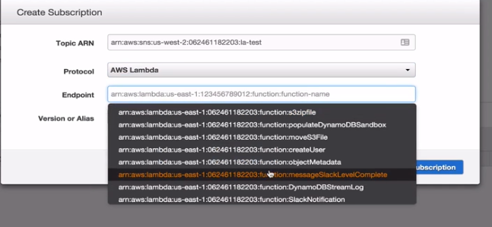

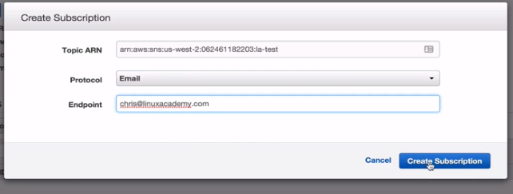

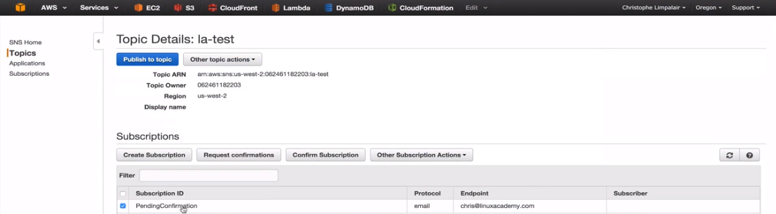

We see a pending subscription and we have to our email to confirm our subscription.

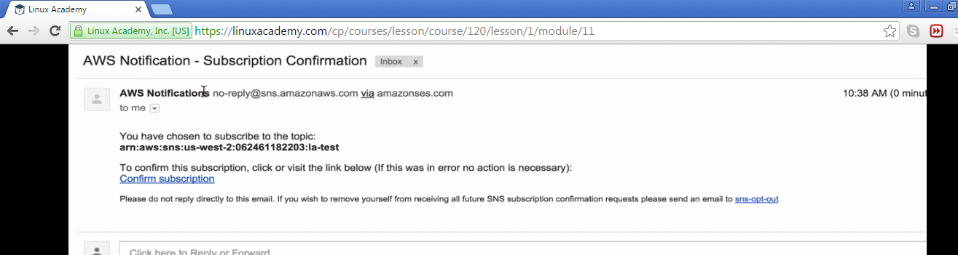

Once after confirming if we go back to the amazon console and refresh the page we see the subscription id instead of the pending status.

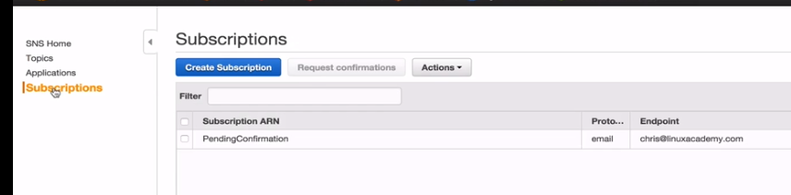

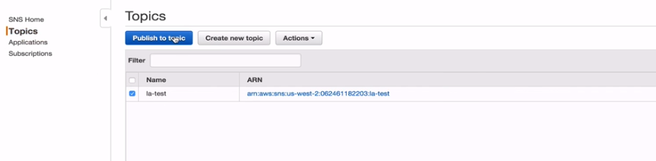

There can be many application publishing to your topic but here we are doing it manually to test.

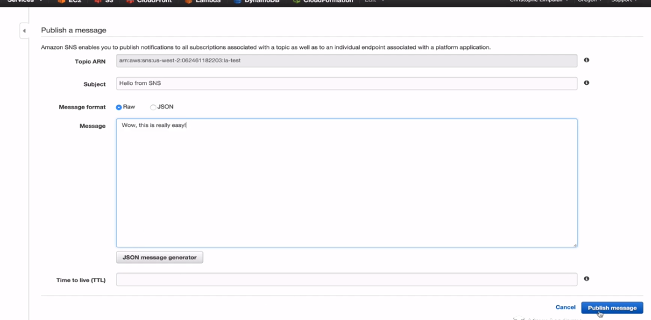

Let me go back to my email and check this message.

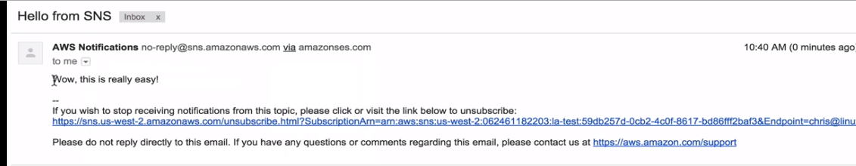

**Lecture: Introduction To Amazon Simple Notification Service (SNS)**

In this lesson we are going to discuss the important concepts surrounding SNS (Simple Notification Service). We'll talk about how different AWS services integrate with SNS and how we can use SNS for mobile push notifications and infrastructure automation.

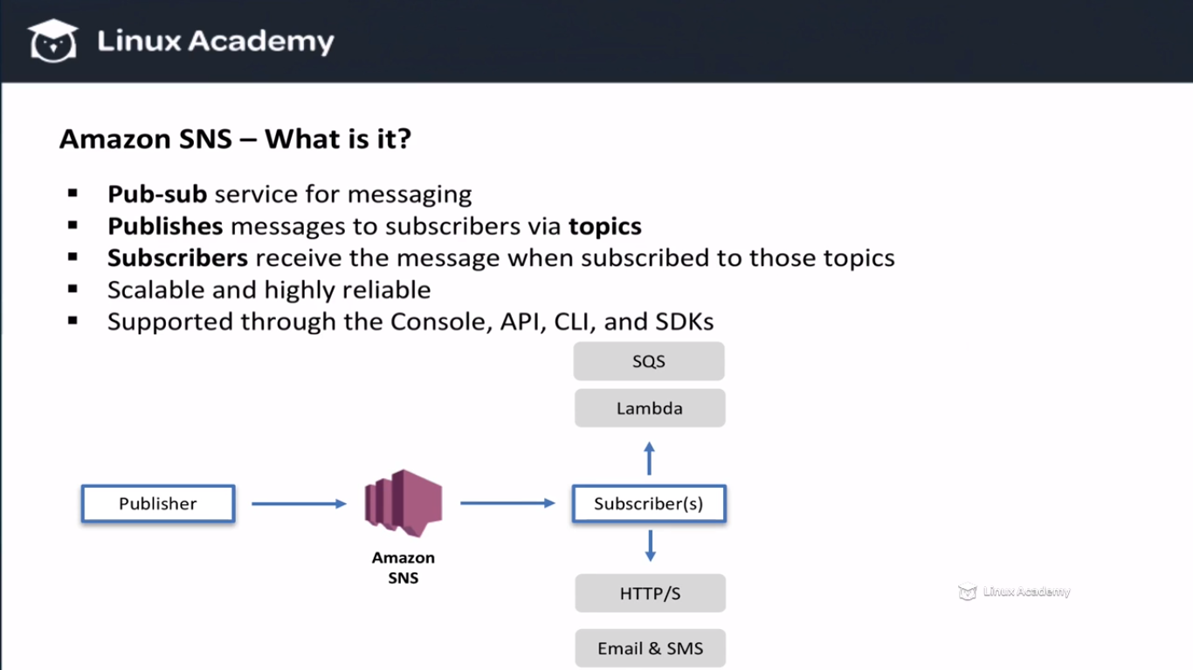

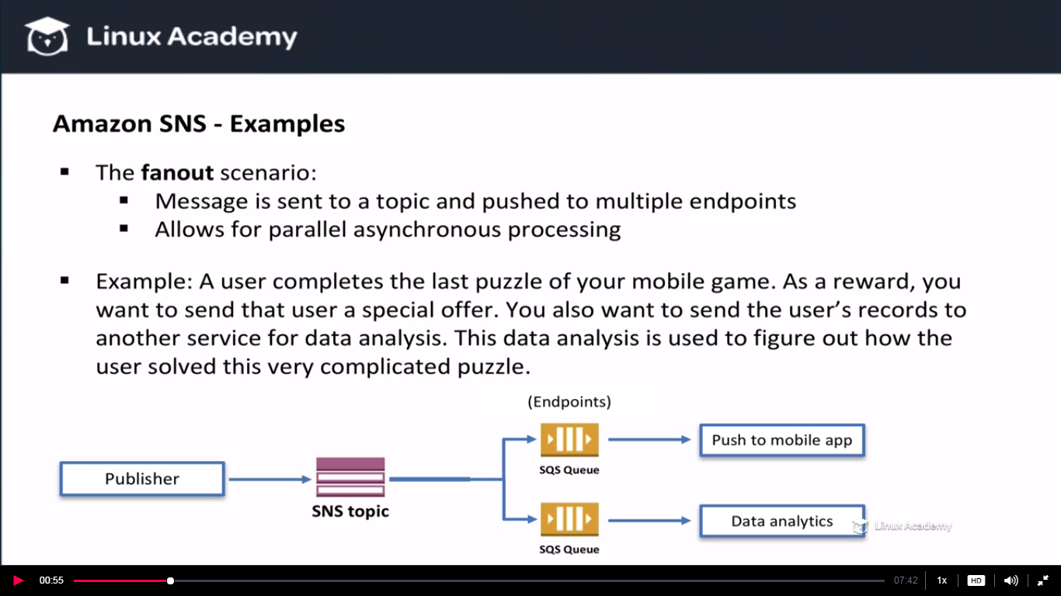

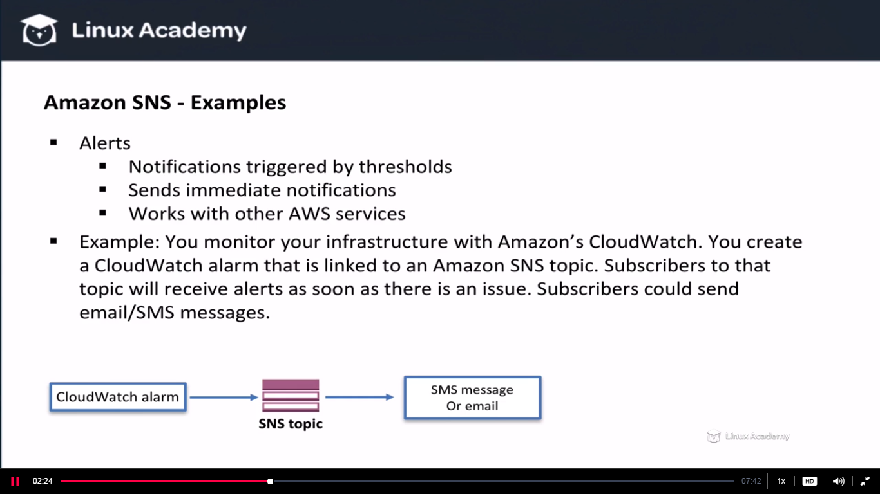

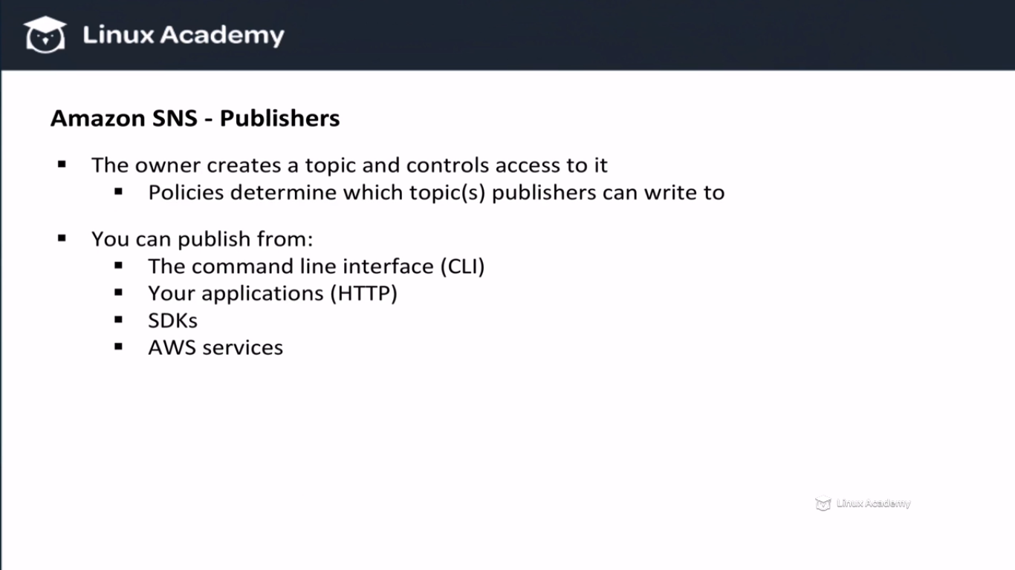

**Publishers—SNS is a pub-sub service. We have publishers and subscribers. The publishers are the ones who send the messages to a SNS topic. These publichers can be different services like a cloudwatch alarm for eg or even your application but these publishers need to have proper permissions in order to publish messages. We can grant these permission using access control policies. Example of publishers are mentioned above.**

Apart from the examples from the screenshot we have cloudwatch, s3, RDS and many more which are the examples of publishers as well.

An example of using S3 would be to trigger a notification on object loss. Say we have an object in reduced redundancy storage which is an amazon s3 option that lets us store non-critical data for cheaper. With standard storage amazon gives 99999999999 durability. With reduced redundancy storage we have only 99.99% of durability. So if we have a vedio file. We would like to transcode it into multiple different formats to be able to stream it in the internet. We need to create multiple different version of that file. Instead of paying the standard storage price we can pay less with reduced redundancy.but we might loose some of those copies over time. With SNS we can get notified of the loss and we can create the lost object automatically. In this case S3 would be the publisher and it would publish a message to our topic

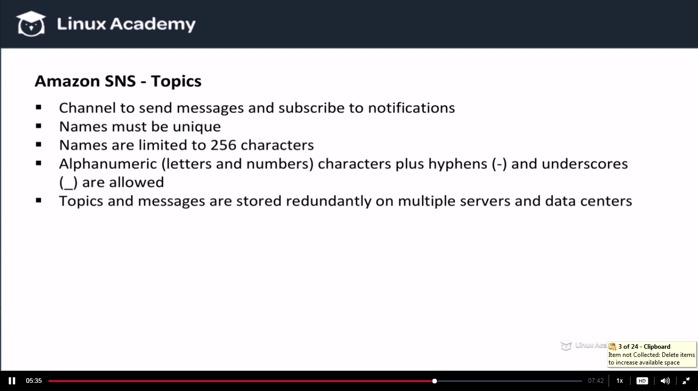

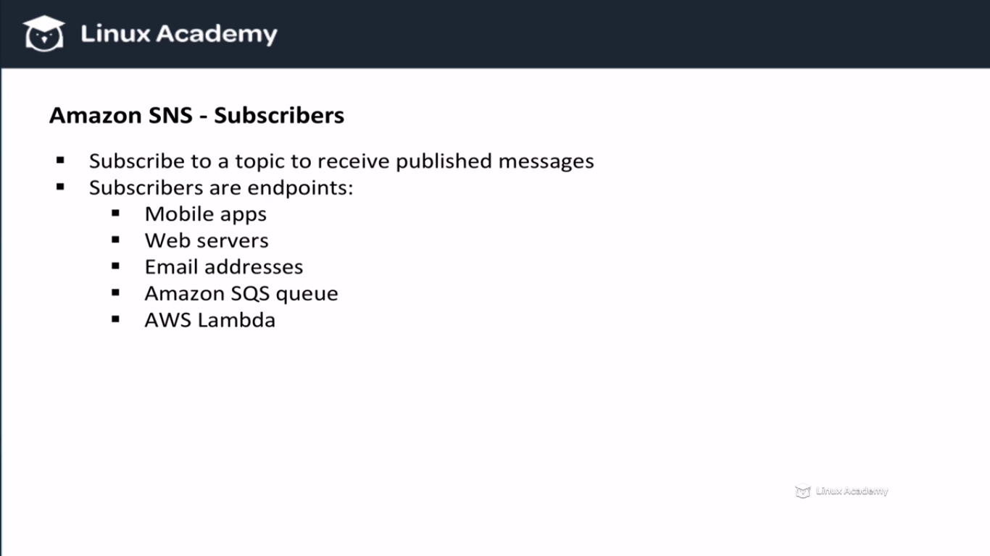

**Now you might be wandering why we want to have SQS as an endpoint fo SNS since they are both messaging services. The reason is because SNS uses a push mechanism while SQS uses a pulling mechanism. By having a reliable pulling mechanism we can de-couple sending and receiving services , by that I mean that sending and receiving sevices do not both have to be available at the exact time. IF the receiving service isn’t available to receive an SQS message that message wont necessary be lost. This is very helpful with distributed application and can help reduce data loss in case of failures.**

**Lecture: Managing Access to SNS Resources**

Just like other services in AWS, we can have complete control over who or what has access to our SNS resources. This lesson explains how we can use both IAM policies and access control policies to accomplish our control goals.

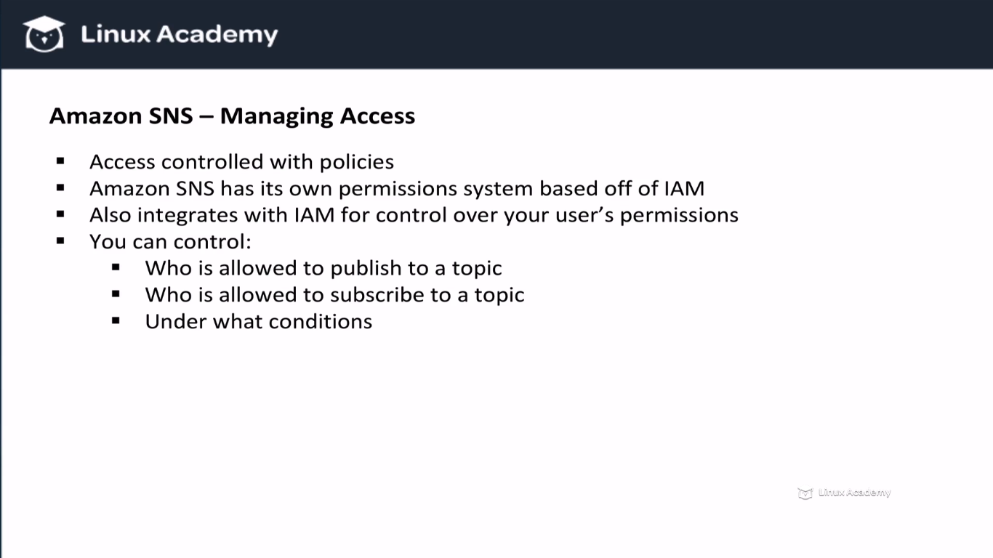

**IAM gives us control over our own resources but not over other AWS services accounts. If we want to grant and restrict access to another account we need to use access control policies. These access control policies can be controlled via the amazon SNS API. Access control policies also gives us the ability to restrict certain protocols like if you want to only allow HTTPS . IT also gives us the option to publish messages to amazon SQS queues.**

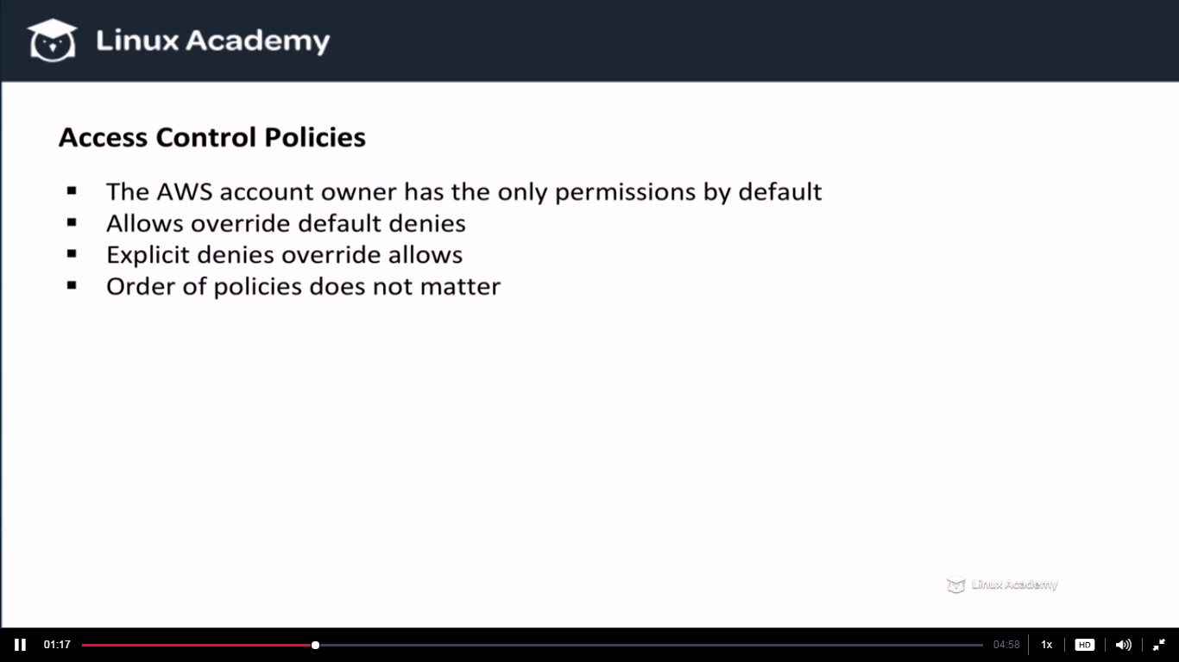

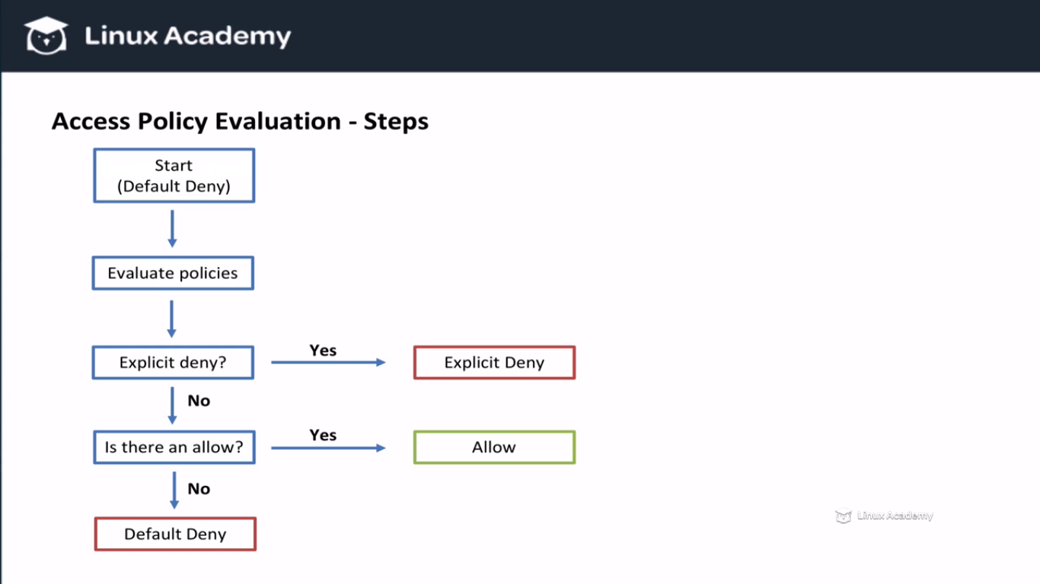

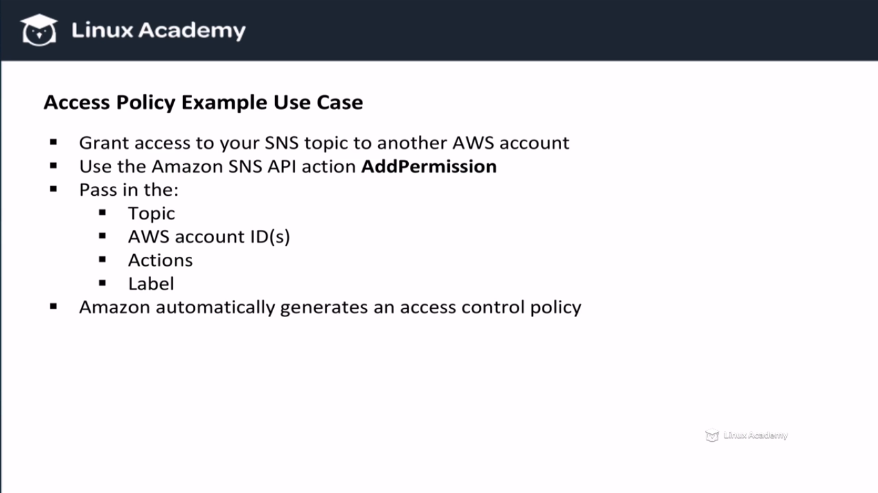

How to give access to our own users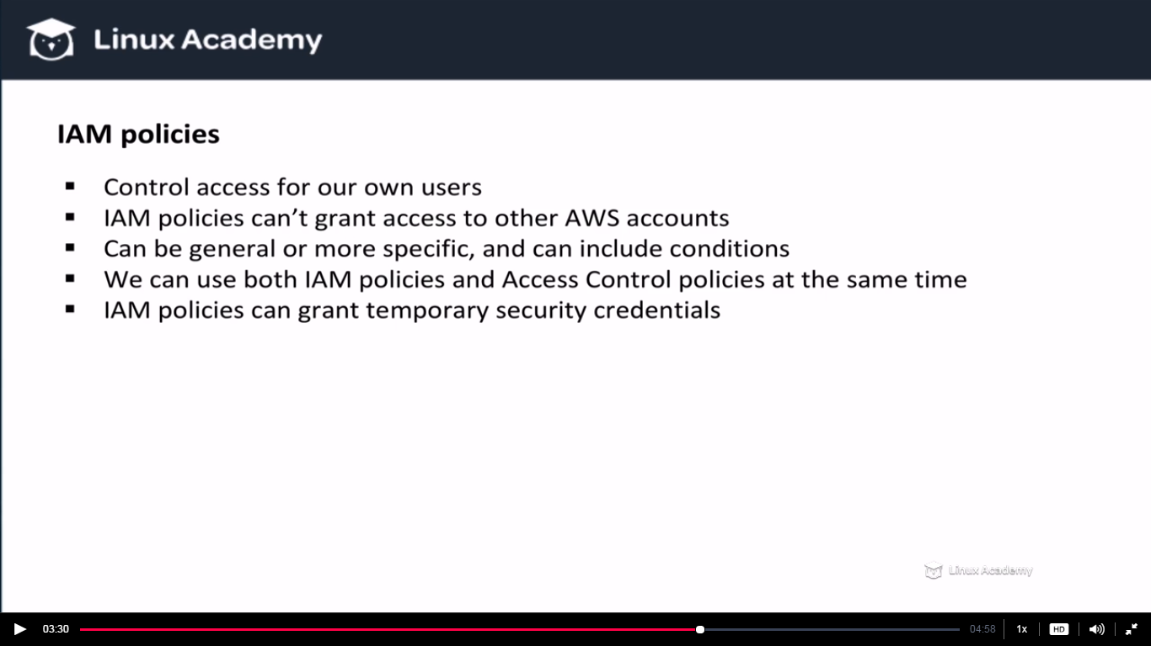

**SNS IAM policies do not let you grant access to another AWS accounts but SNS access control policies do.**

**Lecture: Using SNS with SQS and the CLI**

With SNS, we can use a "fanout" scenario to publish one message to multiple different endpoints. In order to illustrate this concept, we're going to publish a message to a topic that has 3 subscribers: 2 SQS queues and 1 email address. Then, we will publish a message to that topic using the command line interface.

We have seen earlier that one of the subscribers of SNS topic are the SQS. Also we have seen that SQS uses a polling model which means services not need to be available at the exact same time that a message is available. So even if a mobile APP is offline at the time it can process a message later time when it becomes available. SQS gives us that flexibility. Here we are going to use a fanout scenario to demonstrate this.

This scenario allows us to publish one message to a single topic and have that message to be pushed to multiple different subscribers. So in this case we will have two different queues and one email address. Doing this lets us process message in parallel. So for example sending messages to two different queues we can send one message to our mobile app user and we could send one message to a data analytics’ engine. We also going to send an email to the application owner to notify them of something. This could be notify them of a purchase or because the user completed a different level in your game and so you would like to see how it completed that level. Lets start creating this scenario. First lets create 2 queues.

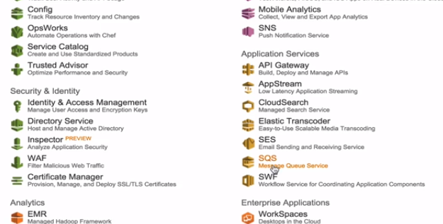

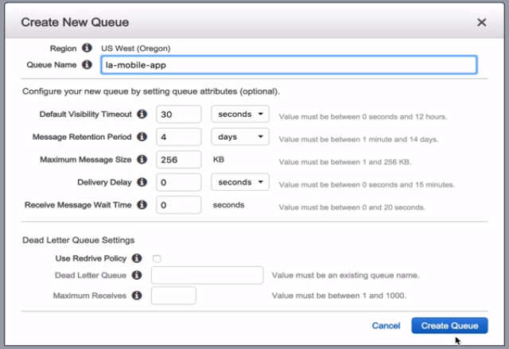

Create this and then create a new queue

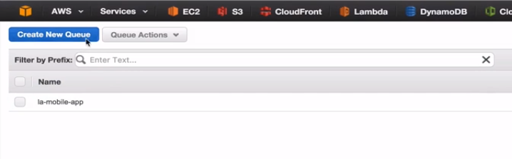

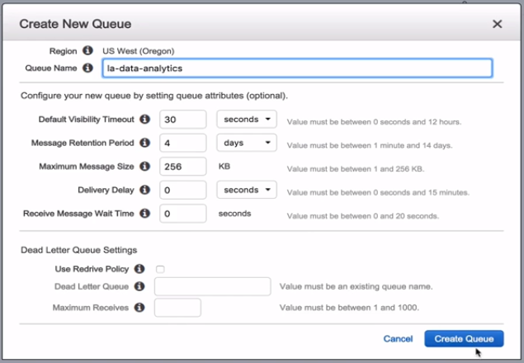

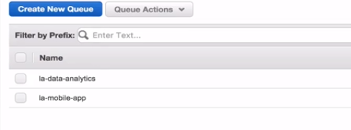

We can select both of the queues and we have a SNS topic from the previous section and hence we can go to queue action by right click as

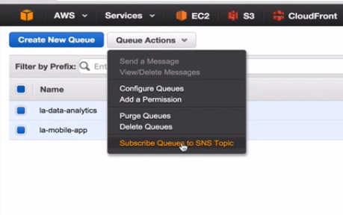

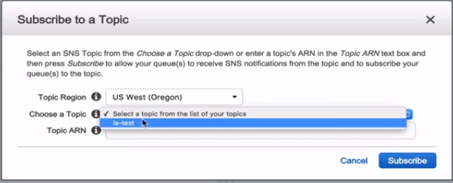

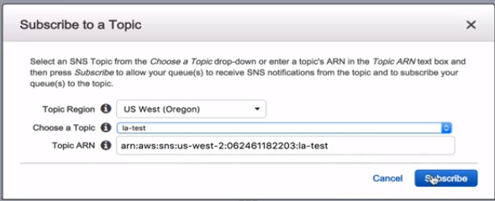

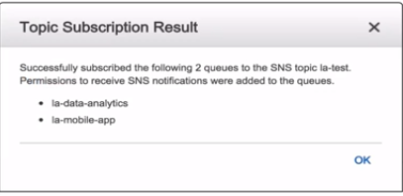

Go to SNS console in another tab

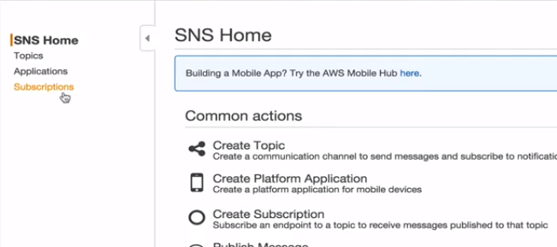

We now see we have 3 different subscribers

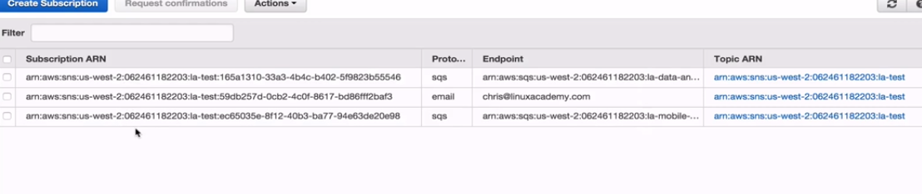

Now we are going to demonstrate how we can publish a message to our topic and how this queues will receive the message but lets do this time with the CLI to show how that works.

So let me create a new user to get API credentials . Go to

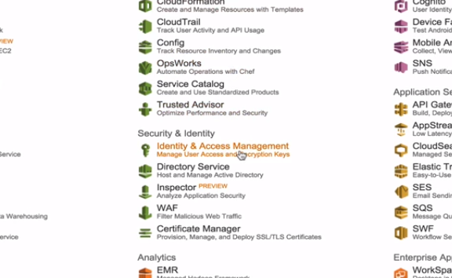

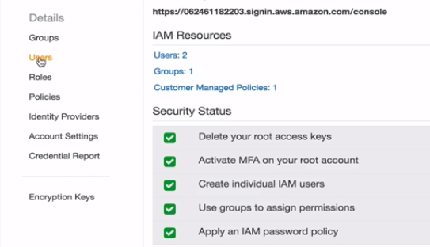

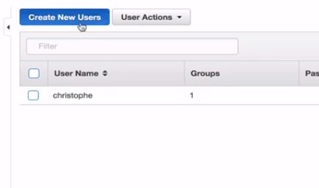

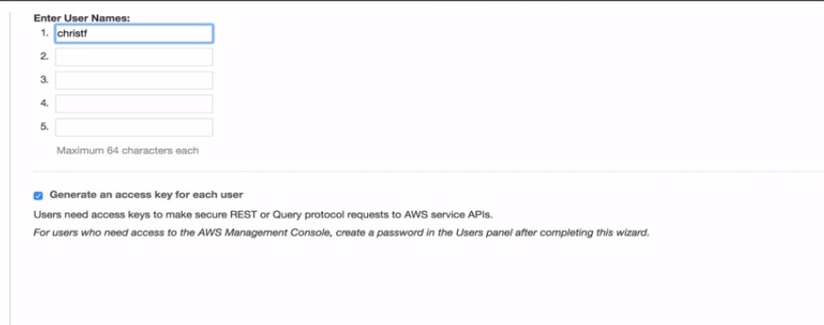

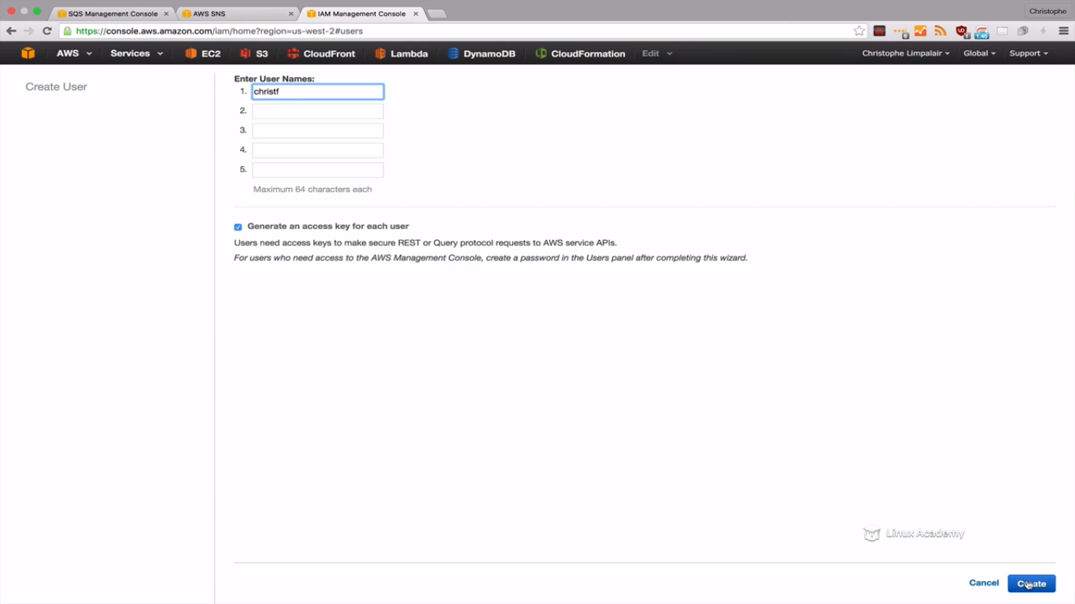

Generate keys.

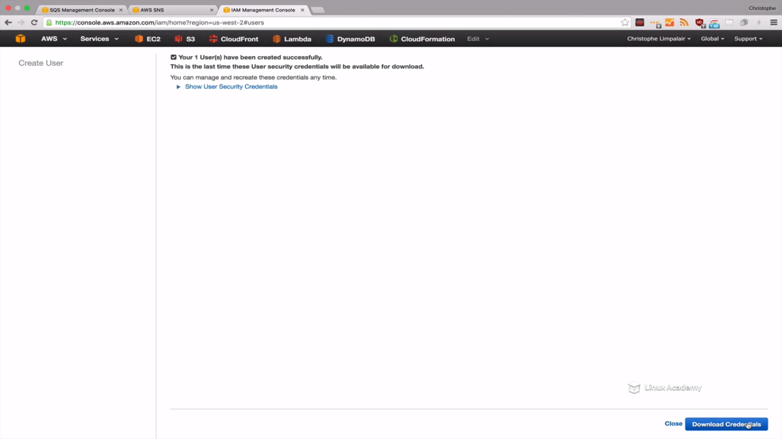

Download the credentials.

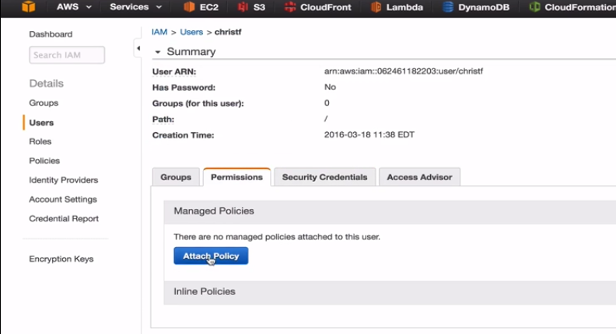

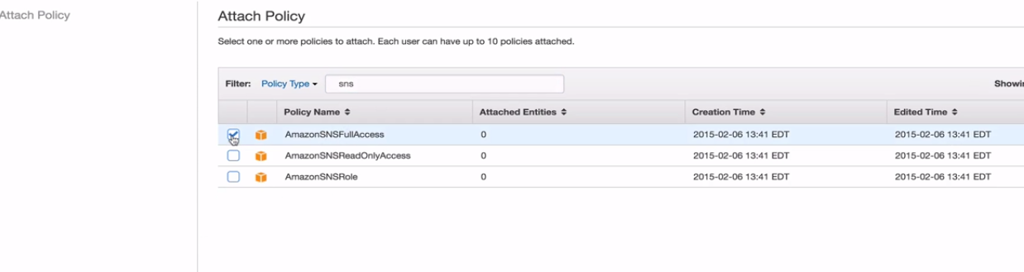



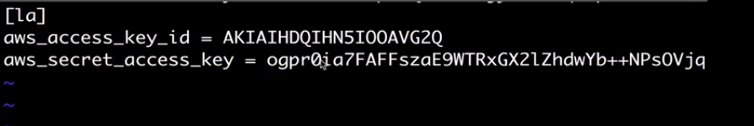

Save and exit after pasting the credentials we downloaded while creating the user.

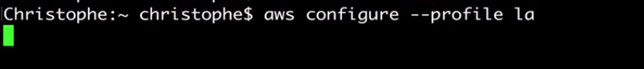

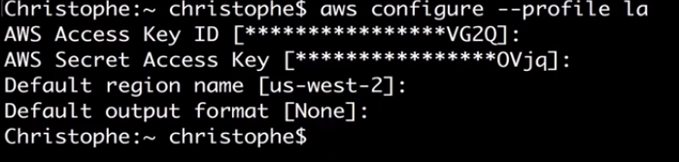

Keep everything as above

To list the topic



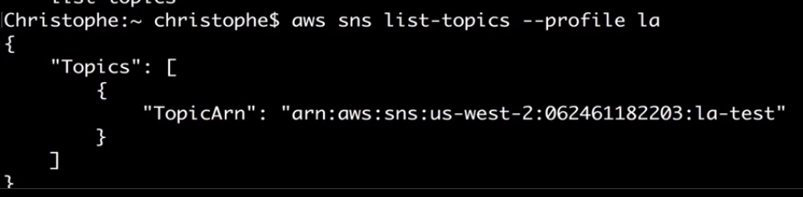

Copy this



Now we will publish a message to out topic as





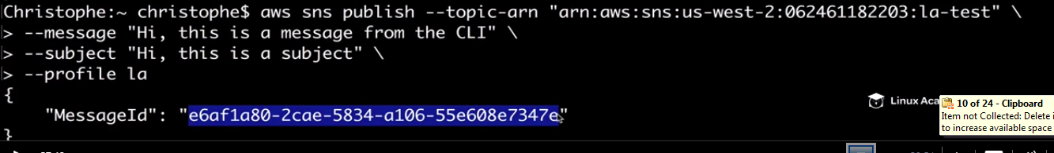

IF you get this message then it’s the sign that everything went good.

Lets get back to the AWS console and to SQS console and refresh it

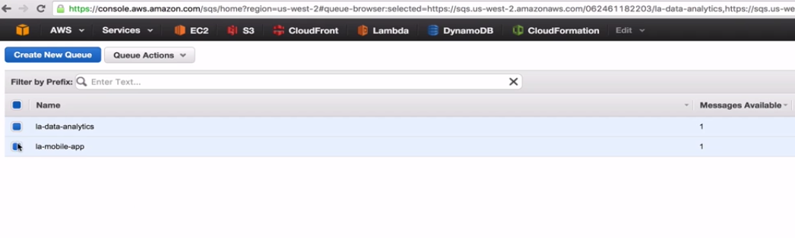

We see two one message in each of the queue.

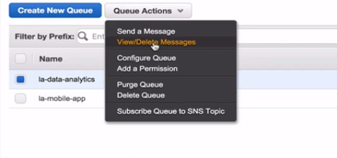

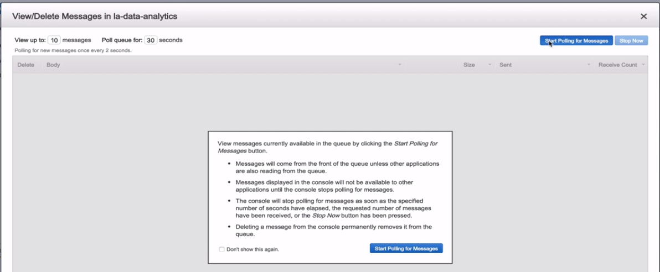

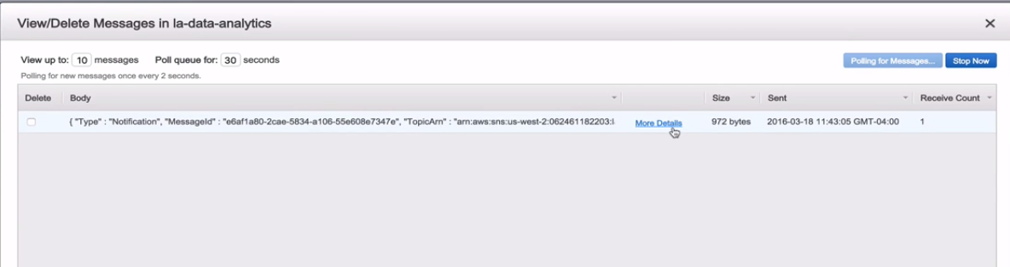

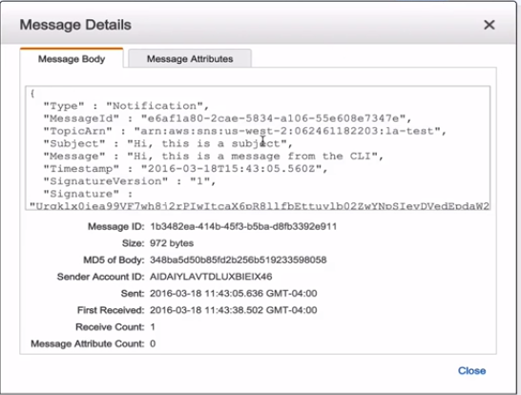

Stop polling and exit out

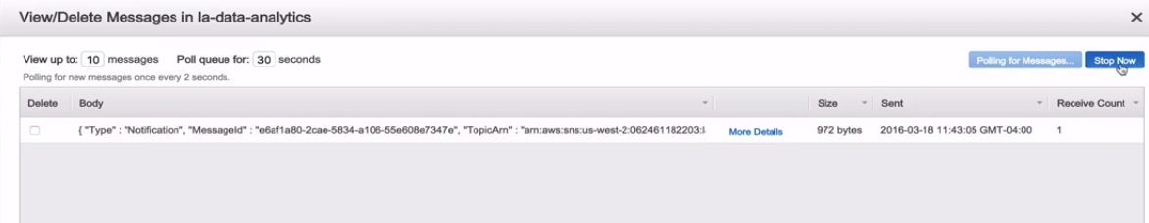

Go to other queue and do the same thing.

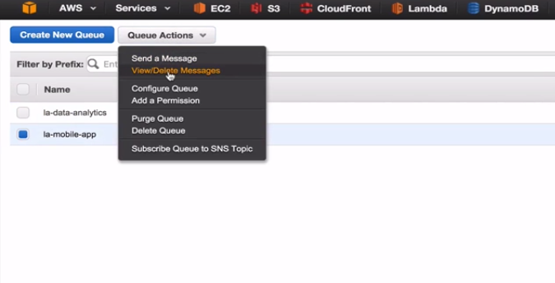

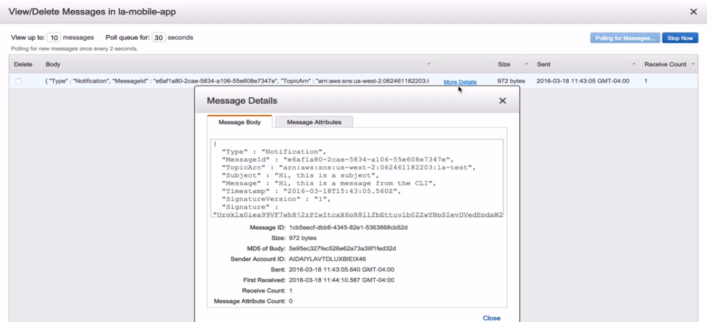

We see the exact same message.

We must see an email too as we have subscribed the email too.

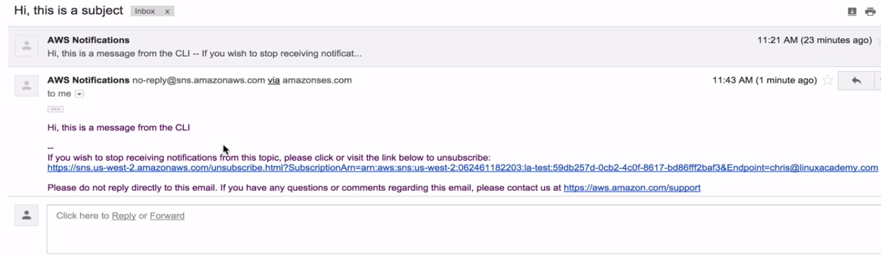

**Lecture: SNS Message Data**

In this lesson we are going to learn about the key:value pairs that are sent along with the SNS messages. We'll talk about how they can be used, and we will look at an example of the JSON data.

Knowing the message data becomes important if you are just sending emails or sms messages. It does becomes important if you are moving data around and needing to parse that data. For eg if we get a notification that an object has been lost in amazon s3 due to reduced redundancy storage we might have that script that grabs that data from that message to figure out which message was lost and to recreate it. By understanding the message data we can built scripts that can parse our data.

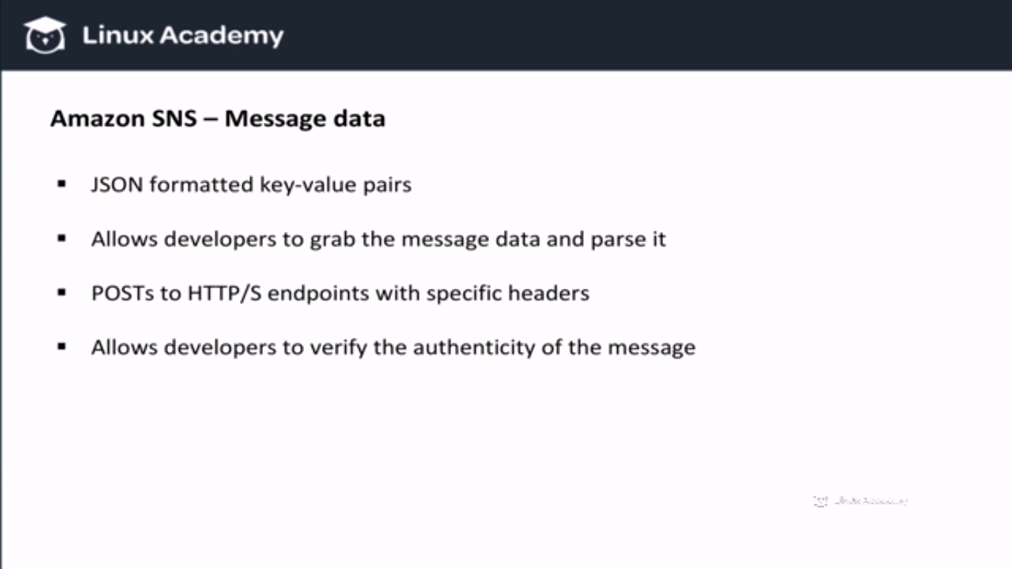

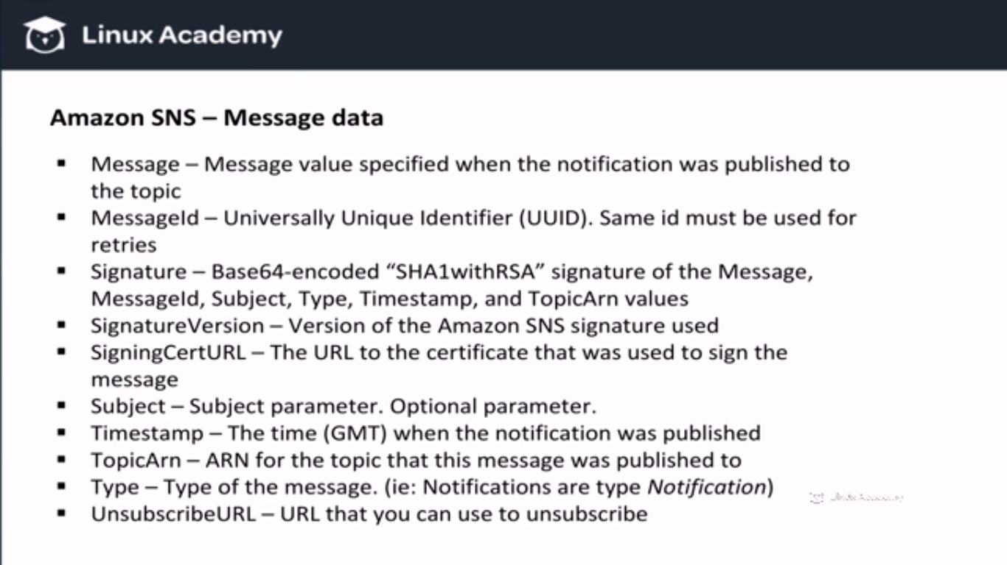

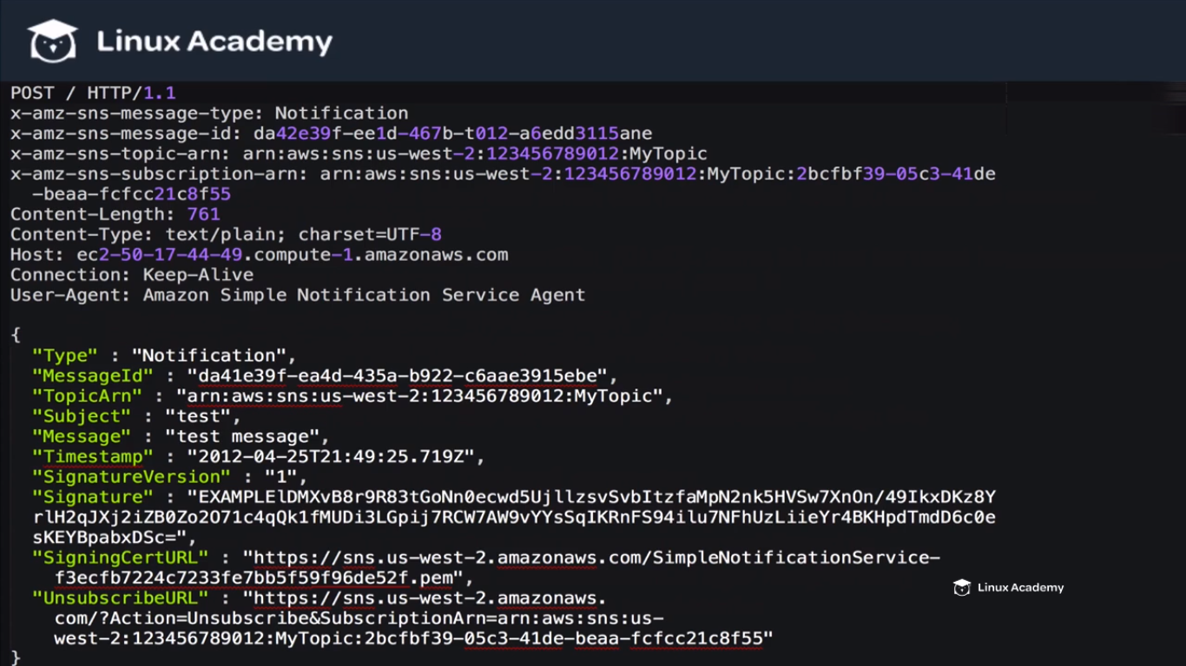

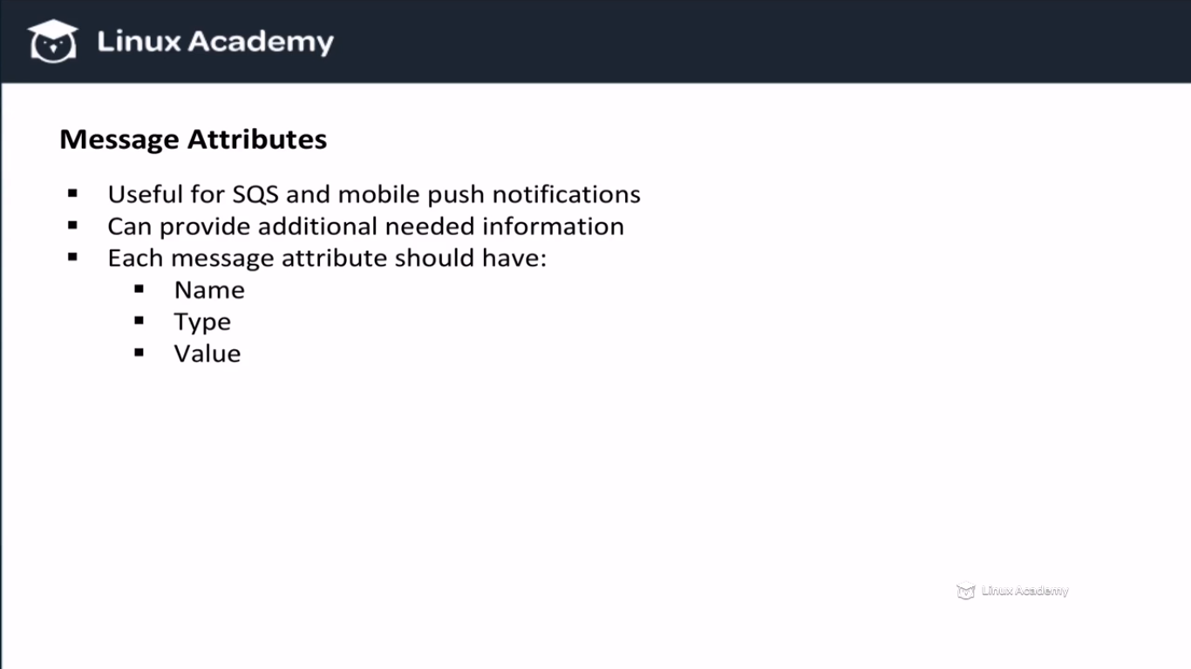

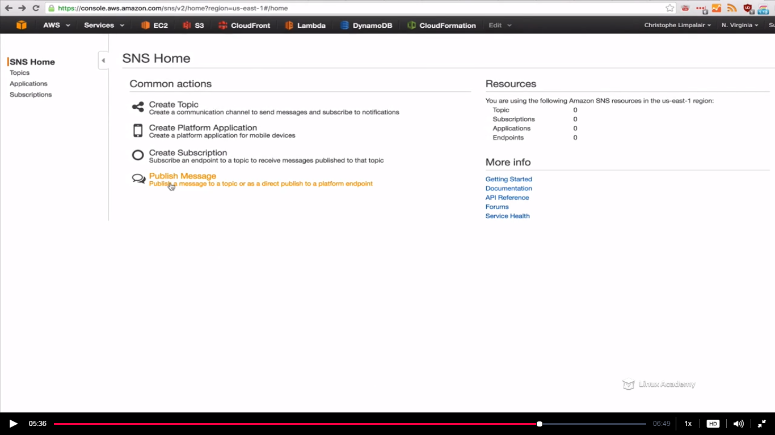

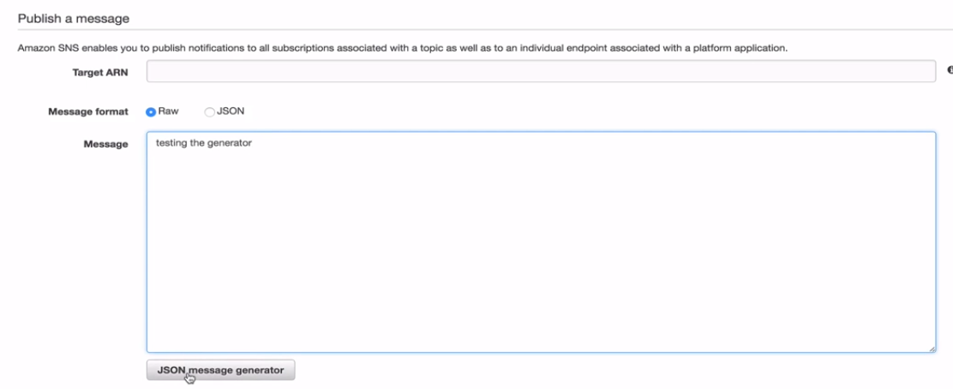

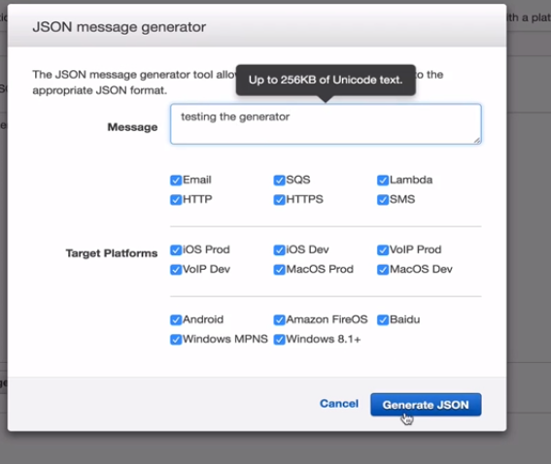

**Lecture: Mobile Apps: Mobile Push With SNS**

In this lesson we are going to discuss how the Amazon Simple Notification Service can be used with different mobile push services like Apple Push Notification Service, Google Cloud Messaging For Android, and Amazon Device Messaging, to name a few. These services allow us to send app notifications to mobile devices.

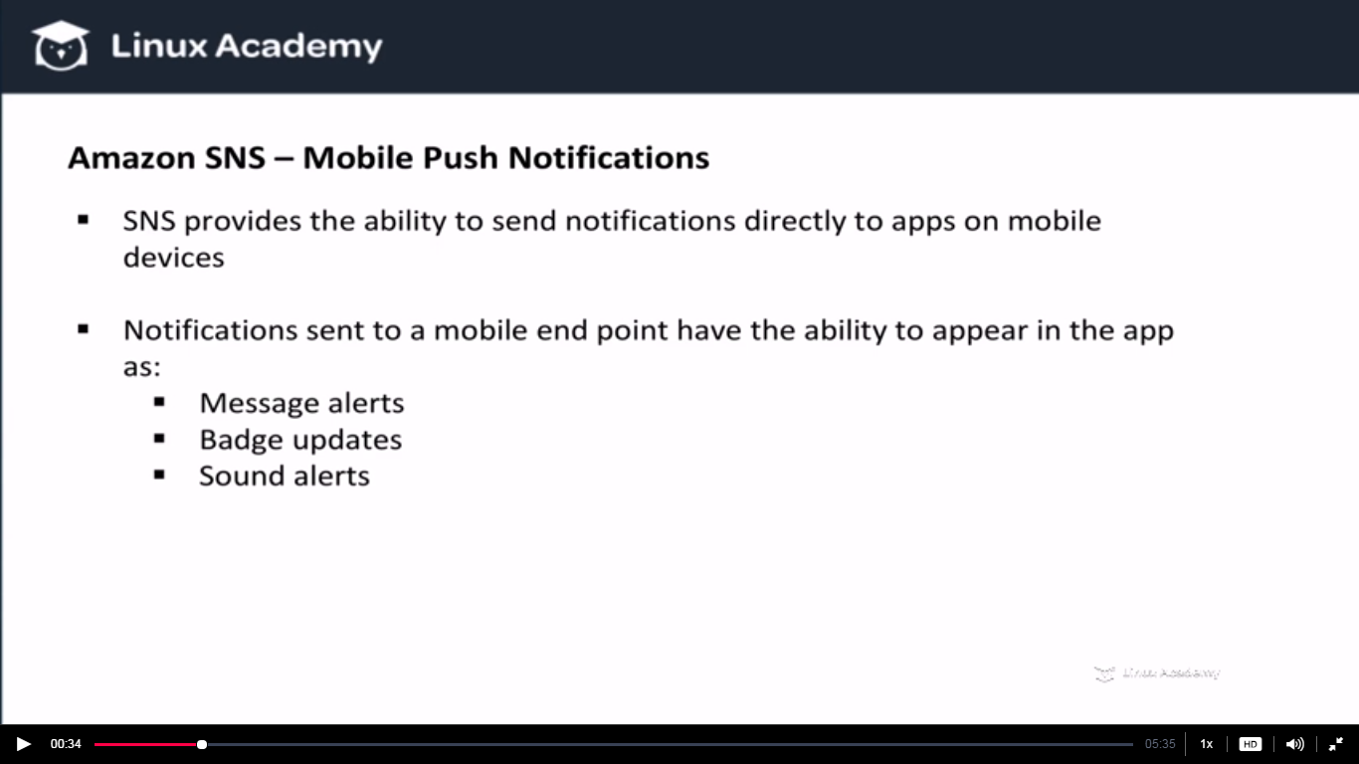

How to send these notifications. We have to use Notification services. SNS cant do it by itself.

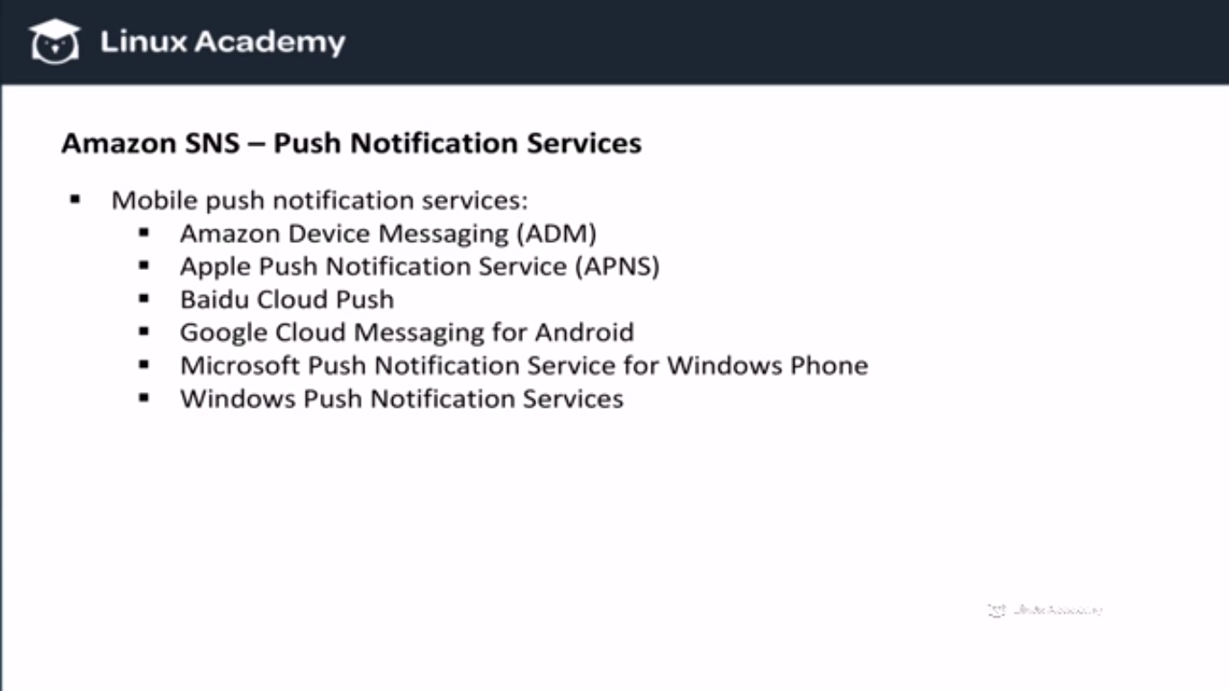

We can use one or more of these services and integrate them with SNS. For eg to push notification to apple devices we can use apple push notification service.

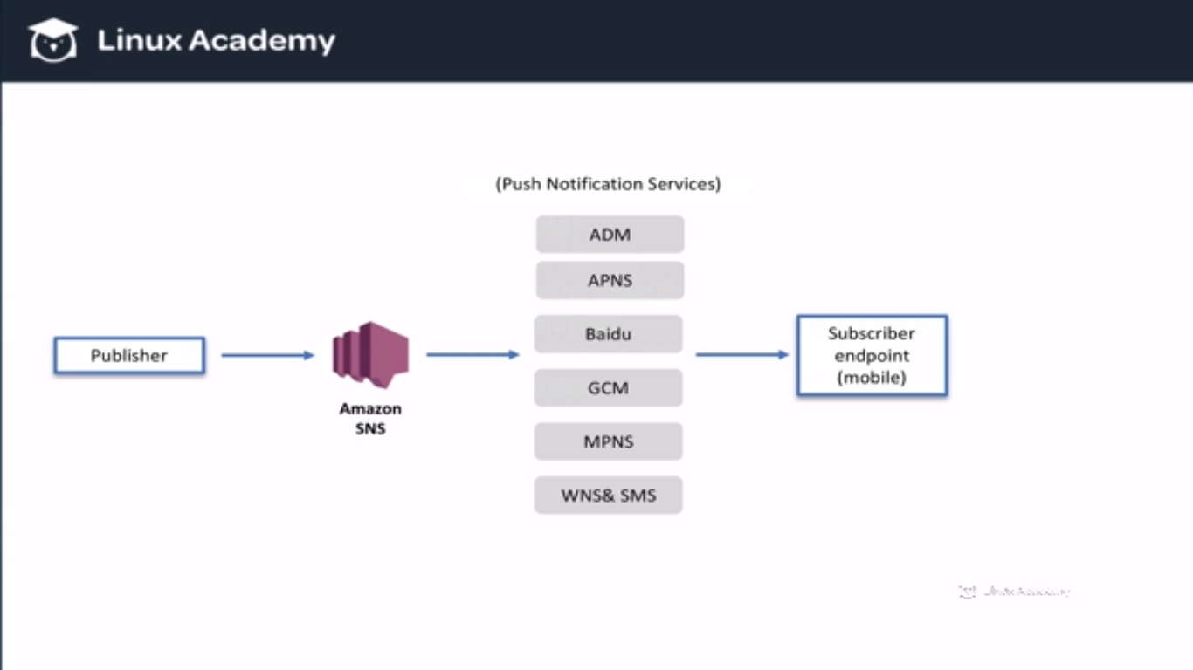

But once we publish our messages to once of these push notification services it will then go and verify our device tokens and once those are validated it will notify our mobile end points. That mobile end point is each mobile device that has our mobile application installed and that has been verified. So it means that everytime an application is downloaded it needs to be registered as an endpoint but how do we automate that so that it happens everytime anyone downloads our application. As a developer you need to understand this.

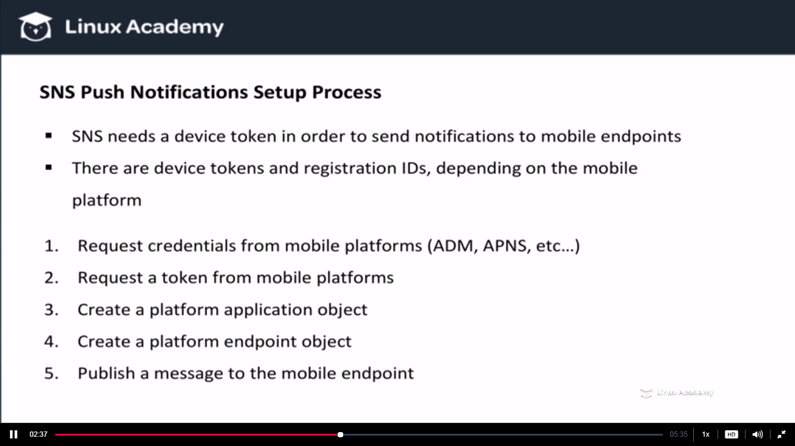

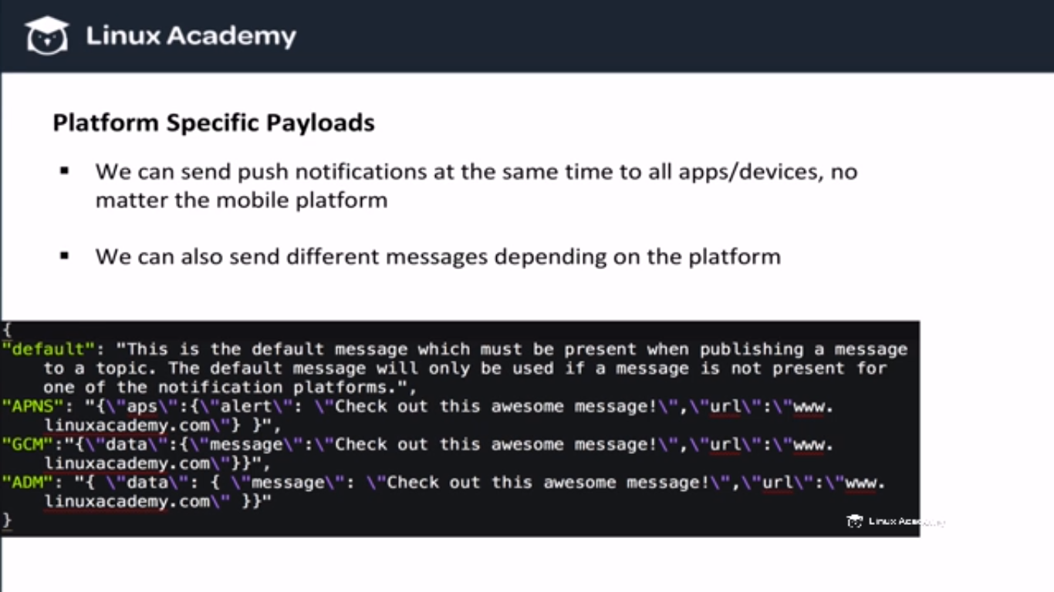

**Lecture: Hands-on: Building Automation With SNS and AWS Lambda**

In this lesson, we take a lot of what we've learned about SNS, and we build a real-world functional system with SNS and AWS Lambda. This system automatically recreates objects when they are lost because of S3's Reduced Redundancy Storage. That way we can benefit from lower storage cost, but without having to worry about losing objects over time. We complete this example from start to finish, and you can download code examples on the main "AWS Certified Developer - Associate Level" page (on the right side, under course downloadables).

For this first we need to do is to go to the amazon s3 console and enable reduced redundancy on few of the objects.

So lets say we have a website and users can save their images over there to share with. We have many customers they upload thousands and millions of images. Not only do we have to store those images but also we have to create multiple versions of those images. So when the user uploads the original image our function automatically create those versions which can already be done by AWS lamda. So we can see it clould increase cost. To reduce cost hence we can use reduced redundancy storage for the alternate images and standard storage for the original image.

So if we do lose some of the alternate images that’s fine we can create them from the original image.

Go to an object inside a bucket.

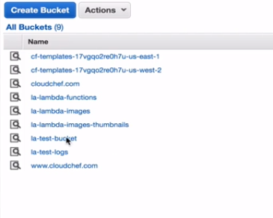

Go manually to an object inside a bucket and chage the source class by right click on that object and go to properties

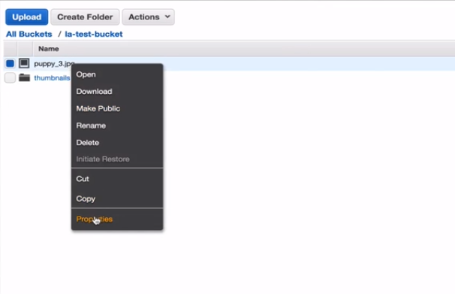

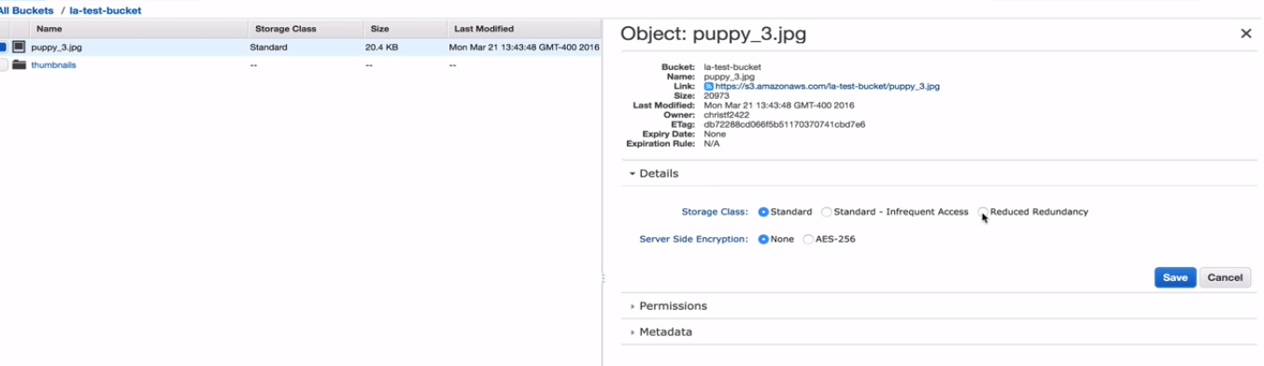

Select reduced redundancy and save.

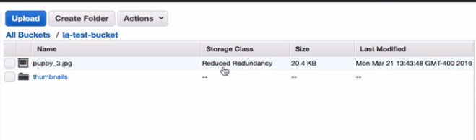

WE can see the storage class changed to reduced redundancy. But offcourse we want to automate this and do it as the user upload the images.

Now below is my original image

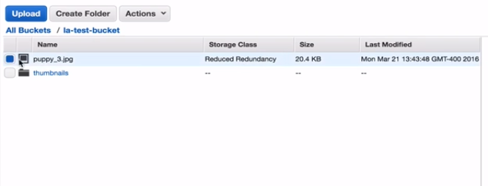

So im going to transform it back to standard storage.

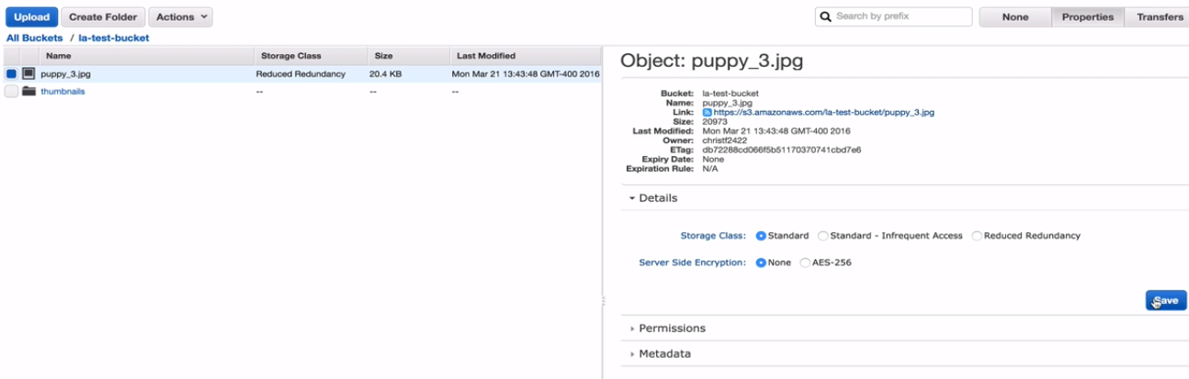

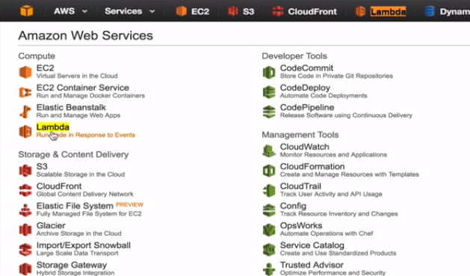

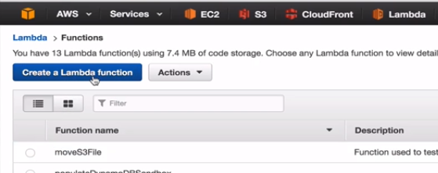

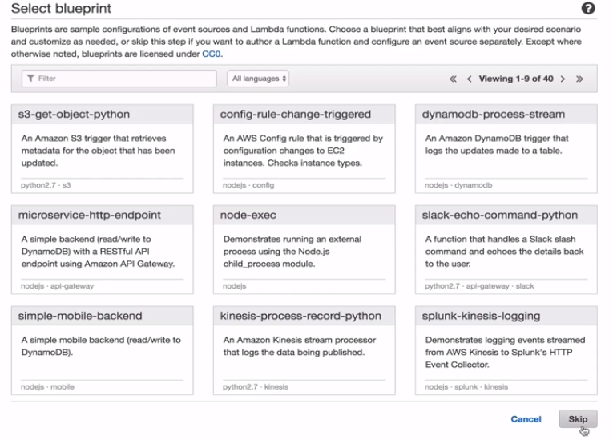

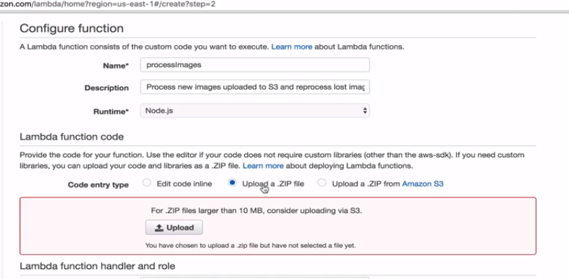

WE are going to upload the zip file from our local system.

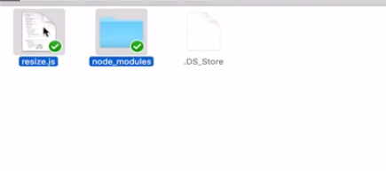

Select and compress these

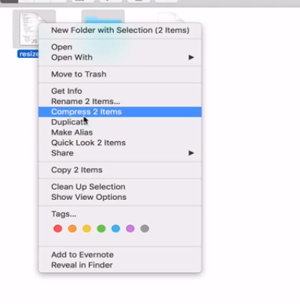

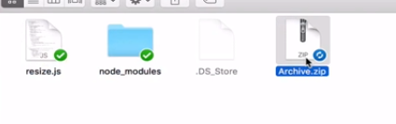

Upload the zip file now

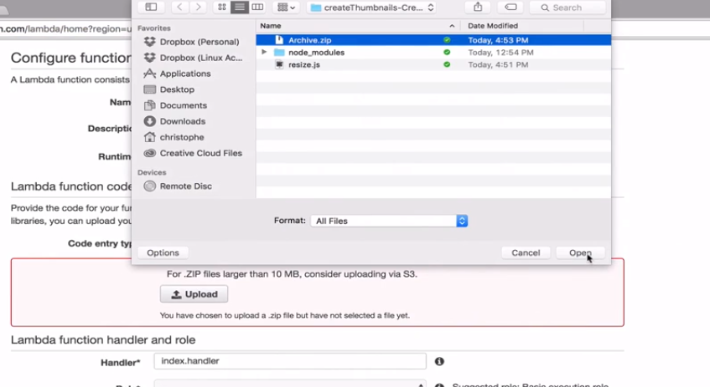

We can download this inside the downloadable content inside the certified developer course on the right hand side of the main course page.

Lets understand the code.

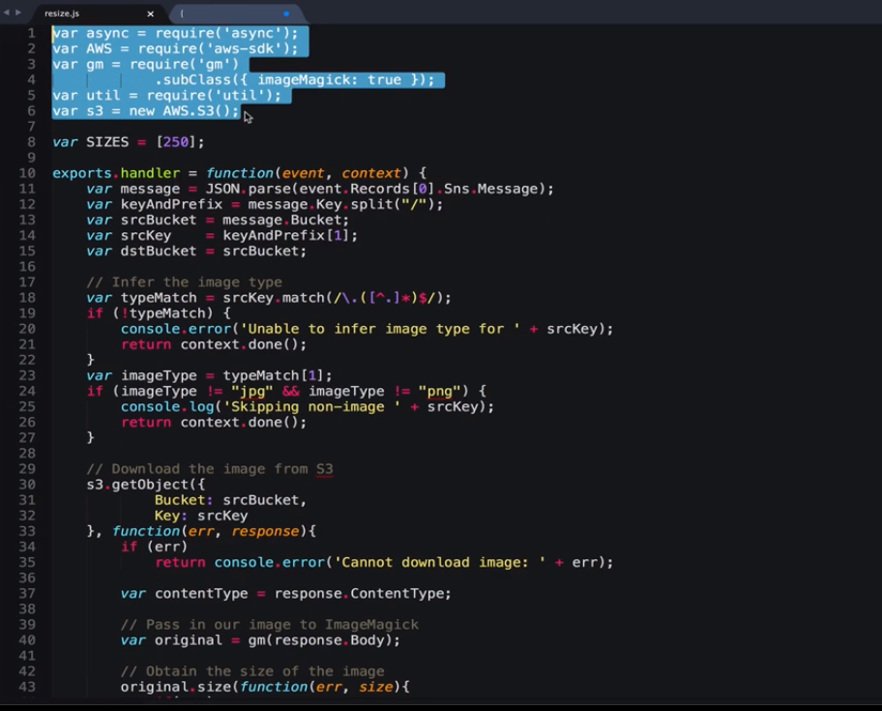

The selected item are the dependencies. The first one is async . This is going to allow us to perform actions asynchronously in our node.js function. The second one is requiring the AWS SDK so that we can access various methods and services in amazon. We also require gm and subclass of image magic. These two are going to allow us to manipulate images in certain ways like resizing them, we can compress them in many ways as well as modify the way they look like add filters etc. Also require util which is going to let us debug if we need to.

And s3 = new im saving the s3 object into a variable so that we can create a connection to s3 and access various methods.

Then there is an array of sizes .



Here we are creating a function and naming it with a handler. The handler is what we are going to use in amazon to call our function whenever our lamda function is invoked. So if I go to amazon lamda console there we have a handler as

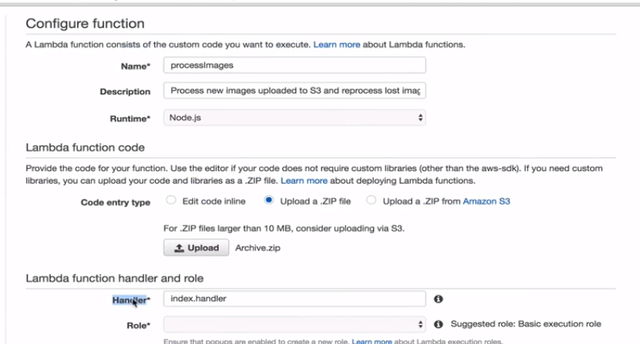

By calling this index.handler we are saying the file that we want to call is called index.js and the function is called handler. And we do have a function called handler but my file name is resize so we are going to change this to **resize.handler.**

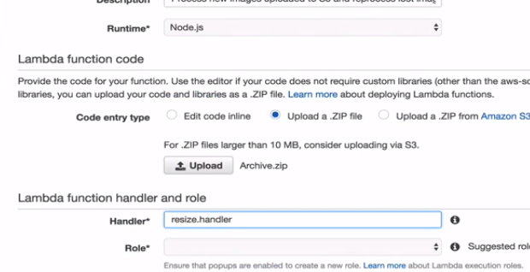

So by this way handler in the code will receive the events and context from the file resize.

Lets focus on the event part



Any event that we are going to receive from our Amazon SNS subscription . When something publishes to SNS, since our function would be subscribed to the topic we are going to receive the message. The message would be going to passed into our event parameter above automatically. And so we can grab various parameters, variables from our event that was passed by SNS.

Next we are passing thorought the JSON what we have received from the message from SNS and grabing them into variables.

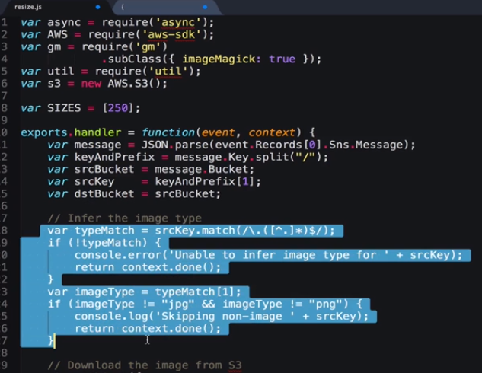

Now in this section we are checking for the image types. We want to make sure its an actual image not some other formats like .txt or something like that.

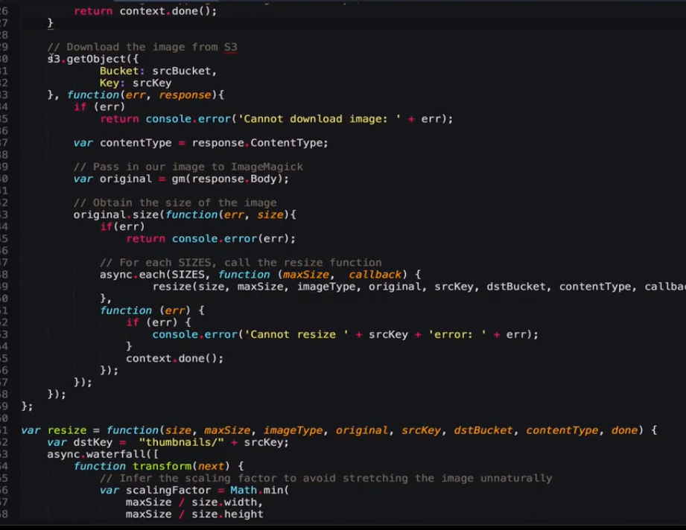

This is the place where we are downloading the actual image because we need to create the other images.

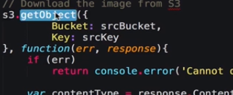

So we get the object from s3 using our source bucket and key, if we get an error we are going to have console error and if we don’t have an error we can grab the content type from the image and the image itself which we are going to pass in the image magic unsing gm.

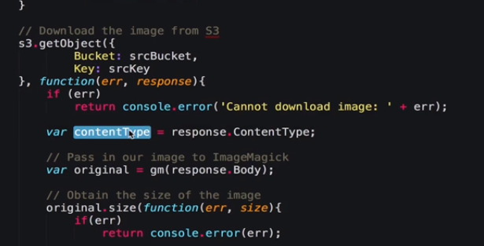

Then we are running a function for resizing the image.This function contains all the logic which is going to resize the image.

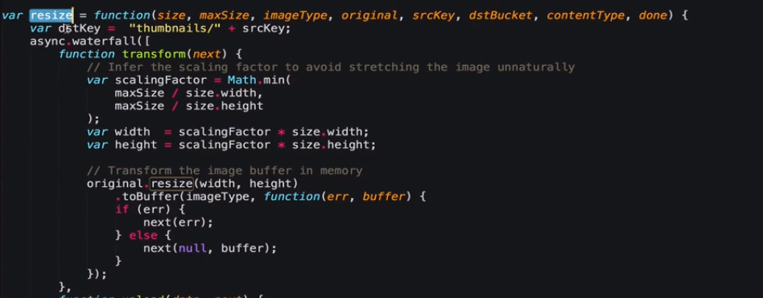

Here we are grabbing the destination key, we are prefixing that with thumbnill. So if you back to s3

Go back to the La-bucket there

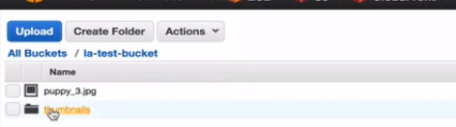

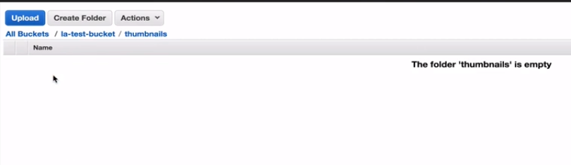

So I want to store here and that way im doing it.

Then im calling a waterfall method on async. This allows to take one function and execute another after that id done passing in the result from the previous function.

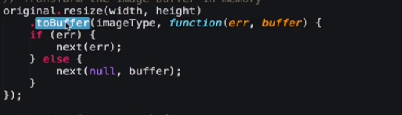

We are calling to Buffer to do the original size in buffer so lamda is going to spin up a container, that container is going to have some memory which we are going to allocate inside of our dashboard here

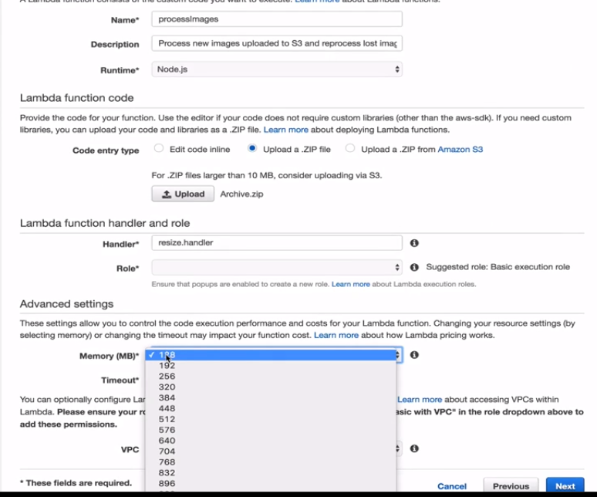

We are going to use a 128 mb. So our container would have a 128mb which would be enough for smaller images . If our resize is successful we then pass our new data to an upload function thanks to the waterfall again . And we are using our putobject to put the object to s3

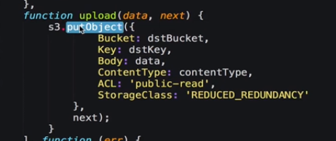

We are saying here the storage class to be reduced redundancy because this is not the original image.

Now we need to save the above file and define a role for lamda.

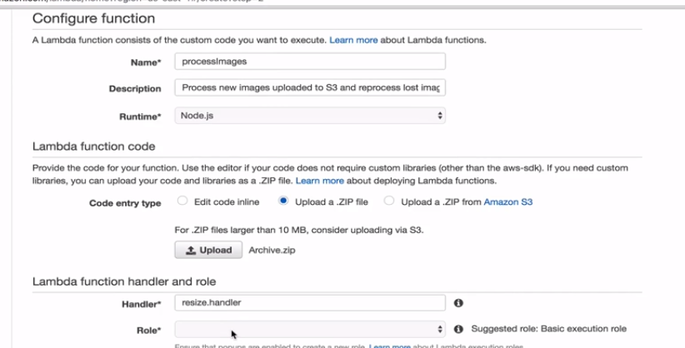

Select the below role

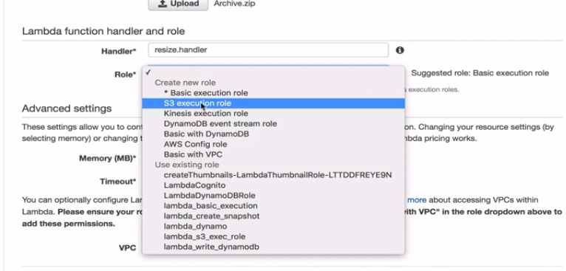

It helps us to log everything what is going to cloudwatch as well as help to put the object.

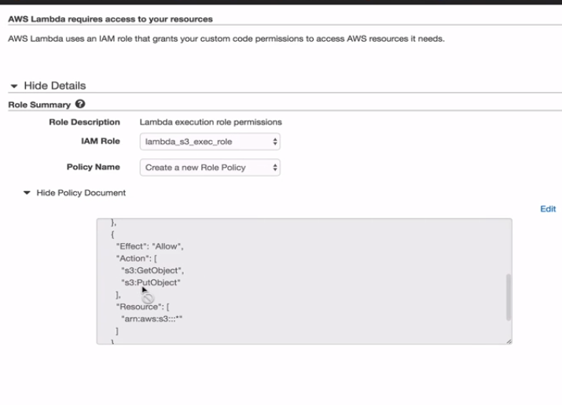

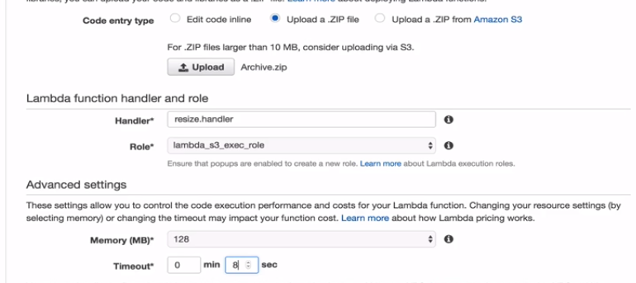

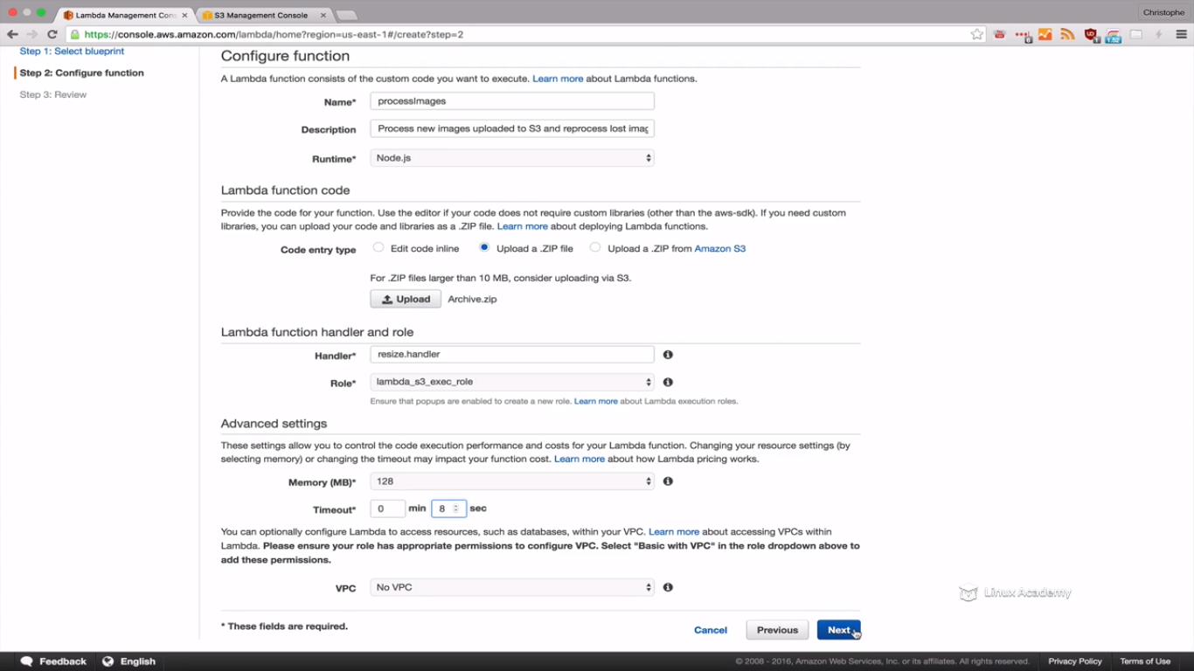

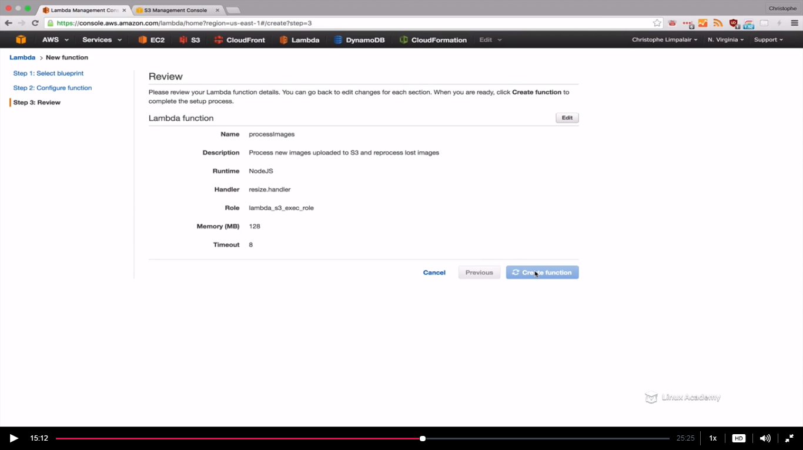

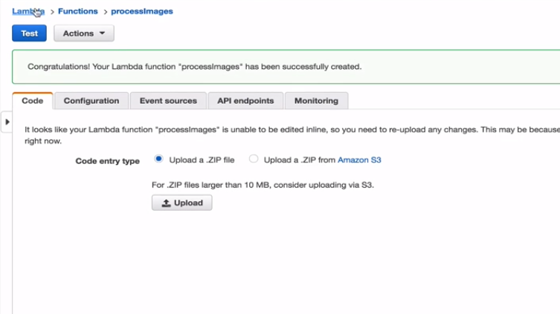

So we have our lamda function ready so lets first go to SNS

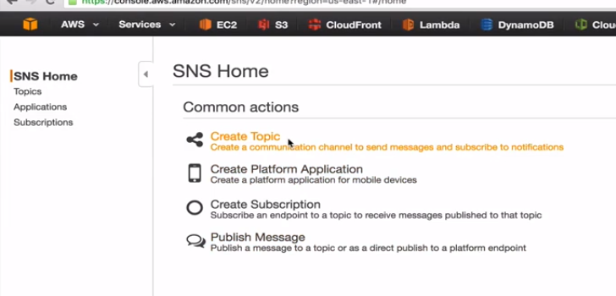

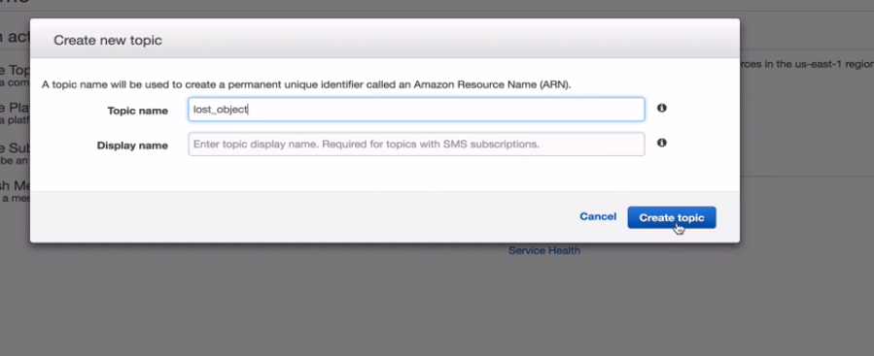

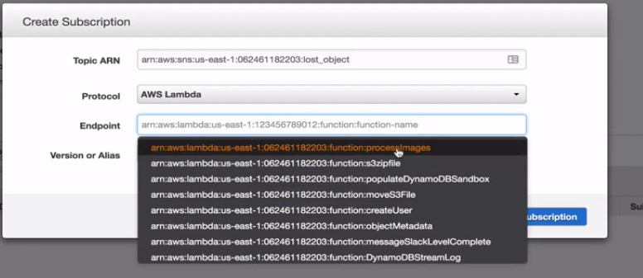

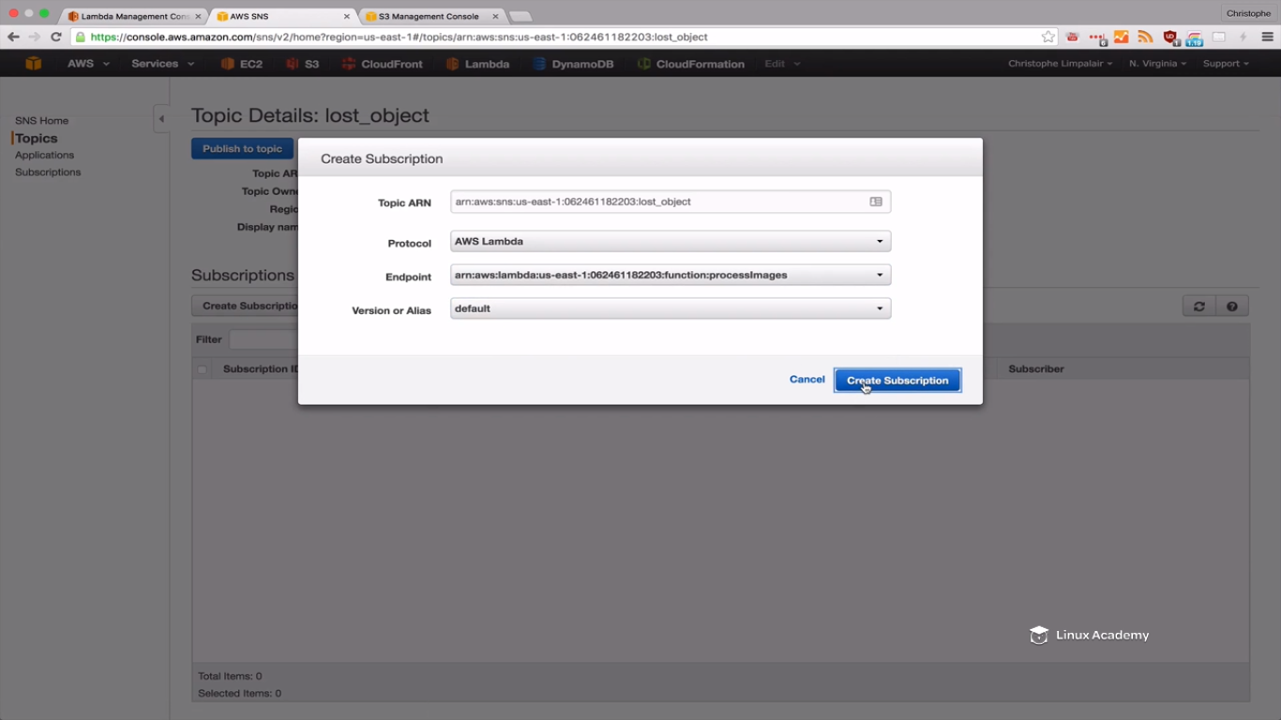

Since now we have the subscription go back to lamda and go to event sources.

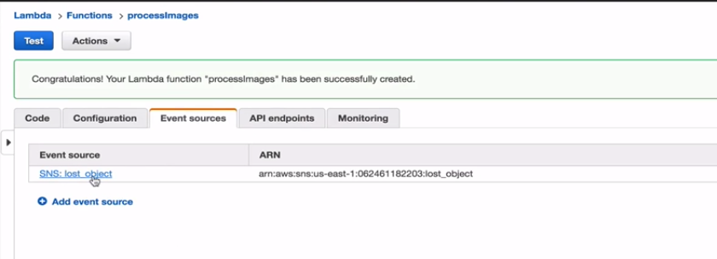

And I can see the SNS-Lost-Object topic.

Now we can go back to s3 and our la-bucket

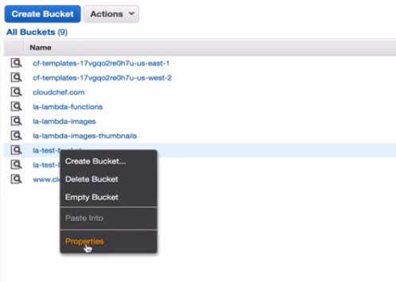

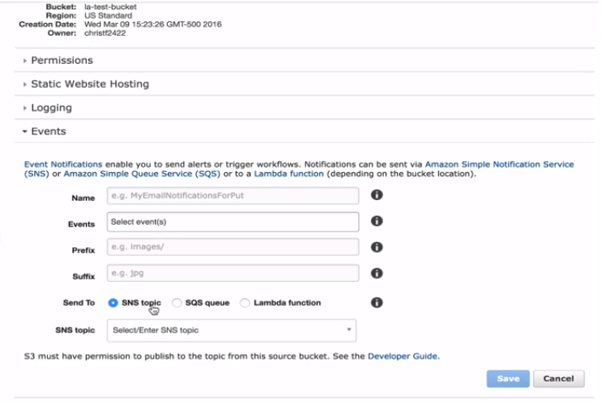

Inside events we can choose our SNS topic to publish to. Again when we loose an object we want to publish a notification to SNS. We can however do directly to lamda function but here we are choosing SNS.

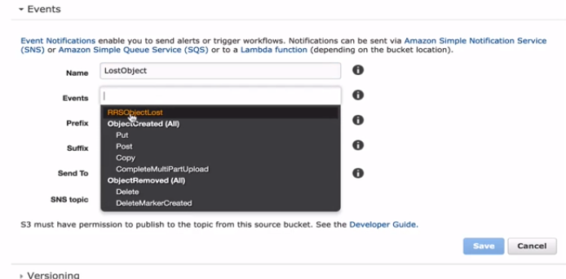

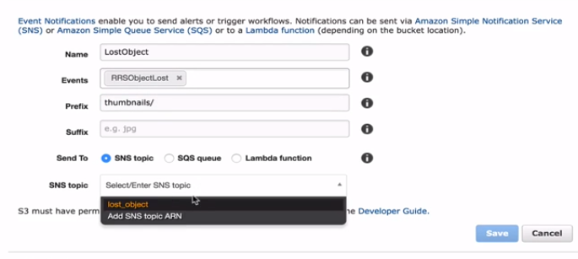

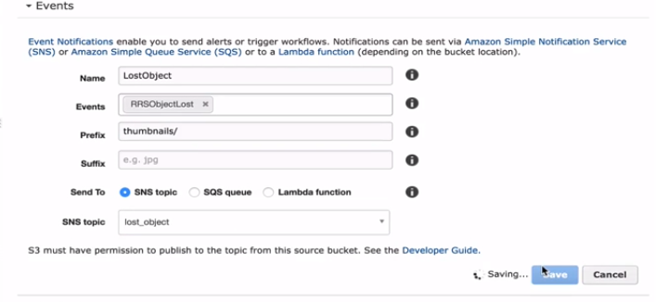

So instead of waiting for an actual object loss which could take a very long time we are going to simulate this using json because that is what amazon will use.

Amazon lost would be using something like this so lets copy the below

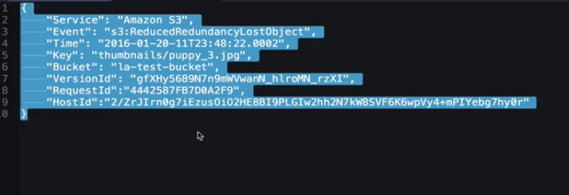

Go to topic again and lets pubish to our topic as

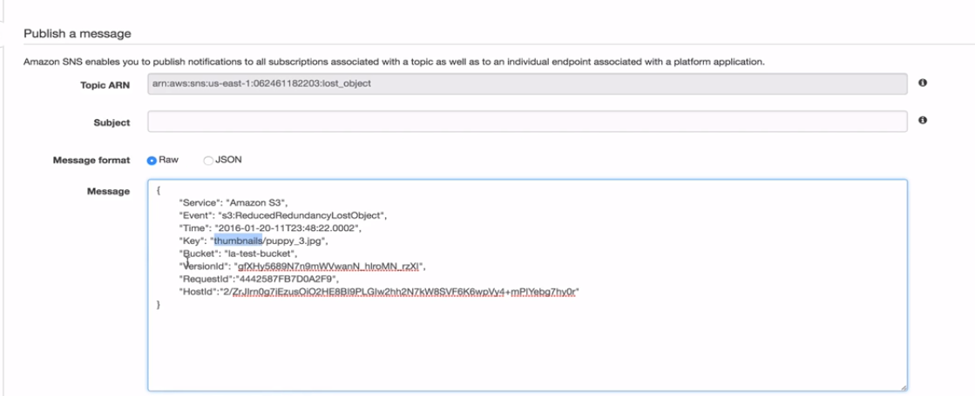

So if you don’t have a prefix you can delete the thumnill but we have a prefix here so im keeping it.

So go back to lamda fuction and see the content of publish we are traversing and parsing there

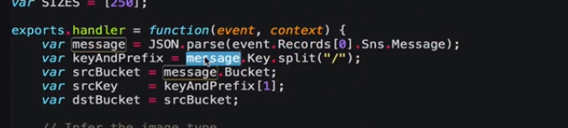

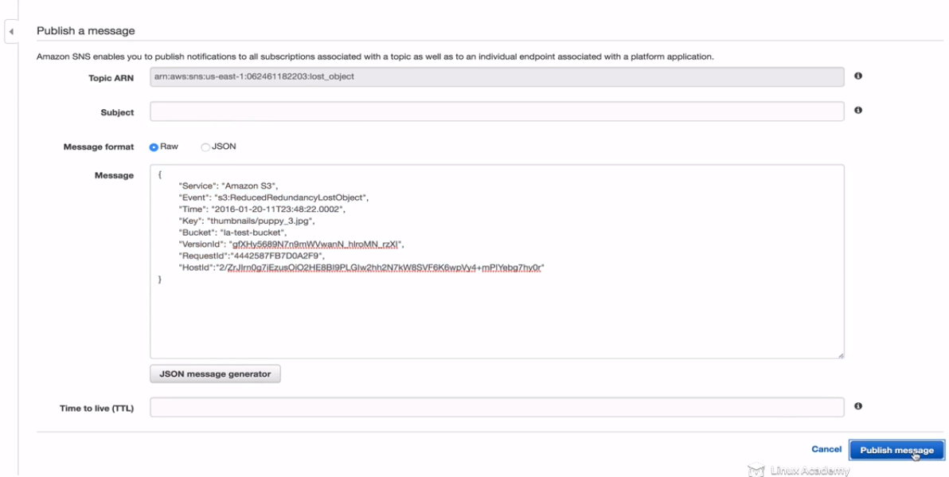

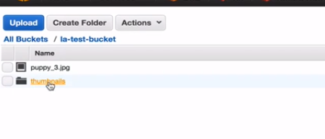

The folder is empty that means it didn’t worked. So lets debug it what went wrong. How we can figure out wat went wrong.

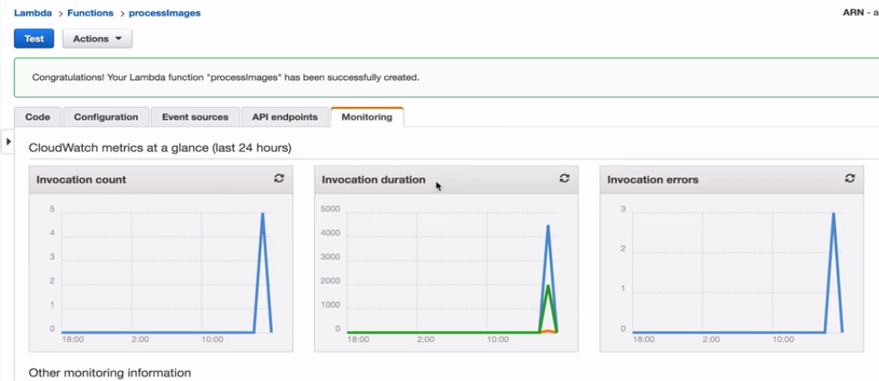

WE can also see the cloudwatch logs as wat went wrong

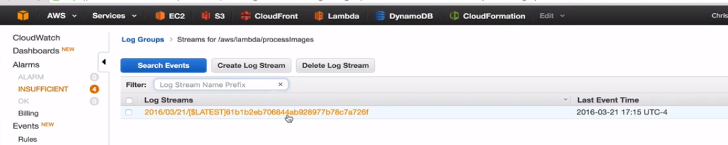

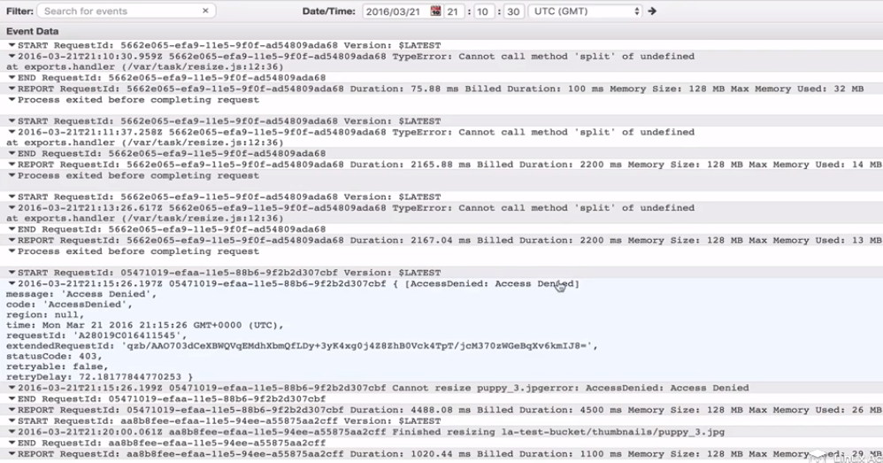

And it says access denied. So we were denied access to S3 hence it got that error.

Go to IAM

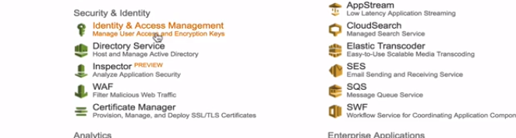

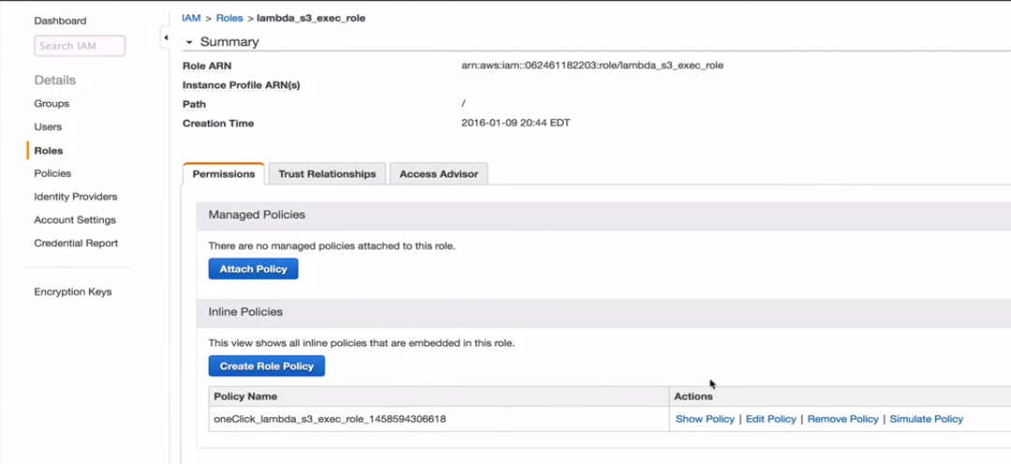

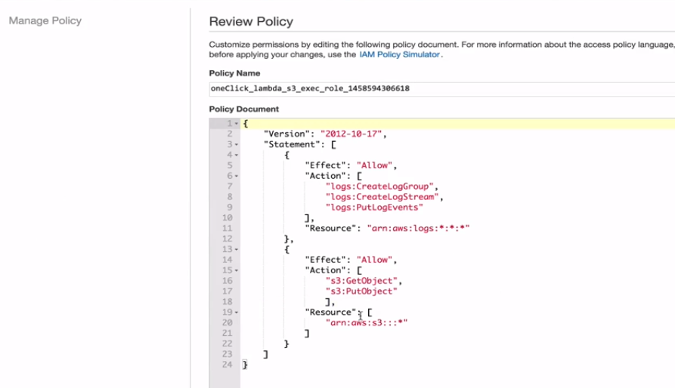

So this is how the permission look like so we have the options of get and put object, so it clould be something else may be we cant set ACL permissions or something. So for now lets give all access to s3 here as do a * in action as

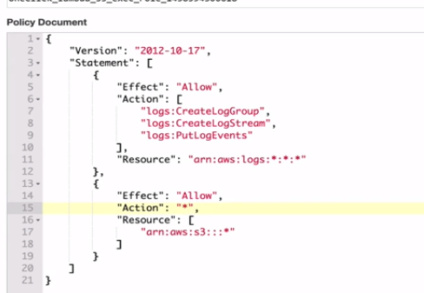

And click appy.

And then lets go backt to SNS and try again.

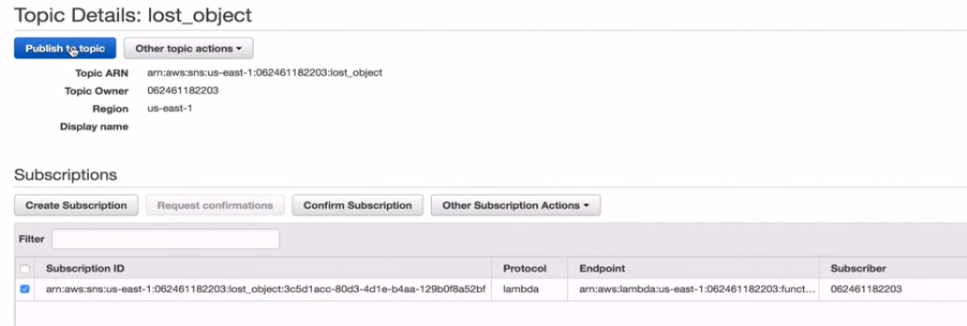

Publish the same message again.

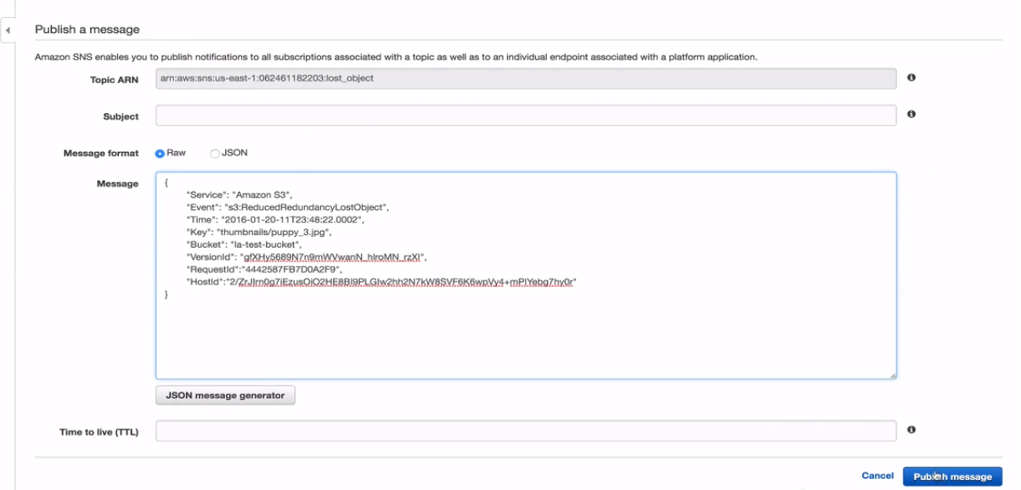

Go to s3 console and refresh

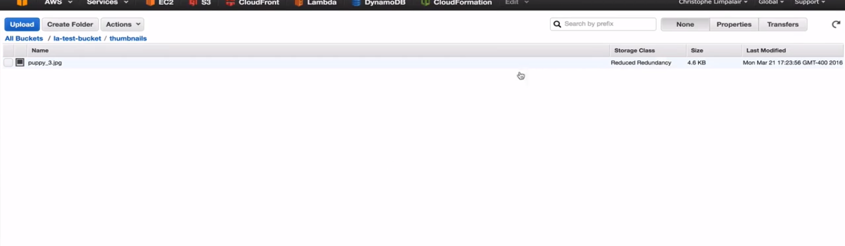

This time we see puppy3 and reduced redundancy.

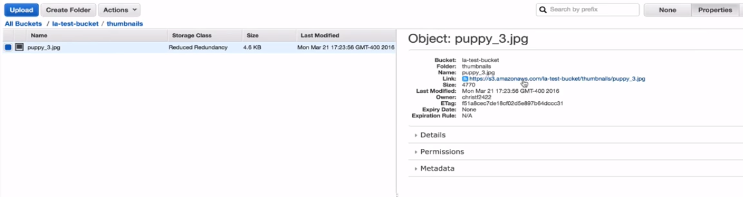

It is publically available, if you click the URL u will see

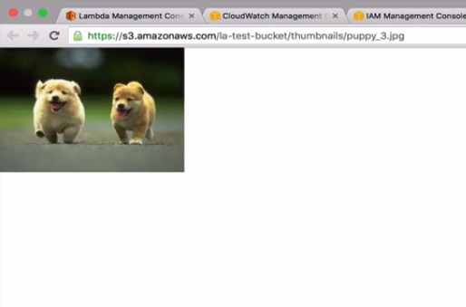

And if we go back to la-bucket

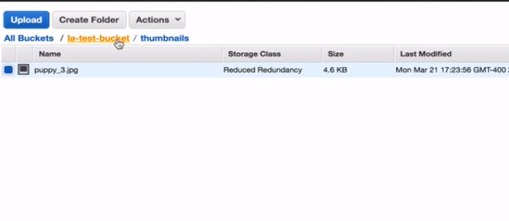

And click the original image

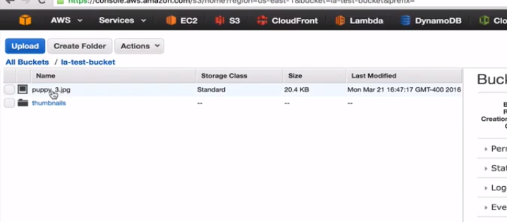

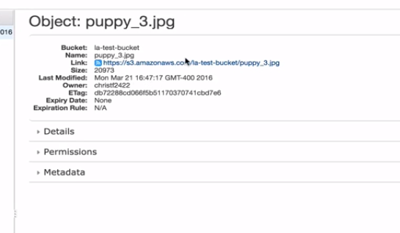

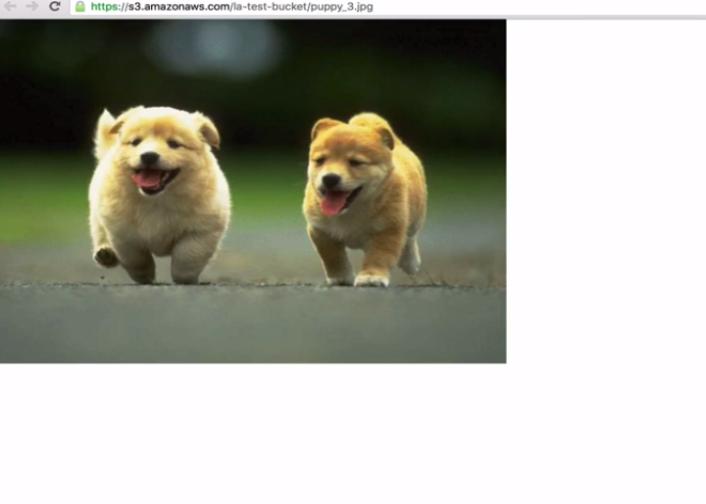

We see there is a size difference.